
SAATHI
AI Weaver Companion for Demand & Income Forecasting
Handloom Hackathon 2026 — “Weaving Innovation”
Problem Statement 4.2: Income Stability & Demand Forecasting Tools
Team: [Your Team Name]
Members: [Name 1], [Name 2], [Name 3], [Name 4]
Institution: Gujarat Technological University – School of Engineering and Technology
“What should I weave this week — and will there be enough money to get there?”
Website URL : [add before submission]
GitHub Link : [add before submission]

EXECUTIVE SUMMARY
Handloom weaving is one of India's largest sources of rural livelihood, and one of its most economically unstable. Demand spikes hard around festivals and weddings, then goes quiet; payment for a finished order often lands weeks after it's delivered; and a weaver planning next week's loom time has no reliable way to know whether to weave sarees, dupattas, or nothing at all. The 4th All India Handloom Census found that two in three weaver households earn less than ₹5,000 a month — not because of a shortage of skill, but because of a shortage of foresight.
Saathi (साथी — “companion”) answers one question, every week, for one weaver at a time: what should I make, and will there be enough money to get there? Underneath a deliberately simple, voice-first, trilingual app sits a real forecasting system — an XGBoost and seasonal-baseline ensemble, walk-forward validated and calibrated with conformal prediction — trained on five years of hybrid data spanning 34 real handloom clusters, festival and wedding timing, cotton price movement, and order-level payment-delay patterns.
The system is not a claim. On a held-out six-month test window it beats a seasonal-naive baseline by 23% (WAPE 0.224 vs 0.293), with empirically verified 90% prediction intervals, and it is most accurate in exactly the weeks that matter most — festival weeks (WAPE 0.196) outperform ordinary ones (0.248). That forecast drives a weekly action card and a cashflow traffic light, scoped to what one active weaver can actually expect, never a misleading cluster-wide total dressed up as personal income.
Where most demand-forecasting entries will stop at a model, Saathi also treats “lack of visibility into future orders” and “delayed payments” as first-class problems — named explicitly in the problem statement, and modelled explicitly here — and delivers all of it through an interface built for a 54-year-old weaver with a basic Android phone, not for the judge reading the dashboard.
PROBLEM STATEMENT & CONTEXT
Official Problem Statement:
“Handloom weavers frequently face irregular income due to seasonal demand fluctuations, uncertain market trends, delayed payments, and lack of visibility into future orders. This income instability affects their financial security and discourages younger generations from pursuing weaving as a livelihood. Create intelligent tools that help weavers anticipate market demand, forecast orders, plan production cycles, and manage income more effectively. The solution should provide actionable insights using local market data, buyer trends, and historical demand patterns to support stable earnings and better business decisions.”
The Ground Reality:
India's handloom sector supports roughly 35 lakh workers — 26.7 lakh weavers and 8.5 lakh allied workers — across the country, per the 4th All India Handloom Census (2019–20). Two-thirds of weaver households earn under ₹5,000 a month. Average weaving activity runs to about 208 days a year, well short of full employment, and the gap is not effort — it is planning. A weaver cannot see three weeks ahead. She does not know if Raksha Bandhan will mean a rush order for silk sarees or a quiet month, whether to buy yarn now while prices are reasonable, or whether the payment for last month's order is two weeks late or two months.
Cooperatives and individual weavers alike make production decisions from memory and word of mouth — “last year around this time we were busy” — rather than from data. When that memory is wrong, the result is either unsold stock tying up scarce working capital, or a missed festival window that cannot be recovered until next year.
Why Existing Solutions Fall Short:
E-commerce platforms solve the last mile — listing and selling a finished product — but say nothing about what to make next, whether that decision is financially sound, or when the money from the last sale will actually arrive. Generic forecasting dashboards, where they exist at all, are built for an analyst, not for a weaver with a basic phone who may be more comfortable speaking than typing, and who has no use for a MAPE score.
Why This Is Different From “Build a Forecasting Model”:
The problem statement names three distinct failures — demand uncertainty, delayed payments, and no order visibility — and most technical teams will only solve the first. Saathi treats all three as one connected system: a forecast is only useful to a weaver if it also tells her whether she can afford to act on it, and whether the money she's owed is actually coming.
PROPOSED SOLUTION: SAATHI
Platform Overview:
Saathi is a mobile-first, voice-first, trilingual (Gujarati, Hindi, English) companion app built around one screen and one question: what should I weave this week? It is deliberately not a dashboard — every raw statistic a model produces is translated into a plain-language recommendation before it reaches a weaver, while a separate Admin mode gives cooperative field officers the full analytical detail they need to act on it. The two modes share one design system and one backend, so nothing has to be built twice.
Core Modules:
Saathi organises the problem statement's four asks — anticipate demand, forecast orders, plan production, manage income — into seven interconnected modules:
1. Weekly Action Card – A single home-screen card stating what to weave this week, how much, why, what material to buy, and the best-selling window — driven by the forecasting ensemble, never hand-written.
2. Forecasting Ensemble – A seasonal-naive baseline blended with XGBoost, calibrated with conformal prediction for an honest 90% interval, not a single falsely-precise number. Full detail in the ML Architecture section.
3. Cashflow Traffic Light – A green/yellow/red income status plus a per-active-weaver earning range — explicitly scoped per weaver, never a cluster-wide total presented as one person's income.
4. AI Explanation Layer – A Gemini-powered voice/text assistant that explains and translates the forecast — it never generates a demand number itself. If Gemini is unavailable, a grounded rule-based fallback keeps the app fully functional.
5. Orders & Payment Visibility – Plain-language order status (“on its way”, not a raw enum) addressing the problem statement's “lack of visibility into future orders” and “delayed payments” directly, not as an afterthought.
6. Printable Card & Offline Resilience – A single-page, high-contrast printable version of the weekly card for weavers without steady smartphone access, plus cached last-known guidance when connectivity drops.
7. Admin Mode – Cluster comparison, full forecast analytics (with plain-language interpretation alongside every metric), and a credit-need queue for field officers managing many weavers at once.
KEY FEATURES & NOVELTY
Direct Mapping to Problem Statement Requirements:
Problem Statement Requirement | How Saathi Delivers
Anticipate market demand | XGBoost + seasonal-baseline ensemble trained on 5 years of hybrid data across 34 clusters; 23% more accurate than the seasonal baseline (measured, not claimed).
Forecast orders | Order-level modelling (buyer type, promised vs. actual delivery) alongside weekly demand — not demand volume alone.
Plan production cycles | Weekly action card states quantity, material to buy, and the selling window, derived directly from the forecast.
Manage income more effectively | Per-weaver cashflow projection with a credit-need traffic light, built from a 5-table cashflow and payment-delay model.
Actionable insights using local market data | Every number is paired with a plain-language reason before it reaches a weaver; nothing is shown as a bare statistic.
Buyer trends | Orders are modelled by buyer type — retail, wholesale, export, cooperative-bulk — not treated as one undifferentiated stream.
Historical demand patterns | 5 years of weekly history, lag features to 52 weeks, walk-forward validated so no future information leaks into training.
Support stable earnings & better decisions | Financial figures are always ranges, always per-weaver scoped, and traffic-light framed — designed to be trusted, not just displayed.

Novelty – What Makes Saathi Different:
Most entries against this problem statement will submit a forecasting model. Saathi's differentiation is not a bigger model — it is treating the full sentence of the problem statement as the spec, including the two clauses about payments and visibility that are easy to skip, and refusing to ship a number that can't be defended.
Feature | What It Does | Why It Is Novel
Measured, not asserted, accuracy | Walk-forward backtest with published WAPE, MAPE, pinball loss and empirical interval coverage. | Most hackathon forecasting entries state an accuracy claim with no methodology shown. Saathi's BACKTEST_RESULTS.md is reproducible from the repo.
Payment-delay & order-visibility modelling | Order-level log tracks promised vs. actual delivery and payment timing, feeding the cashflow projection. | The problem statement names “delayed payments” and “lack of visibility into future orders” explicitly — most teams only model demand and skip both.
Per-weaver scoped financial figures | Cluster-wide totals are divided by active weaver count before ever reaching a weaver-facing screen; only ranges are shown. | A common and easy mistake in this problem space is showing a cooperative's total cashflow as if it were one weaver's income. Saathi's data contract makes that structurally impossible, not just avoided by convention.
Voice-first, trilingual, dual-mode design | The same backend serves a radically simple voice/text weaver experience and a full analytics admin view. | Most technical teams build the dashboard first and simplify later, if at all. Saathi's information architecture starts from a 54-year-old weaver's first ten seconds on the home screen.
Auditable hybrid dataset | Every column across 5 datasets is tagged REAL, REAL-PROXY, or SYNTHETIC-CALIBRATED in a public data dictionary. | No public dataset exists for granular handloom demand. Rather than hide that gap, Saathi documents exactly what's real, what's a live proxy, and what's a calibrated simulation — and why.
TECHNICAL ARCHITECTURE
Saathi is a seven-layer system: weaver and field-officer access, a dual-mode React application, a FastAPI backend, an intelligence layer (forecasting, cashflow, explanation), a documented hybrid data layer, the real-world signals that ground it, and a two-service deployment (Vercel for the frontend, Render/Railway for the backend).
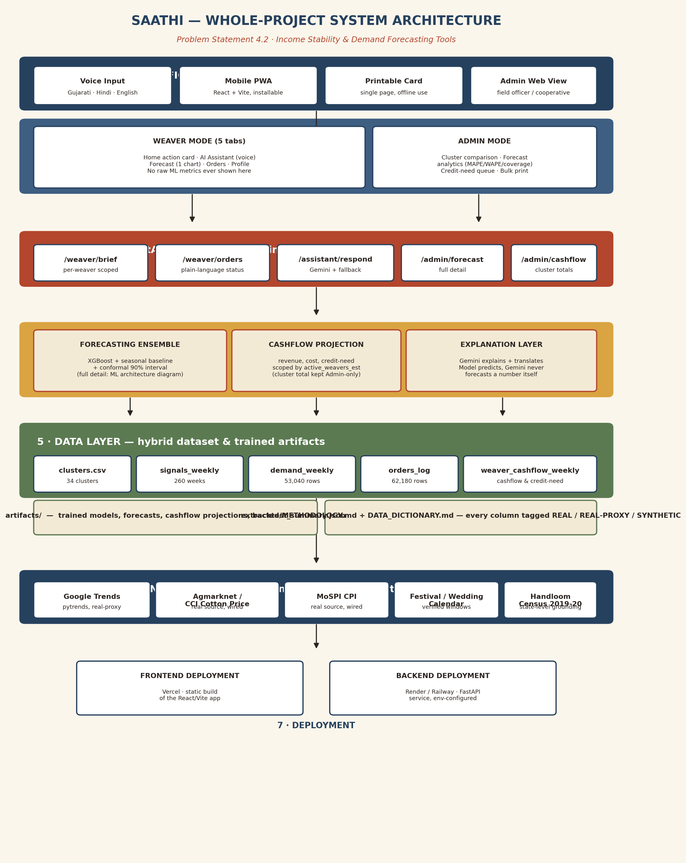
Figure 1 — Whole-project system architecture.
ML ARCHITECTURE & VALIDATION
This is the section most demand-forecasting submissions will not have: a validated, reproducible pipeline with published numbers, not an estimate. The full pipeline runs from the raw hybrid dataset to a weaver-facing action, with a walk-forward backtest re-run on every retrain.
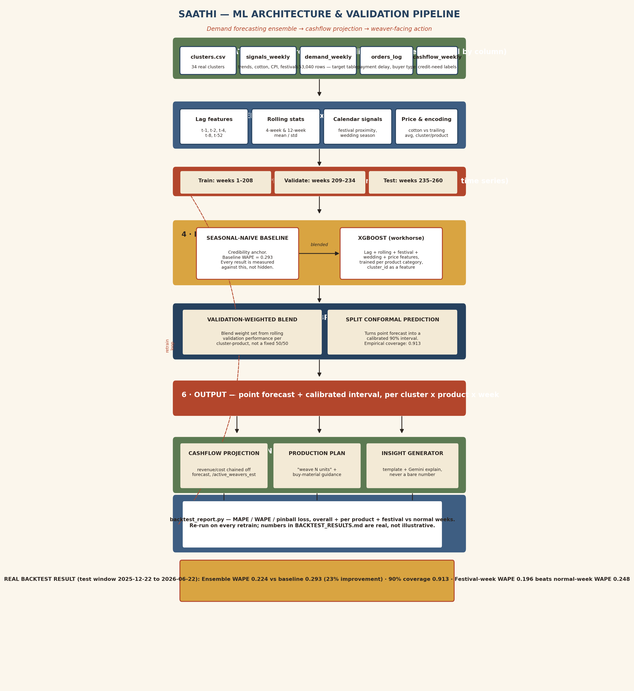
Figure 2 — ML architecture and validation pipeline.
Real Backtest Results (test window: 2025-12-22 to 2026-06-22):
Metric | Baseline (seasonal-naive) | Ensemble (Saathi)
WAPE (overall) | 0.293 | 0.224
MAPE (overall) | — | 0.466 *
90% interval coverage | — | 0.913
WAPE — festival weeks | 0.254 | 0.196
WAPE — normal weeks | 0.325 | 0.248
Best category (saree) WAPE | 0.233 | 0.177
* MAPE is naturally inflated on low-volume weekly counts; WAPE is the more meaningful headline metric here — stated plainly rather than presenting only the flattering number.
Design Choices (defensible in a judge Q&A, not just asserted):
Seasonal-naive baseline as the credibility anchor — every result is measured against a judge-recognisable benchmark, not hidden behind ensemble complexity. XGBoost as the workhorse — handles lagged demand and exogenous signals (festival timing, cotton price, wedding season) without heavy infrastructure. Validation-derived blend weights, not a fixed average, so the ensemble adapts per cluster-product rather than assuming one weighting fits all. Split conformal prediction for intervals — simple, defensible, and empirically checked against actual coverage rather than assumed correct.
Data Methodology:
The dataset is hybrid by necessity: no public dataset tracks granular, weekly, per-cluster handloom demand in India. Every column across five tables — clusters, weekly signals, weekly demand, the order log, and weekly cashflow — is tagged REAL, REAL-PROXY, or SYNTHETIC-CALIBRATED in a published data dictionary, with the exact real source named for every placeholder (Agmarknet / Cotton Corporation of India for cotton price, MoSPI for CPI, live Google Trends via pytrends). This is not a claim of a perfect dataset — it is a transparent account of what's real today and what gets replaced first.
IMPACT & ALIGNMENT WITH ECONOMIC WELL-BEING
Two kinds of claims appear below, and they are kept deliberately separate: what has been measured on held-out data, and what is projected once the system is used by real weavers. Blurring the two is the single easiest way to lose credibility with a technical judge.
Measured (from the backtest, reproducible from the repo):
A 23% reduction in weekly demand forecast error versus a seasonal-naive baseline (WAPE 0.224 vs 0.293), with empirically verified 90% prediction intervals — meaning the range shown to a weaver is honest about its own uncertainty, not falsely precise. Accuracy is highest exactly where it matters most: festival weeks (WAPE 0.196) outperform normal weeks (0.248), so the model is most trustworthy during the highest-stakes production decisions of the year.
Projected (the mechanism is built; the outcome needs real-world validation):
Better production timing — weaving the right product ahead of a demand window instead of after it — should reduce both unsold stock and missed festival opportunities, the two failure modes the ground-reality section described. Earlier visibility into likely cash shortfalls, via the per-weaver cashflow projection and credit-need flag, is intended to let a weaver or cooperative seek credit proactively instead of reactively. Neither of these outcomes is asserted as a percentage here — that number belongs after the mandatory weaver-immersion phase, calibrated against what weavers actually report, not invented in advance.
Financial Figures Are Never Inflated:
Every rupee figure shown to a weaver is a range, scoped to one active weaver's expected outcome for the coming week — never a cluster-wide total, and never a single point number presented as certain. This is a data-contract rule enforced in the backend, not a UI convention that could be bypassed by a future screen.
DEMONSTRATION PLAN / USE CASE FLOW
Step | Actor | What Happens
1 | Weaver | Onboards once: picks Gujarati, Hindi, or English, selects cluster and product.
2 | Saathi | Home screen renders the weekly action card — quantity, reason, material to buy, selling window, confidence.
3 | Weaver | Taps the mic, asks “Should I buy silk this week?” in Gujarati.
4 | Saathi | Gemini explains the recommendation in Gujarati, grounded in the forecast — never invents a number.
5 | Weaver | Opens Forecast tab: one graph, confidence band, festival markers, no jargon visible.
6 | Saathi | Cashflow card shows a yellow traffic light: “Watch receivables — ₹19,700–₹29,550 expected this week.”
7 | Weaver | Checks Orders tab: “Payment on its way” instead of a raw status code.
8 | Field Officer | Opens Admin mode: cluster comparison table, backtest accuracy panel with real WAPE/coverage numbers.
9 | Field Officer | Sees the cluster flagged in the credit-need queue, follows up before the shortfall happens.
10 | Field Officer | Bulk-prints action cards for weavers without steady smartphone access.
End-to-end flow connecting Weaver, Saathi, and Field Officer — forecast to action to follow-up.
FUTURE ROADMAP
Saathi is built to grow through the hackathon's own structure — the mandatory weaver immersion is not a compliance step here, it is Phase 1 of the roadmap, because the model becomes genuinely better the moment it is checked against real weavers instead of only against held-out historical data.
Phase 1: Weaver Immersion & Calibration – Use the hackathon's mandatory weaver-immersion week to calibrate every synthetic-calibrated coefficient — festival lift, payment-delay distribution — against what real weavers report, and publish the before/after difference honestly.
Phase 2: Full Live Data Integration – Replace the remaining synthetic-placeholder signals — cotton price, CPI — with live Agmarknet and MoSPI pulls; Google Trends already runs live where network access allows.
Phase 3: Sequence Model & Production Optimiser – Add a temporal fusion transformer for cross-cluster transfer learning (useful for data-sparse clusters), and a constrained optimiser turning the forecast into a weekly production split across product categories.
Phase 4: Real Delivery Channel – Move the printable card and in-app card to real WhatsApp/SMS delivery with a human-in-the-loop review step before anything is sent to a weaver.
Phase 5: Anomaly & Buyer-Trend-Shift Detection – Monitor real incoming orders against the forecast interval and flag genuine trend shifts — not noise — the moment they appear, rather than waiting for the next scheduled retrain.
Phase 6: National Coverage – Extend from the 34 pilot clusters toward full coverage of the clusters recorded in the Handloom Census, prioritised by income-volatility risk.
CONCLUSION
A weaver does not need a more sophisticated dashboard. She needs a straight answer to a question she asks herself every week — what should I make, and will there be enough money to get there — and she needs to be able to trust that answer the first time she sees it, in a language she reads, on a phone that may not always have signal.
Saathi was built to earn that trust honestly: a forecast that is measured, not claimed, against a real held-out test window; a cashflow figure that is scoped to one person's real week, never a cluster's total dressed up as her income; and an interface built from a 54-year-old weaver's first ten seconds on the home screen, not retrofitted onto an analyst's dashboard afterward.
With the mandatory weaver-immersion phase as its next real milestone, Saathi's roadmap is not aspirational — it is the next step the hackathon's own process already requires, and the point at which projected impact becomes measured impact. Because the question a weaver asks every week deserves an answer she can act on, not just a number on a screen.

