5/2/2023

Kathan Kathrotiya

21BCE115

“Text-to-Speech Convertor into multiple user defined languages”

2CS404-Innovative Assignment

**Packages required:**

*from flask import Flask, request,render_template,send_from_directory,send_file*

*import fitz*

*import docx*

*import datetime*

*from gtts import gTTS*

*from translate import Translator*

To install the necessary libraries in Python, you can use pip, which is a package installer for Python. Here are the commands you can use to install each of the libraries:

*Flask:*

pip install flask

*fitz:*

pip install PyMuPDF

*docx:*

pip install python-docx

*datetime* is a built-in library in Python, so you don't need to install it separately.

*gtts:*

pip install gtts

Once you have installed these libraries, you can import them in your Python code using the import statements you provided.

*translate:*

pip install translate

**Execution flow:**

* All the pages are linked by flask application. So, we need to first run flask application by the name *Web.py* by writing

*python -u "d:\SEM-IV\PSC\Innovative\Web.py"*

* Ctrl+Click on running website port url

Running on <http://127.0.0.1:5000>

* Select file from the device along with the input and output language requirement. File should be either pdf, txt, or doc/docx.
* Wait for the response of API call
* Listen to the converted audio and download the same .mp3 if required

**Features:**

* Translates text to speech of entire file at a time
* Multiple file format is supported
* Website is hosted using Flask so can be deployed easily
* User can hear it on site itself without downloading
* Download option is given to make sharing easy

**Input/Output:**

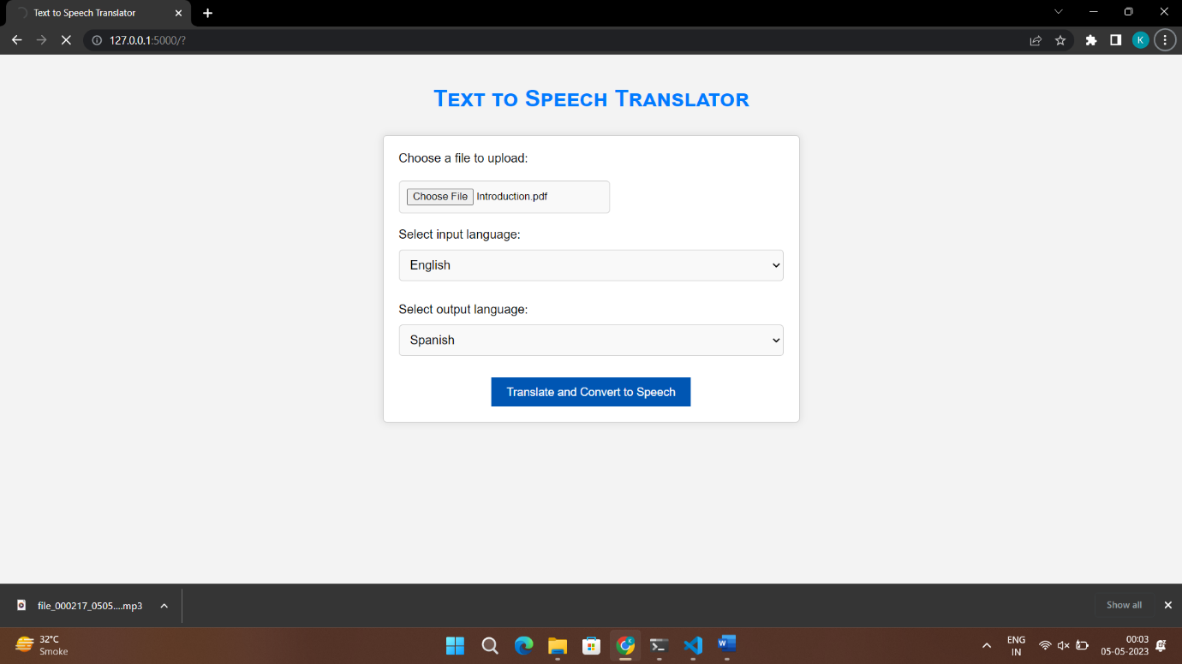

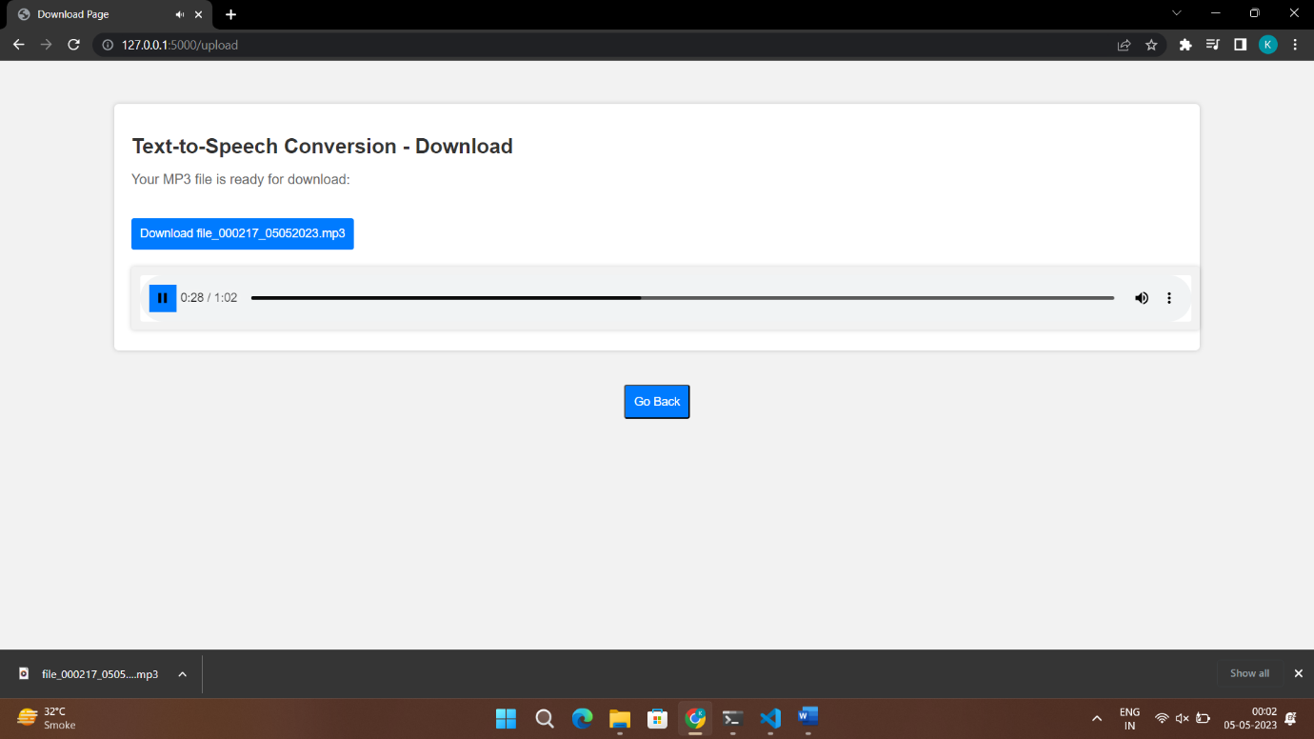

**Designed and Developed by:**

21BCE115-Kathan Kathrotiya