Interplay between BGP, OSPF, and RIP: a simple example

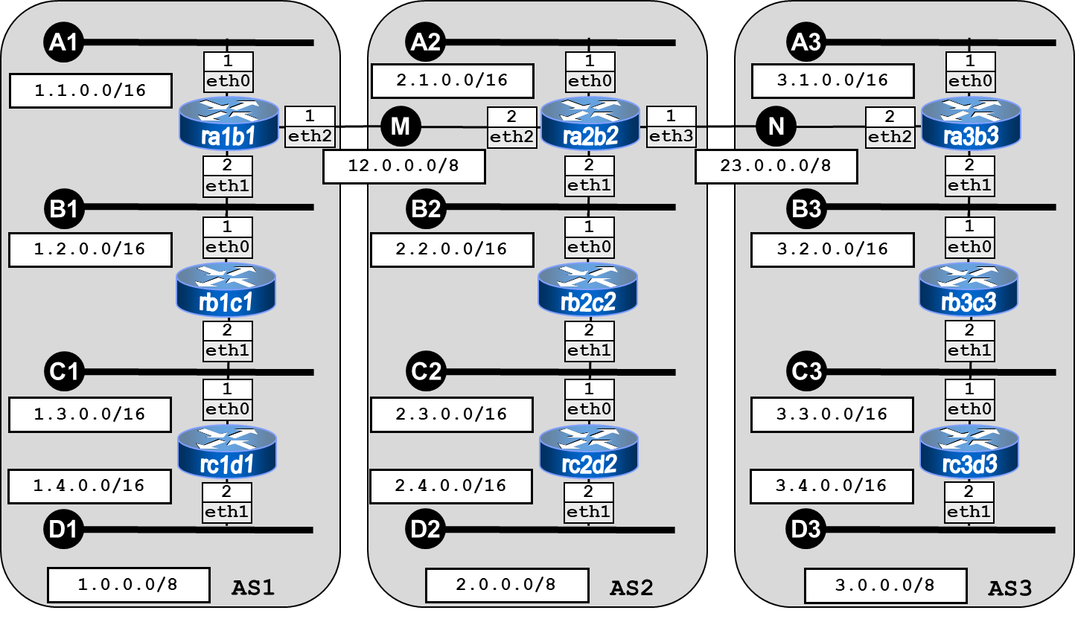

Using Kathará, implement the network depicted in the above figure and described below.
- Routers of AS1 should use RIP; routers of AS2 should use OSPF; routers of AS3 should use RIP.
- Routers ra1b1 and ra2b2 exchange their routes using BGP; routers ra2b2 and ra3b3 exchange their routes using BGP.

Goals:

Let each router to ping all the interfaces of all the other routers (with the possible exception of pings from/to the interdomain interfaces).

