Two levels load balancing for a Web service

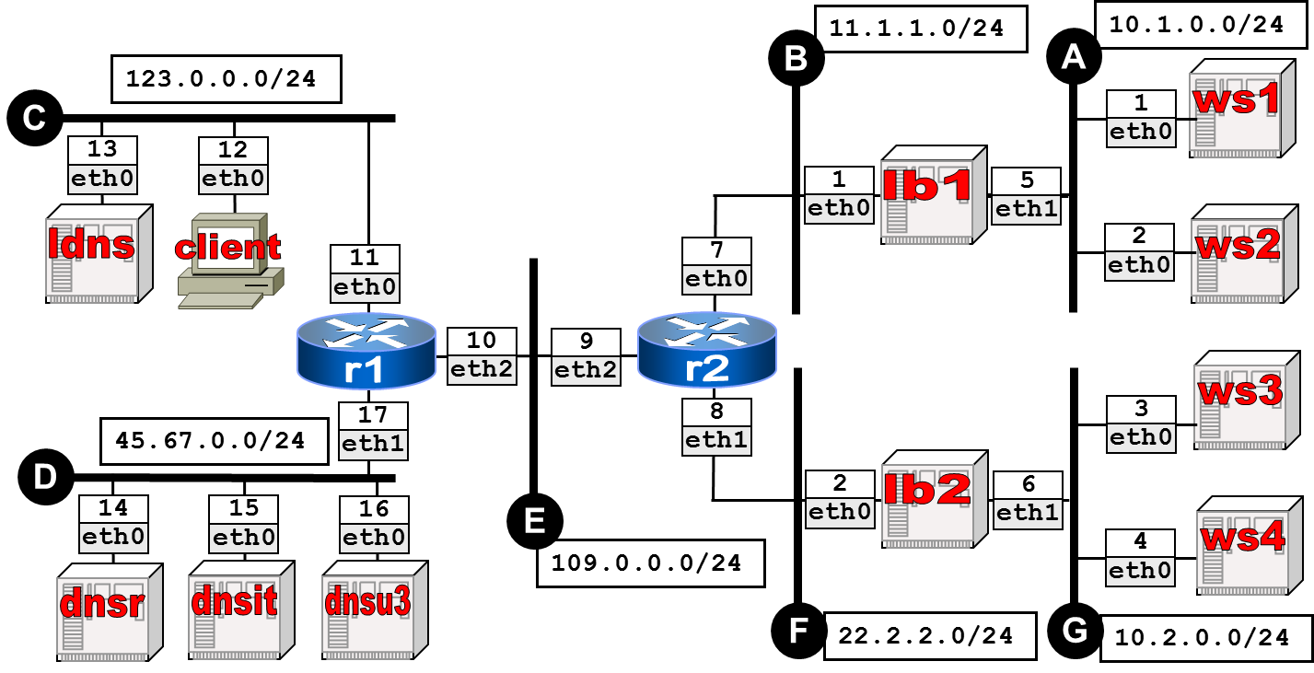
Using Kathará, implement the network depicted in the above figure and described below.
- client is a client that would like to access the Web page www.uniroma3.it; its default name server is ldns. Name server ldns is not an authority for any zone but just offers name resolution to clients. ws1, ws2, ws3, and ws4 are Web servers; they all offer the same www.uniroma3.it Web page (in the lab use different html pages to distinguish the accessed server). lb1 and lb2 are two Level-4 load balancers each executing a random algorithm for selecting one of two Web servers. dnsr is the root name server. dnsit is a name server authority for the it zone. dnsu3 is a name server authority for uniroma3.it.
- dsnu3 performs a simple load balancing using two distinct A records for www.uniroma3.it. Each A record denotes a different Level-4 load balancer.
- The random algorithm executed by lb1 and lb2 is implemented with the following configuration:
  - iptables --table nat --append PREROUTING --destination <VIP-ADDRESS> -p tcp --dport 80 --match statistic --mode random --probability 0.5 --jump DNAT --to-destination <FIRST-SERVER>:80
  - iptables --table nat --append PREROUTING --destination <VIP-ADDRESS> -p tcp --dport 80 --jump DNAT --to-destination <SECOND-SERVER>:80

Goals:
Let client to access the Web page. Balance the load of ws1, ws2, ws3, and ws4.

