**71115112 余泽晨**

Book State Machine Diagram

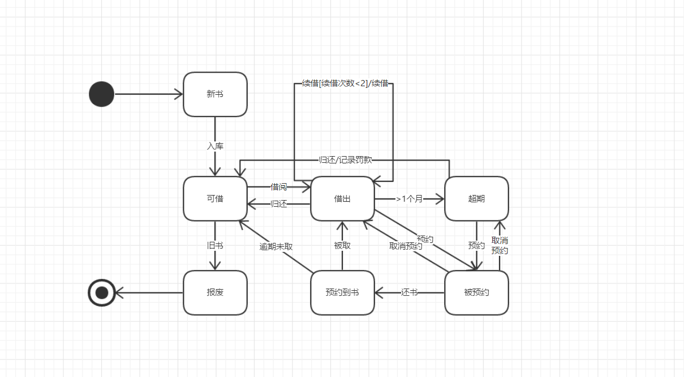

Borrow Books Activity Diagram

