**15-16-2几何与代数数学实验一**

**71115112 余泽晨**

>> format short;

b =[7;1;1;1;5;1;1;2];

a1=[1;1;0;0;0;0;0;0];

a2=[1;2;1;0;0;0;0;0];

a3=[0;1;3;1;0;0;0;0];

a4=[0;0;1;4;1;0;0;0];

a5=[0;0;0;1;5;1;0;0];

a6=[0;0;0;0;1;6;1;0];

a7=[0;0;0;0;0;1;7;1];

a8=[0;0;0;0;0;0;1;8];

A =[a1,a2,a3,a4,a5,a6,a7,a8];

A1=[b ,a2,a3,a4,a5,a6,a7,a8];

A2=[a1,b ,a3,a4,a5,a6,a7,a8];

A3=[a1,a2,b ,a4,a5,a6,a7,a8];

A4=[a1,a2,a3,b ,a5,a6,a7,a8];

A5=[a1,a2,a3,a4,b ,a6,a7,a8];

A6=[a1,a2,a3,a4,a5,b ,a7,a8];

A7=[a1,a2,a3,a4,a5,a6,b ,a8];

A8=[a1,a2,a3,a4,a5,a6,a7,b ];

x1=det(A1)/det(A)

x2=det(A2)/det(A)

x3=det(A3)/det(A)

x4=det(A4)/det(A)

x5=det(A5)/det(A)

x6=det(A6)/det(A)

x7=det(A7)/det(A)

x8=det(A8)/det(A)

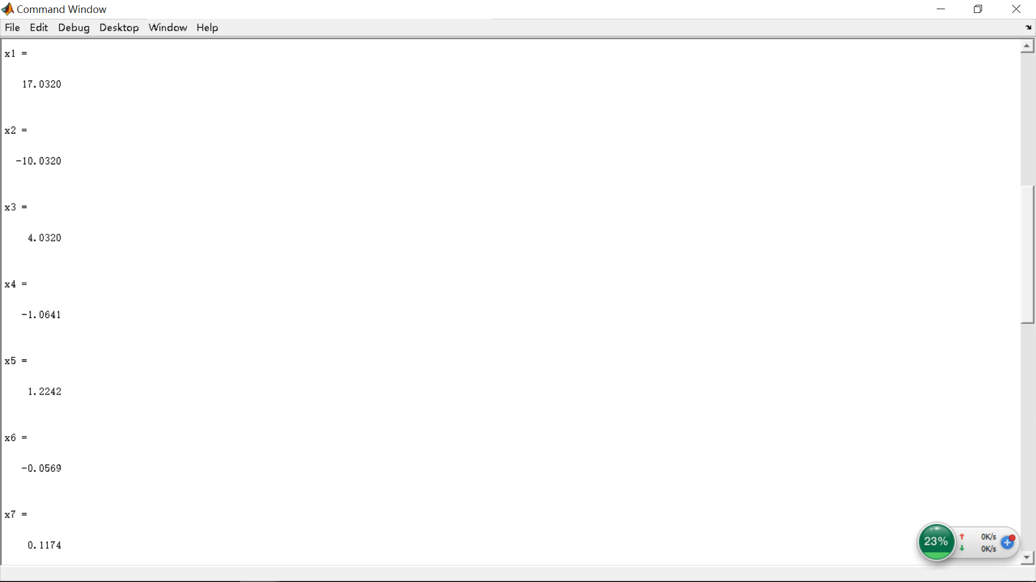

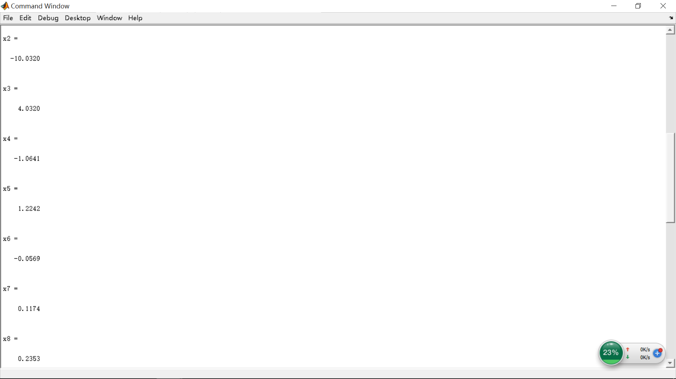

>> format short;

A= [

1,1,0,0,0,0,0,0;

1,2,1,0,0,0,0,0;

0,1,3,1,0,0,0,0;

0,0,1,4,1,0,0,0;

0,0,0,1,5,1,0,0;

0,0,0,0,1,6,1,0;

0,0,0,0,0,1,7,1;

0,0,0,0,0,0,1,8

];

b =[7;1;1;1;5;1;1;2];

X= inv(A)*b

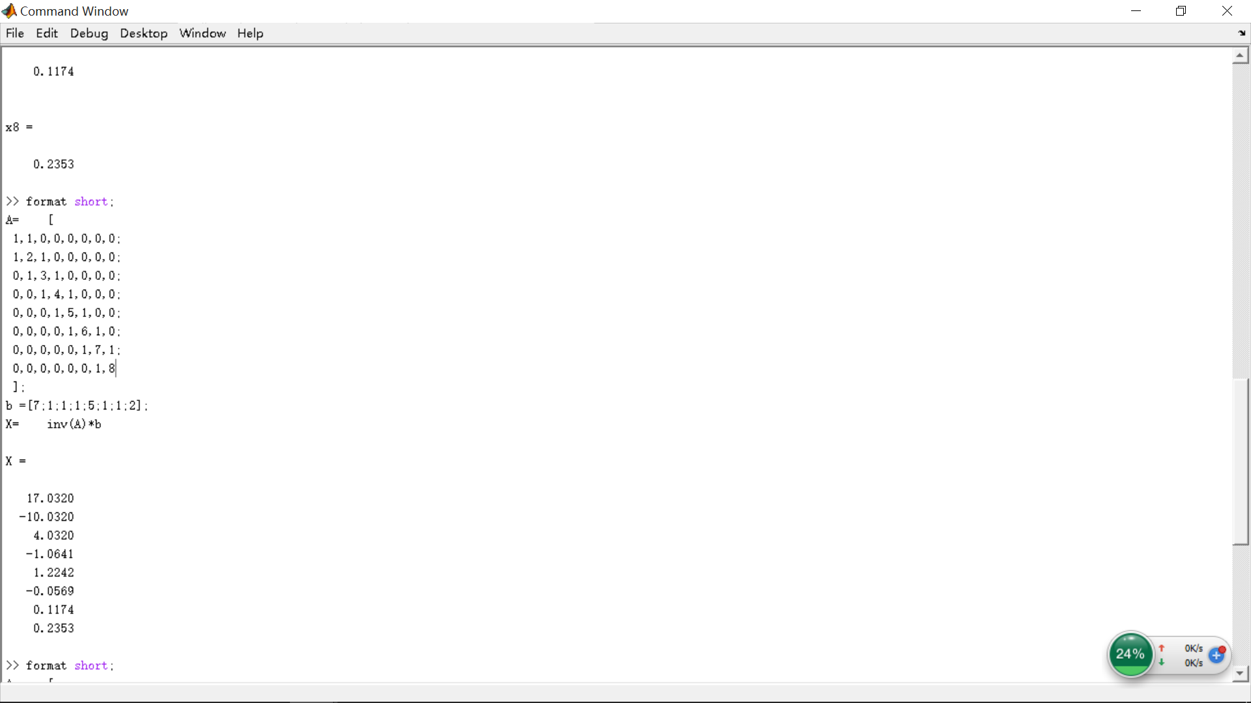

>> format short;

A= [

1,1,0,0,0,0,0,0;

1,2,1,0,0,0,0,0;

0,1,3,1,0,0,0,0;

0,0,1,4,1,0,0,0;

0,0,0,1,5,1,0,0;

0,0,0,0,1,6,1,0;

0,0,0,0,0,1,7,1;

0,0,0,0,0,0,1,8

];

b =[7;1;1;1;5;1;1;2];

rref([A,b])

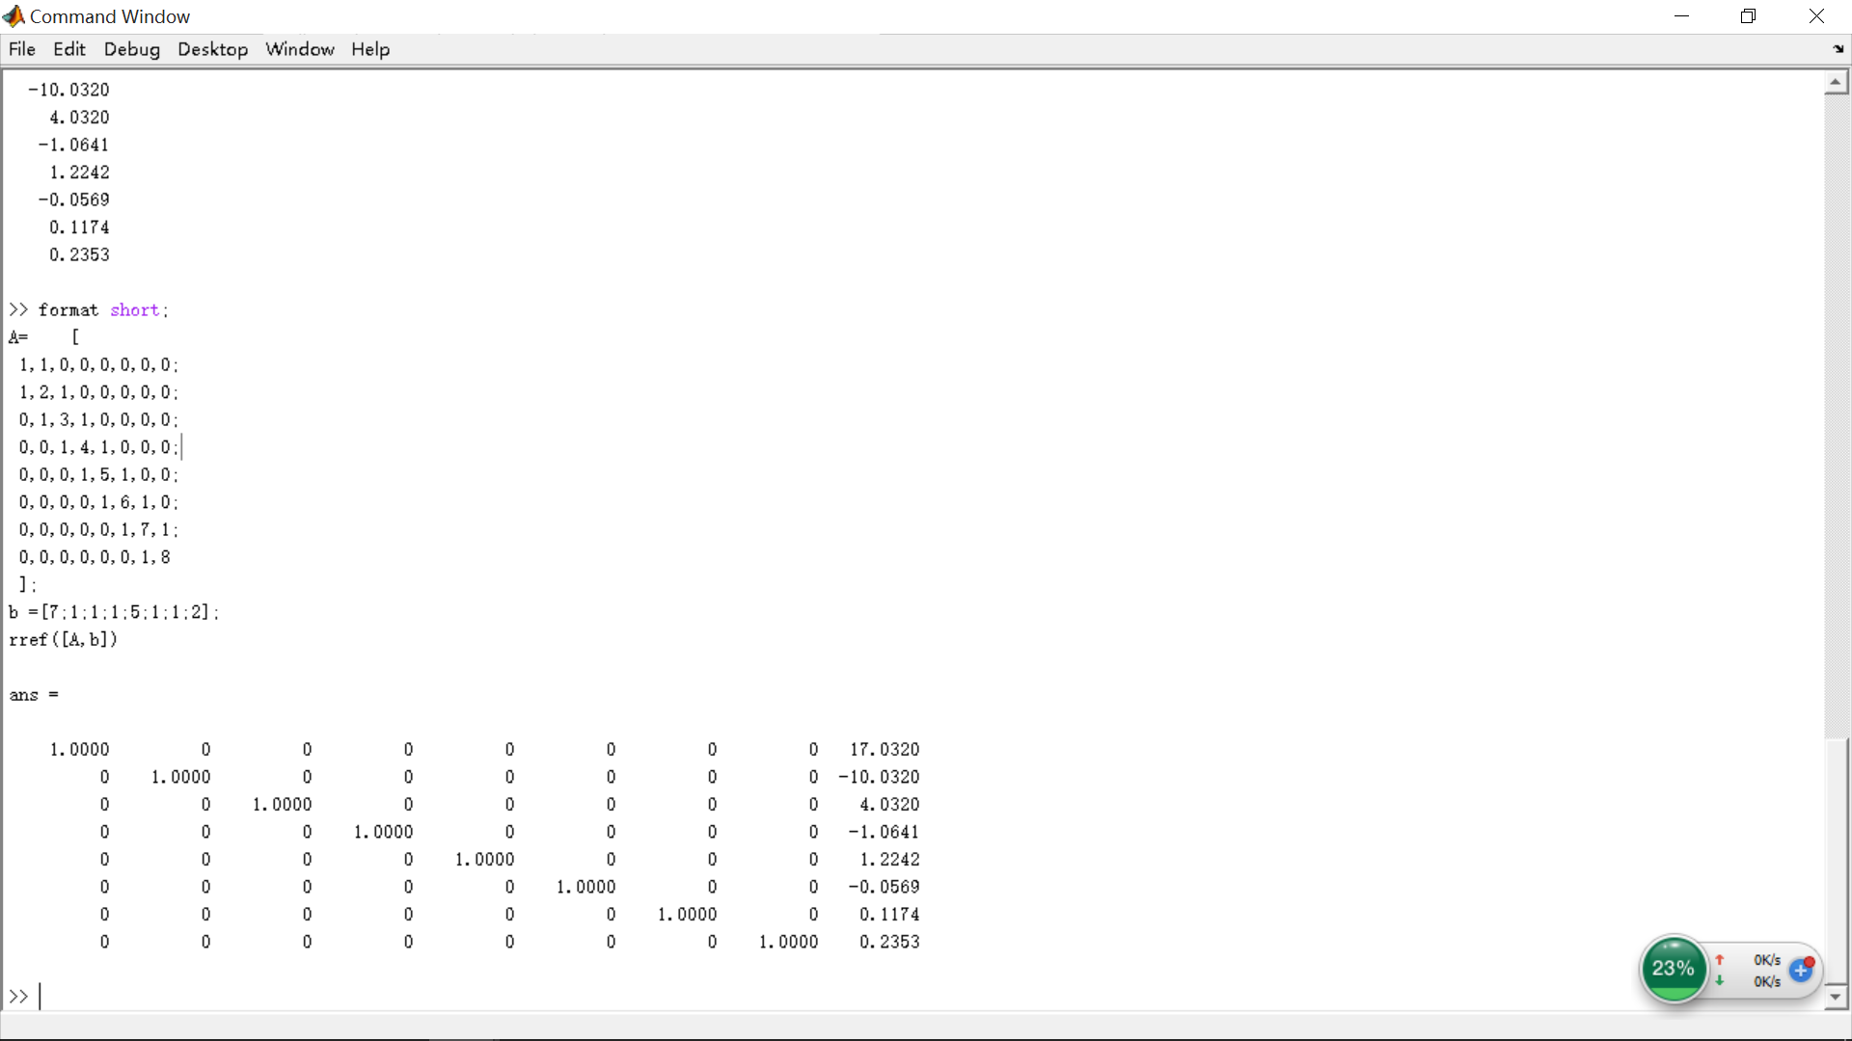

function smile_04clear all, clf, hold offdt = pi/20; t=0:dt:2*pi; xf0=cos(t); yf0=sin(t); % facexe0(1,:)=0.08*xf0-0.3; ye0(1,:)=0.12*yf0+0.2; % left eyexe0(2,:)=0.08*xf0+0.3; ye0(2,:)=ye0(1,:); % right eyes1 = 3*pi/2-1.1; s2 = 3*pi/2+1.1; s = s1:dt:s2; xm0 = 0.5*cos(s); ym0 = 0.5*sin(s); % mouth%figure(1) %绘制初始笑脸图subplot(2,2,1)T0=eye(3);[xf1,yf1,xe1,ye1,xm1,ym1]=DrawSmileFace(xf0,yf0,xe0,ye0,xm0,ym0,T0);title('图1：笑脸初始图');%figure(2) %绘制笑脸图subplot(2,2,2)T1=[1.5 0 0;0 1 0;0 0 1]; %横轴1.5倍,纵轴1倍%T1=[1 0 0;0 1.5 0;0 0 1]; %横轴1倍,纵轴1.5倍[xf2,yf2,xe2,ye2,xm2,ym2]=DrawSmileFace(xf0,yf0,xe0,ye0,xm0,ym0,T1);title('图2：笑脸横轴缩放1.5倍,纵轴不变');%figure(3) %绘制笑脸图subplot(2,2,3)T2=[1 0 1;0 1 -1;0 0 1]; %横轴平移1,纵轴平移-1[xf3,yf3,xe3,ye3,xm3,ym3]=DrawSmileFace(xf2,yf2,xe2,ye2,xm2,ym2,T2);title('图3：笑脸横轴平移1,纵轴平移-1');%figure(4) %绘制笑脸图subplot(2,2,4)theta=pi/6; %逆时针旋转30度x0=sum(xf3)/length(xf3);y0=sum(yf3)/length(yf3);xy0=[x0;y0];T3_1=eye(3);T3_1(1:2,3)=-xy0;T3_2=[cos(theta),-sin(theta),0;sin(theta),cos(theta),0;0 0 1];T3_3=2*eye(3)-T3_1;T3=T3_3*T3_2*T3_1;%T3=[cos(theta),-sin(theta),0;sin(theta),cos(theta),0;0 0 1];[xf4,yf4,xe4,ye4,xm4,ym4]=DrawSmileFace(xf3,yf3,xe3,ye3,xm3,ym3,T3);title('图4：绕笑脸中心逆时针旋转30度');%绘制变换笑脸图子程序function [xf1,yf1,xe1,ye1,xm1,ym1]=DrawSmileFace(xf,yf,xe,ye,xm,ym,T)n1=length(xf); n2=length(xe); n3=length(xm);Pf0=[xf;yf;ones(1,n1)];Pf1=T*Pf0;xf1=Pf1(1,:); yf1=Pf1(2,:);fill(xf1,yf1,'r'); % facehold onPe01=[xe(1,:);ye(1,:);ones(1,n2)];Pe02=[xe(2,:);ye(2,:);ones(1,n2)];Pe1=T*Pe01;Pe2=T*Pe02;xe1(1,:)=Pe1(1,:); ye1(1,:)=Pe1(2,:);xe1(2,:)=Pe2(1,:); ye1(2,:)=Pe2(2,:);plot(xe1(1,:),ye1(1,:),'k','linewidth',5) % left eyeplot(xe1(2,:),ye1(2,:),'k','linewidth',5) % right eyePm0=[xm;ym;ones(1,n3)];Pm1=T*Pm0;xm1=Pm1(1,:);ym1=Pm1(2,:);plot(xm1,ym1,'k','linewidth',2) % mouthgrid on;axis([-3, 3, -2.5, 2.5])hold off

