[**Tableau** IMDb Top Movies Link](https://public.tableau.com/app/profile/alexandervar/viz/IMDBTopMovies_17101706981570/IMDbMovies)

Text

* This visual contains a lot of information. The genre horizontal axis at the top could be reduced to make the genre bigger and the number of movies in each column underneath smaller. It takes up a lot of space to make the description and the drop-down features more apparent on the screen.
* There are labels for everything but the number of movies in each genre. There is also an interactive feature in which when you hover over the dots in each category, it shows a description of each film in that genre specifically. The only aspect of this chart that is not labeled nor interactive is the number of films in each genre on the top, which I described in the last section.
* The visualization is clear even though the table holds a lot of moving information about the rating system through the IMDb website over the years. The only thing that I see as redundant that can be taken out is the Genre column on the left side ( below identifying genre by colored dots). It’s too small, and the information is already the focal point of the analysis.
* **Do colors, shapes, and size scales come with legends?**

There are strong aspects of the visuals and the highlight of this chart. The rating legend at the top shows which movies in the chart had the highest overall rating by website voters. This is determined by the size of the circle in each genre and year. On the right-hand side of the visual, it allows the viewer to look closer to more specific information, including genre, country, title, and cast of the movie.

Color

* Thecolor scheme signifies the genre of the movie and how popular it was that year when it was released. The size of the circle determines this in each column.
* There is a total of 10 colors in this visual.
* Monochromatic color is used heavily in this Visual. Yes, there are colors overlapping in the columns with more than one popular movie in that year. Monochromatic colors in each genre’s specific color family are used to pinpoint each movie if there is an overlap in each vertical column.

**If color is used to draw attention to important information, is the darkest color representing the most important information?** Because the background of this visual is black, colors are a major focal point of the graph, and the design is enticing to draw attention to each important data point in each column. The darker the color of each column is used to identify the overlap of movies in each genre catagorie, the more important the size of each circle is since it means that there were more voters on the website for these movies in the genre.

Other Take-Aways:

1. **Does the visualization teach you something?**

The main purpose of this visual is to look at feature films and their popularity through the IMDd website. This visualization is a great way to find movies that are popular in each country all over the world. Though the visualization doesn’t give much detail, it provides a larger array of information about over 1,000 movies all over the world. It would be valuable to use if you wanted to quickly find a high-quality movie in a genre of interest or recommend a movie to others in a very quick manner. Another feature that I found valuable is the “Top 3 Movies Every Year” shows globally, in which movies were the most popular worldwide through all the genres.

1. **After reviewing the visualization, explain how you’d improve 1–2 components the designer did poorly (e.g., color choice, use of size, lack or overuse of labels, etc.).** The text in the bar graph above each genre column could be smaller since it distracts from and overwhelms each “genre.” I also think it would give room to make the chart's key and summary bigger and more centered.

**One additional point to your checklist based on the visualization.**

Volume and values are an important aspect of visualization to identify how much data you’re looking at, easy to pinpoint what areas you need to focus on, and what areas need to further researched or evaluated to ensure that your data is complete. other questions you need to research further to make the information more clear and detailed to determine where resources should go. This will also enable the users experience to be more enhanced and more easily understood.

**7. Tableau Integration:**

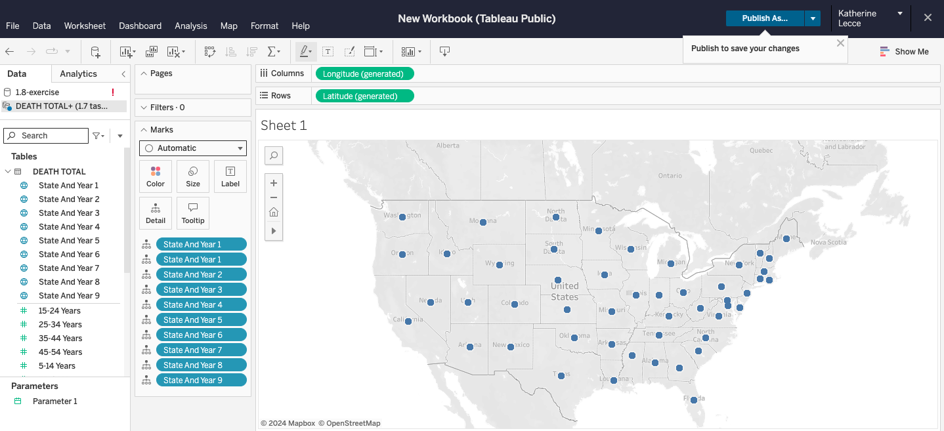

**Dimensions -**

North America

**Measures -**

* State
* Year