1. **Create a pie chart** in Tableau using a categorical variable from your data set. 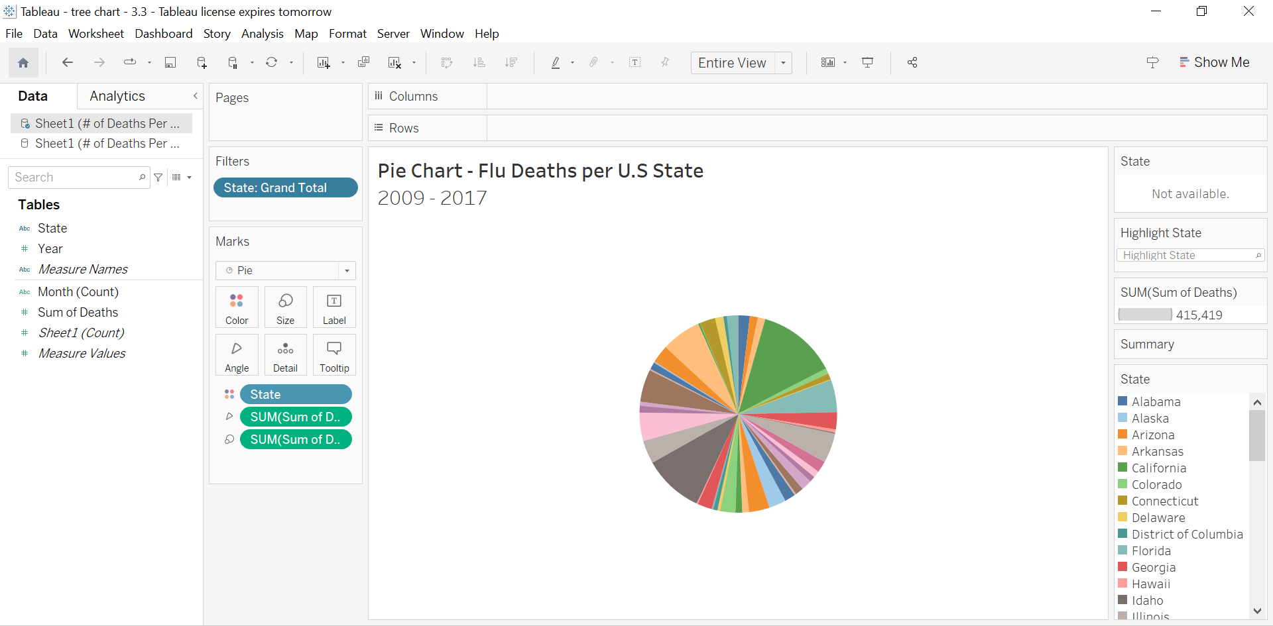

**Determine one reason why a pie chart would or wouldn’t be a good visualization choice. -** Pie charts can be a viable choice for comparing two variables within a specific timeframe, as they offer a straightforward visualization of proportional relationships. For instance, when examining the distribution of Flu-related fatalities across different age groups in the United States. However, when comparing data across multiple years, employing bar graphs or line charts is often more effective. These alternative visualizations provide a more precise representation of longitudinal trends, linearly presenting data rather than measuring it within the confines of segmented sectors, which enhancing interpretability and facilitating comprehensive analysis.

**2. Create a bar (or column/stacked) chart** in Tableau using age as the category. This Bar chart demonstrates how many deaths there were in each age range ( color-coded Key located on the right) 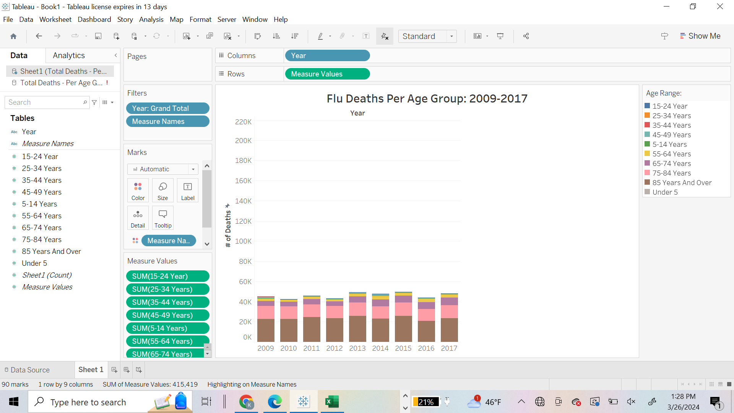

3. Turn the bar chart you created in **step 2 into a treemap.**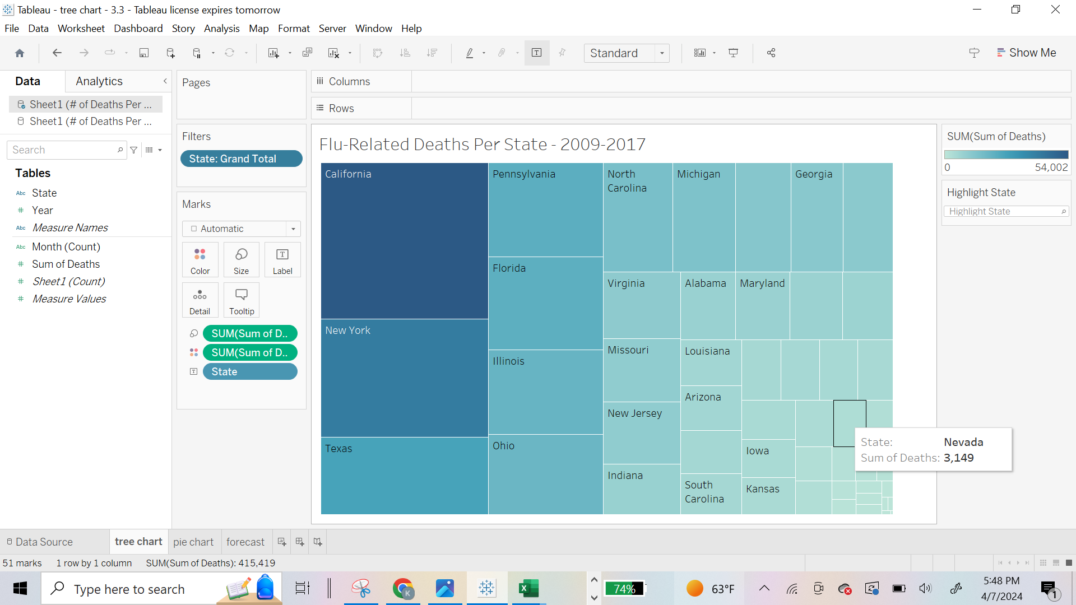

The screenshot of the Tree Map represents each state and shows the number of deaths in each state. The names of the states with fewer data points are not visible but can be easily identified when hovering over the square.