Part 1: Project Reflections

When organizing my thoughts for the final project, it was important to go back to the earlier exercises and pull the most valuable information first. This was the beginning of my thought process of writing a conclusion on the best and most valuable insights of each project to determine what gaming market has the most potential and opportunities for growth.

After looking at sales changes over the last 40 years, I determined that it would be most beneficial to focus on the progression of sales during the previous ten years and create visuals that are easy to understand and demonstrate where sales have fluctuated dramatically in the last decade, by starting by looking globally at the raw data set and creating pivot tables in Excel. I determined that NA Sales have suffered the most from the major gaming markets in the past six years.

After looking globally and targeting North America as the biggest opportunity for sales growth, I focused on creating visuals on where the biggest impact could be when marketing to different gaming consumers and concluded that focusing on the “game” genre of GameCo’s business would be the most significant opportunity for sales growth for the 2017 fiscal year.

In conclusion, GameCo assumes that sales for the various geographic regions have stayed steady in the past decade. However, our data indicates that marketing money could be more wisely spent on increasing excitement around major Sporting events and popular players in the North American Market. The scatterplot created below demonstrates the steady decline in popular genres in NA. I have also included a stacked bar chart to illustrate how the “gaming” genre has fallen short globally. Showing the GameCo marketing team these trends through the stacked bar graph and the scatter plot reflects the fluctuation and lack of investment in NA sales will only continue to drive down sales and year-of-year.

**Visual Examples:**

**North America Market:**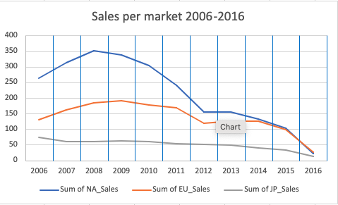

**Global Stacked Bar Chart:**

