Katherine Bilodeau

COP2000

Homework 2

Documentation

Problem Statement: The program should ask display a menu with different types of rooms, and ask the user to choose one. The program should then ask for the needed values to calculate the room. Those values may include width, length, and radius. The program should then calculate the area. If the user enters in an invalid menu choice it should tell the user to restart the program and try again.

Sample Softcopy

Haverly's Room Calculator:

1.) Square Room

2.) Rectangular Room

3.) Round Room

4.) Quit

Please enter a menu item (1-4).

1

What is the length of the room?

4.25

The area of the square room is: 18.06

Symbolic Constant List

|  |  |  |  |  |  |
| --- | --- | --- | --- | --- | --- |
| Identifier | Description | Data Type | Value | Usage | Destination |
| pi | Mathematical value | Floating Point | 3.14 | Used to calculate area of a circle | N/A |

Variable List

|  |  |  |  |  |  |
| --- | --- | --- | --- | --- | --- |
| Identifier | Description | Data Type | Source | Usage | Destination |
| room_length | Number for the length of room | Floating Point | Keyboard | Used to Calculate area of rectangle and square rooms. | Calculations |
| room_width | Number for the width of room | Floating Point | Keyboard | Used to calculate area of rectangle room | Calculations |
| room_radius | Number for the radius of the room | Floating Point | Keyboard | Used to calculate area of round room | Calculations |
| room_choice | User’s menu choice. | Floating Point | Keyboard | Used for switch | Switch |
| area_square_room | Area of the square room | Floating Point | Calculated | Holds the area of the square room | Screen |
| area_rectangle_room | Area of the rectangular room | Floating Point | Calculated | Holds the area of the rectangular room | Screen |
| area_round_room | Area of the round room | Floating Point | Calculated | Holds the area of the round room. | Screen |

Pseudo Code

1. Define Constants and Variables
   1. Create a constant for pi
   2. Create variables for the types of rooms
   3. Create a variable for the room choice.
   4. Create variables for the area of the rooms
2. Display the menu with the room choices.
   1. Ask the user what they wish to calculate.
3. Gather the information needed to calculate area
   1. Ask for radius, width or length if needed.
   2. This calculation should be stored as new variables.
4. Perform the calculation for area
   1. Square = Length*Length
   2. Rectangle= Length*Width
   3. Round= Pi*Radius*Radius

Data Tracing Chart

|  |  |  |  |
| --- | --- | --- | --- |
|  | Input |  |  |
|  | Room Choice | Length | Area |
| 2a | 1 |  |  |
| 3a |  | 4.25 |  |
| 4a |  |  | 18.06 |

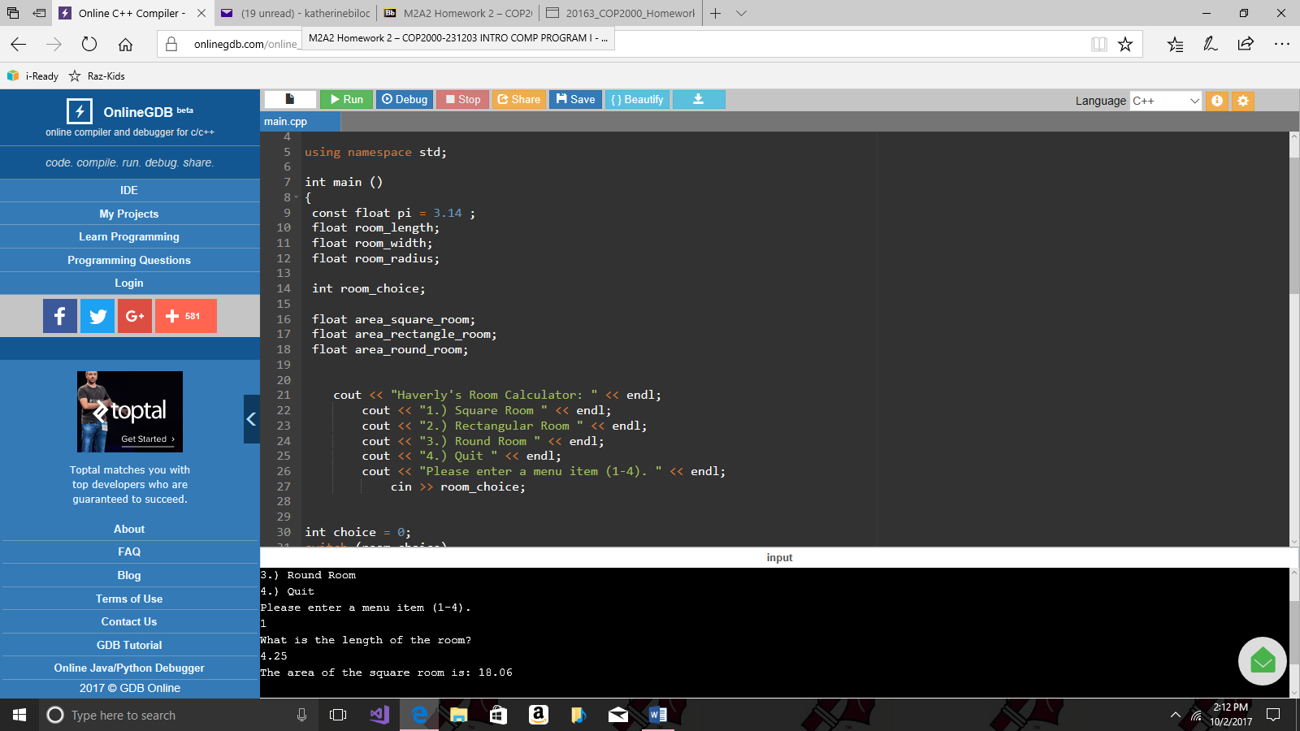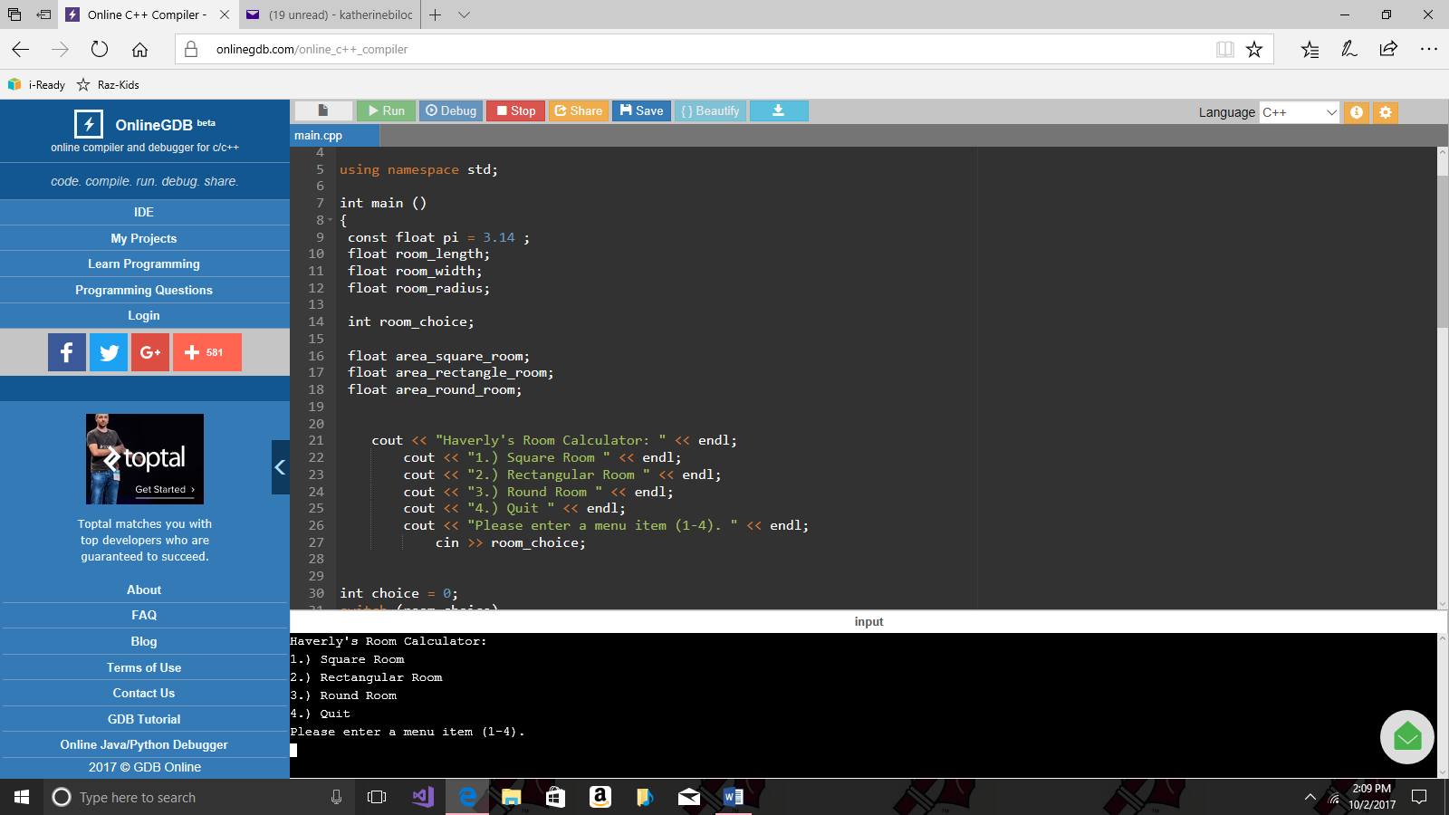Test Softcopy