## Clustering Assignment

**Katherine Mobley**

library(tidyverse)

## -- Attaching packages ----------------------------------------------------- tidyverse 1.2.1 --

## v ggplot2 3.1.0 v purrr 0.2.5  
## v tibble 1.4.2 v dplyr 0.7.7  
## v tidyr 0.8.2 v stringr 1.3.1  
## v readr 1.1.1 v forcats 0.3.0

## -- Conflicts -------------------------------------------------------- tidyverse_conflicts() --  
## x dplyr::filter() masks stats::filter()  
## x dplyr::lag() masks stats::lag()

library(cluster)  
  
install.packages("factoextra")

## Installing package into 'C:/Users/Kathe/Documents/R/win-library/3.5'  
## (as 'lib' is unspecified)

## Error in contrib.url(repos, "source"): trying to use CRAN without setting a mirror

library(factoextra)

## Welcome! Related Books: `Practical Guide To Cluster Analysis in R` at https://goo.gl/13EFCZ

install.packages("dendextend")

## Installing package into 'C:/Users/Kathe/Documents/R/win-library/3.5'  
## (as 'lib' is unspecified)

## Error in contrib.url(repos, "source"): trying to use CRAN without setting a mirror

library(dendextend)

##   
## ---------------------  
## Welcome to dendextend version 1.9.0  
## Type citation('dendextend') for how to cite the package.  
##   
## Type browseVignettes(package = 'dendextend') for the package vignette.  
## The github page is: https://github.com/talgalili/dendextend/  
##   
## Suggestions and bug-reports can be submitted at: https://github.com/talgalili/dendextend/issues  
## Or contact: <tal.galili@gmail.com>  
##   
## To suppress this message use: suppressPackageStartupMessages(library(dendextend))  
## ---------------------

##   
## Attaching package: 'dendextend'

## The following object is masked from 'package:stats':  
##   
## cutree

Read In Data Set

Trucks = read_csv("trucks.csv")

## Parsed with column specification:  
## cols(  
## Driver_ID = col_double(),  
## Distance = col_double(),  
## Speeding = col_integer()  
## )

# Task 1

Plot the relationship between Distance and Speeding.

ggplot(Trucks, aes(x=Distance , y =Speeding )) +geom_point()

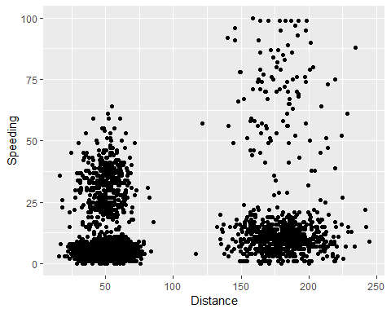

According to this scatter plot the further the distance driver the higher the rate of speed people would have. There does appear to be a cluster around the 50 mile mark and those people maintained speeds from 25 to 50. This is probably relative to a person driving around in their city, they may not have the opportunity to get on roads to travel at a higher speed. Another cluster appears to be around the 150 to 200 distance and the 0 to 25 speeding. Theres also a possible third cluster between 150 to 200 distance and a 75 to 100 speeding.

# Task 2

Create a New data frame that exclude Driver_ID

Trucks2 = Trucks %>% select("Distance", "Speeding")  
  
Trucks2_scaled = scale(Trucks2)

# Task 3

set.seed(1234)  
clusters1 <- kmeans(Trucks2_scaled, 2)  
clusters1

## K-means clustering with 2 clusters of sizes 799, 3201  
##   
## Cluster means:  
## Distance Speeding  
## 1 1.9460595 0.5534421  
## 2 -0.4857549 -0.1381444  
##   
## Clustering vector:  
## [1] 2 2 2 2 2 2 2 2 2 2 2 2 2 2 2 2 2 2 2 2 2 2 2 2 2 2 2 2 2 2 2 2 2 2  
## [35] 2 2 2 2 2 2 2 2 2 2 2 2 2 2 2 2 2 2 2 2 2 2 2 2 2 2 2 2 2 2 2 2 2 2  
## [69] 2 2 2 2 2 2 2 2 2 2 2 2 2 2 2 2 2 2 2 2 2 2 2 2 2 2 2 2 2 2 2 2 2 2  
## [103] 2 2 2 2 2 2 2 2 2 2 2 2 2 2 2 2 2 2 2 2 2 2 2 2 2 2 2 2 2 2 2 2 2 2  
## [137] 2 2 2 2 2 2 2 2 2 2 2 2 2 2 2 2 2 2 2 2 2 2 2 2 2 2 2 2 2 2 2 2 2 2  
## [171] 2 2 2 2 2 2 2 2 2 2 2 2 2 2 2 2 2 2 2 2 2 2 2 2 2 2 2 2 2 2 2 2 2 2  
## [205] 2 2 2 2 2 2 2 2 2 2 2 2 2 2 2 2 2 2 2 2 2 2 2 2 2 2 2 2 2 2 2 2 2 2  
## [239] 2 2 2 2 2 2 2 2 2 2 2 2 2 2 2 2 2 2 2 2 2 2 2 2 2 2 2 2 2 2 2 2 2 2  
## [273] 2 2 2 2 2 2 2 2 2 2 2 2 2 2 2 2 2 2 2 2 2 2 2 2 2 2 2 2 2 2 2 2 2 2  
## [307] 2 2 2 2 2 2 2 2 2 2 2 2 2 2 2 2 2 2 2 2 2 2 2 2 2 2 2 2 2 2 2 2 2 2  
## [341] 2 2 2 2 2 2 2 2 2 2 2 2 2 2 2 2 2 2 2 2 2 2 2 2 2 2 2 2 2 2 2 2 2 2  
## [375] 2 2 2 2 2 2 2 2 2 2 2 2 2 2 2 2 2 2 2 2 2 2 2 2 2 2 2 2 2 2 2 2 2 2  
## [409] 2 2 2 2 2 2 2 2 2 2 2 2 2 2 2 2 2 2 2 2 2 2 2 2 2 2 2 2 2 2 2 2 2 2  
## [443] 2 2 2 2 2 2 2 2 2 2 2 2 2 2 2 2 2 2 2 2 2 2 2 2 2 2 2 2 2 2 2 2 2 2  
## [477] 2 2 2 2 2 2 2 2 2 2 2 2 2 2 2 2 2 2 2 2 2 2 2 2 2 2 2 2 2 2 2 2 2 2  
## [511] 2 2 2 2 2 2 2 2 2 2 2 2 2 2 2 2 2 2 2 2 2 2 2 2 2 2 2 2 2 2 2 2 2 2  
## [545] 2 2 2 2 2 2 2 2 2 2 2 2 2 2 2 2 2 2 2 2 2 2 2 2 2 2 2 2 2 2 2 2 2 2  
## [579] 2 2 2 2 2 2 2 2 2 2 2 2 2 2 2 2 2 2 2 2 2 2 2 2 2 2 2 2 2 2 2 2 2 2  
## [613] 2 2 2 2 2 2 2 2 2 2 2 2 2 2 2 2 2 2 2 2 2 2 2 2 2 2 2 2 2 2 2 2 2 2  
## [647] 2 2 2 2 2 2 2 2 2 2 2 2 2 2 2 2 2 2 2 2 2 2 2 2 2 2 2 2 2 2 2 2 2 2  
## [681] 2 2 2 2 2 2 2 2 2 2 2 2 2 2 2 2 2 2 2 2 2 2 2 2 2 2 2 2 2 2 2 2 2 2  
## [715] 2 2 2 2 2 2 2 2 2 2 2 2 2 2 2 2 2 2 2 2 2 2 2 2 2 2 2 2 2 2 2 2 2 2  
## [749] 2 2 2 2 2 2 2 2 2 2 2 2 2 2 2 2 2 2 2 2 2 2 2 2 2 2 2 2 2 2 2 2 2 2  
## [783] 2 2 2 2 2 2 2 2 2 2 2 2 2 2 2 2 2 2 2 2 2 2 2 2 2 2 2 2 2 2 2 2 2 2  
## [817] 2 2 2 2 2 2 2 2 2 2 2 2 2 2 2 2 2 2 2 2 2 2 2 2 2 2 2 2 2 2 2 2 2 2  
## [851] 2 2 2 2 2 2 2 2 2 2 2 2 2 2 2 2 2 2 2 2 2 2 2 2 2 2 2 2 2 2 2 2 2 2  
## [885] 2 2 2 2 2 2 2 2 2 2 2 2 2 2 2 2 2 2 2 2 2 2 2 2 2 2 2 2 2 2 2 2 2 2  
## [919] 2 2 2 2 2 2 2 2 2 2 2 2 2 2 2 2 2 2 2 2 2 2 2 2 2 2 2 2 2 2 2 2 2 2  
## [953] 2 2 2 2 2 2 2 2 2 2 2 2 2 2 2 2 2 2 2 2 2 2 2 2 2 2 2 2 2 2 2 2 2 2  
## [987] 2 2 2 2 2 2 2 2 2 2 2 2 2 2 2 2 2 2 2 2 2 2 2 2 2 2 2 2 2 2 2 2 2 2  
## [1021] 2 2 2 2 2 2 2 2 2 2 2 2 2 2 2 2 2 2 2 2 2 2 2 2 2 2 2 2 2 2 2 2 2 2  
## [1055] 2 2 2 2 2 2 2 2 2 2 2 2 2 2 2 2 2 2 2 2 2 2 2 2 2 2 2 2 2 2 2 2 2 2  
## [1089] 2 2 2 2 2 2 2 2 2 2 2 2 2 2 2 2 2 2 2 2 2 2 2 2 2 2 2 2 2 2 2 2 2 2  
## [1123] 2 2 2 2 2 2 2 2 2 2 2 2 2 2 2 2 2 2 2 2 2 2 2 2 2 2 2 2 2 2 2 2 2 2  
## [1157] 2 2 2 2 2 2 2 2 2 2 2 2 2 2 2 2 2 2 2 2 2 2 2 2 2 2 2 2 2 2 2 2 2 2  
## [1191] 2 2 2 2 2 2 2 2 2 2 2 2 2 2 2 2 2 2 2 2 2 2 2 2 2 2 2 2 2 2 2 2 2 2  
## [1225] 2 2 2 2 2 2 2 2 2 2 2 2 2 2 2 2 2 2 2 2 2 2 2 2 2 2 2 2 2 2 2 2 2 2  
## [1259] 2 2 2 2 2 2 2 2 2 2 2 2 2 2 2 2 2 2 2 2 2 2 2 2 2 2 2 2 2 2 2 2 2 2  
## [1293] 2 2 2 2 2 2 2 2 2 2 2 2 2 2 2 2 2 2 2 2 2 2 2 2 2 2 2 2 2 2 2 2 2 2  
## [1327] 2 2 2 2 2 2 2 2 2 2 2 2 2 2 2 2 2 2 2 2 2 2 2 2 2 2 2 2 2 2 2 2 2 2  
## [1361] 2 2 2 2 2 2 2 2 2 2 2 2 2 2 2 2 2 2 2 2 2 2 2 2 2 2 2 2 2 2 2 2 2 2  
## [1395] 2 2 2 2 2 2 2 2 2 2 2 2 2 2 2 2 2 2 2 2 2 2 2 2 2 2 2 2 2 2 2 2 2 2  
## [1429] 2 2 2 2 2 2 2 2 2 2 2 2 2 2 2 2 2 2 2 2 2 2 2 2 2 2 2 2 2 2 2 2 2 2  
## [1463] 2 2 2 2 2 2 2 2 2 2 2 2 2 2 2 2 2 2 2 2 2 2 2 2 2 2 2 2 2 2 2 2 2 2  
## [1497] 2 2 2 2 2 2 2 2 2 2 2 2 2 2 2 2 2 2 2 2 2 2 2 2 2 2 2 2 2 2 2 2 2 2  
## [1531] 2 2 2 2 2 2 2 2 2 2 2 2 2 2 2 2 2 2 2 2 2 2 2 2 2 2 2 2 2 2 2 2 2 2  
## [1565] 2 2 2 2 2 2 2 2 2 2 2 2 2 2 2 2 2 2 2 2 2 2 2 2 2 2 2 2 2 2 2 2 2 2  
## [1599] 2 2 2 2 2 2 2 2 2 2 2 2 2 2 2 2 2 2 2 2 2 2 2 2 2 2 2 2 2 2 2 2 2 2  
## [1633] 2 2 2 2 2 2 2 2 2 2 2 2 2 2 2 2 2 2 2 2 2 2 2 2 2 2 2 2 2 2 2 2 2 2  
## [1667] 2 2 2 2 2 2 2 2 2 2 2 2 2 2 2 2 2 2 2 2 2 2 2 2 2 2 2 2 2 2 2 2 2 2  
## [1701] 2 2 2 2 2 2 2 2 2 2 2 2 2 2 2 2 2 2 2 2 2 2 2 2 2 2 2 2 2 2 2 2 2 2  
## [1735] 2 2 2 2 2 2 2 2 2 2 2 2 2 2 2 2 2 2 2 2 2 2 2 2 2 2 2 2 2 2 2 2 2 2  
## [1769] 2 2 2 2 2 2 2 2 2 2 2 2 2 2 2 2 2 2 2 2 2 2 2 2 2 2 2 2 2 2 2 2 2 2  
## [1803] 2 2 2 2 2 2 2 2 2 2 2 2 2 2 2 2 2 2 2 2 2 2 2 2 2 2 2 2 2 2 2 2 2 2  
## [1837] 2 2 2 2 2 2 2 2 2 2 2 2 2 2 2 2 2 2 2 2 2 2 2 2 2 2 2 2 2 2 2 2 2 2  
## [1871] 2 2 2 2 2 2 2 2 2 2 2 2 2 2 2 2 2 2 2 2 2 2 2 2 2 2 2 2 2 2 2 2 2 2  
## [1905] 2 2 2 2 2 2 2 2 2 2 2 2 2 2 2 2 2 2 2 2 2 2 2 2 2 2 2 2 2 2 2 2 2 2  
## [1939] 2 2 2 2 2 2 2 2 2 2 2 2 2 2 2 2 2 2 2 2 2 2 2 2 2 2 2 2 2 2 2 2 2 2  
## [1973] 2 2 2 2 2 2 2 2 2 2 2 2 2 2 2 2 2 2 2 2 2 2 2 2 2 2 2 2 2 2 2 2 2 2  
## [2007] 2 2 2 2 2 2 2 2 2 2 2 2 2 2 2 2 2 2 2 2 2 2 2 2 2 2 2 2 2 2 2 2 2 2  
## [2041] 2 2 2 2 2 2 2 2 2 2 2 2 2 2 2 2 2 2 2 2 2 2 2 2 2 2 2 2 2 2 2 2 2 2  
## [2075] 2 2 2 2 2 2 2 2 2 2 2 2 2 2 2 2 2 2 2 2 2 2 2 2 2 2 2 2 2 2 2 2 2 2  
## [2109] 2 2 2 2 2 2 2 2 2 2 2 2 2 2 2 2 2 2 2 2 2 2 2 2 2 2 2 2 2 2 2 2 2 2  
## [2143] 2 2 2 2 2 2 2 2 2 2 2 2 2 2 2 2 2 2 2 2 2 2 2 2 2 2 2 2 2 2 2 2 2 2  
## [2177] 2 2 2 2 2 2 2 2 2 2 2 2 2 2 2 2 2 2 2 2 2 2 2 2 2 2 2 2 2 2 2 2 2 2  
## [2211] 2 2 2 2 2 2 2 2 2 2 2 2 2 2 2 2 2 2 2 2 2 2 2 2 2 2 2 2 2 2 2 2 2 2  
## [2245] 2 2 2 2 2 2 2 2 2 2 2 2 2 2 2 2 2 2 2 2 2 2 2 2 2 2 2 2 2 2 2 2 2 2  
## [2279] 2 2 2 2 2 2 2 2 2 2 2 2 2 2 2 2 2 2 2 2 2 2 2 2 2 2 2 2 2 2 2 2 2 2  
## [2313] 2 2 2 2 2 2 2 2 2 2 2 2 2 2 2 2 2 2 2 2 2 2 2 2 2 2 2 2 2 2 2 2 2 2  
## [2347] 2 2 2 2 2 2 2 2 2 2 2 2 2 2 2 2 2 2 2 2 2 2 2 2 2 2 2 2 2 2 2 2 2 2  
## [2381] 2 2 2 2 2 2 2 2 2 2 2 2 2 2 2 2 2 2 2 2 2 2 2 2 2 2 2 2 2 2 2 2 2 2  
## [2415] 2 2 2 2 2 2 2 2 2 2 2 2 2 2 2 2 2 2 2 2 2 2 2 2 2 2 2 2 2 2 2 2 2 2  
## [2449] 2 2 2 2 2 2 2 2 2 2 2 2 2 2 2 2 2 2 2 2 2 2 2 2 2 2 2 2 2 2 2 2 2 2  
## [2483] 2 2 2 2 2 2 2 2 2 2 2 2 2 2 2 2 2 2 2 2 2 2 2 2 2 2 2 2 2 2 2 2 2 2  
## [2517] 2 2 2 2 2 2 2 2 2 2 2 2 2 2 2 2 2 2 2 2 2 2 2 2 2 2 2 2 2 2 2 2 2 2  
## [2551] 2 2 2 2 2 2 2 2 2 2 2 2 2 2 2 2 2 2 2 2 2 2 2 2 2 2 2 2 2 2 2 2 2 2  
## [2585] 2 2 2 2 2 2 2 2 2 2 2 2 2 2 2 2 2 2 2 2 2 2 2 2 2 2 2 2 2 2 2 2 2 2  
## [2619] 2 2 2 2 2 2 2 2 2 2 2 2 2 2 2 2 2 2 2 2 2 2 2 2 2 2 2 2 2 2 2 2 2 2  
## [2653] 2 2 2 2 2 2 2 2 2 2 2 2 2 2 2 2 2 2 2 2 2 2 2 2 2 2 2 2 2 2 2 2 2 2  
## [2687] 2 2 2 2 2 2 2 2 2 2 2 2 2 2 2 2 2 2 2 2 2 2 2 2 2 2 2 2 2 2 2 2 2 2  
## [2721] 2 2 2 2 2 2 2 2 2 2 2 2 2 2 2 2 2 2 2 2 2 2 2 2 2 2 2 2 2 2 2 2 2 2  
## [2755] 2 2 2 2 2 2 2 2 2 2 2 2 2 2 2 2 2 2 2 2 2 2 2 2 2 2 2 2 2 2 2 2 2 2  
## [2789] 2 2 2 2 2 2 2 2 2 2 2 2 2 2 2 2 2 2 2 2 2 2 2 2 2 2 2 2 2 2 2 2 2 2  
## [2823] 2 2 2 2 2 2 2 2 2 2 2 2 2 2 2 2 2 2 2 2 2 2 2 2 2 2 2 2 2 2 2 2 2 2  
## [2857] 2 2 2 2 2 2 2 2 2 2 2 2 2 2 2 2 2 2 2 2 2 2 2 2 2 2 2 2 2 2 2 2 2 2  
## [2891] 2 2 2 2 2 2 2 2 2 2 2 2 2 2 2 2 2 2 2 2 2 2 2 2 2 2 2 2 2 2 2 2 2 2  
## [2925] 2 2 2 2 2 2 2 2 2 2 2 2 2 2 2 2 2 2 2 2 2 2 2 2 2 2 2 2 2 2 2 2 2 2  
## [2959] 2 2 2 2 2 2 2 2 2 2 2 2 2 2 2 2 2 2 2 2 2 2 2 2 2 2 2 2 2 2 2 2 2 2  
## [2993] 2 2 2 2 2 2 2 2 2 2 2 2 2 2 2 2 2 2 2 2 2 2 2 2 2 2 2 2 2 2 2 2 2 2  
## [3027] 2 2 2 2 2 2 2 2 2 2 2 2 2 2 2 2 2 2 2 2 2 2 2 2 2 2 2 2 2 2 2 2 2 2  
## [3061] 2 2 2 2 2 2 2 2 2 2 2 2 2 2 2 2 2 2 2 2 2 2 2 2 2 2 2 2 2 2 2 2 2 2  
## [3095] 2 2 2 2 2 2 2 2 2 2 2 2 2 2 2 2 2 2 2 2 2 2 2 2 2 2 2 2 2 2 2 2 2 2  
## [3129] 2 2 2 2 2 2 2 2 2 2 2 2 2 2 2 2 2 2 2 2 2 2 2 2 2 2 2 2 2 2 2 2 2 2  
## [3163] 2 2 2 2 2 2 2 2 2 2 2 2 2 2 2 2 2 2 2 2 2 2 2 2 2 2 2 2 2 2 2 2 2 2  
## [3197] 2 2 2 2 1 1 1 1 1 1 1 1 1 1 1 1 1 1 1 1 1 1 1 1 1 1 1 1 1 1 1 1 1 1  
## [3231] 1 1 1 1 1 1 1 1 1 1 1 1 1 1 1 1 1 1 1 1 1 1 1 1 1 1 1 1 1 1 1 1 1 1  
## [3265] 1 1 1 1 1 1 1 1 1 1 1 1 1 1 1 1 1 1 1 1 1 1 1 1 1 1 1 1 1 1 1 1 1 1  
## [3299] 1 1 1 1 1 1 1 1 1 1 1 1 1 1 1 1 1 1 1 1 1 1 1 1 1 1 1 1 1 1 1 1 1 1  
## [3333] 1 1 1 1 1 1 1 1 1 1 1 1 1 1 1 1 1 1 1 1 1 1 1 1 1 1 1 1 1 1 1 1 1 1  
## [3367] 1 1 1 1 1 1 1 1 1 1 1 1 1 1 1 1 1 1 1 1 1 1 1 1 1 1 1 1 1 1 1 1 1 1  
## [3401] 1 1 1 1 1 1 1 1 1 1 1 1 1 1 1 1 1 1 1 1 1 1 1 1 1 1 1 1 1 1 1 1 1 1  
## [3435] 1 1 1 1 1 1 1 1 1 1 1 1 1 1 1 1 1 1 1 1 1 1 1 1 1 1 1 1 1 1 1 1 1 1  
## [3469] 1 1 1 1 1 1 1 1 1 1 1 1 1 1 1 1 1 1 1 1 1 1 1 1 1 1 1 1 1 1 1 1 1 1  
## [3503] 1 1 1 1 1 1 1 1 1 1 1 1 1 1 1 1 1 1 1 1 1 1 1 1 1 1 1 1 1 1 1 1 1 1  
## [3537] 1 1 1 1 1 1 1 1 1 1 1 1 1 1 1 1 1 1 1 1 1 1 1 1 1 1 1 1 1 1 1 1 1 1  
## [3571] 1 1 1 1 1 1 1 1 1 1 1 1 1 1 1 1 1 1 1 1 1 1 1 1 1 1 1 1 1 1 1 1 1 1  
## [3605] 1 1 1 1 1 1 1 1 1 1 1 1 1 1 1 1 1 1 1 1 1 1 1 1 1 1 1 1 1 1 1 1 1 1  
## [3639] 1 1 1 1 1 1 1 1 1 1 1 1 1 1 1 1 1 1 1 1 1 1 1 1 1 1 1 1 1 1 1 1 1 1  
## [3673] 1 1 1 1 1 1 1 1 1 1 1 1 1 1 1 1 1 1 1 1 1 1 1 1 1 1 1 1 1 1 1 1 1 1  
## [3707] 1 1 1 1 1 1 1 1 1 1 1 1 1 1 1 1 1 1 1 1 1 1 1 1 1 1 1 1 1 1 1 1 1 1  
## [3741] 1 1 1 1 1 1 1 1 1 1 1 1 1 1 1 1 1 1 1 1 1 1 1 1 1 1 1 1 1 1 1 1 1 1  
## [3775] 1 1 1 1 1 1 1 1 1 1 1 1 1 1 1 1 1 1 1 1 1 1 1 1 1 1 1 1 1 1 1 1 1 1  
## [3809] 1 1 1 1 1 1 1 1 1 1 1 2 1 1 1 1 1 1 1 1 1 1 1 1 1 1 1 1 1 1 1 1 1 1  
## [3843] 1 1 1 1 1 1 1 1 1 1 1 1 1 1 1 1 1 1 1 1 1 1 1 1 1 1 1 1 1 1 1 1 1 1  
## [3877] 1 1 1 1 1 1 1 1 1 1 1 1 1 1 1 1 1 1 1 1 1 1 1 1 1 1 1 1 1 1 1 1 1 1  
## [3911] 1 1 1 1 1 1 1 1 1 1 1 1 1 1 1 1 1 1 1 1 1 1 1 1 1 1 1 1 1 1 1 1 1 1  
## [3945] 1 1 1 1 1 1 1 1 1 1 1 1 1 1 1 1 1 1 1 1 1 1 1 1 1 1 1 1 1 1 1 1 1 1  
## [3979] 1 1 1 1 1 1 1 1 1 1 1 1 1 1 1 1 1 1 1 1 1 1  
##   
## Within cluster sum of squares by cluster:  
## [1] 2090.892 1820.056  
## (between_SS / total_SS = 51.1 %)  
##   
## Available components:  
##   
## [1] "cluster" "centers" "totss" "withinss"   
## [5] "tot.withinss" "betweenss" "size" "iter"   
## [9] "ifault"

fviz_cluster(clusters1, Trucks2_scaled)

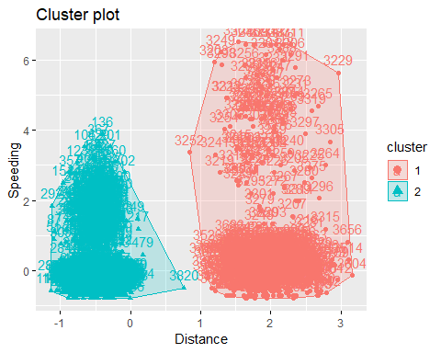 The clusters appear to fit with the data. In the blue category there appears to be a few outliers one being the number 3820. In cluster 1 there appears to be a large amount of numbers in this group. This cluster could be split into two potential clusters.

# Task 4

set.seed(123)  
fviz_nbclust(Trucks2_scaled, kmeans, method = "wss")

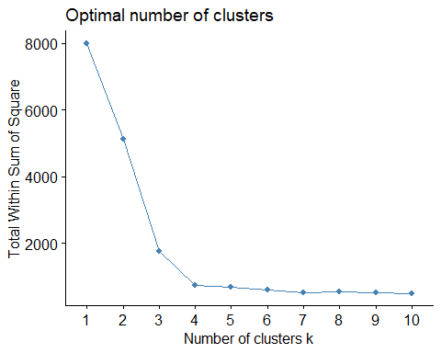

set.seed(123)  
clusters2 <- kmeans(Trucks2_scaled, 3)  
clusters2

## K-means clustering with 3 clusters of sizes 405, 2901, 694  
##   
## Cluster means:  
## Distance Speeding  
## 1 0.1426515 2.50992364  
## 2 -0.4870196 -0.34642059  
## 3 1.9525505 -0.01664689  
##   
## Clustering vector:  
## [1] 1 2 1 2 2 2 2 2 1 2 1 1 2 2 1 1 1 1 2 1 2 1 2 2 1 1 1 2 2 1 1 1 1 1  
## [35] 1 1 2 1 1 1 1 2 2 1 2 2 2 1 1 2 2 2 2 1 1 1 1 1 2 1 1 2 2 1 2 1 1 1  
## [69] 1 1 2 2 1 1 2 1 1 2 1 1 2 2 1 2 2 2 2 1 1 1 2 2 1 2 1 2 1 1 1 1 2 2  
## [103] 2 1 1 1 1 2 2 2 1 2 2 2 1 2 1 2 1 1 1 1 1 2 1 2 1 2 1 1 1 1 1 2 1 1  
## [137] 1 2 2 2 2 1 1 1 2 1 2 1 1 2 1 1 2 1 2 1 2 2 2 1 1 2 2 1 2 2 1 1 2 1  
## [171] 1 2 2 2 1 1 1 2 1 1 2 1 1 2 1 1 1 2 2 1 2 1 1 1 1 1 2 1 1 1 1 1 1 1  
## [205] 1 1 1 1 2 2 2 1 1 1 2 1 1 2 1 1 1 1 1 2 1 1 1 2 1 1 1 1 1 1 2 1 1 1  
## [239] 2 2 1 1 1 1 1 1 2 1 1 2 1 1 1 2 1 1 1 1 1 1 1 1 2 2 1 2 1 1 2 2 1 1  
## [273] 1 1 1 2 2 1 1 2 1 1 1 2 2 1 2 2 2 2 1 1 1 2 1 2 1 1 1 1 2 1 1 2 2 1  
## [307] 2 2 2 1 2 1 1 1 1 1 1 2 1 1 1 1 1 1 2 2 1 1 2 1 1 1 1 1 1 2 1 2 1 1  
## [341] 2 1 1 1 1 2 2 2 1 1 1 1 1 1 1 1 1 1 1 2 1 1 1 1 1 2 1 1 1 1 1 1 2 2  
## [375] 1 2 1 1 1 2 1 1 1 1 1 2 1 2 1 1 2 2 2 2 1 1 1 1 1 2 2 1 1 2 1 1 1 1  
## [409] 2 2 1 2 2 1 2 2 2 2 1 2 1 2 1 2 1 1 2 2 1 1 2 2 2 1 2 2 1 2 2 2 2 2  
## [443] 2 1 1 2 1 1 1 2 1 1 2 1 2 1 1 1 2 1 1 1 1 1 1 1 1 1 2 1 2 2 1 1 2 1  
## [477] 1 1 2 1 2 2 2 2 2 2 2 2 2 2 2 2 2 2 2 2 2 2 2 2 2 2 2 2 2 2 2 2 2 2  
## [511] 2 2 2 2 2 2 2 2 2 2 2 2 2 2 2 2 2 2 2 2 2 2 2 2 2 2 2 2 2 2 2 2 2 2  
## [545] 2 2 2 2 2 2 2 2 2 2 2 2 2 2 2 2 2 2 2 2 2 2 2 2 2 2 2 2 2 2 2 2 2 2  
## [579] 2 2 2 2 2 2 2 2 2 2 2 2 2 2 2 2 2 2 2 2 2 2 2 2 2 2 2 2 2 2 2 2 2 2  
## [613] 2 2 2 2 2 2 2 2 2 2 2 2 2 2 2 2 2 2 2 2 2 2 2 2 2 2 2 2 2 2 2 2 2 2  
## [647] 2 2 2 2 2 2 2 2 2 2 2 2 2 2 2 2 2 2 2 2 2 2 2 2 2 2 2 2 2 2 2 2 2 2  
## [681] 2 2 2 2 2 2 2 2 2 2 2 2 2 2 2 2 2 2 2 2 2 2 2 2 2 2 2 2 2 2 2 2 2 2  
## [715] 2 2 2 2 2 2 2 2 2 2 2 2 2 2 2 2 2 2 2 2 2 2 2 2 2 2 2 2 2 2 2 2 2 2  
## [749] 2 2 2 2 2 2 2 2 2 2 2 2 2 2 2 2 2 2 2 2 2 2 2 2 2 2 2 2 2 2 2 2 2 2  
## [783] 2 2 2 2 2 2 2 2 2 2 2 2 2 2 2 2 2 2 2 2 2 2 2 2 2 2 2 2 2 2 2 2 2 2  
## [817] 2 2 2 2 2 2 2 2 2 2 2 2 2 2 2 2 2 2 2 2 2 2 2 2 2 2 2 2 2 2 2 2 2 2  
## [851] 2 2 2 2 2 2 2 2 2 2 2 2 2 2 2 2 2 2 2 2 2 2 2 2 2 2 2 2 2 2 2 2 2 2  
## [885] 2 2 2 2 2 2 2 2 2 2 2 2 2 2 2 2 2 2 2 2 2 2 2 2 2 2 2 2 2 2 2 2 2 2  
## [919] 2 2 2 2 2 2 2 2 2 2 2 2 2 2 2 2 2 2 2 2 2 2 2 2 2 2 2 2 2 2 2 2 2 2  
## [953] 2 2 2 2 2 2 2 2 2 2 2 2 2 2 2 2 2 2 2 2 2 2 2 2 2 2 2 2 2 2 2 2 2 2  
## [987] 2 2 2 2 2 2 2 2 2 2 2 2 2 2 2 2 2 2 2 2 2 2 2 2 2 2 2 2 2 2 2 2 2 2  
## [1021] 2 2 2 2 2 2 2 2 2 2 2 2 2 2 2 2 2 2 2 2 2 2 2 2 2 2 2 2 2 2 2 2 2 2  
## [1055] 2 2 2 2 2 2 2 2 2 2 2 2 2 2 2 2 2 2 2 2 2 2 2 2 2 2 2 2 2 2 2 2 2 2  
## [1089] 2 2 2 2 2 2 2 2 2 2 2 2 2 2 2 2 2 2 2 2 2 2 2 2 2 2 2 2 2 2 2 2 2 2  
## [1123] 2 2 2 2 2 2 2 2 2 2 2 2 2 2 2 2 2 2 2 2 2 2 2 2 2 2 2 2 2 2 2 2 2 2  
## [1157] 2 2 2 2 2 2 2 2 2 2 2 2 2 2 2 2 2 2 2 2 2 2 2 2 2 2 2 2 2 2 2 2 2 2  
## [1191] 2 2 2 2 2 2 2 2 2 2 2 2 2 2 2 2 2 2 2 2 2 2 2 2 2 2 2 2 2 2 2 2 2 2  
## [1225] 2 2 2 2 2 2 2 2 2 2 2 2 2 2 2 2 2 2 2 2 2 2 2 2 2 2 2 2 2 2 2 2 2 2  
## [1259] 2 2 2 2 2 2 2 2 2 2 2 2 2 2 2 2 2 2 2 2 2 2 2 2 2 2 2 2 2 2 2 2 2 2  
## [1293] 2 2 2 2 2 2 2 2 2 2 2 2 2 2 2 2 2 2 2 2 2 2 2 2 2 2 2 2 2 2 2 2 2 2  
## [1327] 2 2 2 2 2 2 2 2 2 2 2 2 2 2 2 2 2 2 2 2 2 2 2 2 2 2 2 2 2 2 2 2 2 2  
## [1361] 2 2 2 2 2 2 2 2 2 2 2 2 2 2 2 2 2 2 2 2 2 2 2 2 2 2 2 2 2 2 2 2 2 2  
## [1395] 2 2 2 2 2 2 2 2 2 2 2 2 2 2 2 2 2 2 2 2 2 2 2 2 2 2 2 2 2 2 2 2 2 2  
## [1429] 2 2 2 2 2 2 2 2 2 2 2 2 2 2 2 2 2 2 2 2 2 2 2 2 2 2 2 2 2 2 2 2 2 2  
## [1463] 2 2 2 2 2 2 2 2 2 2 2 2 2 2 2 2 2 2 2 2 2 2 2 2 2 2 2 2 2 2 2 2 2 2  
## [1497] 2 2 2 2 2 2 2 2 2 2 2 2 2 2 2 2 2 2 2 2 2 2 2 2 2 2 2 2 2 2 2 2 2 2  
## [1531] 2 2 2 2 2 2 2 2 2 2 2 2 2 2 2 2 2 2 2 2 2 2 2 2 2 2 2 2 2 2 2 2 2 2  
## [1565] 2 2 2 2 2 2 2 2 2 2 2 2 2 2 2 2 2 2 2 2 2 2 2 2 2 2 2 2 2 2 2 2 2 2  
## [1599] 2 2 2 2 2 2 2 2 2 2 2 2 2 2 2 2 2 2 2 2 2 2 2 2 2 2 2 2 2 2 2 2 2 2  
## [1633] 2 2 2 2 2 2 2 2 2 2 2 2 2 2 2 2 2 2 2 2 2 2 2 2 2 2 2 2 2 2 2 2 2 2  
## [1667] 2 2 2 2 2 2 2 2 2 2 2 2 2 2 2 2 2 2 2 2 2 2 2 2 2 2 2 2 2 2 2 2 2 2  
## [1701] 2 2 2 2 2 2 2 2 2 2 2 2 2 2 2 2 2 2 2 2 2 2 2 2 2 2 2 2 2 2 2 2 2 2  
## [1735] 2 2 2 2 2 2 2 2 2 2 2 2 2 2 2 2 2 2 2 2 2 2 2 2 2 2 2 2 2 2 2 2 2 2  
## [1769] 2 2 2 2 2 2 2 2 2 2 2 2 2 2 2 2 2 2 2 2 2 2 2 2 2 2 2 2 2 2 2 2 2 2  
## [1803] 2 2 2 2 2 2 2 2 2 2 2 2 2 2 2 2 2 2 2 2 2 2 2 2 2 2 2 2 2 2 2 2 2 2  
## [1837] 2 2 2 2 2 2 2 2 2 2 2 2 2 2 2 2 2 2 2 2 2 2 2 2 2 2 2 2 2 2 2 2 2 2  
## [1871] 2 2 2 2 2 2 2 2 2 2 2 2 2 2 2 2 2 2 2 2 2 2 2 2 2 2 2 2 2 2 2 2 2 2  
## [1905] 2 2 2 2 2 2 2 2 2 2 2 2 2 2 2 2 2 2 2 2 2 2 2 2 2 2 2 2 2 2 2 2 2 2  
## [1939] 2 2 2 2 2 2 2 2 2 2 2 2 2 2 2 2 2 2 2 2 2 2 2 2 2 2 2 2 2 2 2 2 2 2  
## [1973] 2 2 2 2 2 2 2 2 2 2 2 2 2 2 2 2 2 2 2 2 2 2 2 2 2 2 2 2 2 2 2 2 2 2  
## [2007] 2 2 2 2 2 2 2 2 2 2 2 2 2 2 2 2 2 2 2 2 2 2 2 2 2 2 2 2 2 2 2 2 2 2  
## [2041] 2 2 2 2 2 2 2 2 2 2 2 2 2 2 2 2 2 2 2 2 2 2 2 2 2 2 2 2 2 2 2 2 2 2  
## [2075] 2 2 2 2 2 2 2 2 2 2 2 2 2 2 2 2 2 2 2 2 2 2 2 2 2 2 2 2 2 2 2 2 2 2  
## [2109] 2 2 2 2 2 2 2 2 2 2 2 2 2 2 2 2 2 2 2 2 2 2 2 2 2 2 2 2 2 2 2 2 2 2  
## [2143] 2 2 2 2 2 2 2 2 2 2 2 2 2 2 2 2 2 2 2 2 2 2 2 2 2 2 2 2 2 2 2 2 2 2  
## [2177] 2 2 2 2 2 2 2 2 2 2 2 2 2 2 2 2 2 2 2 2 2 2 2 2 2 2 2 2 2 2 2 2 2 2  
## [2211] 2 2 2 2 2 2 2 2 2 2 2 2 2 2 2 2 2 2 2 2 2 2 2 2 2 2 2 2 2 2 2 2 2 2  
## [2245] 2 2 2 2 2 2 2 2 2 2 2 2 2 2 2 2 2 2 2 2 2 2 2 2 2 2 2 2 2 2 2 2 2 2  
## [2279] 2 2 2 2 2 2 2 2 2 2 2 2 2 2 2 2 2 2 2 2 2 2 2 2 2 2 2 2 2 2 2 2 2 2  
## [2313] 2 2 2 2 2 2 2 2 2 2 2 2 2 2 2 2 2 2 2 2 2 2 2 2 2 2 2 2 2 2 2 2 2 2  
## [2347] 2 2 2 2 2 2 2 2 2 2 2 2 2 2 2 2 2 2 2 2 2 2 2 2 2 2 2 2 2 2 2 2 2 2  
## [2381] 2 2 2 2 2 2 2 2 2 2 2 2 2 2 2 2 2 2 2 2 2 2 2 2 2 2 2 2 2 2 2 2 2 2  
## [2415] 2 2 2 2 2 2 2 2 2 2 2 2 2 2 2 2 2 2 2 2 2 2 2 2 2 2 2 2 2 2 2 2 2 2  
## [2449] 2 2 2 2 2 2 2 2 2 2 2 2 2 2 2 2 2 2 2 2 2 2 2 2 2 2 2 2 2 2 2 2 2 2  
## [2483] 2 2 2 2 2 2 2 2 2 2 2 2 2 2 2 2 2 2 2 2 2 2 2 2 2 2 2 2 2 2 2 2 2 2  
## [2517] 2 2 2 2 2 2 2 2 2 2 2 2 2 2 2 2 2 2 2 2 2 2 2 2 2 2 2 2 2 2 2 2 2 2  
## [2551] 2 2 2 2 2 2 2 2 2 2 2 2 2 2 2 2 2 2 2 2 2 2 2 2 2 2 2 2 2 2 2 2 2 2  
## [2585] 2 2 2 2 2 2 2 2 2 2 2 2 2 2 2 2 2 2 2 2 2 2 2 2 2 2 2 2 2 2 2 2 2 2  
## [2619] 2 2 2 2 2 2 2 2 2 2 2 2 2 2 2 2 2 2 2 2 2 2 2 2 2 2 2 2 2 2 2 2 2 2  
## [2653] 2 2 2 2 2 2 2 2 2 2 2 2 2 2 2 2 2 2 2 2 2 2 2 2 2 2 2 2 2 2 2 2 2 2  
## [2687] 2 2 2 2 2 2 2 2 2 2 2 2 2 2 2 2 2 2 2 2 2 2 2 2 2 2 2 2 2 2 2 2 2 2  
## [2721] 2 2 2 2 2 2 2 2 2 2 2 2 2 2 2 2 2 2 2 2 2 2 2 2 2 2 2 2 2 2 2 2 2 2  
## [2755] 2 2 2 2 2 2 2 2 2 2 2 2 2 2 2 2 2 2 2 2 2 2 2 2 2 2 2 2 2 2 2 2 2 2  
## [2789] 2 2 2 2 2 2 2 2 2 2 2 2 2 2 2 2 2 2 2 2 2 2 2 2 2 2 2 2 2 2 2 2 2 2  
## [2823] 2 2 2 2 2 2 2 2 2 2 2 2 2 2 2 2 2 2 2 2 2 2 2 2 2 2 2 2 2 2 2 2 2 2  
## [2857] 2 2 2 2 2 2 2 2 2 2 2 2 2 2 2 2 2 2 2 2 2 2 2 2 2 2 2 2 2 2 2 2 2 2  
## [2891] 2 2 2 2 2 2 2 2 2 2 2 2 2 2 2 2 2 2 2 2 2 2 2 2 2 2 2 2 2 2 2 2 2 2  
## [2925] 2 2 2 2 2 2 2 2 2 2 2 2 2 2 2 2 2 2 2 2 2 2 2 2 2 2 2 2 2 2 2 2 2 2  
## [2959] 2 2 2 2 2 2 2 2 2 2 2 2 2 2 2 2 2 2 2 2 2 2 2 2 2 2 2 2 2 2 2 2 2 2  
## [2993] 2 2 2 2 2 2 2 2 2 2 2 2 2 2 2 2 2 2 2 2 2 2 2 2 2 2 2 2 2 2 2 2 2 2  
## [3027] 2 2 2 2 2 2 2 2 2 2 2 2 2 2 2 2 2 2 2 2 2 2 2 2 2 2 2 2 2 2 2 2 2 2  
## [3061] 2 2 2 2 2 2 2 2 2 2 2 2 2 2 2 2 2 2 2 2 2 2 2 2 2 2 2 2 2 2 2 2 2 2  
## [3095] 2 2 2 2 2 2 2 2 2 2 2 2 2 2 2 2 2 2 2 2 2 2 2 2 2 2 2 2 2 2 2 2 2 2  
## [3129] 2 2 2 2 2 2 2 2 2 2 2 2 2 2 2 2 2 2 2 2 2 2 2 2 2 2 2 2 2 2 2 2 2 2  
## [3163] 2 2 2 2 2 2 2 2 2 2 2 2 2 2 2 2 2 2 2 2 2 2 2 2 2 2 2 2 2 2 2 2 2 2  
## [3197] 2 2 2 2 1 1 1 1 1 1 3 1 1 1 1 1 1 3 1 3 1 1 1 1 3 1 1 1 1 1 1 1 1 1  
## [3231] 1 1 1 1 1 1 1 1 1 1 1 3 1 1 1 1 1 3 1 3 1 1 1 1 1 1 1 1 1 1 1 3 1 1  
## [3265] 1 1 1 1 1 1 1 1 1 1 1 1 1 1 3 1 3 1 1 1 1 1 1 1 3 1 1 1 3 1 1 3 1 1  
## [3299] 1 1 1 1 1 1 1 1 1 1 1 1 1 1 1 3 3 1 1 1 1 1 3 3 3 3 3 3 3 3 3 3 3 3  
## [3333] 3 3 3 3 3 3 3 3 3 3 3 3 3 3 3 3 3 3 3 3 3 3 3 3 3 3 3 3 3 3 3 3 3 3  
## [3367] 3 3 3 3 3 3 3 3 3 3 3 3 3 3 3 3 3 3 3 3 3 3 3 3 3 3 3 3 3 3 3 3 3 3  
## [3401] 3 3 3 3 3 3 3 3 3 3 3 3 3 3 3 3 3 3 3 3 3 3 3 3 3 3 3 3 3 3 3 3 3 3  
## [3435] 3 3 3 3 3 3 3 3 3 3 3 3 3 3 3 3 3 3 3 3 3 3 3 3 3 3 3 3 3 3 3 3 3 3  
## [3469] 3 3 3 3 3 3 3 3 3 3 3 3 3 3 3 3 3 3 3 3 3 3 3 3 3 3 3 3 3 3 3 3 3 3  
## [3503] 3 3 3 3 3 3 3 3 3 3 3 3 3 3 3 3 3 3 3 3 3 3 3 3 3 3 3 3 3 3 3 3 3 3  
## [3537] 3 3 3 3 3 3 3 3 3 3 3 3 3 3 3 3 3 3 3 3 3 3 3 3 3 3 3 3 3 3 3 3 3 3  
## [3571] 3 3 3 3 3 3 3 3 3 3 3 3 3 3 3 3 3 3 3 3 3 3 3 3 3 3 3 3 3 3 3 3 3 3  
## [3605] 3 3 3 3 3 3 3 3 3 3 3 3 3 3 3 3 3 3 3 3 3 3 3 3 3 3 3 3 3 3 3 3 3 3  
## [3639] 3 3 3 3 3 3 3 3 3 3 3 3 3 3 3 3 3 3 3 3 3 3 3 3 3 3 3 3 3 3 3 3 3 3  
## [3673] 3 3 3 3 3 3 3 3 3 3 3 3 3 3 3 3 3 3 3 3 3 3 3 3 3 3 3 3 3 3 3 3 3 3  
## [3707] 3 3 3 3 3 3 3 3 3 3 3 3 3 3 3 3 3 3 3 3 3 3 3 3 3 3 3 3 3 3 3 3 3 3  
## [3741] 3 3 3 3 3 3 3 3 3 3 3 3 3 3 3 3 3 3 3 3 3 3 3 3 3 3 3 3 3 3 3 3 3 3  
## [3775] 3 3 3 3 3 3 3 3 3 3 3 3 3 3 3 3 3 3 3 3 3 3 3 3 3 3 3 3 3 3 3 3 3 3  
## [3809] 3 3 3 3 3 3 3 3 3 3 3 2 3 3 3 3 3 3 3 3 3 3 3 3 3 3 3 3 3 3 3 3 3 3  
## [3843] 3 3 3 3 3 3 3 3 3 3 3 3 3 3 3 3 3 3 3 3 3 3 3 3 3 3 3 3 3 3 3 3 3 3  
## [3877] 3 3 3 3 3 3 3 3 3 3 3 3 3 3 3 3 3 3 3 3 3 3 3 3 3 3 3 3 3 3 3 3 3 3  
## [3911] 3 3 3 3 3 3 3 3 3 3 3 3 3 3 3 3 3 3 3 3 3 3 3 3 3 3 3 3 3 3 3 3 3 3  
## [3945] 3 3 3 3 3 3 3 3 3 3 3 3 3 3 3 3 3 3 3 3 3 3 3 3 3 3 3 3 3 3 3 3 3 3  
## [3979] 3 3 3 3 3 3 3 3 3 3 3 3 3 3 3 3 3 3 3 3 3 3  
##   
## Within cluster sum of squares by cluster:  
## [1] 1165.9776 387.5316 202.6053  
## (between_SS / total_SS = 78.0 %)  
##   
## Available components:  
##   
## [1] "cluster" "centers" "totss" "withinss"   
## [5] "tot.withinss" "betweenss" "size" "iter"   
## [9] "ifault"

fviz_cluster(clusters2, Trucks2_scaled)

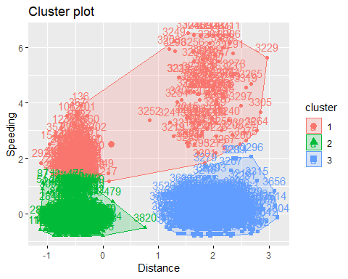

Two Methods

set.seed(123)  
clusters3 <- fviz_nbclust(Trucks2_scaled, kmeans, method = "silhouette") #maximize how well points sit in their clusters  
clusters3

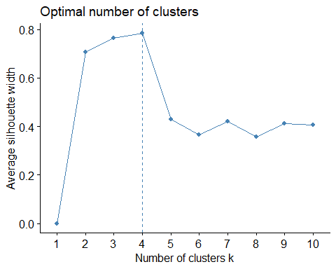

set.seed(123)  
clusters4 = kmeans(Trucks2_scaled, 4)  
fviz_cluster(clusters4, Trucks2_scaled)

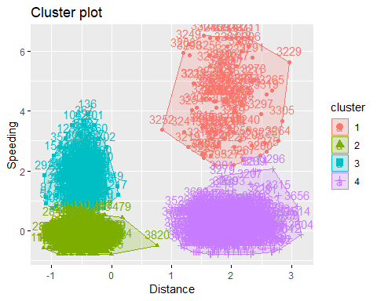

The best cluster plot seems to have 4 clusters. This allows the data to be grouped with very minimal overlap. The census between the two is that 4 clusters was better than 3. Three clusters grouped the data towards the top of the chart. #Task 5

set.seed(1234)  
clusters5 = kmeans(Trucks2_scaled, 4)  
fviz_cluster(clusters5, Trucks2_scaled)

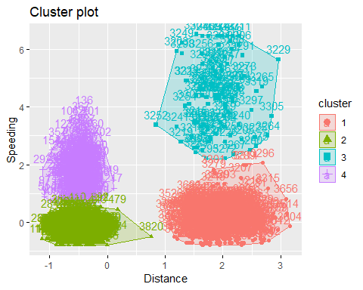

# Task 6

Cluster 1 would be categorized as those people who travel futher but tend to not speed. Cluster two is a shortage distance with less speeding. Cluster 3 is those who travel further and who speed more. Cluster 4 is those people who are travel less distance but tend to speed more.

# WINE DATASET

Wine = read_csv("wineprice.csv")

## Parsed with column specification:  
## cols(  
## Year = col_integer(),  
## Price = col_double(),  
## WinterRain = col_integer(),  
## AGST = col_double(),  
## HarvestRain = col_integer(),  
## Age = col_integer(),  
## FrancePop = col_double()  
## )

Wine2 = Wine %>% select("Price", "WinterRain", "AGST", "HarvestRain", "Age")  
  
Wine2_scaled = scale(Wine2)

# Task 7

set.seed(123)  
fviz_nbclust(Wine2_scaled, kmeans, method = "wss")

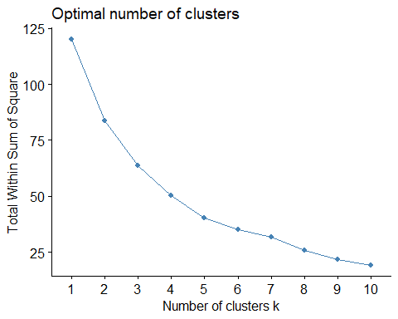

set.seed(123)  
clusters7.1 <- fviz_nbclust(Wine2_scaled, kmeans, method = "silhouette") #maximize how well points sit in their clusters  
clusters7.1

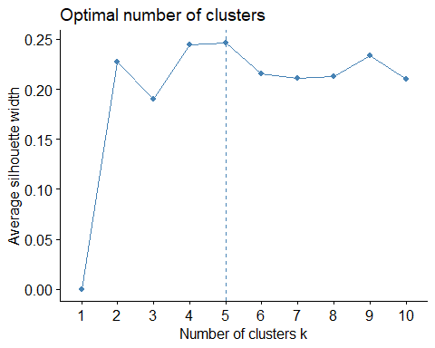

In the first graph there is no real elbow that shows the optimal number of clusters. The second graph shows us that the optimal number of clusters is 5. In the first graph you could argue it is there, but I could also see wanting to test 4 or 6 clusters.

set.seed(123)  
clusters7 <- kmeans(Wine2_scaled, 3)  
clusters7

## K-means clustering with 3 clusters of sizes 6, 10, 9  
##   
## Cluster means:  
## Price WinterRain AGST HarvestRain Age  
## 1 1.0343950 0.9945219 0.08076338 -1.10938718 0.1040043  
## 2 -0.9571657 0.2511378 -0.78867116 0.66702979 -0.1950081  
## 3 0.3739208 -0.9420566 0.82245903 -0.00155276 0.1473395  
##   
## Clustering vector:  
## [1] 3 1 3 3 2 3 2 1 1 2 3 2 1 2 2 2 1 3 2 3 2 3 3 2 1  
##   
## Within cluster sum of squares by cluster:  
## [1] 13.85401 25.32312 24.60922  
## (between_SS / total_SS = 46.8 %)  
##   
## Available components:  
##   
## [1] "cluster" "centers" "totss" "withinss"   
## [5] "tot.withinss" "betweenss" "size" "iter"   
## [9] "ifault"

# Task 8

set.seed(1234)  
clusters8 = kmeans(Wine2_scaled, 5)  
fviz_cluster(clusters8, Wine2_scaled)

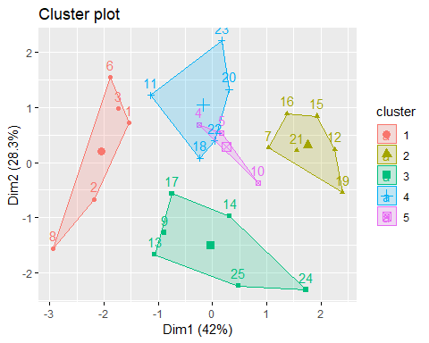

# Task 9

Agglomerative Clustering

m = c( "average", "single", "complete", "ward")  
names(m) = c( "average", "single", "complete", "ward")  
  
ac = function(x) {  
 agnes(Wine2_scaled, method = x)$ac  
}  
map_dbl(m, ac)

## average single complete ward   
## 0.5666719 0.2920143 0.7196616 0.8112139

hc = agnes(Wine2_scaled, method = "ward")  
pltree(hc, cex = 0.6, hang = -1, main = "Agglomerative Dendrogram")

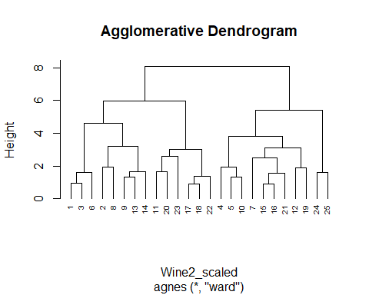

# Task 10

Divise Clustering

hc2 = diana(Wine2_scaled)  
pltree(hc2, cex = 0.6, hang = -1, main = "Divisive Dendogram")

