Project Propsal

Home Loan Monitor

John Jamieson

*Katherine Mulder & Alex Borawski*

Easter Institute of Technology NZ Bachelor of Computing Systems

ITPR7.508 Business Application Programming

|  |  |
| --- | --- |
|  | REVISION DATE: Ongoing |

Home Loan Monitor

|  |  |  |  |  |
| --- | --- | --- | --- | --- |
| **Approver Name** | **Title** | **Email** | **Signature** | **Date** |
| John Jamieson | Software Client | jjamieson@eit.ac.nz |  |  |
| Katherine Mulder | Project leader/ Software Engineer | [huangs3@student.eit.ac.nz](mailto:%48%55%41N%47%533@s%74u%64e%6et%2ee%69%74%2ea%63%2en%7a) | KM |  |
| Alex Borawski | Soft developer/ Quality Assurance | [borawa1@student.eit.ac.nz](mailto:%42%4f%52%41%57%41%31@s%74%75%64en%74%2ee%69%74%2ea%63.%6e%7a) | AB |  |

Contents

Section 1. Overview 1

1.1 Purpose 1

1.2 Business Context 1

1.3 Scope 1

1.4 User Characteristics 1

Section 2. Assumptions, Dependencies, and Constraints 2

2.1 Assumptions 2

2.2 Dependencies 2

2.3 Constraints 2

Section 3. Requirements 3

3.1 Business Requirements 3

3.2 Functional Requirements 3

3.3 Logical Data Requirements 4

3.4 User Requirements 4

3.5 Information Management Requirements 4

3.6 Systems Requirements 4

3.7 Interfaces 4

3.8 Other Requirements 5

Section 4. Requirements Traceability Matrix 6

Section 5. References 7

Section 6. Glossary 8

Section 7. Revision History 9

Section 8. Appendices 10

# 

# Section 1. Overview

## Purpose

The purpose of this document is to propose the development of a user-friendly home loan monitor. It aims to simplify mortgage management by providing tools for calculating payments, tracking interest rates, managing multiple mortgages, and planning financial strategies effectively. This monitor will offer intuitive navigation, unobtrusive design, and advanced functionalities to enhance productivity and streamline the mortgage management process for users.

## Business Context

In today's changing real estate market, managing mortgages can be complex. Our software aims to simplify this by offering a user-friendly solution tailored to your needs. It helps individuals and businesses effectively manage mortgage obligations despite fluctuating interest rates and evolving financial products.

## 1.3 Scope

|  |
| --- |
| **Project Include** |
| A mortgage calculator module that allows users to calculate monthly or fortnightly payments based on loan amount, interest rate, and loan term. |
| Incorporate ability to compare multiple loan and interest rates. |
| Enable users to input variable interest rates over specific periods and automatically update mortgage calculations accordingly. |
| Include a feature to view historical mortgage data. |
| Support multiple mortgages, allowing users to manage multiple properties simultaneously. |
| Include a chat to display mortgage data. |
| Development of a user-friendly interface webpage. |
| The project will include the utilized test files. |

|  |
| --- |
| **Project Exclude** |
| Not the actual deployment of the website onto designated servers. |
| Not include extensive SEO services such as keyword research, on-page optimization, or link building. |
| The project does not involve custom graphic design services beyond the scope of interface design and layout. |
| Not include the necessary maintenance and updates for the software. Not post. |

## User Characteristics

The target users of the home loan monitor/calculator software are diverse and may include individuals, families, real estate investors, and financial advisors. These users may have varying levels of familiarity with financial concepts and software usage. As such, the software will be designed with an intuitive interface and comprehensive help resources to accommodate users with diverse backgrounds and skill levels.

# Section 2. Assumptions, Dependencies, Constraints

## 2.1 Assumptions

For this project we have had to make a few assumptions to ensure an understanding of the project’s conditions is understood correctly by all parties. These are listed below:

* **Loan Terms:** We must assume that loan terms are homogenized across all potential loans that utilize the software. This means that we will assume all loans carry the same terms regarding any “hidden” fees such as insurance and tax, which will be excluded from the final product and we will also assume that mortgages run through this software will have a full amortization, meaning that the loan will be paid off in full at the end of the term defined by the user.
* **Calculator Formula:** We also assume that the accuracy of all given formulas is empirically correct, but we will also allow for a margin of error of 0.1% to allow for any minor differences between the calculation from the software when compared to the real world.
* **Regulatory Compliance:**  As this software overlaps with areas of personal finances, we assume that all data used is compliant with Privacy laws around customer information. We also assume that all information is also compliant with relevant financial information laws.

## 2.2 Dependencies

We will rely on some dependencies for this project to be able to develop the software that meets the requirements laid out. These are as follows:

* **Data Sources:** This software is reliant on being given accurate and up-to-date information regarding the financial information of a given mortgage case. This information includes, but is not limited to, interest rates, repayment periods, loan amounts, loan term.
* **Platform Compatibility:** The software will also require that the platform that it is being run on is compatible with the software’s design. This information is flexible until the agreed upon design is settled on, in which the compatible software will be locked in and discussed in the Formal documentation as well as the user documentation at the end of the project.
* **Mathematical Libraries:** If the software utilized in these projects uses any mathematical libraries, we would then be dependent on the accuracy of these libraries.

## 2.3 Constraints

There are a few key constraints to consider that will impact on the project’s scope and development. These are:

* **Time:** This project will need to be completed by 7th of June 2024, so it will be important to prioritize the key functionalities of the software to complete the project on schedule.
* **Budget:** The budget for this project will be set prior to the project’s start, meaning that we will need to operate within what the budget allows over the course of this project.
* **Legal:** We will need to operate within all relevant laws regarding this project, which may include privacy of data and security as financial data is involved.
* **Technical:** We do also need to ensure that we operate that we work within the limitations of the software used and the intended hardware for the software.

# Section 3. Requirements

## 3.1 Business Requirements

To provide software to simplify the process of mortgage calculations. This software will be delivered in full on or by the 7th of June 2024 alongside complete user documentation. This project will cost up to (number).

## 3.2 Functional Requirements

**Mortgage Calculation:**

### Mortgage Calculation Purpose:

This function is to calculate mortgage payment based on user- provided input, including loan amount, interest rate, and payment frequency.

#### Home loan Inputs:

|  |  |
| --- | --- |
| **Function input** | **Definition** |
| Principal | The initial amount of money borrowed for purchasing a home. |
| Principal Increment | An increasing value of the principle. |
| Interest | The additional amount charged by the lender for borrowing the principal amount. |
| Interest Increment | An increasing value of the interest. |
| Years | The total duration of the loan in years. |
| Months | The specific month within the loan term. |
| Payment override option | Confirming if a payment override is to be included. |
| Payment override amount | The adjustment amount used instead for mortgage calculation. |
| payment override format | The repayment period the override applies to. |

#### Home Loan Operations:

* Calculate mortgage payments based on Principal, interest, and term (years and months).
* Calculate payments based on increment amounts to a set value.
* If an override is provided by the user, then calculate based on those values.

#### Home Loan Outputs:

### 3.2.*xu* Use Case *Y*

*When use cases are used as the means of specifying the functional requirements, provide a 3.2.xu subfunction for each use case. Each 3.2.xu subfunction should be labeled and titled appropriately for a specific use case, where xu is the appropriate sequential subfunction number and Y is the name of the specific use case.*

*Within each use case subfunction, specify the use case information, including the actor, pre-conditions, post-conditions, scenarios, and alternate scenarios.*

⇒

Mortgage Graphing Function:

## 3.3 Logical Data Requirements

The software will need to utilize the following formulas to calculate all of the required values to correctly track the mortgage over time.

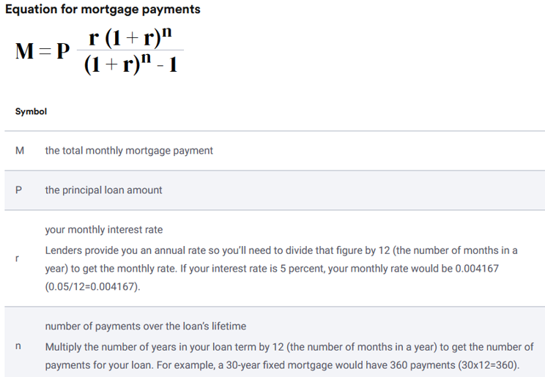First is the equation for calculating the mortgage repayments which is done with the following formula:

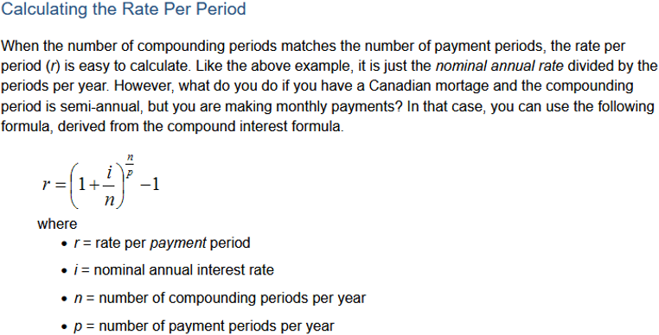We will also need a wat to calculate the rate per period which is done with this formula:

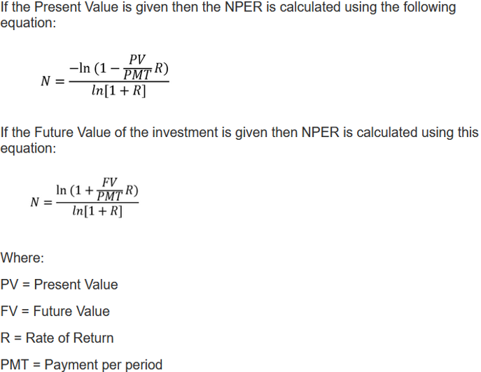Lastly, we need a formula to calculate the number of periods to repay the loan:

## 3.4 User Requirements

*Describe the user requirements for the software.*

⇒

## 3.5 Information Management Requirements

We require the data to be held inside a database with access done via user logins to ensure that they can only access data relating to them. We will also have the inclusion of an admin account to access overarching controls. We will also store information in the server that is more sensitive behind an encryption layer to ensure privacy of more important data such as user’s passwords, loan amounts, repayment amounts and what user is associated with each mortgage.

## 3.6 Systems Requirements

### 3.6.1 Performance Requirements

The software will be required to operate with a fast response time as it is operating locally, also scalability issues will not be considered as it is operating locally, and it will not be designed with multiple concurrent users utilizing the software.

### 3.6.2 Quality Requirements

The software’s function will pass all available unit testing, integration testing and functional testing, with the level of accuracy of the repayments being limited to no greater than 0.1% difference.

## 3.7 Interfaces

The software will have options to login in and out, create a new user account, update and view their current mortgages and visually see how their mortgages are progressing via a graph.

# Section 4. Requirements Traceability Matrix

*Provide reference to the location of the Requirements Traceability Matrix that indicates traceability from the system requirements documented in the System Requirements Specification to the design elements documented in the System Design Description to the software requirements documented in this Software Requirements Specification (SRS).*

⇒

# Section 5. References

*Provide a list of all documents and other sources of information referenced in the SRS and utilized in developing the SRS. Include for each the document number, title, date, and author.*

| **Document No.** | **Document Title** | **Date** | **Author** |
| --- | --- | --- | --- |
|  |  |  |  |
|  |  |  |  |
|  |  |  |  |
|  |  |  |  |
|  |  |  |  |
|  |  |  |  |

# 

# Section 6. Glossary

*Define all terms and acronyms required to interpret the SRS properly.*

⇒

# Section 7. Revision History

*Identify changes to the SRS.*

| **Version** | **Date** | **Name** | **Description** |
| --- | --- | --- | --- |
|  |  |  |  |
|  |  |  |  |
|  |  |  |  |
|  |  |  |  |
|  |  |  |  |
|  |  |  |  |

# Section 8. Appendices

*Include any relevant appendices.*

⇒