I’ve created a very simple project and purposefully broken a few things, and not completed others. The “challenges” will get progressively more difficult, **and there is another bug not listed here for bonus points!**

1/ The title doesn’t look quite right, it should say “broken-project”.

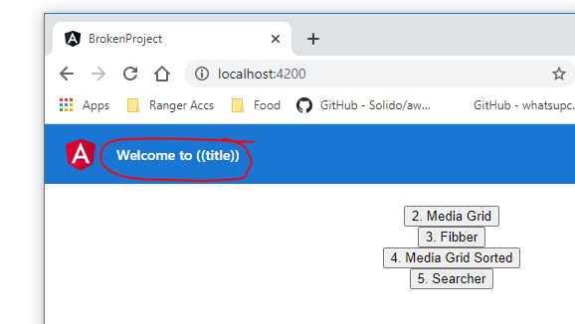

2/ **[/media-grid]** The dogs are going down the page, when I want them going across it. (Bonus points if they wrap to the next line when I shrink the window)

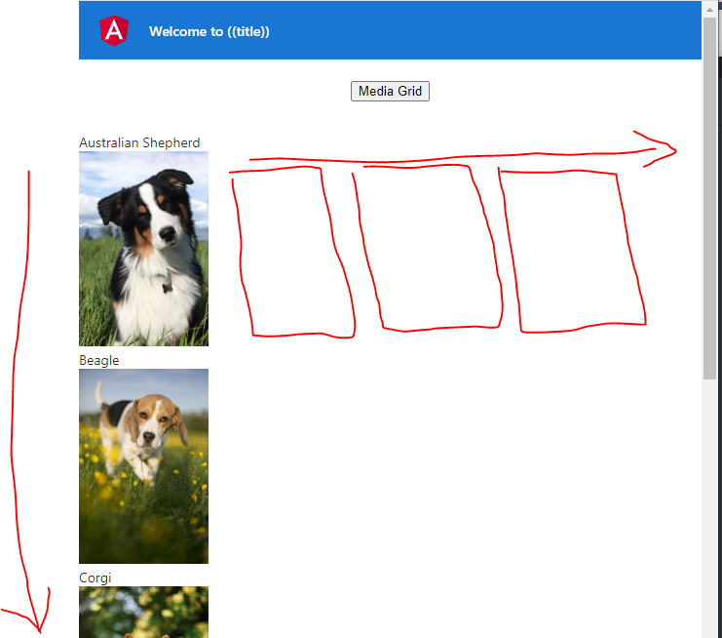

3/ **[/fibber]** My Fibonacci calculator is playing up again!

What it *should* look like:  
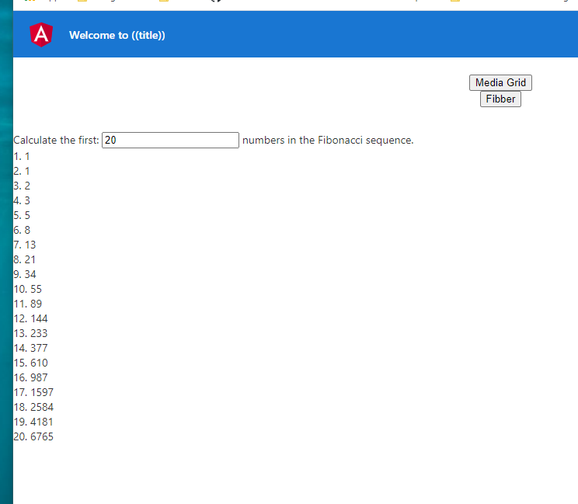

What it looks like now: (Please note, when I change the number in the text box, the calculator should run again to show that number of items in the list, i.e. it should show 10 numbers here)

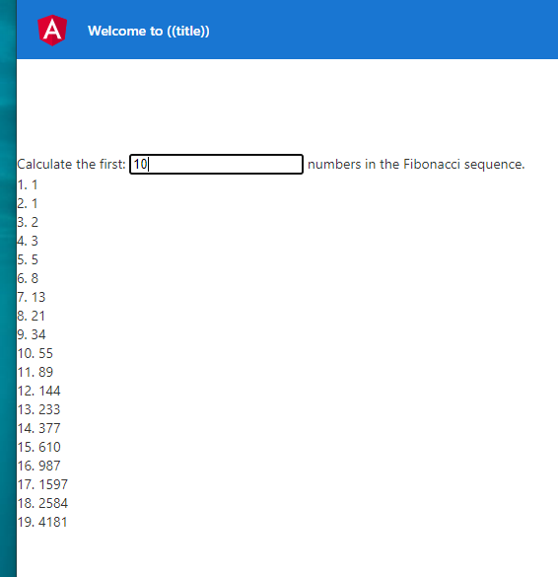

4/ **[/media-sorted]** The dogs are back, but this time I have ranked them in my favourite order. However, I haven’t done any of the work required to sort them on the page… would you be so kind to help? (**HINT**: Check the media.json file)

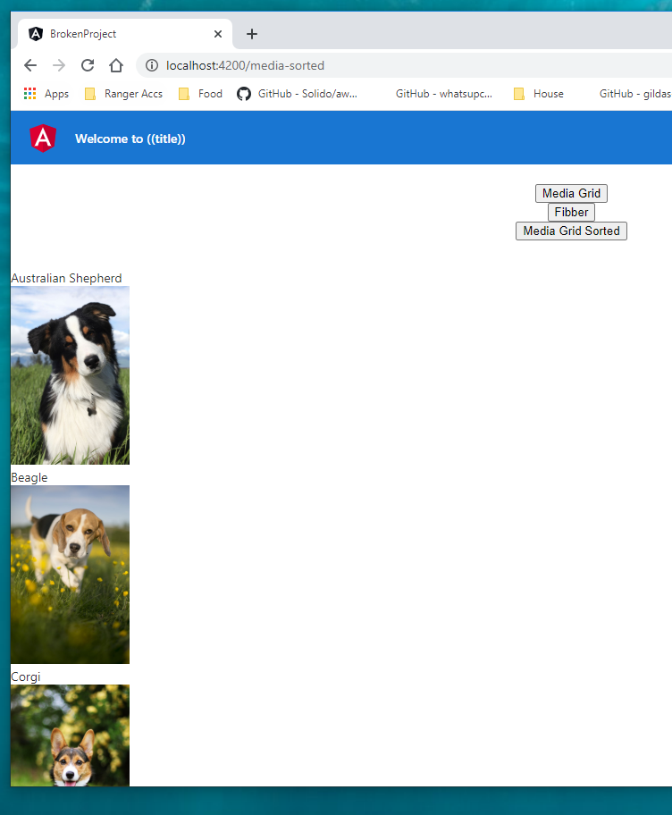

5/ **[/searcher]**

This will hopefully be a bit of a challenge! I’ve created a fake api that returns a list of names, with the option to provide a parameter that will filter the list.

However, I’ve added in a restriction on the API: You can only search every 1 seconds.

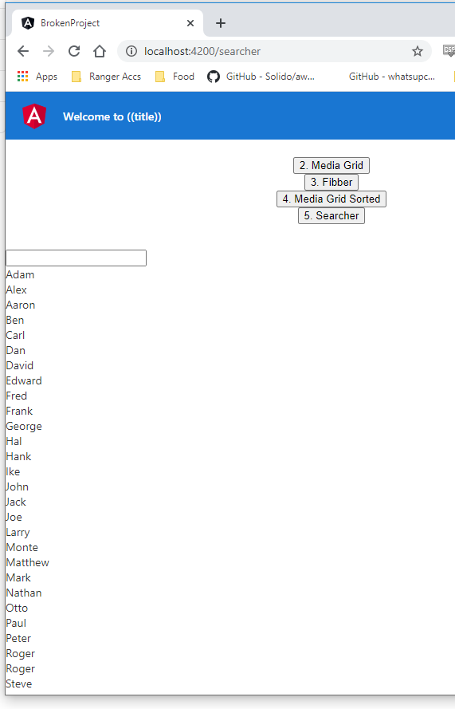Currently, every time a character is entered into the search box, it will query the API for the filtered list of names, which could happen faster than every 1 seconds depending on how quick you can type. You will need to *debounce* the input.

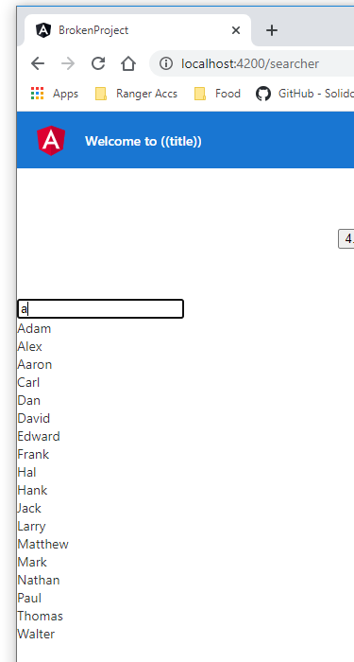

You will see the error in the Admin Console:

