Design and Analysis of Algorithms
Kathin M
ch.sc.u4cse24262

1.Prim’s Algorithm
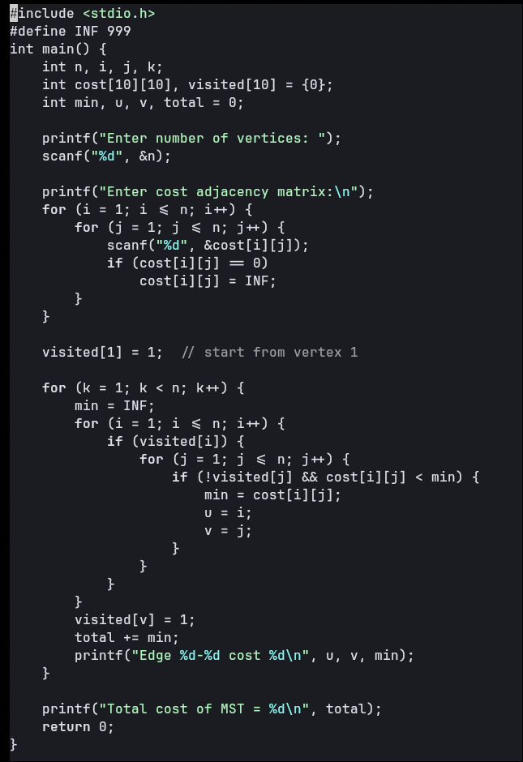

Output:
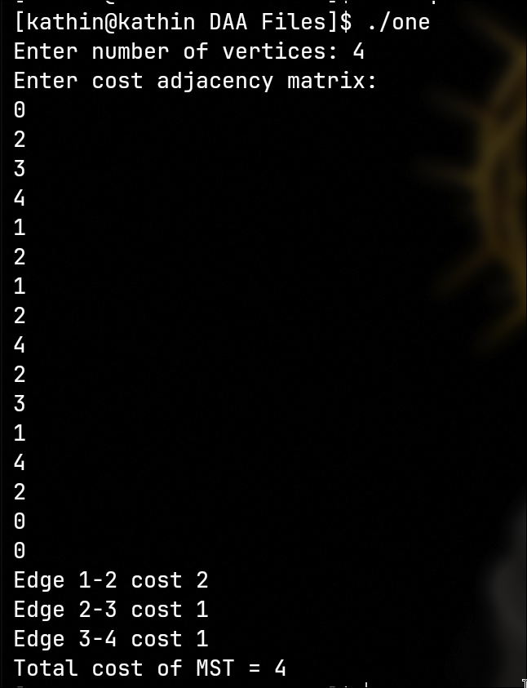

2.Kruskal’s Algorithm
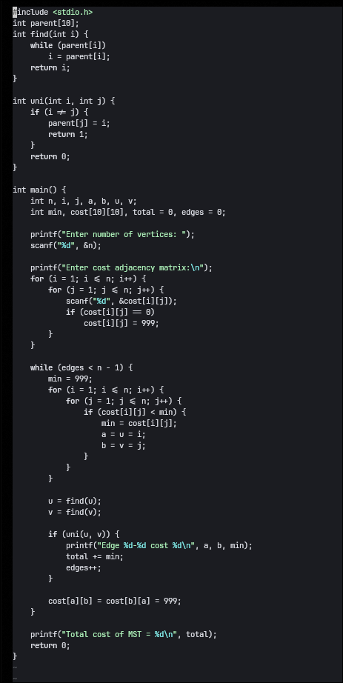

Output:
