Design and Analysis of Algorithms
Kathin M
ch.sc.u4cse24262
1) Sum of n Natural Numbers

Program:
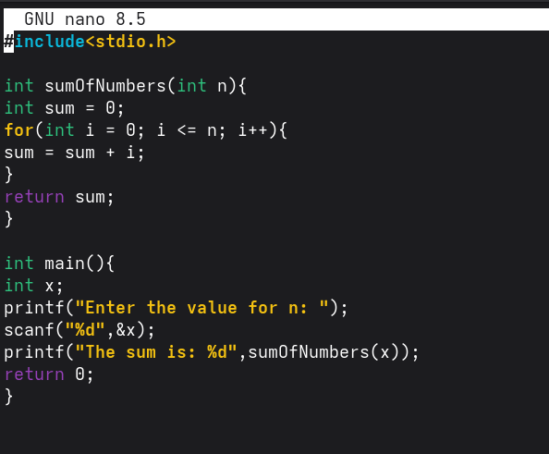

Output:



Time Complexity: O(n)
Space Complexity: O(1)

2)Sum of Square of n Natural Numbers

Program:

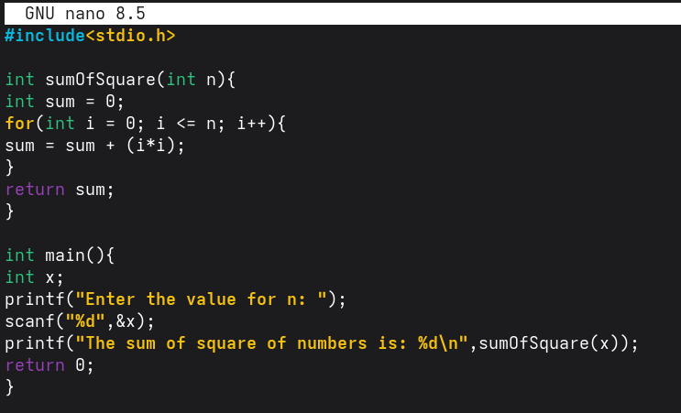
Output:
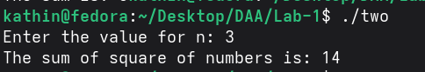

Time Complexity: O(n)
Space Complexity: O(1)

3)Sum of Cubes of n Natural Numbers

Program:
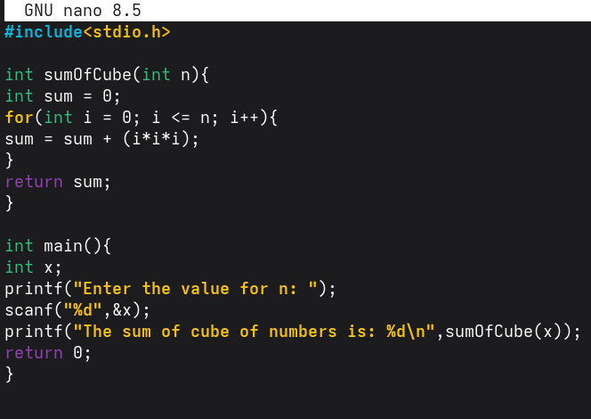
Output:


Time Complexity: O(n)
Space Complexity: O(1)

4)Factorial using recursive function

Program:
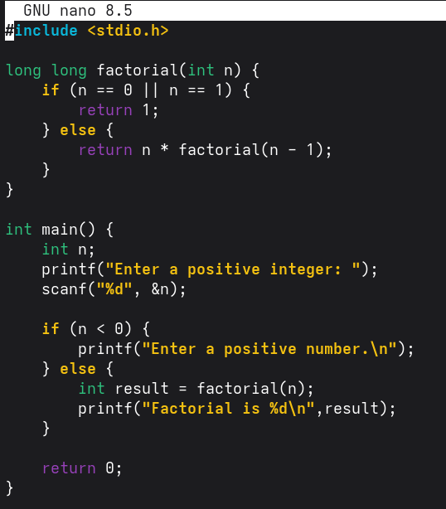

Output:
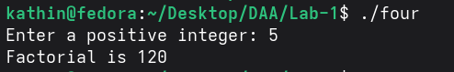

Time Complexity: O(n)
Space Complexity: O(n)

5)Transpose of a Matrix

Program:
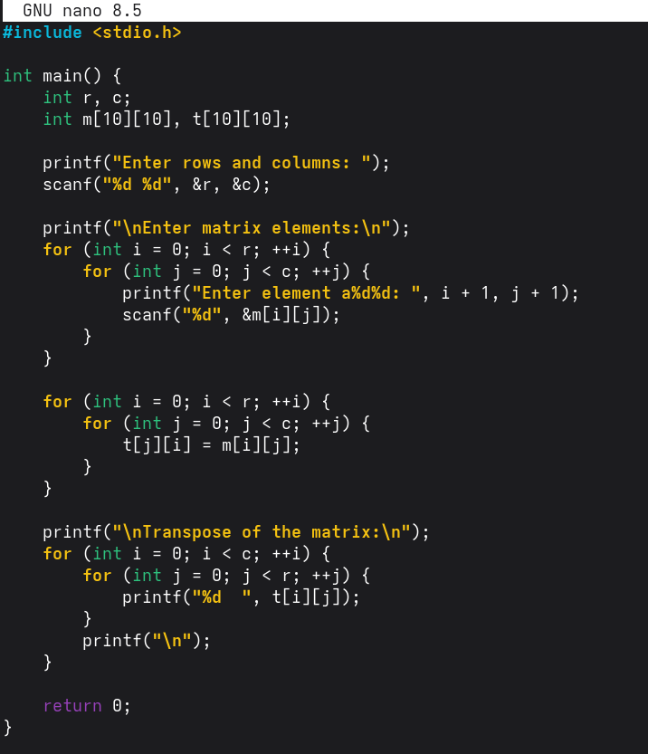

Output:
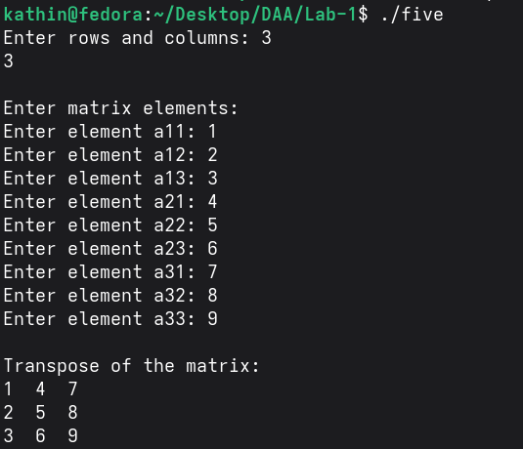

Time Complexity: O(n x m)
Space Complexity: O(1)

6)Fibonacci series up to a given number

Program:
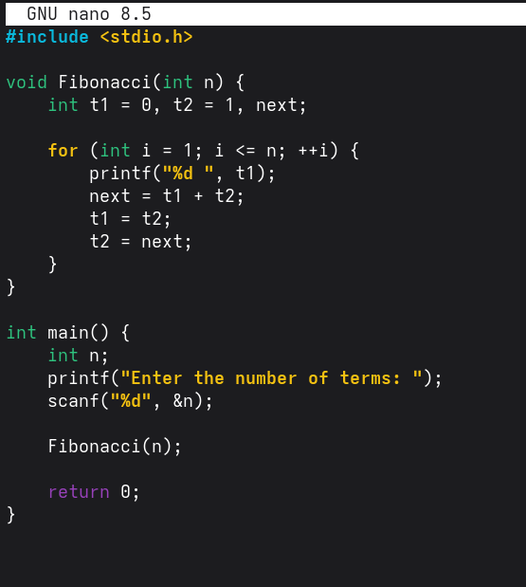

Output:
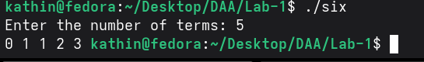

Time Complexity: O(n)
Space Complexity: O(1)

