Design and Analysis of Algorithms
Kathin M
ch.sc.u4cse24262

1)Merge Sort
Code:
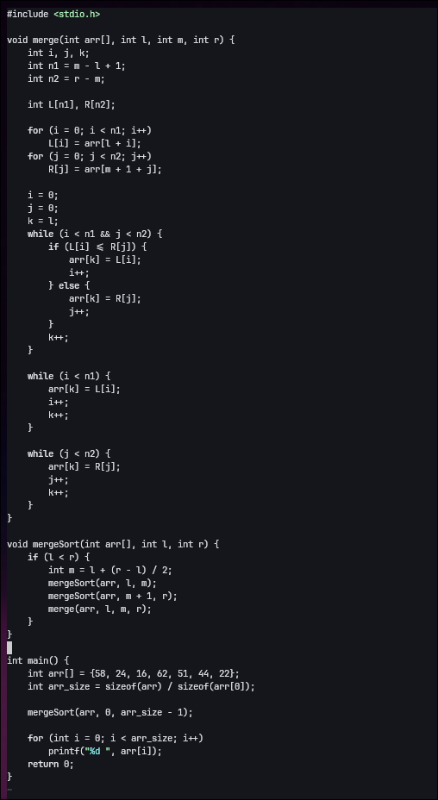

Output:
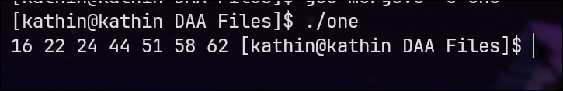

2)Quick Sort
Code:
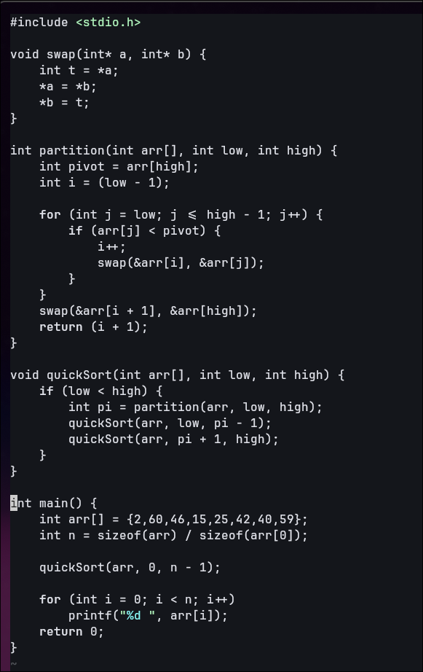
Output:
