Design and Analysis of Algorithms
Kathin M
ch.sc.u4cse24262

1) Depth First Search

Code:
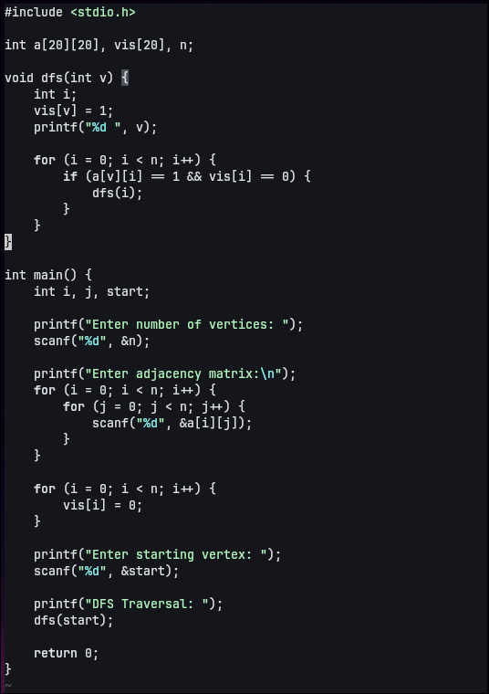

Output:
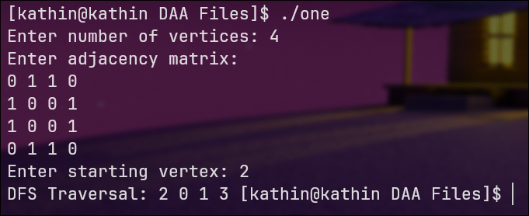

2) Breadth First Search

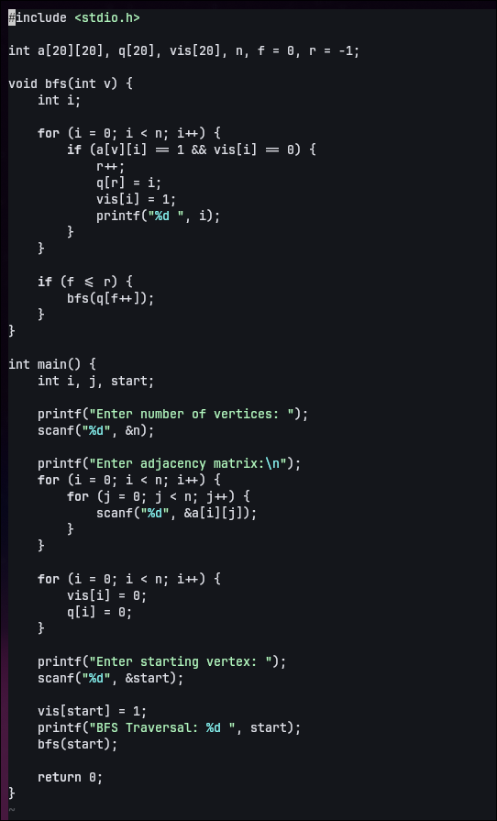
Code:

Output:

