Design and Analysis of Algorithms
Kathin M
ch.sc.u4cse24262

1)Bubble Sort

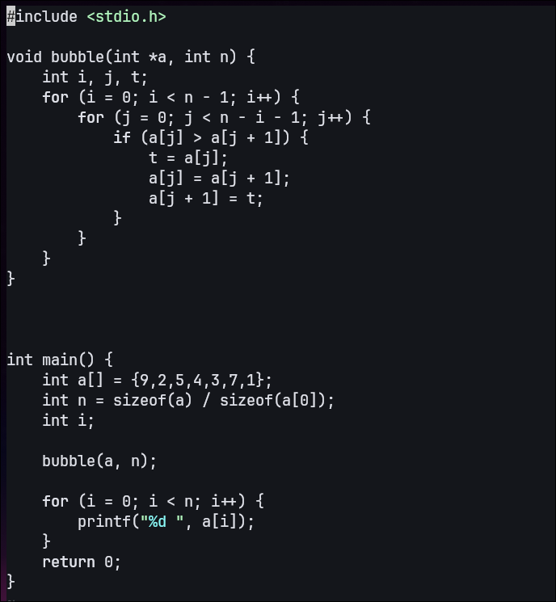
Program:

Output:
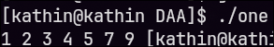

2)Bucket Sort
2)Bucket Sort
Program:
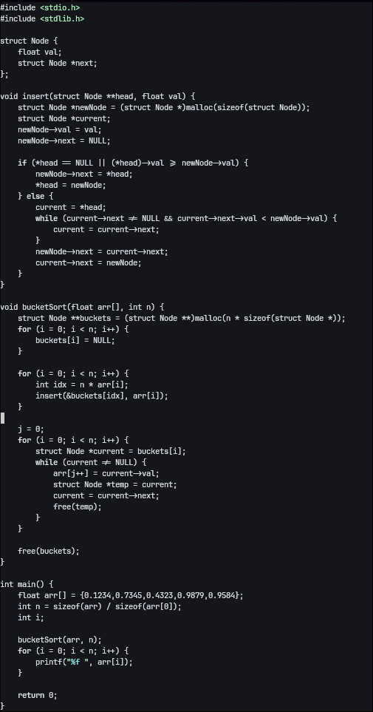

Output:
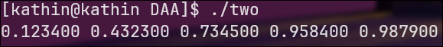
3)Selection Sort
Program:

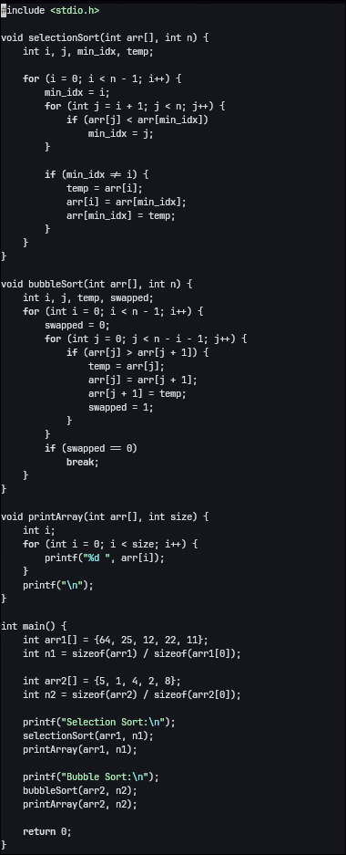

Output:
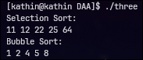

4)Insertion Sort
Program:
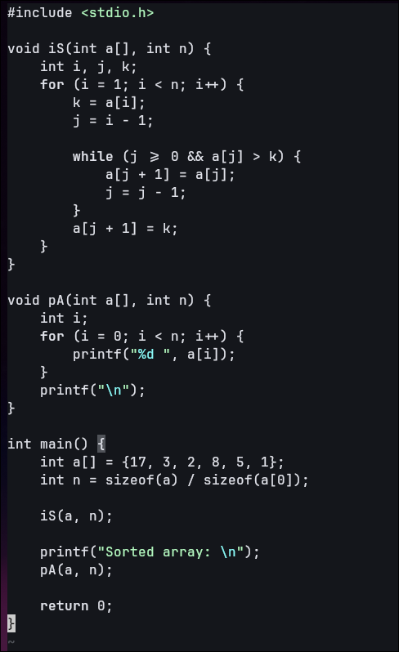

Output:
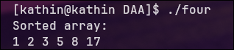

5)Heap Sort
Program:
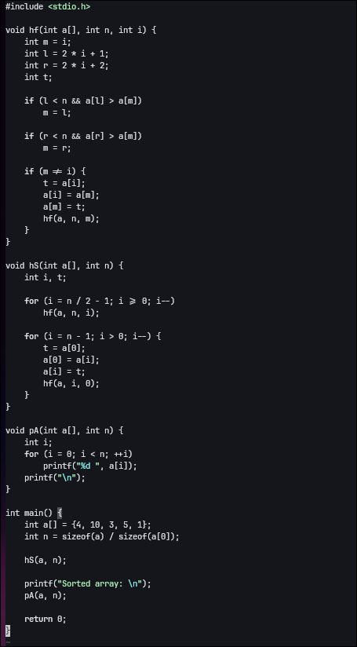

Output:
