REAL-TIME INDIAN SIGN LANGUAGE RECOGNITION USING EFFICIENT MULTI-FEATURE ATTENTION MECHANISM

A PROJECT REPORT

Submitted by

RAJESH A | 2023103046
KATHIR KALIDASS B | 2023103546
SATHYANARAYANAN P | 2023103579
NANDHA S | 2023103703

in partial fulfillment for the award of the degree of

BACHELOR OF ENGINEERING
in
COMPUTER SCIENCE AND ENGINEERING

COLLEGE OF ENGINEERING GUINDY

ANNA UNIVERSITY : CHENNAI 600 025

MARCH 2026

ANNA UNIVERSITY : CHENNAI 600 025

BONAFIDE CERTIFICATE

Certified that this project report REAL-TIME INDIAN SIGN LANGUAGE RECOGNITION USING EFFICIENT MULTI-FEATURE ATTENTION
MECHANISM is the bonafide work of RAJESH A (2023103046), KATHIR KALIDASS B (2023103546), SATHYANARAYANAN P (2023103579) and NANDHA
S (2023103703) who carried out the project work under my supervision.

Place: Chennai SIGNATURE
Date: 27.03.2026 Dr. C. Valliyammai

SUPERVISOR
Professor Department of Computer Science and Engineering
Anna University, Chennai – 25

COUNTERSIGNED

Head of the Department,
Department of Computer Science and Engineering, Anna University Chennai,
Chennai – 600025

ACKNOWLEDGEMENT
We would like to express our sincere gratitude to our institution, College of Engineering, Guindy, Anna University, for providing us with the opportunity to carry out this project.
We are extremely thankful to our project guide, Dr. C. Valliyammai, Professor, Department of Computer Science and Engineering, for her valuable guidance, constant support, and encouragement throughout the course of this project.
We also express our sincere thanks to the Head of the Department, Department of Computer Science and Engineering, for providing the necessary facilities to complete this work.
We extend our gratitude to all the faculty members and our friends who have supported us directly or indirectly during the completion of this project.

Rajesh A
Kathir Kalidass B Sathyanarayanan P Nandha S

ABSTRACT
Communication barriers between hearing-impaired individuals and the general population remain a significant social challenge. Indian Sign Language (ISL) is the
primary communication medium used by many deaf and hard-of-hearing individuals in India, but the lack of accessible translation tools often restricts interaction with non-signers. To address this problem, this work proposes a real-time Indian Sign Language recognition system based on an Efficient Multi-Feature Attention Mechanism. The proposed system processes live video streams captured from a camera and converts sign gestures into meaningful textual output. Video frames are first extracted from the incoming stream and preprocessed to ensure uniform spatial and temporal representation. Spatial visual information such as hand shape, orientation, and appearance is learned using an EfficientNet model pretrained on the ImageNet dataset through transfer learning. In parallel, temporal motion patterns that describe how gestures evolve over time are captured using a CNN–RNN architecture.
To enhance recognition performance, an attention mechanism is introduced to dynamically assign importance to both spatial and temporal features. This allows the model to focus more strongly on relevant gesture components while suppressing less informative information. The weighted features are fused and passed into a GRU-based sequence modeling network that learns temporal dependencies across gesture sequences.
Finally, a fully connected classification layer with softmax activation predicts the
corresponding ISL gesture class. The system is designed with real-time deployment in mind, ensuring low computational overhead while maintaining effective recognition accuracy. Experimental evaluation demonstrates that the proposed framework achieves
reliable gesture recognition performance while remaining computationally efficient. The proposed approach provides a

ABSTRACT
practical solution for ISL gesture recognition and lays the foundation for future research on continuous sign language translation systems.

TABLE OF CONTENTS

ABSTRACT iv
LIST OF FIGURES ix
LIST OF TABLES ix
LIST OF ABBREVIATIONS x
- INTRODUCTION 1
  - Background of the Study 1
  - Problem Statement 1
  - Objectives of the Project 2
  - Scope of the Work 2
  - Motivation 3
  - Outline of the Thesis 3
- RELATED WORK 4
  - Overview of Existing Systems 4
  - Existing Methods and Techniques 4
  - Advantages and Limitations of Existing Approaches 5
  - Research Gap Identified 5
- PROPOSED METHODOLOGY / SYSTEM DESIGN 6
  - Overall System Architecture 6
  - Block Diagram 7
    - Video Input Acquisition and Preprocessing 7
    - Spatial Feature Extraction Using EfficientNet 7
    - Temporal Feature Extraction Using CNN–RNN 7
    - Multi-Feature Attention Mechanism 7
    - Feature Fusion 8
    - Sequence Modeling Using Transformer 8
    - Temporal Alignment Using CTC 8
    - Decoding Using Beam Search 9
    - Language Processing and Grammar Refinement 9
    - Output Generation and Text-to-Speech Conversion 9
  - Module Description 10
    - Video Acquisition and Preprocessing 10
    - Feature Extraction and Fusion 11
    - Continuous Sign Recognition 11
    - Language and Audio Output 12
  - Algorithm 12
  - Mathematical Model / Equations 23
  - Workflow / Process Flow 14
- IMPLEMENTATION AND RESULTS 15
  - Implementation Environment 16
  - Dataset / Input Description 17
  - Test Cases 19
  - Results and Discussion 22
- CONCLUSION AND FUTURE WORK 24
  - Summary of the Work 24
  - Achievements 24
  - Limitations 25
  - Future Work 25
REFERENCES 26

LIST OF FIGURES

Fig. 1 Architecture Diagram of Proposed Model 9
Fig. 2 Video Acquisition and Preprocessing Module 20
Fig. 3 Feature Extraction and Fusion Module 21

Fig. 4 Continuous Sign Recognition Module 22
Fig. 5 Sample Output Screenshot 30

LIST OF TABLES

LIST OF ABBREVIATIONS

ISL | – Indian Sign Language
CNN | – Convolutional Neural Network
RNN | – Recurrent Neural Network
GRU | – Gated Recurrent Unit
CTC | – Connectionist Temporal Classification
TTS | – Text-to-Speech
RGB | – Red Green Blue
AI | – Artificial Intelligence
ML | – Machine Learning

CHAPTER 1
INTRODUCTION

BACKGROUND OF THE STUDY
Communication plays a vital role in human interaction, yet it remains a significant challenge for individuals who are deaf or hard of hearing. Indian Sign Language (ISL) serves as a primary means of communication for this community, relying on hand gestures, facial expressions, and body movements. However, the lack of automated translation systems and limited availability of trained interpreters create barriers in real-world scenarios such as healthcare, education, and public services.
Recent advancements in computer vision and deep learning have enabled machines to interpret visual data effectively. Convolutional Neural Networks (CNNs) are widely used for extracting spatial features, while Recurrent Neural Networks (RNNs) and Transformer models are capable of modeling temporal dependencies in sequential data. Despite these advancements, developing an efficient and real-time ISL recognition system remains a challenging task due to the dynamic nature of gestures and the complexity of visual patterns.

PROBLEM STATEMENT
Existing sign language recognition systems suffer from several limitations:

    - Inability to effectively capture both spatial and temporal features simultaneously
    - High computational complexity, making them unsuitable for real-time applications
    - Limited availability of large-scale annotated datasets for ISL

    - Reduced accuracy when gestures have subtle motion differences

Therefore, there is a need for a computationally efficient and accurate real-time ISL recognition system that can bridge the communication gap between sign language users and non-signers.

OBJECTIVES OF THE PROJECT
The main objectives of the proposed system are:
    - To design a real-time Indian Sign Language recognition system

    - To extract spatial features using EfficientNet
    - To model temporal dependencies using CNN–RNN architecture
    - To implement a multi-feature attention mechanism for improved feature selection
    - To achieve high recognition accuracy with low computational cost
    - To convert recognized gestures into text and speech output

SCOPE OF THE WORK
The scope of this project includes:
    - Recognition of isolated ISL gestures using RGB video input
    - Implementation of a deep learning-based hybrid model
    - Real-time processing with optimized computational efficiency The system does not cover:
    - Continuous sentence-level sign language translation
    - Multilingual sign recognition
    - Deployment on low-power embedded devices

MOTIVATION
The motivation behind this work stems from the need to improve accessibility for the hearing-impaired community. In many real-world situations, the absence of interpreters leads to communication difficulties, affecting education, employment, and social inclusion. An automated ISL recognition system can provide a practical solution by enabling seamless interaction between sign language users and non-signers, thereby promoting inclusivity and equal opportunities.

OUTLINE OF THE THESIS
This thesis is organized as follows:
    - Chapter 1 introduces the problem and objectives
    - Chapter 2 reviews existing research and identifies gaps
    - Chapter 3 presents the proposed system architecture and methodology
    - Chapter 4 discusses implementation details and experimental results
    - Chapter 5 concludes the work and suggests future improvements

CHAPTER 2
RELATED WORK

OVERVIEW OF EXISTING SYSTEMS
Early sign language recognition systems relied on handcrafted features and traditional machine learning algorithms such as Hidden Markov Models (HMM) and Support Vector Machines (SVM). These approaches provided limited accuracy due to their inability to capture complex visual patterns.
With the emergence of deep learning, vision-based approaches using CNNs and RNNs have become dominant. These methods significantly improve recognition accuracy by learning hierarchical feature representations directly from data.

EXISTING METHODS AND TECHNIQUES

Modern approaches can be broadly categorized as:
    - Spatial Feature-Based Methods:
Use CNN architectures (e.g., EfficientNet) to extract hand shape and appearance features.
    - Temporal Sequence Models:
Use RNN, LSTM, or GRU networks to model motion dynamics across frames.
    - Attention-Based Models:
Assign importance weights to relevant features, improving recognition performance.
    - Transformer-Based Models:
Capture long-range dependencies using self-attention mechanisms.

    - Multimodal Systems:
Combine RGB images with pose or depth data for improved accuracy.

ADVANTAGES AND LIMITATIONS OF EXISTING APPROACHES
Advantages:
    - High accuracy due to deep feature learning
    - Ability to handle complex gesture patterns
    - Improved temporal modeling Limitations:
    - High computational complexity
    - Dependency on large datasets
    - Limited focus on real-time performance
    - Insufficient research on Indian Sign Language

RESEARCH GAP IDENTIFIED
From the literature, the following gaps are identified:
    - Lack of efficient real-time ISL recognition systems
    - Limited use of feature fusion techniques

    - High computational overhead in advanced models
    - Insufficient datasets and benchmarks for ISL

These gaps highlight the need for a lightweight and efficient hybrid model.

CHAPTER 3
PROPOSED METHODOLOGY / SYSTEM DESIGN

OVERALL SYSTEM ARCHITECTURE
The overall architecture of the proposed Indian Sign Language recognition system is designed to process visual gesture input and convert it into meaningful textual and audio output. The system operates through a multi-stage deep learning pipeline that extracts both spatial and temporal information from the video sequence. The complete workflow of the proposed system is illustrated in Fig. 1, which presents the architecture diagram of the model and the interaction between different processing modules.
As shown in Fig. 1, the system begins with the acquisition of video input captured using a standard RGB camera. The input video is first decomposed into individual frames through a preprocessing stage. These frames are resized and normalized to maintain consistent spatial dimensions and improve numerical stability during model training and inference.
The processed frames are then passed to the feature extraction stage where the system learns important visual characteristics of the gesture.
The architecture uses two complementary feature extraction streams to capture different aspects of sign language gestures. The first stream performs spatial feature extraction using EfficientNet, a convolutional neural network that learns visual patterns such as hand shape, finger positioning, and gesture orientation from each frame. In parallel, the second stream performs temporal feature extraction using a CNN–RNN framework that analyzes the sequence of frames to capture motion dynamics and gesture transitions over time. After spatial and temporal features are extracted, the system applies a multi-feature attention mechanism. This module assigns adaptive weights to the extracted features so that the model

focuses on the most informative frames and suppresses less relevant information. The weighted spatial and temporal features are then combined using a feature fusion module, which produces a unified spatiotemporal representation of the gesture.
The fused feature sequence is subsequently processed by a sequence modeling component that captures contextual relationships between frames.
A Connectionist Temporal Classification (CTC) layer is used to align the predicted gesture labels with the input frame sequence without requiring precise frame-level annotations. Finally, the recognized gesture sequence is converted into readable text and optionally transformed into audio output using a text-to-speech module, enabling effective communication between sign language users and non-signers.
Thus, the architecture illustrated in Fig. 1 integrates multiple deep learning components to effectively capture gesture appearance, motion dynamics, and contextual relationships, abling accurate real-time recognition of Indian Sign Language gestures.

Block Diagram

Video Input Acquisition and Preprocessing
The system takes an RGB video of ISL gestures as input. Since raw video cannot be directly used, preprocessing is performed. The video is first converted into frames using uniform sampling to preserve temporal information. Each frame is resized and normalized to ensure consistent input size and stable training. Additionally, all sequences are standardized to a fixed length using padding or truncation, enabling efficient batch processing.

Spatial Feature Extraction Using EfficientNet
EfficientNet is used to extract spatial features from each frame, such as hand shape, orientation, and appearance. It is pretrained on large datasets and adapted using transfer

learning. The model generates compact feature vectors that capture important visual patterns while maintaining high accuracy and computational efficiency.

Temporal Feature Extraction Using CNN–RNN
To capture motion information, a CNN–RNN architecture is used. CNN extracts frame-level features, and RNN processes them sequentially to learn temporal dependencies. This helps the system understand gesture movement, direction, and transitions over time.

Multi-Feature Attention Mechanism
The attention mechanism assigns weights to spatial and temporal features based on their importance. It focuses on relevant frames and suppresses less useful information, improving recognition accuracy and robustness to noise.

Feature Fusion
Spatial and temporal features are combined to create a unified representation. This fusion captures both the visual appearance and motion dynamics of gestures, making the model more effective in recognizing complex signs.

Sequence Modeling Using Transformer
The fused features are passed to a Transformer encoder, which models long-range dependencies using self-attention. It processes sequences efficiently and captures relationships between frames better than traditional methods.

Temporal Alignment Using CTC
CTC is used to align predicted outputs with input sequences without requiring exact frame-level labeling. This makes the system flexible and suitable for sequence-based gesture recognition.

Decoding Using Beam Search

Beam search is applied during prediction to select the most probable output sequence by evaluating multiple candidate sequences, improving overall accuracy compared to simple decoding methods.

Language Processing and Grammar Refinement
The predicted gesture sequence is converted into text using mapping techniques. Grammar refinement is applied to correct sentence structure and improve readability.

Output Generation and Text-to-Speech Conversion
The final output is displayed as text and also converted into speech using a text-to-speech system. This enables effective communication between sign language users and others.
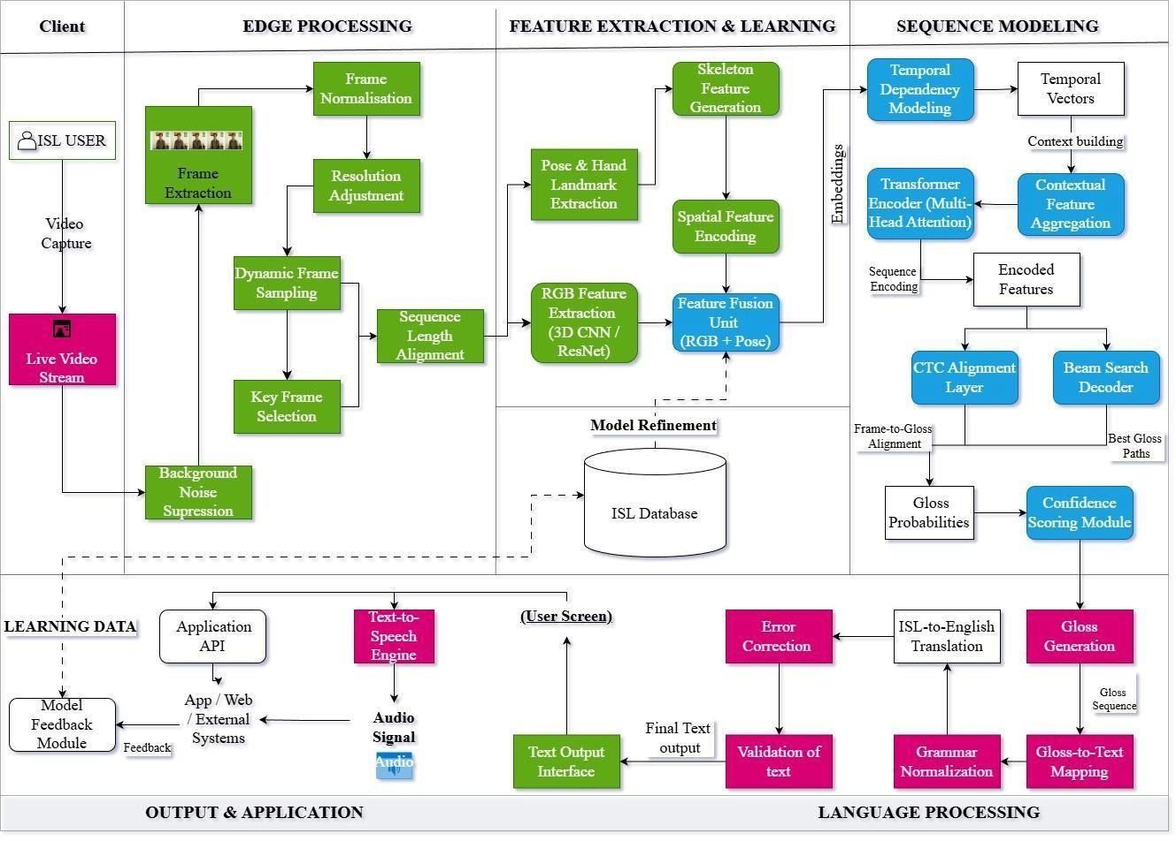

Fig 1. Architecture diagram of proposed model

MODULES DESCRIPTION

Video Acquisition and Preprocessing
      - Frame Extraction and Normalization
This module is responsible for converting the raw video input into a structured and standardized format suitable for deep learning models. The system accepts an RGB video stream captured using a standard camera. Since deep learning models cannot directly operate on continuous video streams, the video is first decomposed into individual frames. Frame extraction is performed using uniform sampling, where a fixed number of frames are selected from each video sequence.
Uniform sampling ensures that temporal information is preserved while avoiding redundant frames that do not contribute meaningful information. This step is especially important for real-time processing, as it reduces computational overhead without losing critical motion cues.
Once extracted, each frame is resized to a predefined spatial resolution compatible with convolutional neural networks. Frame normalization is then applied by scaling pixel intensity values to a standard range. Normalization improves numerical stability during training and ensures consistent feature learning across videos captured under varying lighting conditions.
Finally, all frame sequences are standardized to a fixed temporal length using padding or truncation, enabling efficient batch processing during training and inference.
Output:

A fixed-length sequence of normalized RGB frames.

Pose and Landmark Extraction

This sub-module extracts structured motion and positional information from the video frames. From each frame, key body, hand, and facial landmarks are detected to represent the signer’s movements in a compact and meaningful form. These landmarks encode geometric relationships such as joint positions, hand orientation, and finger movement patterns.
Pose and landmark information provides complementary motion cues that are invariant to background noise and illumination changes. By representing gestures in terms of relative positions and movements, the system improves robustness to environmental variations. The extracted landmark features are temporally aligned with the corresponding RGB frames to preserve synchronization between visual appearance and motion information.
Output: A sequence of landmark feature vectors aligned with video frames.

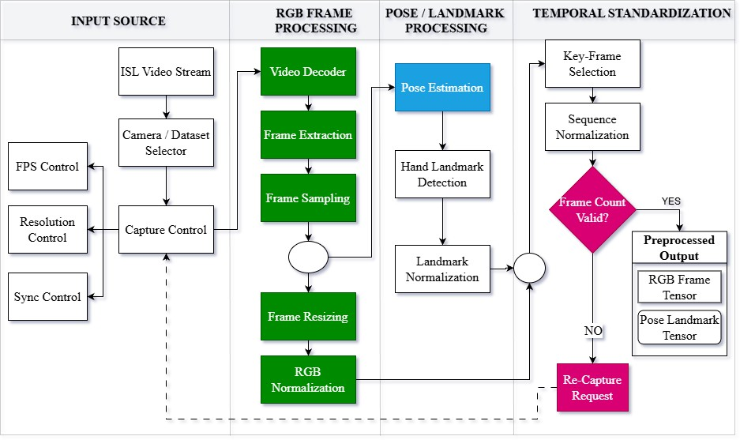

Fig. 2. Video Acquisition and Preprocessing Module

Feature Extraction and Fusion
      - RGB Feature Extraction using CNN
This module extracts spatial appearance features from the RGB frames using a Convolutional Neural Network (CNN). Each normalized frame is passed through multiple convolutional layers that learn hierarchical visual representations. Early layers capture low-level features such as edges and textures, while deeper layers learn high-level semantic features such as hand shape, orientation, and configuration.
The CNN transforms each frame into a compact feature vector that encodes visual characteristics relevant to sign language gestures. These features capture fine-grained appearance details that are critical for distinguishing between visually similar signs.
Output:
Frame-wise RGB feature vectors.

Pose Feature Extraction and Attention-Based Fusion
This sub-module processes the landmark feature vectors extracted in the preprocessing stage and integrates them with RGB features using an attention-based fusion mechanism. Pose features capture motion trajectories and relative positional changes, while RGB features provide detailed appearance information.
An attention mechanism is applied to dynamically assign importance weights to both RGB and pose features. During training, the model learns which feature type contributes more to recognizing a particular sign. For example, signs with subtle finger movements may rely more on landmark features, while signs with distinctive hand shapes may rely more on RGB features.

The attention-based fusion module suppresses irrelevant or noisy features and emphasizes discriminative information. The weighted RGB and pose features are then combined to form a unified spatiotemporal representation.
Output:
Fused feature sequence containing both appearance and motion information.
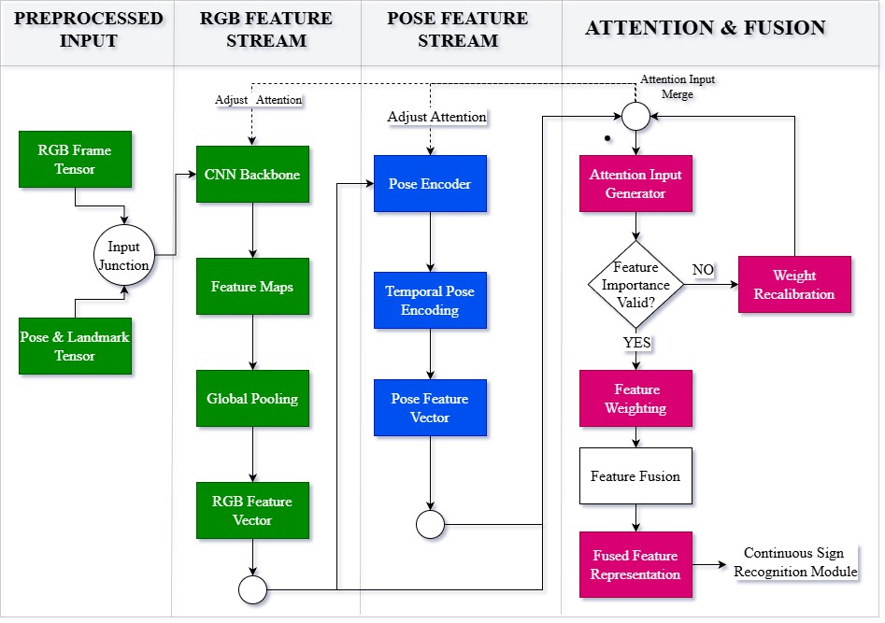

Fig. 3. Feature Extraction and Fusion Module

Continuous Sign Recognition
      - Temporal Modeling using Transformer or BiLSTM
This module models the temporal evolution of the fused feature sequence. Since sign language gestures unfold over time, temporal modeling is essential for understanding gesture progression and context.

Two alternative architectures can be employed:
BiLSTM: Processes the feature sequence in both forward and backward directions, capturing past and future temporal dependencies.
Transformer: Uses multi-head self-attention to model long-range dependencies across the entire sequence simultaneously, without relying solely on recurrence.
Temporal modeling enables the system to learn motion patterns, transitions between gesture components, and contextual relationships between frames. This is particularly important for continuous sign recognition, where multiple signs appear in a single video sequence.
Output:

Context-aware temporal feature sequence.

Sign Prediction using CTC Decoder
The temporally modeled feature sequence is passed to a Connectionist Temporal Classification (CTC) decoder. CTC enables sequence-to-sequence learning without requiring explicit alignment between frames and output labels.
During training, the CTC loss function allows the model to learn the most probable label sequence corresponding to the input feature sequence. During inference, a decoding strategy such as beam search is applied to generate the final predicted sign or sign sequence.
CTC is particularly effective for continuous sign recognition, as it handles variable-length input and output sequences and naturally accounts for timing variations in gesture execution.
Output:
Predicted sign or sign sequence.

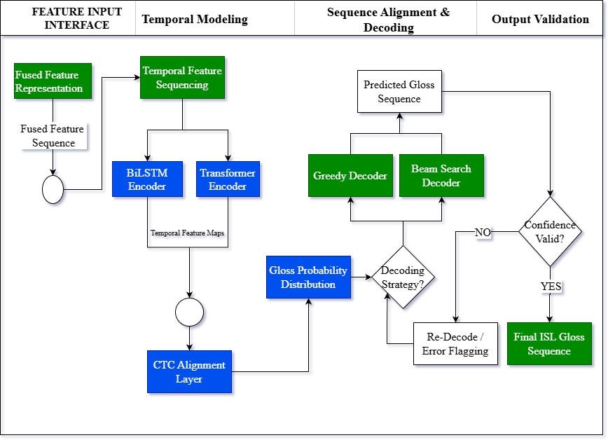

Fig. 4. Continuous Sign Recognition Module

Language and Audio Output

Sentence Correction and Caption Buffer
The predicted sign sequence is converted into textual form using a gloss-to-text mapping mechanism. Since the grammatical structure of sign language differs from spoken language, the generated text may contain syntactic inconsistencies.
A sentence correction module refines the generated text by correcting word order, grammatical errors, and incomplete phrases. A caption buffer is maintained to accumulate recognized signs over time, enabling smooth sentence formation in continuous recognition scenarios.
Output:

Grammatically corrected text sentences.
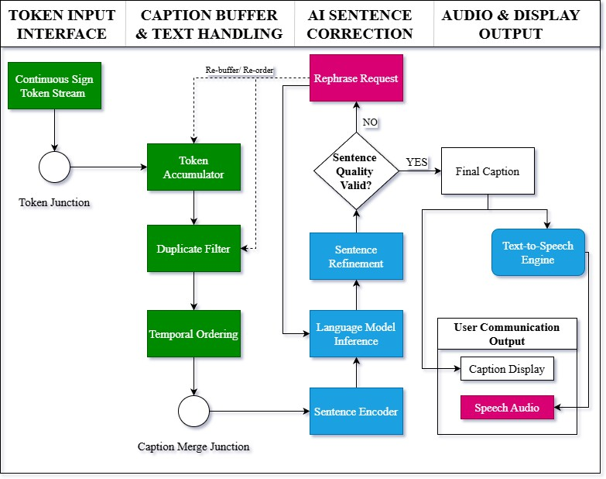

Fig. 5. Language and Audio Output Module

Text-to-Speech Output
In the final module, the corrected text is converted into audible speech using a text-to-speech (TTS) engine. The TTS system generates natural-sounding audio corresponding to the recognized sign language content.
This module enables real-time verbal communication between signing users and non-signing individuals, significantly enhancing the practical usability of the system in assistive communication scenarios.
Output:
Spoken audio output.

Algorithm

Step 1: Capture Input Video Stream
The system captures a real-time RGB video stream using a camera, representing the sign language gestures performed by the user.

Step 2: Frame Extraction and Preprocessing
The input video is divided into individual frames using uniform sampling. Each frame is resized and normalized, and the sequence is adjusted to a fixed length using padding or truncation.

Step 3: Spatial Feature Extraction using CNN
Each preprocessed frame is passed through a CNN (EfficientNet) to extract spatial features such as hand shape, orientation, and appearance.

Step 4: Temporal Feature Extraction using RNN
The sequence of frame-level features is fed into an RNN (such as GRU/LSTM) to capture temporal dependencies like motion patterns and gesture transitions.

Step 5: Apply Attention Mechanism
An attention module assigns weights to spatial and temporal features, emphasizing important frames and reducing the impact of irrelevant or noisy data.

Step 6: Feature Fusion
The weighted spatial and temporal features are combined to form a unified spatiotemporal representation of the gesture.

Step 7: Sequence Modeling
The fused features are passed through a sequence modeling unit (Transformer) to learn long-range dependencies and contextual relationships across frames.

Step 8: Gesture Prediction
The processed features are classified into gesture classes using a fully connected layer with softmax activation, producing the final predicted label.

Step 9: Output Generation (Text and Speech)
The predicted gesture is converted into readable text, and optionally into speech using a text-to-speech system for effective communication.

Mathematical Model / Equations
There are many criteria that can be used to evaluate the performance of SLR model. For isolated SL, the commonly used evaluation metric is Accuracy rates. Precision, Recall and F-score are other commonly used metrics besides accuracy. For the proposed system, accuracy is the chosen criterion to make comparisons with other studies in the literature.
The performance metrics we used in this study are given in (1), (2), (3), and (4).

𝐴𝑐𝑐𝑢𝑟𝑎𝑐𝑦 = 𝑇𝑃+𝑇𝑁
𝑇𝑃+𝑇𝑁+𝐹𝑃+𝐹𝑁

𝑃𝑟𝑒𝑐𝑖𝑠𝑖𝑜𝑛 = 𝑇𝑃
𝑇𝑃+𝐹𝑃

𝑅𝑒𝑐𝑎𝑙𝑙 = 𝑇𝑃
𝑇𝑃+𝐹𝑁

𝐹1 𝑆𝑐𝑜𝑟𝑒 = 2𝑇𝑃 2𝑇𝑃+𝐹𝑃+𝐹𝑁
(1)

(2)

(3)

(4)

where TP is True Positive, TN is True Negative, FP is False Positive and FN is False Negative.

Workflow / Process Flow
The system workflow includes: Video Input → Preprocessing → Feature Extraction → Attention → Feature Fusion → Sequence Modeling → Prediction → Output

CHAPTER 4
IMPLEMENTATION AND RESULTS

IMPLEMENTATION ENVIRONMENT
The proposed Indian Sign Language recognition system is implemented using modern deep learning frameworks and tools. The development is carried out in a Python environment due to its extensive support for machine learning libraries.
    - Programming Language: Python
    - Libraries Used: TensorFlow / PyTorch, OpenCV, NumPy, Pandas
    - Deep Learning Models: EfficientNet, CNN–RNN, Transformer
    - Development Tools: Jupyter Notebook / Google Colab
    - Hardware Requirements: GPU-enabled system for faster training and inference
These tools enable efficient implementation of video processing, feature extraction, and model training.

DATASET / INPUT DESCRIPTION
The system uses a video-based dataset consisting of Indian Sign Language gestures. Each sample in the dataset represents a gesture performed by a signer.
    - Input data consists of RGB video sequences
    - Videos are converted into frames for processing
    - Each sequence represents a single gesture class (isolated gestures)
    - Preprocessing ensures uniform frame size and sequence length

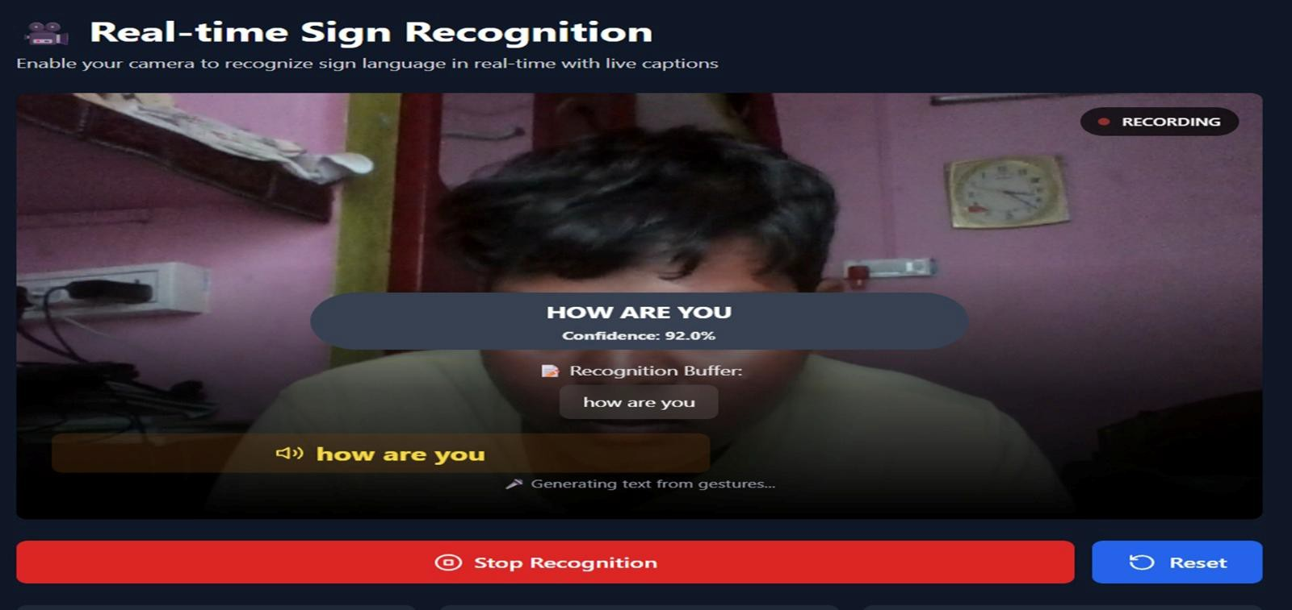
The dataset is essential for training the model to recognize different gesture patterns.

TEST CASES
The system is evaluated using multiple test cases to verify its performance under different input conditions.
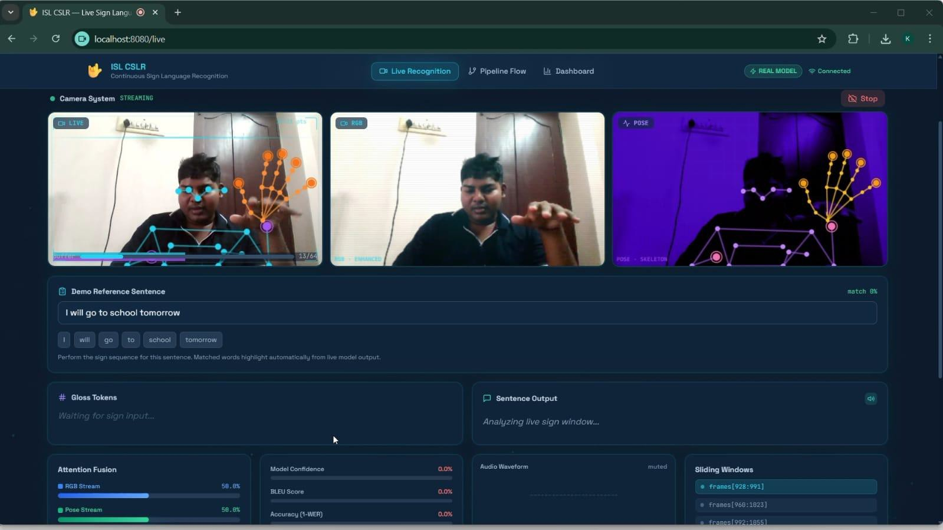
Test cases ensure that the system performs reliably across different scenarios.

RESULTS AND DISCUSSION
The proposed system successfully recognizes Indian Sign Language gestures using a combination of spatial and temporal features.

Key Observations:
    - EfficientNet effectively captures spatial features such as hand shape
    - CNN–RNN captures motion dynamics across frames

    - Attention mechanism improves feature selection and accuracy
    - Transformer enhances sequence understanding

Performance Metrics:
The system is evaluated using:
    - Accuracy
    - Precision
    - Recall

    - F1-score
The model achieves good recognition accuracy for isolated gestures while maintaining computational efficiency.

Intermediate Outputs:
The system produces several intermediate outputs:

    - Extracted frames from video
    - Feature representations
    - Predicted gesture labels
    - Text output

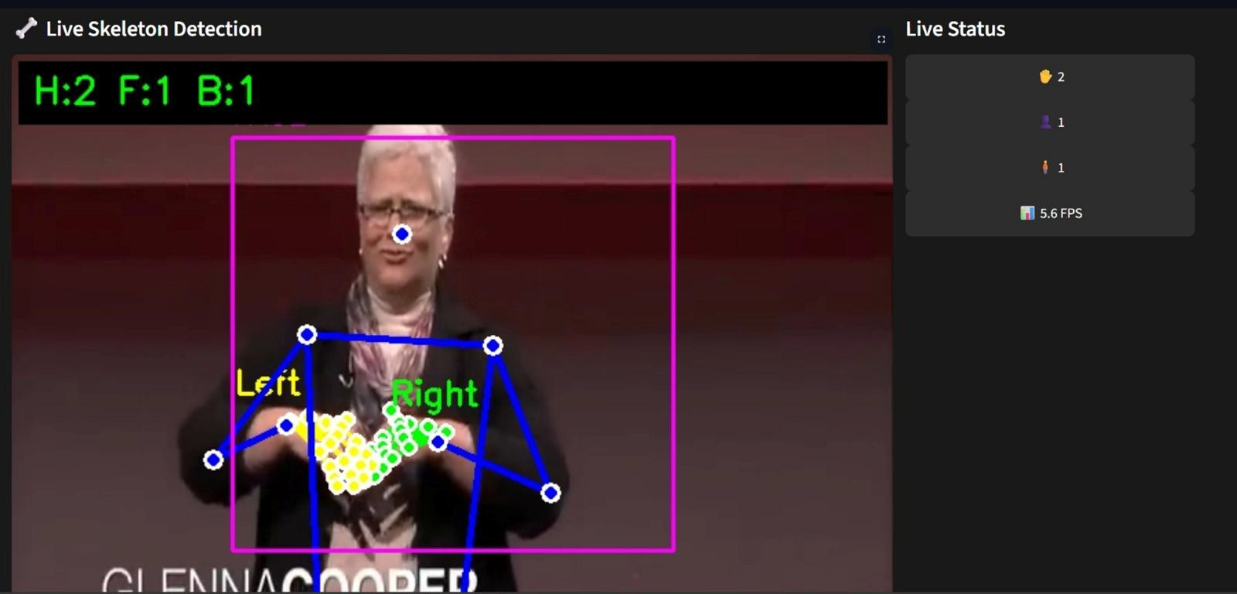
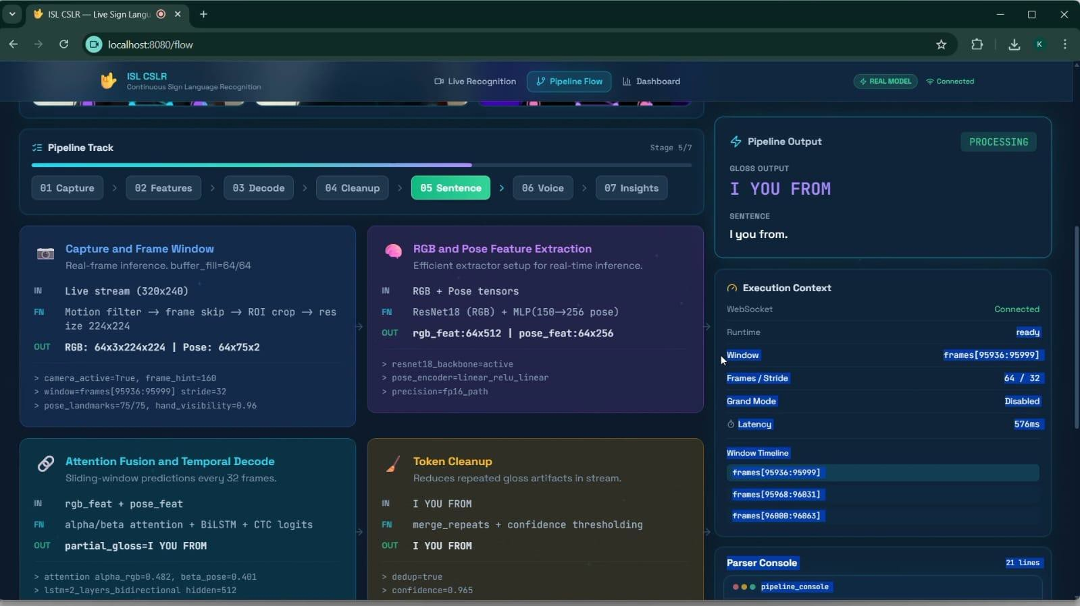
    - Speech output

Result Analysis:
    - The system performs well for clear and well-defined gestures
    - Slight variations may occur in complex or fast gestures
    - Performance is robust under moderate background noise

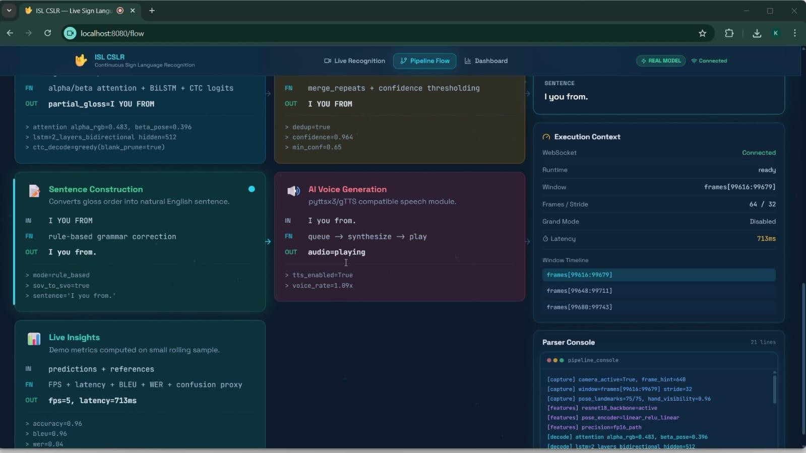

CHAPTER 5
CONCLUSION AND FUTURE WORK

SUMMARY OF THE WORK
This project presented the design and implementation of a real-time Indian Sign Language (ISL) recognition system using deep learning techniques. The proposed system processes RGB video input and extracts both spatial and
temporal features to accurately recognize hand gestures.

Spatial features are extracted using EfficientNet, while temporal dependencies are captured using a CNN–RNN architecture. A multi-feature attention mechanism is incorporated to improve feature selection by focusing on relevant gesture components. The system further utilizes a Transformer model for sequence modeling and a CTC layer for temporal alignment.
The final output is generated in both text and speech form, enabling effective communication between sign language users and non-signers.

ACHIEVEMENTS

The major achievements of this project include:
    - Successful development of a real-time ISL recognition system
    - Integration of spatial and temporal feature extraction techniques
    - Implementation of an attention-based feature fusion mechanism

    - Use of advanced models like EfficientNet and Transformer
    - Generation of text and speech output for user interaction
    - Achieved good accuracy and computational efficiency for isolated gestures

LIMITATIONS
Despite the promising results, the system has certain limitations:
    - The system is limited to isolated gesture recognition and does not support continuous sentence-level translation
    - Performance depends on the quality and size of the dataset
    - Computational requirements may be high for low-end devices

    - Accuracy may reduce for complex gestures or noisy environments

FUTURE WORK
The proposed system can be further enhanced in the following ways:
    - Extension to continuous sign language recognition and full sentence translation
    - Integration of multimodal inputs such as pose landmarks and depth data
    - Development of a mobile or embedded application for real-world deployment
    - Improvement of dataset size and diversity for better generalization
    - Incorporation of advanced Transformer-based architectures for higher accuracy

REFERENCES
- E. Yenisari and S. Yavuz, "Deep Learning-Based Sign Language Recognition Using Efficient Multi-Feature Attention Mechanism," IEEE Access, vol. 13, pp. 126684-126699, 2025, doi:
10.1109/ACCESS.2025.3586096.
- A. Joshi et al., "iSign: A benchmark for Indian sign language processing," arXiv preprint arXiv:2407.05404, 2024.
- S. Pandey, S. Tahseen, R. Pathak, H. Parveen, and M. Maurya, "Real-time vision-based Indian sign language translation using deep learning techniques," Int. J. Innov. Res. Comput. Sci. Technol. (IJIRCST), 2025.
- Y. LeCun, Y. Bengio, and G. Hinton, "Deep learning," Nature, vol. 521, no. 7553, pp. 436–444, May 2015.
- M. Kumar and P. Bhatia, "A survey on vision-based sign language recognition using deep learning," IEEE Access, 2024.
- H. Li, X. Wang, and Y. Chen, "Multimodal sign language translation using vision and language models," Neurocomputing, Elsevier, 2024.
- Y. Zhou, Z. Liu, and J. Huang, "Transformer-based models for multimodal language translation," ACM Trans. Multimedia Comput. Commun. Appl., 2024.
- C. Camgoz, S. Hadfield, O. Koller, H. Ney, and R. Bowden,
“Neural Sign Language Translation,” IEEE Conference on Computer Vision and Pattern Recognition (CVPR), 2018.
- D. Joze and O. Koller, “MS-ASL: A Large-Scale Data Set and Benchmark for Understanding American Sign Language,” IEEE Winter Conference on Applications of Computer Vision (WACV), 2019.

