DEVOPS WEEK 4 : GIT PULL AND REBASE COMMANDS
GIT PULL
Changing a file in new branch
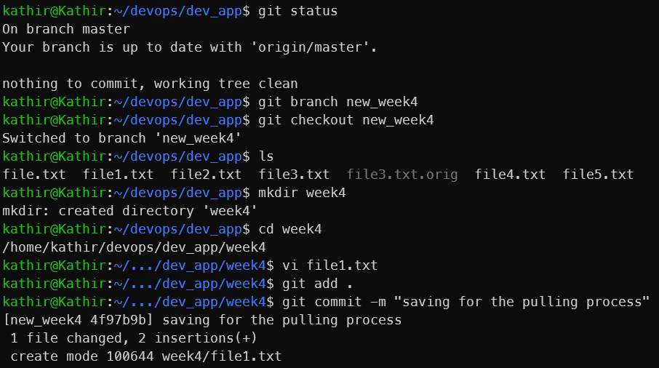
Now pushing to remote in new branch and then pulling the changes in master branch

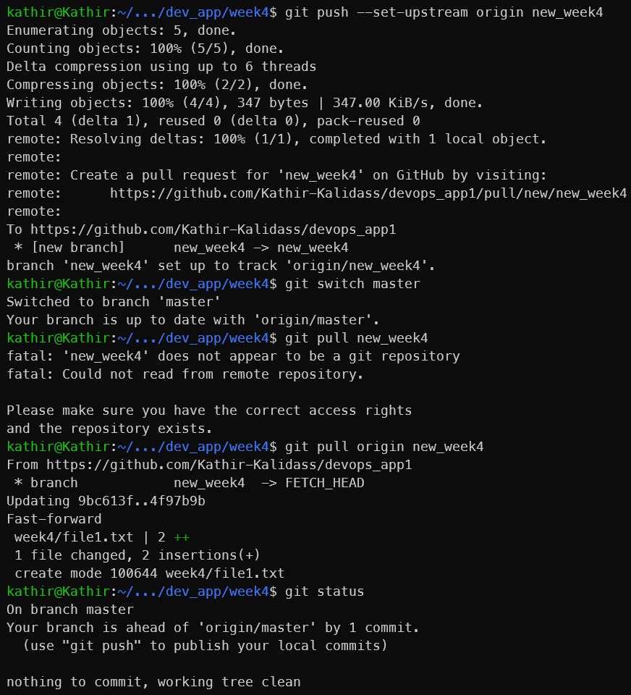

GIT REBASE
Git logs
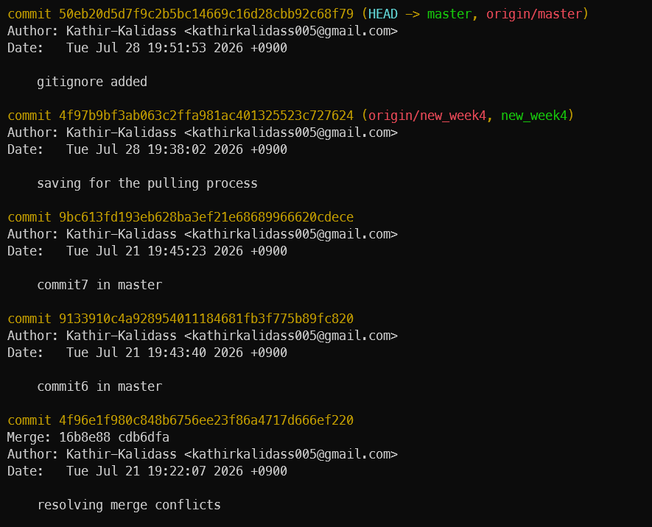
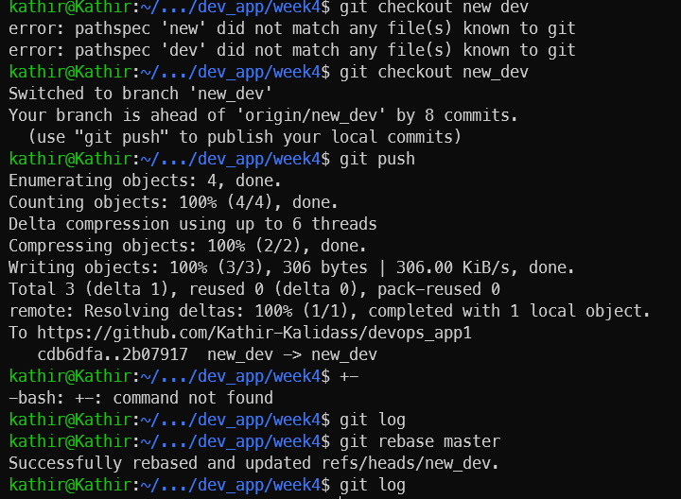
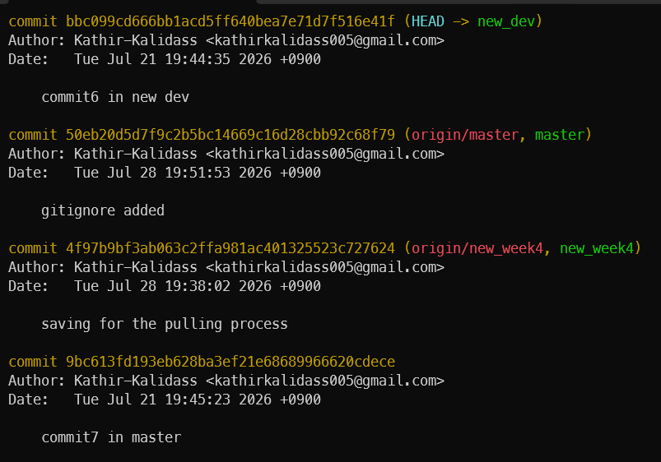

.gitignore
