DEVOPS WEEK 5 : Working with Maven
Maven Project Initialise
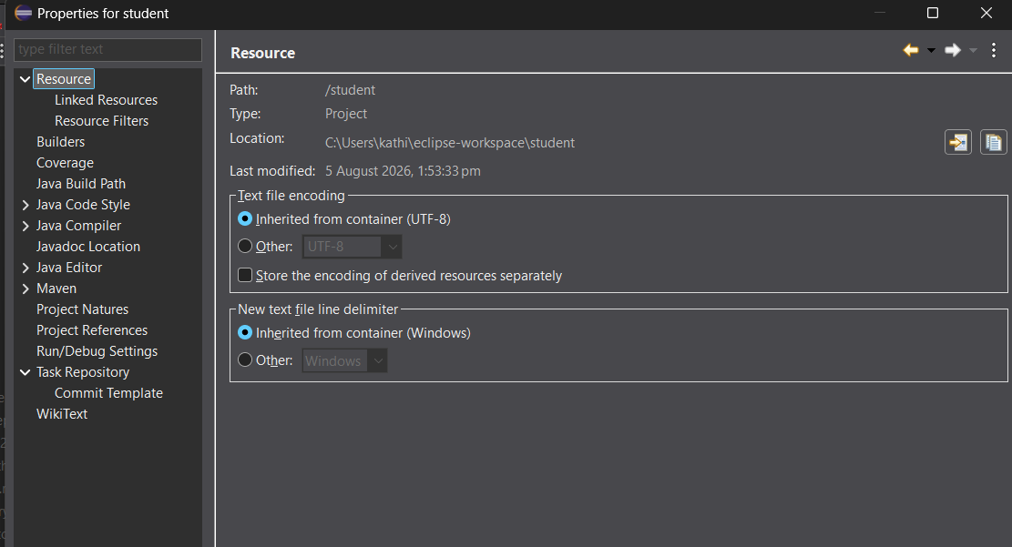
<groupId>DevOps</groupId>
<artifactId>student</artifactId>
<version>0.0.1-SNAPSHOT</version>
<packaging>jar</packaging>
<name>mp3_artist_reader</name>
<description>MP3 Artist Reader</description>
POM file setup inside project
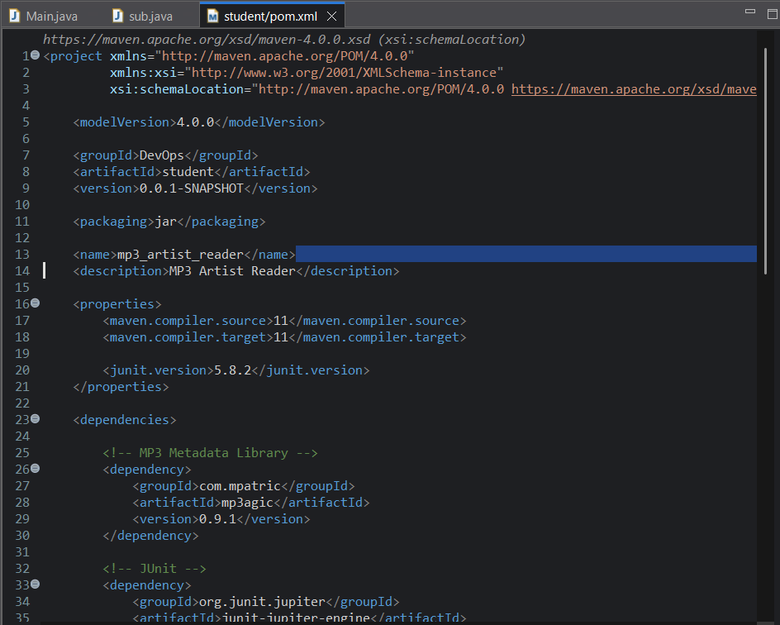
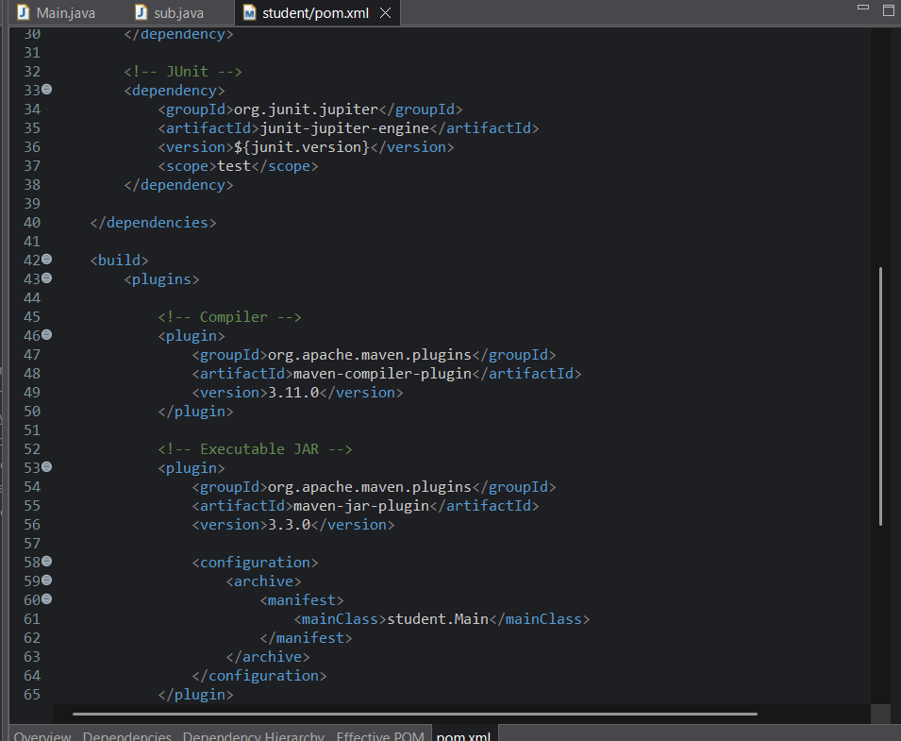

Create Package
src/main/java
New -> package
Name : student

Create Main.java
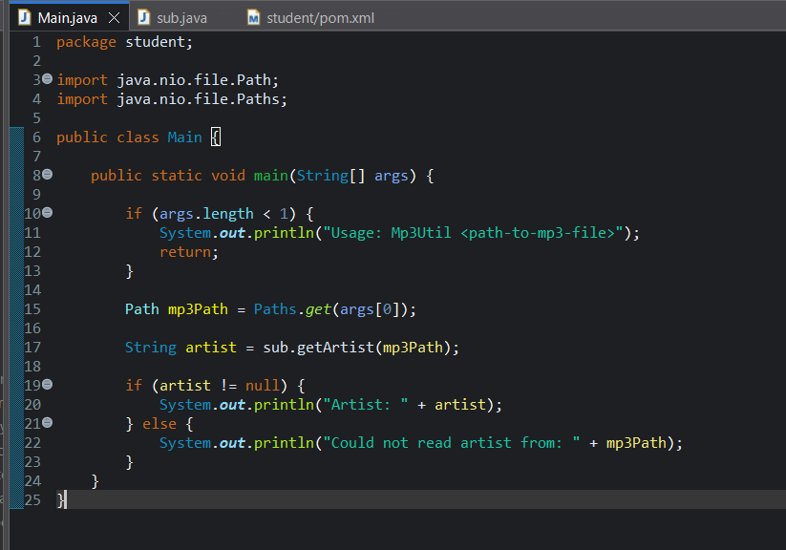

Create sub.java
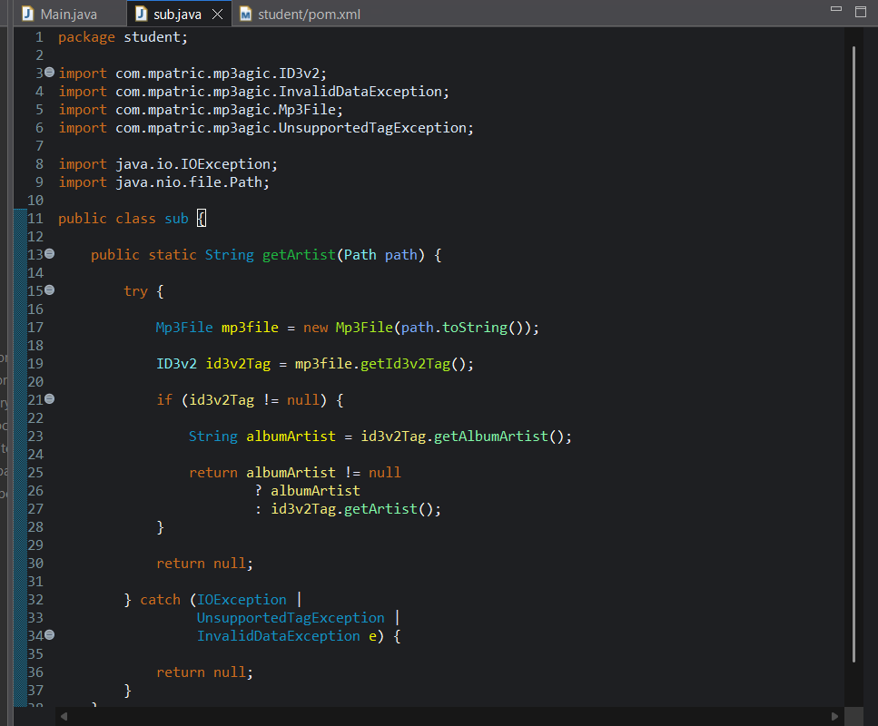

Maven Build
Run->run as -> Maven install
Maven dependencies are installed
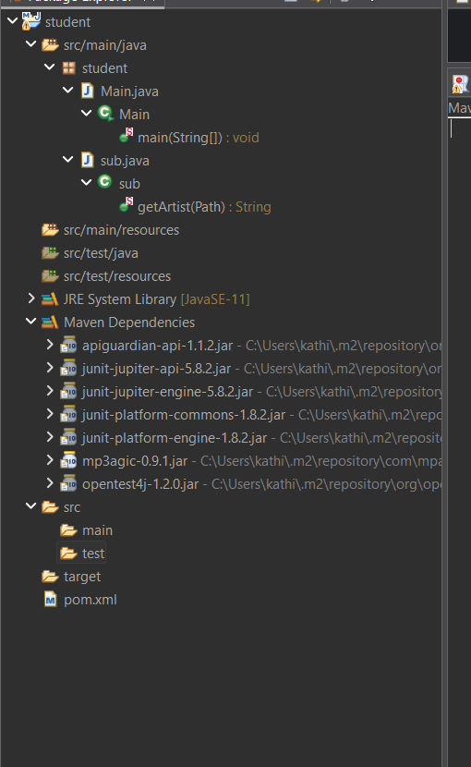
Run the Program
Run the main.java class
Run As Java Application
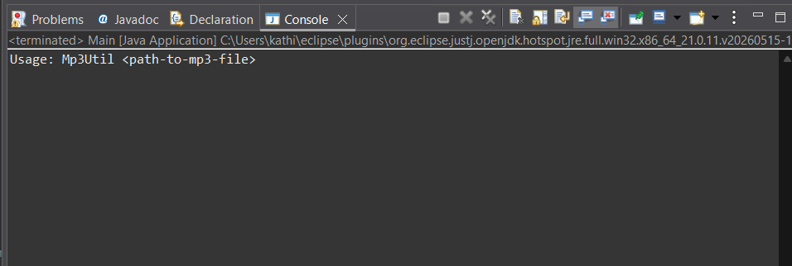
Add Program Arguments
In Run-> run Configurations
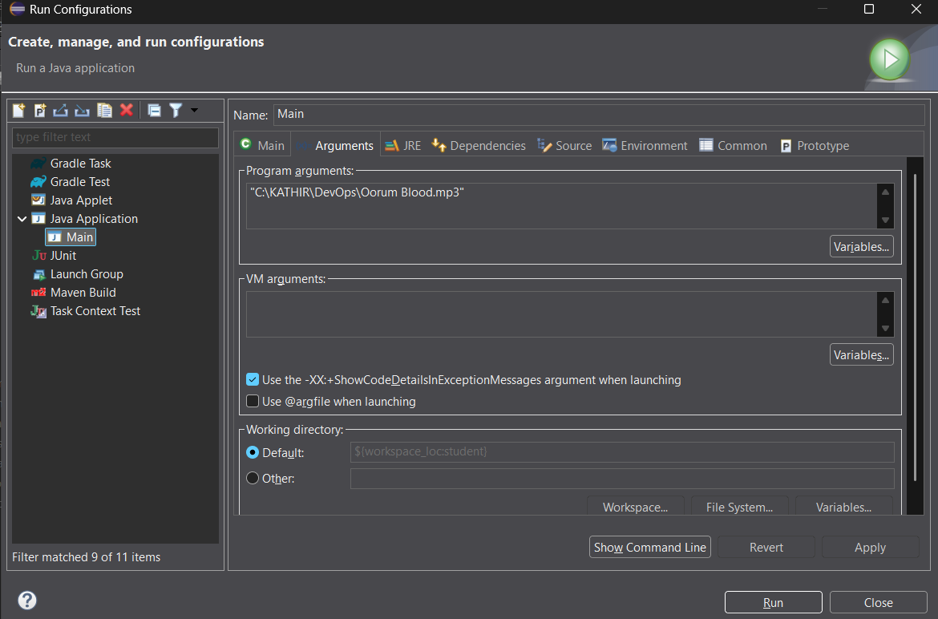
Output
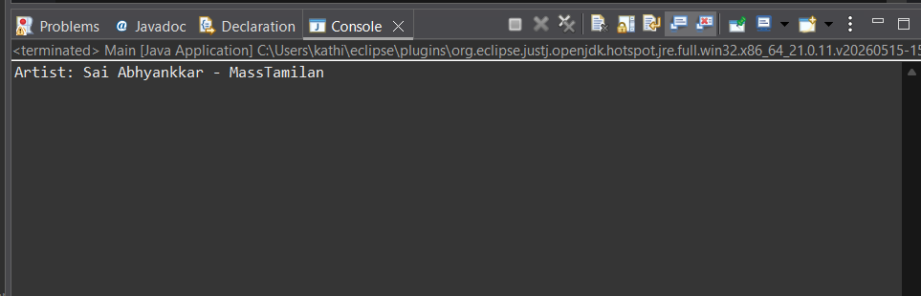

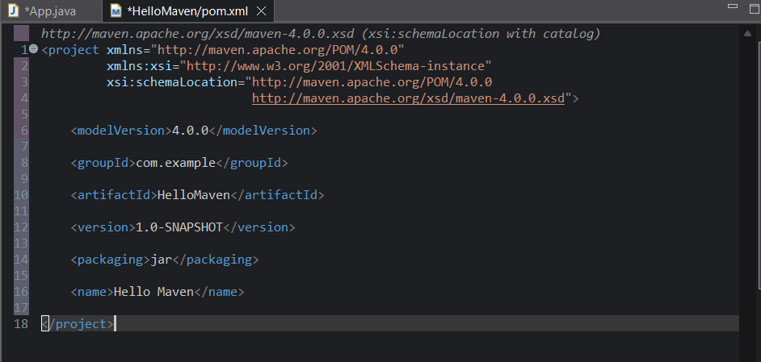
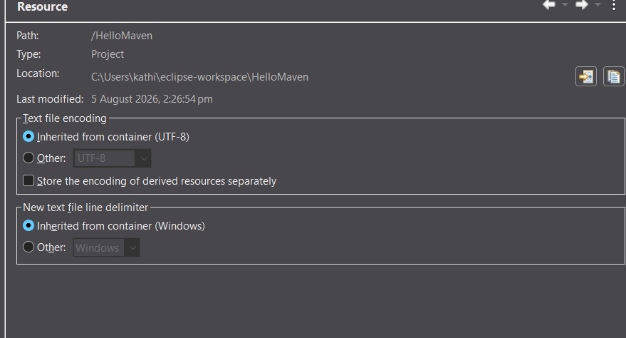
2)Maven project to create a simple jar file 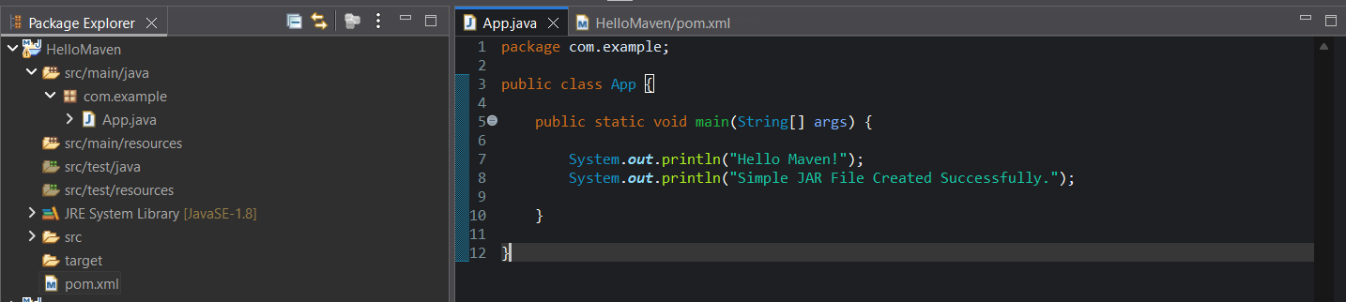
Maven Build
