 | COLLEGE OF ENGINEERING,GUINDY  ANNA UNIVERSITY, CHENNAI – 25  Embedded Systems and Internet of Things | 

A CASE STUDY ON

IoT-Enabled Intelligent Railway Safety Signalling System for Collision Prevention and Wildlife Intrusion IoT-Enabled Intelligent Railway Safety Signalling System for Collision Prevention and Wildlife Intrusion Detection
Detection

Submitted By
Team: 14

2023103546 | Kathir Kalidass B
2023103597 | Malini R
2023103600 | Parthasarathi S
2023103714 | Paril T

1. Domain and Problem Statement
The project belongs to Smart Transportation and Intelligent Railway Systems, focusing on railway sections that pass through forests, wildlife corridors and other high-risk environments. Conventional signalling mainly reports train movement and track occupancy; it cannot directly identify an unexpected animal or object entering the track. The system therefore combines three safety functions:
- Automatic Train Protection (Kavach) – movement supervision, prevention of Signal Passing at Danger (SPAD) and protection against specified collision scenarios.
- IoT-based wildlife intrusion detection – identifying elephants and other animals approaching or entering the track.
- Edge-AI and communication infrastructure – processing sensor data locally and generating timely alerts.

2. Abstract
This project proposes an IoT-Enabled Intelligent Railway Safety Signalling System that combines railway collision prevention with real-time wildlife and obstacle intrusion detection. The architecture has five functional layers: physical railway environment, sensing and identification, edge processing and safety, communication and networking, and railway control/application/analytics. When an intrusion is confirmed, the system determines its location and severity and sends an alert over a railway communication network to the locomotive pilot, station master and control room. Information can also be passed to an existing train-protection system such as Kavach, subject to safety certification and interface approval.
The approach is consistent with Indian Railways initiatives on wildlife intrusion detection (AI-enabled DAS-based elephant detection, thermal-vision trials, fencing, warning signs, speed restrictions and underpasses) and with Wildlife Institute of India recommendations to combine technology with physical mitigation. The 2025 IEEE review on railway obstacle detection identifies cameras, LiDAR and millimetre-wave radar with AI-based detection as key enabling technologies.
The sensing and alert logic of the trackside node was implemented and verified in the Wokwi online simulator, using a microcontroller with PIR and ultrasonic sensors and visible/serial alert outputs. The remaining layers (edge-AI camera classification, LoRa/RF link, Kavach integration and control-room analytics) are presented as the system architecture and design.

Project Objectives
- Detect elephants, other animals, humans and track obstructions early using multi-sensor fusion.
- Classify intrusions at the edge and generate a location- and severity-aware alert within seconds.
- Deliver alerts to the loco pilot, station master and control room without disturbing certified Kavach functions.
- Store events for analytics, hotspot identification and preventive planning.

3. IoT Architecture
Figure 3.1 shows the integrated architecture. Trackside nodes collect motion, distance, image and vibration data; edge processing performs local detection and risk assessment; confirmed alerts reach the train and the control centre, while Kavach independently performs its train-protection functions. This separation lets the IoT layer complement, not replace, the certified railway safety system.
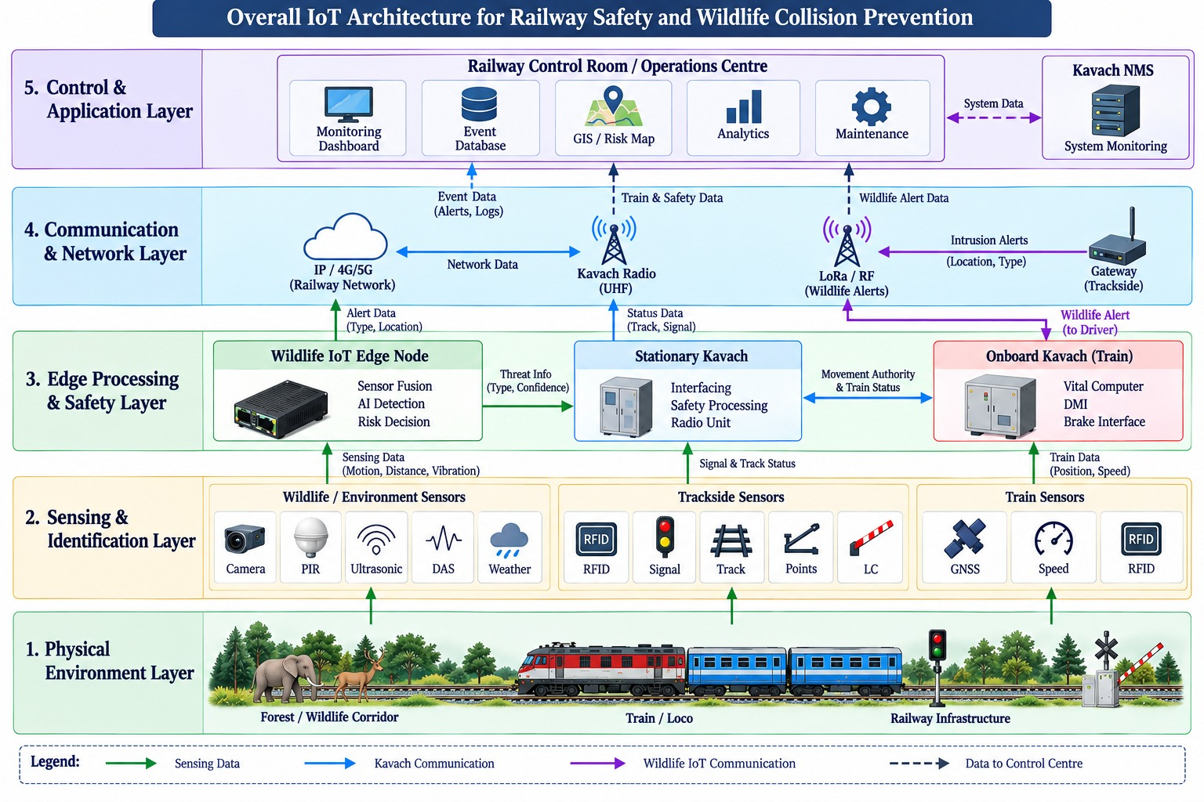
Figure 3.1 – Overall IoT Architecture for Railway Safety and Wildlife Collision Prevention

Layer-wise description
Layer | Role in the system
1. Physical environment | Forest/wildlife corridor, train/loco and railway infrastructure (signals, level crossings, points).
2. Sensing & identification | Camera, PIR, ultrasonic, DAS and weather sensors for wildlife; RFID, signal, track, points and LC status for trackside; GNSS, speed sensor and RFID reader on the train.
3. Edge processing & safety | Wildlife IoT edge node (sensor fusion, AI detection, risk decision); Stationary Kavach (interfacing, safety processing, radio unit); Onboard Kavach (vital computer, DMI, brake interface).
4. Communication & network | IP/4G/5G railway network, Kavach UHF radio, and LoRa/RF link with a trackside gateway for wildlife alerts.
5. Control & application | Control-room monitoring dashboard, event database, GIS/risk map, analytics, maintenance, and Kavach NMS.

4. Workflow

4.1 Kavach-based train collision prevention
Signalling information is processed by Stationary Kavach and exchanged with Onboard Kavach over bidirectional UHF radio. The onboard system combines location (from RFID tags and the directional speed-sensor output), speed and movement authority to supervise the train against its permitted speed profile. The DMI warns the loco pilot, and the brake interface applies braking when the specified safety conditions demand it.
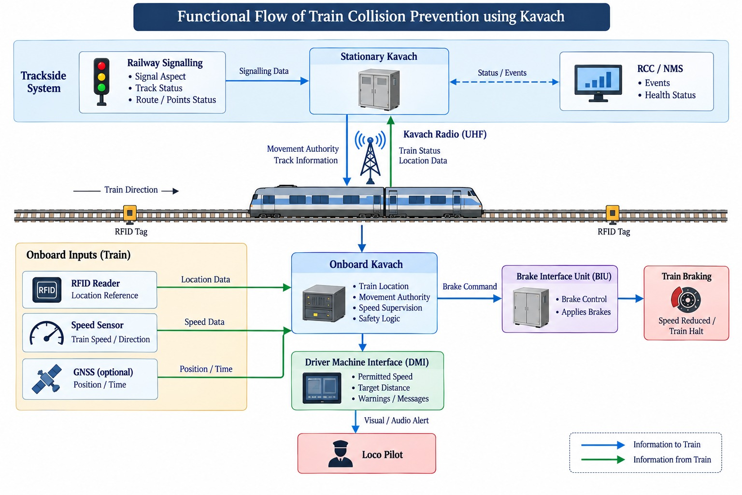
Figure 3.2 – Functional flow of train collision prevention using Kavach

4.2 Wildlife / obstacle detection and alert flow
PIR and ultrasonic sensing give the first indication of an intrusion; the camera then captures visual evidence for edge-AI classification (elephant, animal, human or track obstruction). A risk decision is generated locally and the alert is sent via LoRa/RF to the train-side receiver and the control centre (Figure 3.3). Local processing reduces dependence on continuous cloud connectivity in remote corridors; NETRA demonstrates a comparable sensor-fusion, edge-AI and LoRa-based alert design.
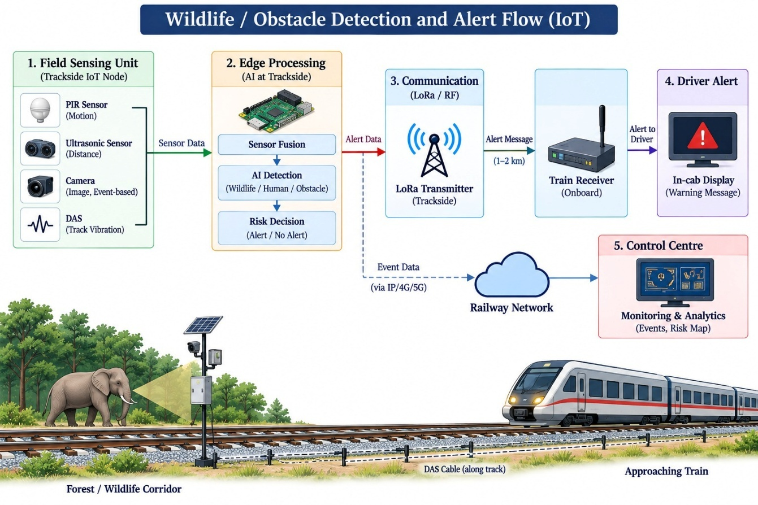
Figure 3.3 – Wildlife / obstacle detection and alert flow (IoT)

4.3 Step-by-step operation
Step | Action
1 | Field node senses motion/distance (PIR → ultrasonic) in the monitored track section.
2 | Camera is triggered; the image is sent to the edge computer.
3 | Edge AI classifies the object and returns a confidence value; temporal validation filters false triggers.
4 | If confidence ≥ threshold, a risk decision (alert / no alert) with severity is generated.
5 | Alert is sent by LoRa/RF to the train receiver (in-cab display) and via IP/4G/5G to the control centre.
6 | Event is logged in the database for analytics; Kavach continues its independent protection functions.

Sample MQTT event message (non-safety-critical monitoring layer):
EVENT { Track Section = T-24; Object = Elephant; Confidence = 0.94; Direction = North; Time = 22:14:05; Severity = HIGH }

The two safety paths – the certified Kavach path and the IoT perception path – are deliberately separated at the safety-critical level, so a failure in the IoT/cloud layer cannot compromise train protection. Stored detections also feed a closed loop: real-time alerts for immediate response, historical data for future mitigation planning.

5. Peripherals / Devices

Component | Function | Typical interface* | In Wokwi simulation
PIR sensor | Motion trigger in low-cost edge nodes | GPIO | Yes
Ultrasonic sensor | Short-range distance confirmation | GPIO (trigger/echo) | Yes
Microcontroller | Sensor acquisition and local control | GPIO, UART, I²C, SPI | Yes
Alert output | Local alert indication (LED / buzzer / display) | GPIO | Yes
RGB camera | Visual detection and classification | USB / CSI | Design only
Thermal camera | Detection at night and in poor visibility | USB / SPI / I²C | Design only
Optical fibre / DAS | Distributed acoustic/vibration sensing along the corridor | Interrogator → Ethernet | Design only
Edge computer | Local AI processing and sensor fusion | Ethernet / UART | Design only
Communication gateway | Transfers alerts/data to the railway network | LoRa/RF, Ethernet, 4G/5G | Design only
Train display / alert unit | Warning to the locomotive crew | LoRa/RF receiver | Design only
Control-room server | Event monitoring and historical storage | Ethernet, MQTT/HTTPS | Design only
GNSS / railway location source | Position/time reference (Kavach location uses RFID + directional speed sensor) | UART | Design only
RFID tag + onboard reader | Track location reference for onboard Kavach | Railway-specific | Design only
UPS / battery / solar | Backup power for remote trackside nodes | Power | Design only

6. Hardware / Simulation Setup
The project was implemented as a software simulation in Wokwi, a browser-based online simulator for microcontroller projects. Wokwi lets the circuit be wired and the firmware run without physical hardware, and provides a Serial Monitor to observe the output. No physical hardware prototype was built; the simulation represents one trackside sensing node.

6.1 Topology
Aspect | Topology
Overall | Hybrid hierarchical topology
Trackside sensing | Distributed / linear deployment along vulnerable railway corridors
Edge | Multiple sensing nodes connected to local edge/gateway units
Railway safety | Stationary Kavach units communicate with Onboard Kavach and adjacent stationary units
Control | Hierarchical link from field/gateway systems to railway monitoring and control infrastructure

6.2 Wokwi simulation configuration
Item | Details
Simulation platform | Wokwi online simulator (wokwi.com)
Microcontroller | Microcontroller board simulated in Wokwi (reads sensors, runs the detection logic, drives outputs)
Sensors | PIR motion sensor and ultrasonic distance sensor
Output / indicators | Alert indicator (LED / buzzer) and Serial Monitor messages
Firmware | Embedded C/C++ program running in the simulator
Edge logic implemented | PIR → Ultrasonic → Confidence/decision → Alert
Test scenarios | No intrusion; motion only (no confirmation – false trigger); motion + object within threshold distance (confirmed intrusion and alert)

6.3 Simulation logic
Step | Action in the simulation
1 | PIR output is read continuously; the node stays idle while no motion is sensed.
2 | On motion, the ultrasonic sensor measures the distance of the object.
3 | If the distance is below the set threshold distance, the intrusion is confirmed; otherwise it is treated as a false trigger.
4 | On confirmation, the alert output is activated and an alert message is printed on the Serial Monitor.
5 | When motion stops or the object moves away, the node returns to the normal (no intrusion) state.

7. Tools and Technology
Tool / technology | Use in the project
Wokwi online simulator | Circuit design and firmware simulation of the trackside sensing node; Serial Monitor for output.
Embedded C/C++ firmware | Reads the sensors and executes the detection and alert logic in the simulator.
Artificial intelligence (computer vision) | Design level: classifies elephants, cattle, deer, humans, vehicles, fallen objects and other obstructions at the edge.
Sensor fusion | PIR → Ultrasonic → Camera → Edge AI → Confidence Check → Alert; far more reliable than alerting from a single sensor. PIR + ultrasonic stages are simulated.
Distributed Acoustic Sensing (DAS) | Optical-fibre disturbance detection; Indian Railways reports AI-enabled DAS over 141 route-km on NFR, with 1158 route-km sanctioned.
Data analytics | Wildlife hotspots, time-of-day and seasonal patterns, repeated false alarms, high-risk sections, sensor failures – enabling preventive safety.

Level | Protocols
Sensor level | GPIO (used in simulation); UART (Serial Monitor); I²C, SPI depending on hardware
Network level (non-safety) | IPv4/IPv6, TCP/IP, Ethernet, MQTT, HTTPS, TLS
Wildlife alert link | LoRa / RF (approx. 1–2 km trackside-to-train)
Railway safety | Kavach UHF radio with CBC-MAC message authentication; controlled, certified interfaces (not consumer IoT links)

MQTT suits compact event messages; the safety-critical signalling interface is kept separate from IoT monitoring traffic so that failures in the IoT/cloud layer cannot affect train protection.

8. Dashboards
Simulation output view. In the Wokwi implementation, the live view of the node is the simulator window (sensor states and alert indicator) together with the Serial Monitor, which shows sensor readings and the alert message.
Proposed control-room dashboard. For the full system , the dashboard gives operators and the railway control room a live view of the corridor. Its panels are:
Panel | Content
Live alert panel | Latest events: track section, object type, confidence, direction, time and severity (e.g. HIGH – Elephant, T-24)
GIS / risk map | Node locations and intrusion points along the corridor; high-risk sections highlighted
Event database / history | Searchable log of detections, alerts and false alarms
Analytics | Hotspots, time-of-day and seasonal trends, false-alarm rate
Node health & maintenance | Sensor/gateway status, battery/solar level, fault and tamper flags
In-cab display (train side) | Warning message to the loco pilot on receiving a confirmed alert

[ INSERT SCREENSHOT ] Wokwi live view / Serial Monitor output
Paste screenshot of the simulator output (delete this box after pasting the image)
Figure 8.1 – Wokwi simulation output (Serial Monitor and alert indicator)

9. Features and Functions Implemented

9.1 Implemented and demonstrated in the Wokwi simulation
Feature / function | Description
Motion-triggered detection | PIR sensor detects presence/motion near the track section.
Distance confirmation | Ultrasonic sensor measures the object distance to confirm the intrusion and reduce false alarms.
Sensor-fusion decision | An alert is raised only when both PIR and ultrasonic conditions are met; PIR alone is treated as a false trigger.
Local alert output | The alert indicator (LED / buzzer) is activated on a confirmed intrusion.
Serial alert message | Sensor values and alert status are printed on the Serial Monitor.
Automatic reset | The node returns to the normal state when the intrusion clears.

9.2 Designed in the system architecture
Feature / function | Description
Edge-AI classification | Local classification into elephant / animal / human / track obstruction with a confidence score.
Severity and location tagging | Every event carries track section, direction, time and severity.
Long-range alerting | LoRa/RF alert to train receiver and in-cab display; IP/4G/5G to control centre.
Event logging and analytics | All events stored for hotspot and trend analysis.
Kavach separation | IoT layer is advisory; certified Kavach retains train-protection and braking authority.
Security controls | Device identity, authenticated/signed firmware, TLS, message integrity and replay protection, access control.

Security
Device: unique identity, secure boot, signed firmware updates, restricted physical access. Communication: mutual authentication, encryption, TLS for IP links, integrity checks, replay protection; Kavach uses CBC-MAC authentication with security zones/conduits aligned to IEC 62443. Edge: hardening against unauthorised login, malware, malicious firmware and tampering. False-alarm protection: sensor fusion, confidence thresholds, temporal validation, redundant sensing and health monitoring.
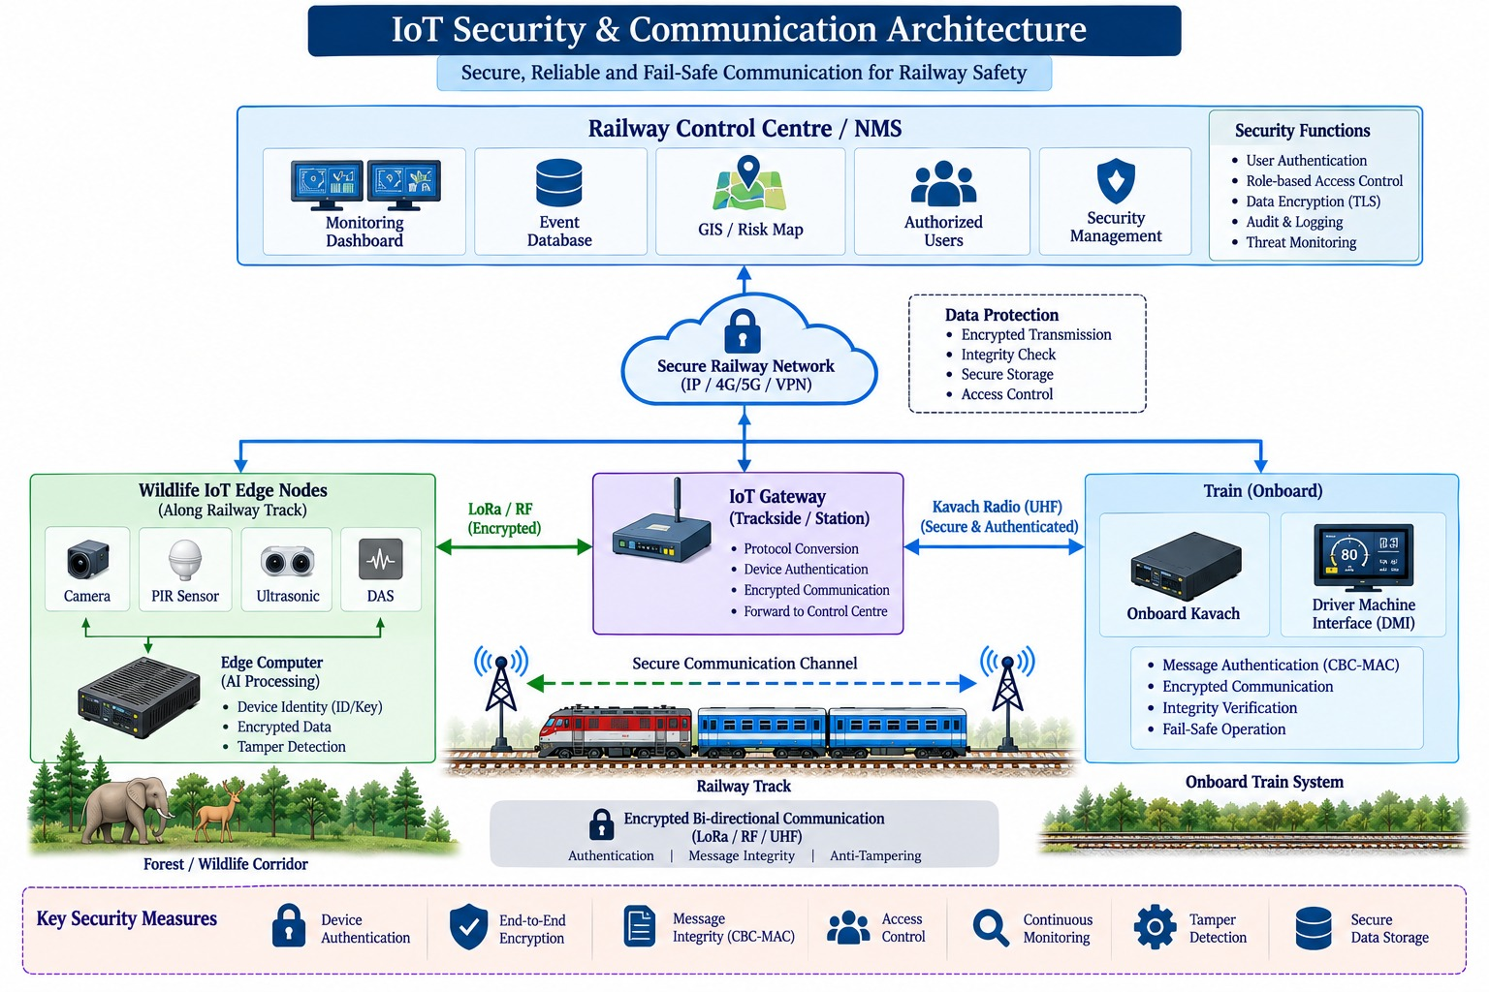
Figure 3.4 – IoT security and communication architecture

10. Screenshots of Simulation

Screenshots to add
Figure 10.1 – Wokwi circuit of the trackside sensing node
Figure 10.2 – Simulation in the normal (no intrusion) state
Figure 10.3 – Simulation showing confirmed intrusion and alert

11. Scalability and Future Scope
Stage | Scope
1 – Pilot corridor | Small high-risk wildlife section; monitor accuracy, false alarms, communication reliability, response time and power use.
2 – Multiple corridors | Extend to other wildlife hotspots (Indian Railways: 141 R km operational, 1158 R km sanctioned).
3 – Network integration | Control rooms, station systems, maintenance management, wildlife departments, historical databases.
4 – Predictive safety | Estimate high-risk locations, likely movement periods, sensor degradation and maintenance needs.

Future scenarios: multi-species detection (deer, cattle, wild boar, tigers, leopards, humans); general obstacle detection (fallen trees, rocks, vehicles, objects placed on tracks); and a railway digital twin combining train position, track condition, wildlife activity, signalling state and environmental data.

12. References
- Ministry of Railways, Government of India, “Indian Railways Implements Innovative Measures to Protect Elephants and Wildlife on Tracks,” Press Information Bureau, Mar. 21, 2025.
- Research Designs & Standards Organisation, Ministry of Railways, Government of India, Specification of Kavach (Train Collision Avoidance System), RDSO/SPN/196/2020, Version 4.0 d2.
- Project Elephant Division, Ministry of Environment, Forest and Climate Change, Government of India, and Wildlife Institute of India, Suggested Measures to Mitigate Elephant and Other Wildlife Train Collisions on Vulnerable Railway Stretches in India, 2025.
- X.-Y. Xu, S.-M. Wang, W.-Q. Liu, and Y.-Q. Ni, “Advancements in Obstacle Intrusion Detection Methods for Rail Transit: A Comprehensive Review,” IEEE Transactions on Instrumentation and Measurement, vol. 74, 2025.
- N. Gayathri et al., “WildlifeRailGuard: A novel conservation technology to mitigate train-animal collisions in forest regions,” Journal of Rail Transport Planning & Management, vol. 37, 2026, Art. no. 100565.
- P. Kumar et al., “NETRA,” arXiv:2605.08246, 2026.
- Wokwi, “Wokwi Online Simulator for Arduino, ESP32 and more,” https://wokwi.com.

