MINOR PROJECT REPORT
HOME AUTOMATION SYSTEM USING BLUETOOTH
(ESP32-Based Implementation)

Submitted by
KATHIRAVAN V
Register Number: 2114251060175

Department of Electronics and Communication Engineering
PANIMALAR ENGINEERING COLLEGE

Academic Year: 2025–2029
Year / Semester: 2nd Year – 3rd Semester

ABSTRACT
This project presents a low-cost Bluetooth-based home automation system for switching household or demonstration lights using a smartphone. An ESP32 development board receives short commands over its built-in Bluetooth Classic serial interface and controls a relay module connected to a light. Commands are mapped to simple actions: A/1 turns the light ON, B/0 turns it OFF, and S requests the current commanded state. The system is designed to be simple to assemble, easy to demonstrate, and useful for understanding embedded control, wireless communication, and relay switching. This implementation uses the available ESP32, relay module, and lights, so a separate HC-05 module or Arduino Uno is not required. The code is for classic ESP32 models that support Bluetooth Classic; ESP32-C3 and ESP32-S3 boards need a different Bluetooth approach or compatible code. Initial testing should use a low-voltage lamp.

CONTENTS
- 1. Introduction
- 2. Objective
- 3. Problem Statement
- 4. Components Required
- 5. System Design and Working Principle
- 6. Circuit Connections
- 7. Software and Program Code
- 8. Smartphone App Instructions
- 9. Testing and Results
- 10. Advantages, Limitations and Applications
- 11. Safety Precautions
- 12. Conclusion
- 13. References

1. INTRODUCTION
Home automation uses electronic control systems to operate appliances with less manual effort. This project demonstrates a simple system in which a smartphone sends commands to an ESP32 over Bluetooth. The ESP32 processes each command and changes the state of a relay, which switches the connected light.
The original brief names an HC-05 and Arduino. The available implementation uses an ESP32, which can provide Bluetooth directly on classic ESP32 models. If the assessment specifically requires HC-05 hardware, the circuit and code must be adapted to a compatible controller and UART connection.

2. OBJECTIVE
To develop a low-cost Bluetooth-based home automation prototype that allows a user to switch a light ON or OFF from a smartphone and receive text feedback about the commanded state.
- Establish Bluetooth communication between a smartphone and the ESP32.
- Receive and interpret simple character commands.
- Control a relay module through a digital output pin.
- Provide feedback through the Bluetooth terminal and serial monitor.
- Demonstrate a low-cost, expandable approach to appliance control.

3. PROBLEM STATEMENT
Manual operation of household appliances may be inconvenient for elderly people and people with mobility limitations. Commercial automation systems can be expensive or complex for a small demonstration. This project addresses the problem with a basic, affordable Bluetooth-controlled switching system using an ESP32 and relay module. The prototype is intended for local control within Bluetooth range; it does not provide internet or remote-away-from-home control.

4. COMPONENTS REQUIRED
Component | Purpose / specification
ESP32 development board | Controller; use a classic ESP32 model that supports Bluetooth Classic for the supplied code.
Relay module (1/2/4 channel) | Electrically switches the load. This report's sample code controls one relay on GPIO 23.
Light / demo lamp | Output appliance. Prefer a low-voltage DC lamp for initial testing.
Smartphone | Runs a Bluetooth Classic serial terminal app (Android recommended for this code).
USB cable and jumper wires | Programming and low-voltage control connections.
Suitable regulated power supply | Powers the ESP32 and relay according to each module's specifications.

5. SYSTEM DESIGN AND WORKING PRINCIPLE
The system contains four functional blocks: smartphone, Bluetooth communication, ESP32 controller, and relay/load. The user sends a character from a Bluetooth terminal. The ESP32 reads the character and compares it with the defined commands. A valid ON command drives the relay input to its ON level; an OFF command drives it to its OFF level. The ESP32 sends a status message back to the terminal.
Command | Action | Bluetooth response
A or 1 | Switch light ON | Light is ON
B or 0 | Switch light OFF | Light is OFF
S | Report commanded state | Light Status: ON / OFF
Other character | No switching action | Invalid command message

6. CIRCUIT CONNECTIONS
For a common ESP32 DevKit V1 / ESP32-WROOM-32 and one relay module, use these low-voltage control connections. Check the printed labels and datasheets of the actual board and relay before wiring.
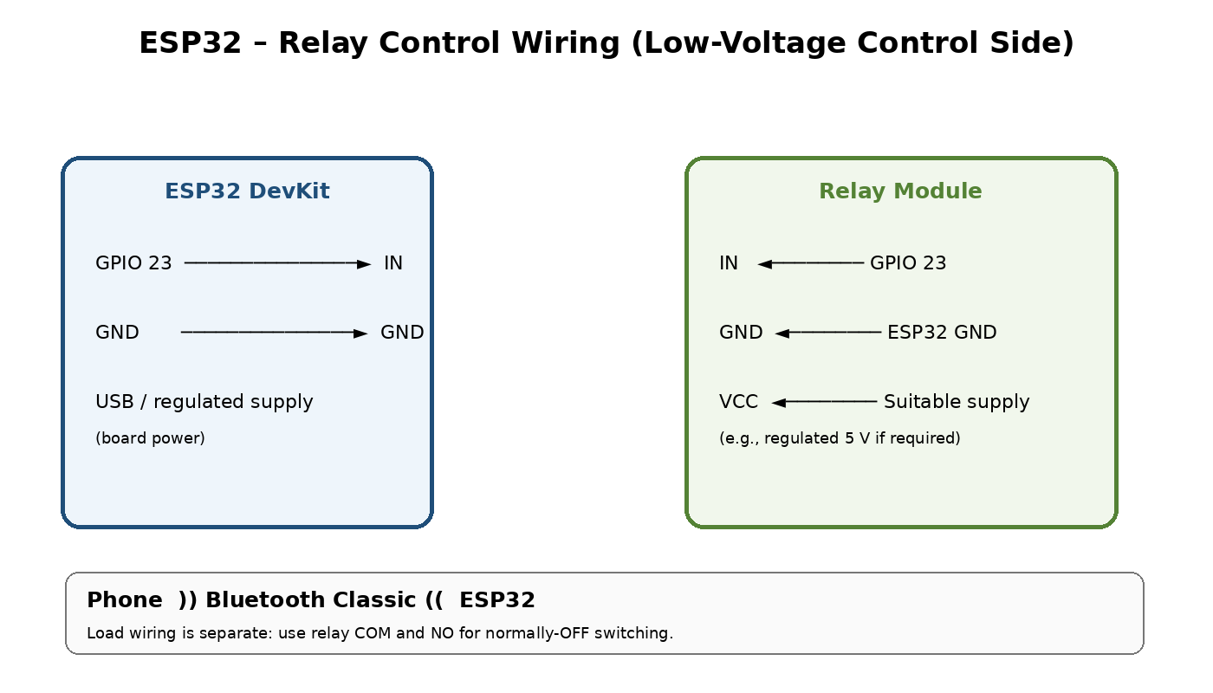

ESP32 / supply | Relay module | Notes
GPIO 23 | IN | Control signal; use only a GPIO that is available on your board.
GND | GND | Common ground is needed for a typical non-isolated logic input.
Regulated supply as specified | VCC | Many relay modules use 5 V. Do not assume the ESP32 3.3 V pin can power a 5 V relay coil.
Relay COM and NO contacts | Lamp supply path | Normally-off switching. Load wiring is separate from ESP32 signal wiring.

The code assumes an active-LOW relay module (LOW = ON, HIGH = OFF). For an active-HIGH module, swap RELAY_ON and RELAY_OFF. Confirm that the relay input is compatible with the ESP32's 3.3 V GPIO.
SAFETY: The diagram covers only the low-voltage control side. Never handle exposed 230 V AC wiring while powered. Use a low-voltage DC lamp for student testing. Household mains installation must be enclosed, correctly rated, and completed by a qualified electrician.

7. SOFTWARE AND PROGRAM CODE
Use Arduino IDE with the ESP32 board package installed. Select the correct ESP32 board and port. BluetoothSerial is included with the ESP32 Arduino core. This code is for classic ESP32 models with Bluetooth Classic support; ESP32-C3 and ESP32-S3 require a BLE or other compatible implementation.
/*
MINOR PROJECT: Bluetooth-Based Home Automation Using ESP32
Submitted by: KATHIRAVAN V
Board: ESP32 DevKit V1 / ESP32-WROOM-32 (Bluetooth Classic supported models)
Relay: One-channel relay module
Relay input: GPIO 23
Commands:
A or 1 = Light ON
B or 0 = Light OFF
S = Report commanded state
NOTE:
This sketch assumes an active-LOW relay input.
For an active-HIGH relay, swap RELAY_ON and RELAY_OFF.
*/
#include "BluetoothSerial.h"
BluetoothSerial SerialBT;
const int RELAY_PIN = 23;
const int RELAY_ON = LOW; // Common active-LOW relay modules
const int RELAY_OFF = HIGH;
bool lightState = false;
void setup() {
Serial.begin(115200);
// Initialize output in the OFF state.
digitalWrite(RELAY_PIN, RELAY_OFF);
pinMode(RELAY_PIN, OUTPUT);
digitalWrite(RELAY_PIN, RELAY_OFF);
if (!SerialBT.begin("ESP32_Home_Automation")) {
Serial.println("Bluetooth failed to start.");
while (true) {
delay(1000);
}
}
Serial.println("Home Automation System Ready");
Serial.println("Pair with ESP32_Home_Automation");
Serial.println("A = Light ON | B = Light OFF | S = Status");
}
void loop() {
if (SerialBT.available()) {
char command = SerialBT.read();
// Ignore common terminal line endings and spaces.
if (command == '\n' || command == '\r' || command == ' ') {
return;
}
// Accept lowercase and uppercase commands.
if (command >= 'a' && command <= 'z') {
command = command - 'a' + 'A';
}
switch (command) {
case 'A':
case '1':
digitalWrite(RELAY_PIN, RELAY_ON);
lightState = true;
SerialBT.println("Light is ON");
Serial.println("Light is ON");
break;
case 'B':
case '0':
digitalWrite(RELAY_PIN, RELAY_OFF);
lightState = false;
SerialBT.println("Light is OFF");
Serial.println("Light is OFF");
break;
case 'S':
SerialBT.println(lightState
? "Light Status: ON"
: "Light Status: OFF");
break;
default:
SerialBT.println("Invalid command. Use A=ON, B=OFF, S=STATUS");
break;
}
}
}

8. SMARTPHONE APP INSTRUCTIONS
- Install a Bluetooth Classic serial terminal application on an Android smartphone.
- Upload the sketch and power the ESP32.
- Pair with ESP32_Home_Automation in the phone's Bluetooth settings. If a PIN is requested, try 1234 or 0000; behavior depends on device and software version.
- Open the terminal app and connect to ESP32_Home_Automation.
- Send A to turn the light ON, B to turn it OFF, or S to request the commanded state.
- Observe the relay indicator and low-voltage lamp, then record the actual results.
Compatibility note: Many iPhone terminal apps do not support generic Bluetooth Classic SPP. For iPhone use, a BLE-based version or another supported method may be needed.

9. TESTING AND RESULTS
This table is a test record template. Complete the Observed Result column only after testing the actual hardware; no experimental results are assumed.
Test | Input / action | Expected result | Observed result
1 | Power ESP32 | Board starts; Bluetooth device is available | To be recorded
2 | Pair and connect phone | Terminal connects to ESP32 | To be recorded
3 | Send A | Relay activates; lamp turns ON | To be recorded
4 | Send B | Relay deactivates; lamp turns OFF | To be recorded
5 | Send S after ON/OFF | Terminal reports commanded state | To be recorded
6 | Send invalid character | Error/help message; no state change | To be recorded

Suggested evidence to attach
- Photograph of ESP32 and relay connections before powering the load.
- Screenshot showing Bluetooth connection and sent commands.
- Photograph of relay indicator and lamp during ON and OFF tests.
- Final circuit photograph with unsafe exposed mains wiring excluded.

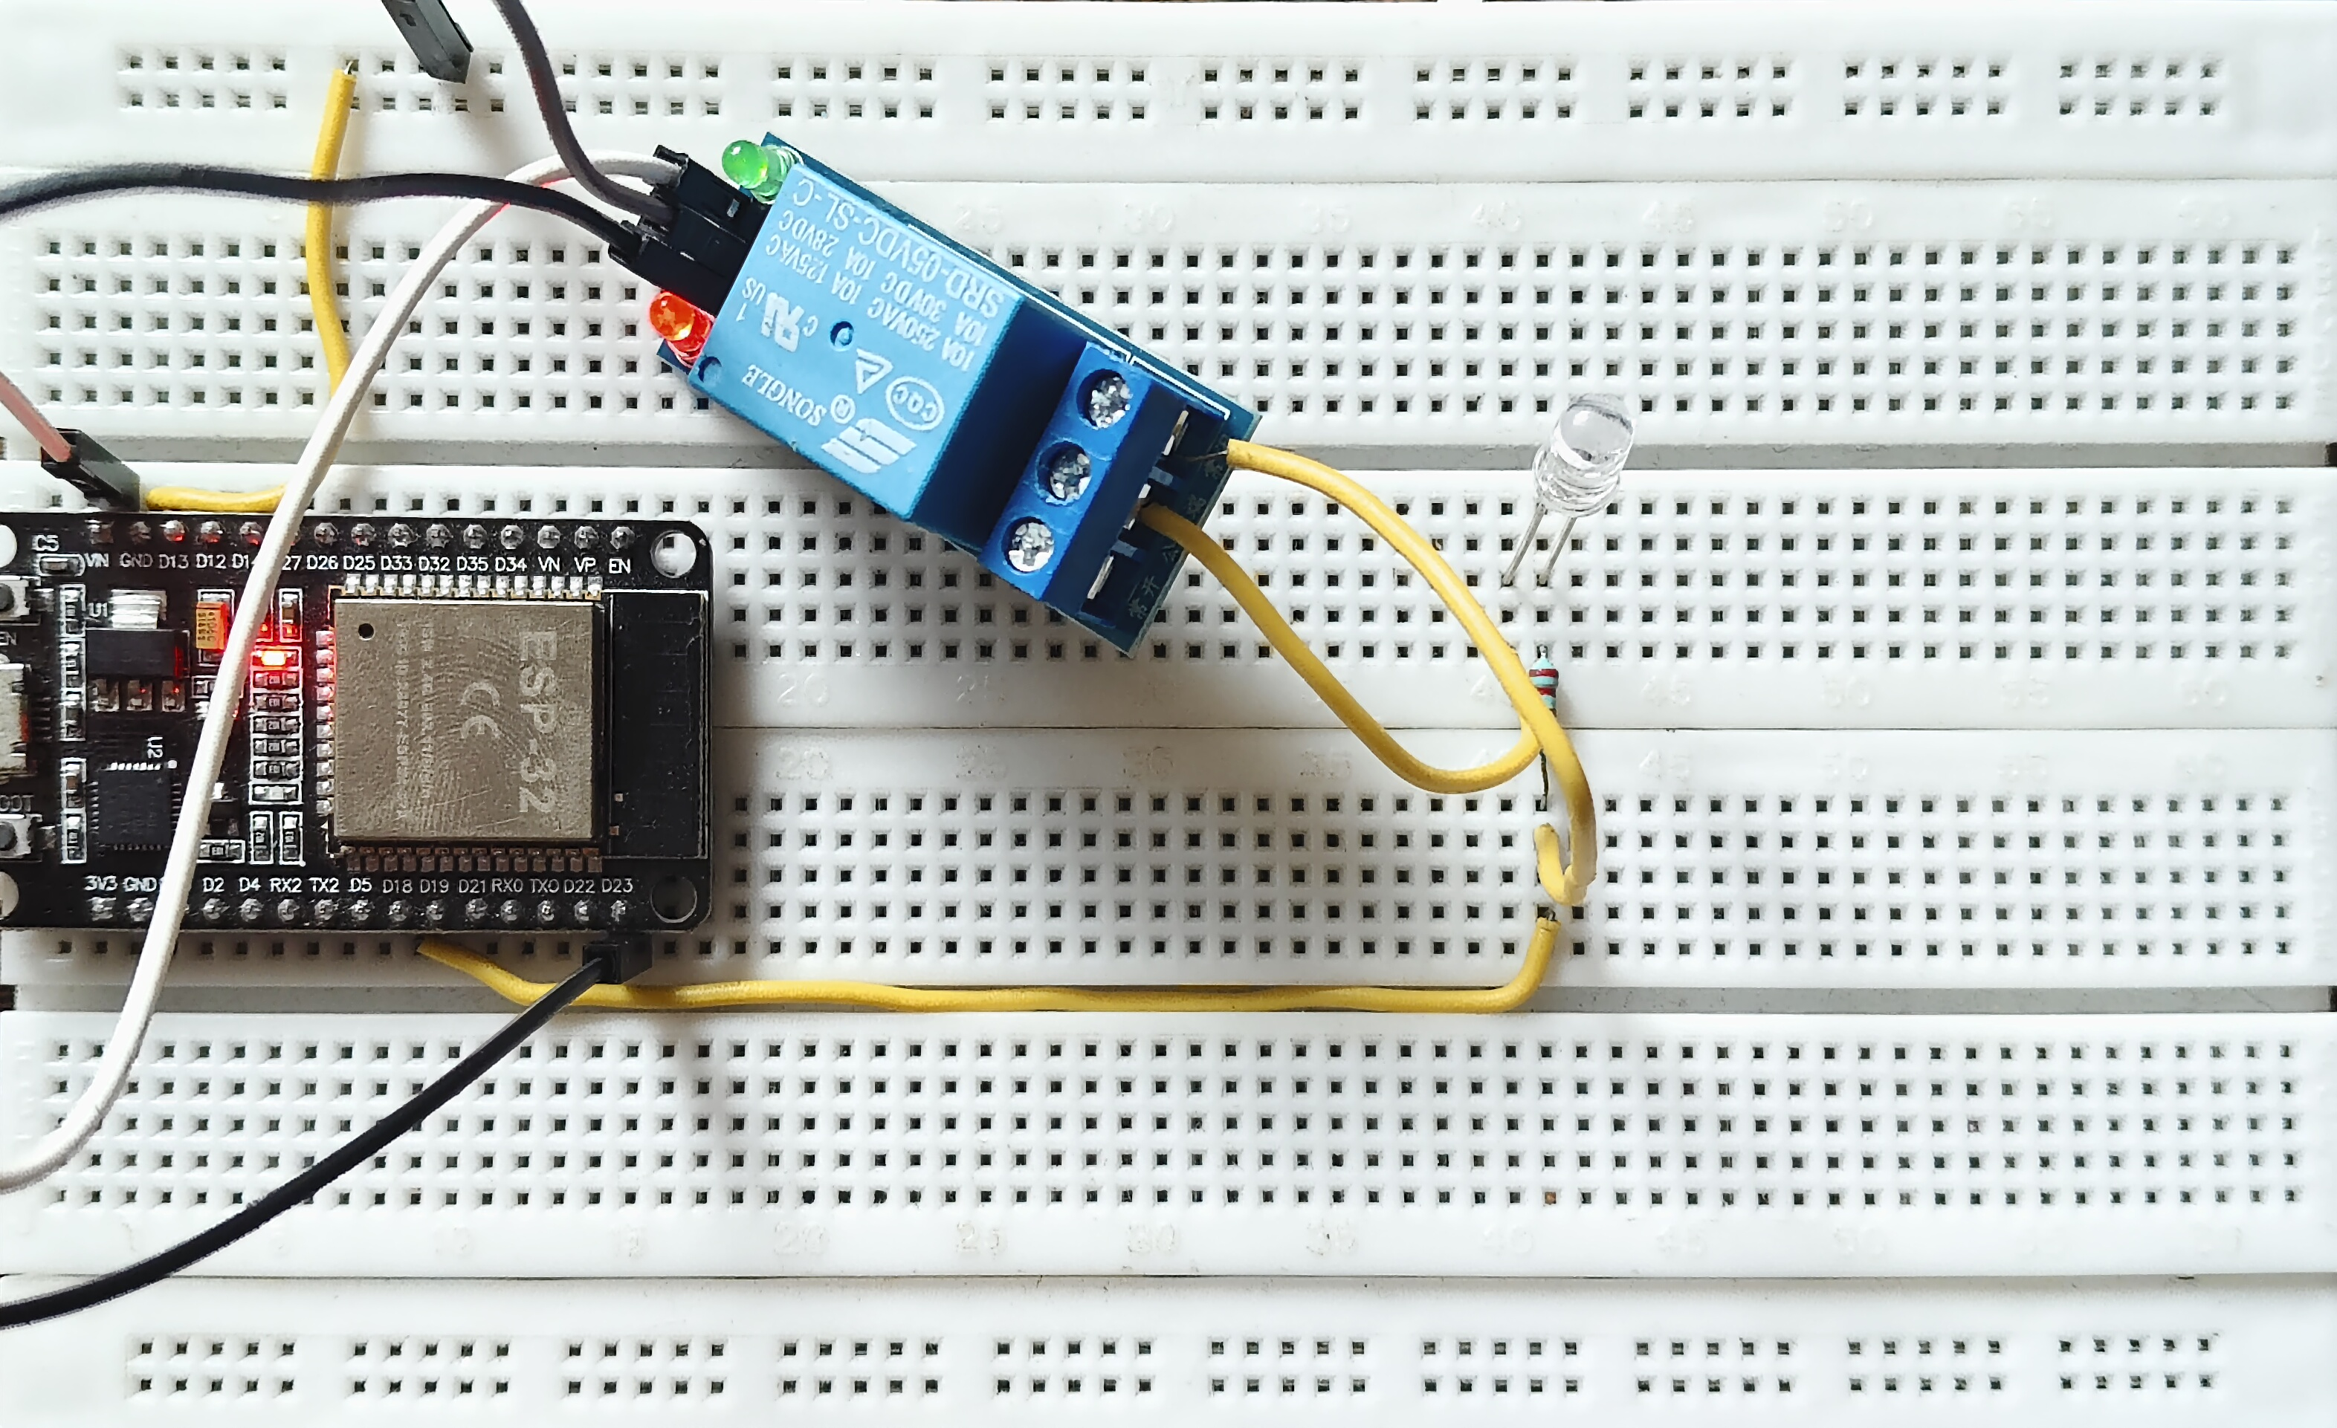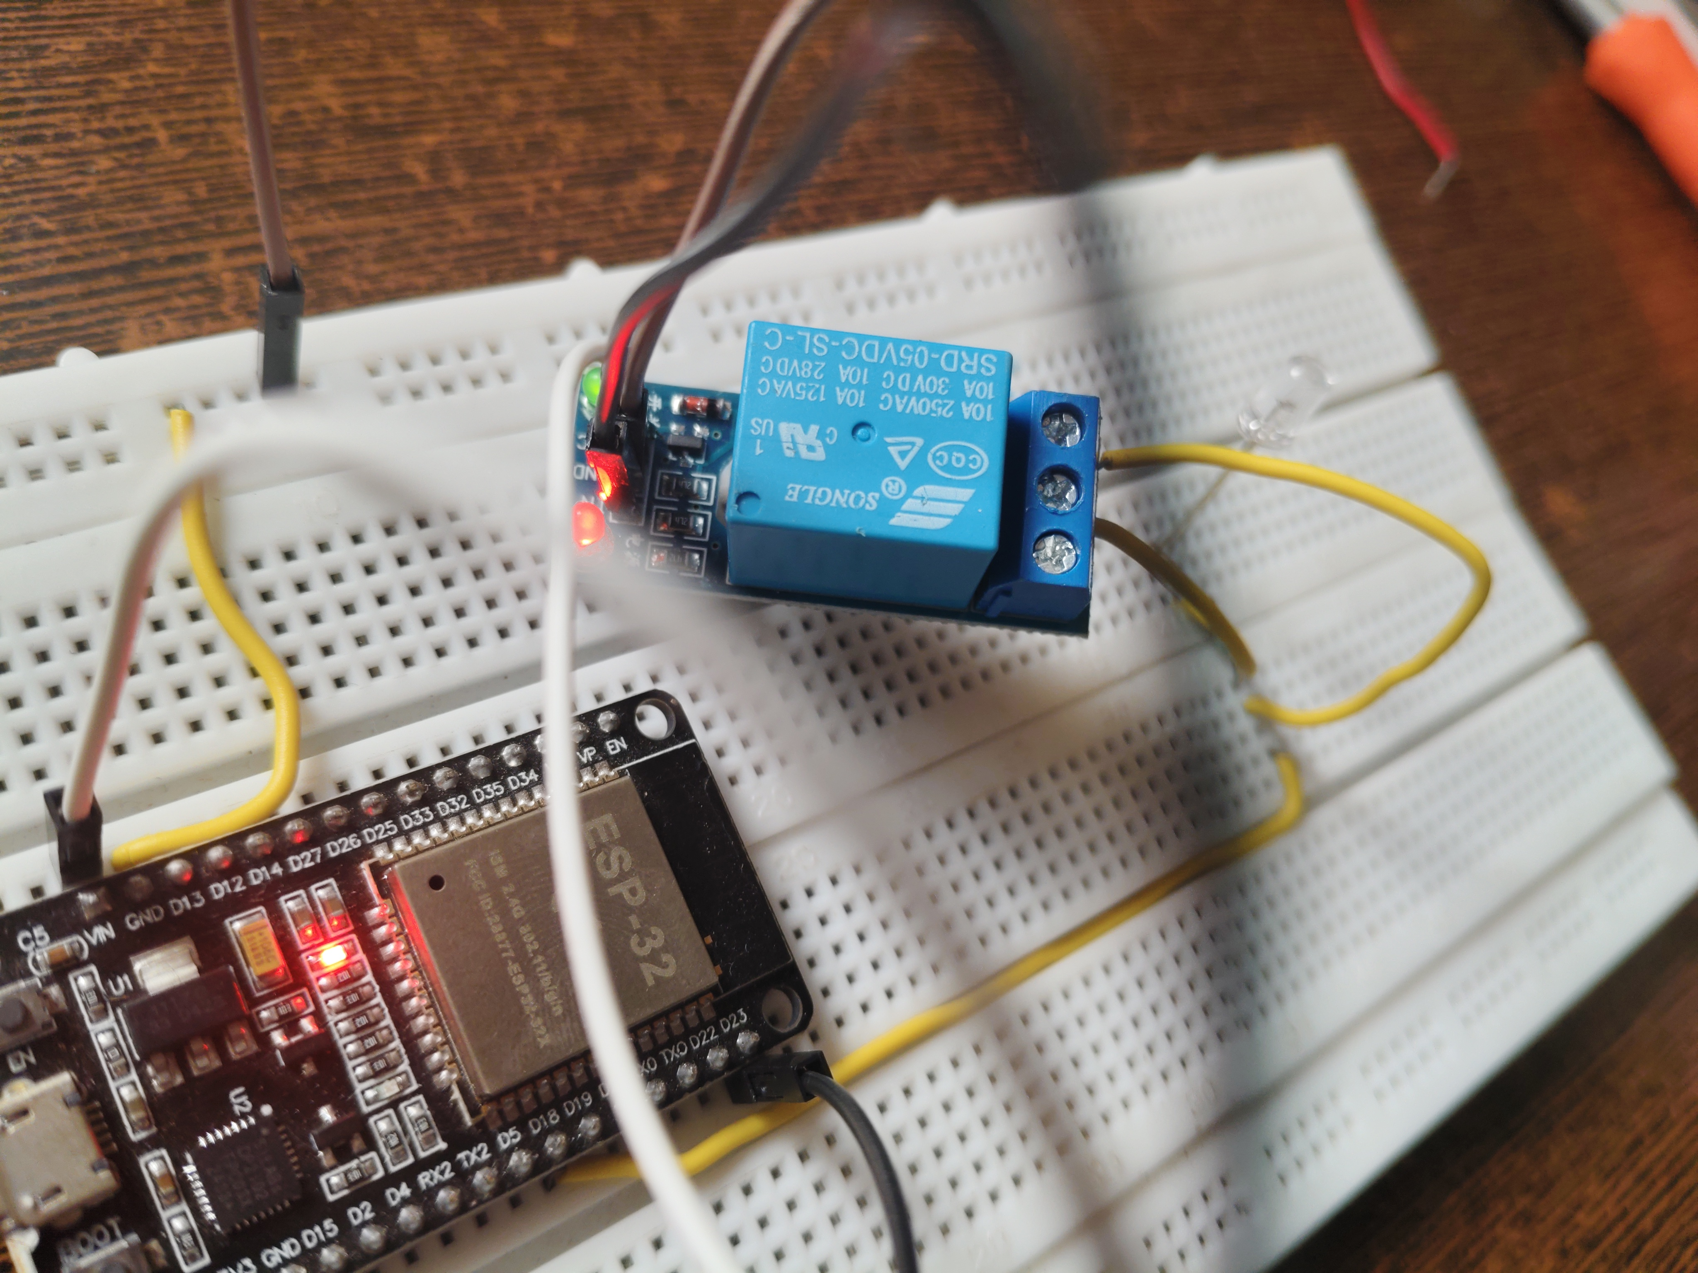
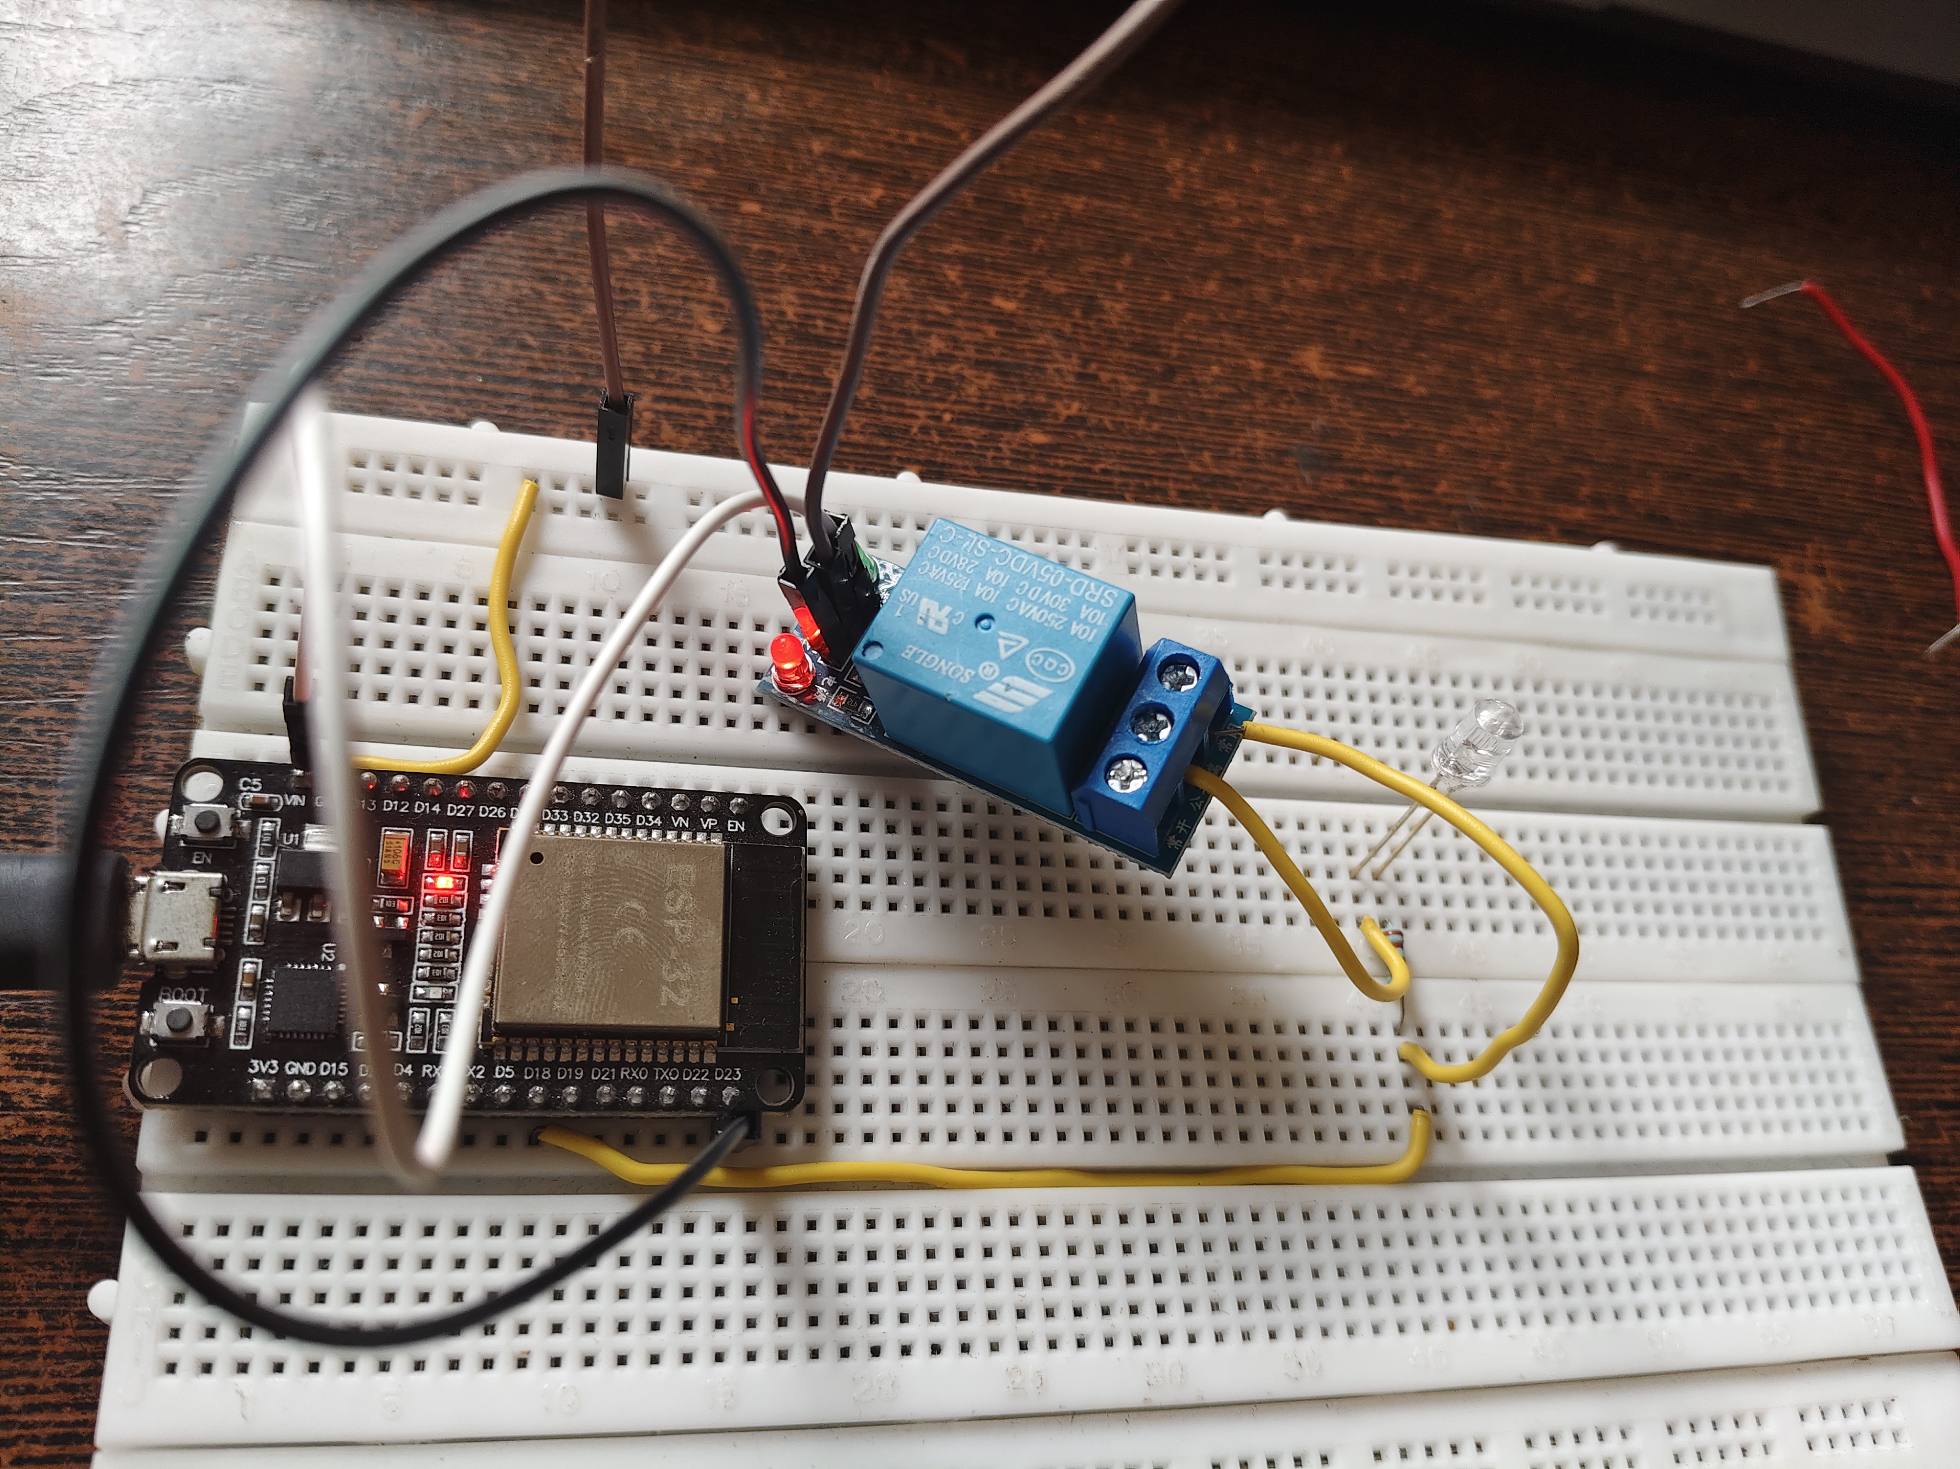

Troubleshooting
- Bluetooth device not visible: verify that the board supports Bluetooth Classic, confirm upload succeeded, and restart the ESP32.
- BluetoothSerial compile error: check the selected board and ESP32 core; the board may be a C3/S3 model without Bluetooth Classic SPP.
- Relay does not switch: verify IN/GND/VCC, relay supply voltage, GPIO selection, trigger polarity, and 3.3 V input compatibility.
- Relay switches but lamp does not: test with a low-voltage lamp and verify COM/NO contacts and load supply.

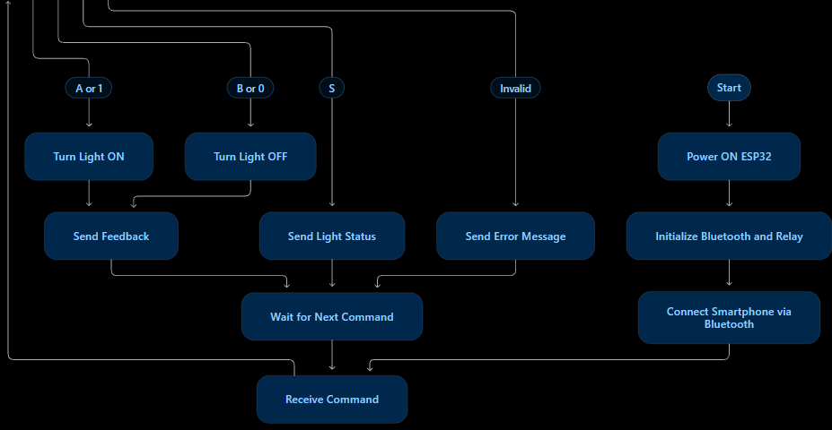

10. ADVANTAGES, LIMITATIONS AND APPLICATIONS
Advantages: low component count, low cost, simple command interface, local wireless operation, and potential expansion to additional relay channels.
Limitations: Bluetooth range is limited; this example controls one relay; operation depends on power and Bluetooth compatibility; status feedback reports the commanded state rather than independently sensing the lamp.
Applications: educational demonstrations, low-voltage lighting prototypes, and simple local appliance-control experiments.

11. SAFETY PRECAUTIONS
- Disconnect power before changing wiring.
- Use a relay module rated for the load and supply it with the correct voltage.
- Do not power a relay coil directly from an ESP32 GPIO pin.
- Keep mains and low-voltage sections physically separated and enclosed.
- Never use a breadboard or exposed jumper wires for household mains.
- Test first with a low-voltage DC lamp; mains wiring must be done by a qualified electrician.
- Do not treat a Bluetooth status message as proof that the physical load is energized or de-energized.

12. CONCLUSION
This report describes a Bluetooth-controlled home automation prototype using an ESP32 and relay module. The ESP32 receives commands from a smartphone and controls a connected light while sending text feedback to the terminal. The implementation demonstrates embedded programming, wireless communication, and switching control. Add actual wiring photographs and observed test results after testing the hardware. The ESP32 implementation replaces the HC-05 named in the initial brief because the available ESP32 hardware can provide Bluetooth directly on supported models.

13. REFERENCES
- Espressif Systems, ESP32 Series Datasheets and Technical Documentation: https://www.espressif.com/
- Espressif Arduino-ESP32 documentation, including Bluetooth Serial examples: https://docs.espressif.com/projects/arduino-esp32/
- Arduino IDE documentation: https://docs.arduino.cc/software/ide/
- Manufacturer datasheet for the exact relay module used.

