MAJOR PROJECT REPORT
SMART ATTENDANCE SYSTEM USING RFID

Submitted by:KATHIRAVAN V
Register Number: 2114251060175
Department: ELECTRONICS AND COMMUNICATION ENGINEERING
Institution: PANIMALAR ENGINEERING COLLEGE
Academic Year: 2025-2029
Year: 2nd year 3rd sem

Hardware platform: ESP32-WROOM-32 | RFID reader: MFRC522 | Display: 16x2 I2C LCD

Abstract
The Smart Attendance System Using RFID is a prototype designed to automate attendance marking using radio-frequency identification. Each registered student is associated with the unique identifier (UID) read from an RFID card. An ESP32-WROOM-32 microcontroller receives the UID from an MFRC522 reader, checks it against a list of registered students, and provides feedback through a 16x2 LCD, LED and buzzer. Recognized cards are marked present in a temporary in-memory log, while unknown cards are rejected and repeat scans are identified. The current prototype prints attendance details to the Arduino Serial Monitor. Persistent storage and reliable date/time stamping are identified as future enhancements.

1. Introduction
Attendance is commonly recorded manually in classrooms and workplaces. Manual processes consume time, can contain recording errors, and make it difficult to review records quickly. RFID provides a convenient way to identify a card without manually entering a student number. This project demonstrates a low-cost embedded attendance prototype using an ESP32 and an RFID reader.

2. Objective
- Design and develop an automated attendance prototype using RFID technology.
- Read a card UID and compare it with registered student records.
- Display the student's name and the attendance status on a 16x2 LCD.
- Provide visual and audible feedback using an LED and buzzer.
- Detect unknown cards and prevent duplicate marking during one power session.
- Provide a base that can later be extended with timestamping and permanent data storage.

3. Problem Statement
Manual attendance systems can be time-consuming and susceptible to human error or misuse. They may not provide immediate feedback or convenient electronic records. The proposed system uses RFID card identification and a microcontroller to automate the basic attendance workflow. The prototype improves convenience, but card UID matching alone does not provide strong security against card cloning or sharing.

4. Scope and Current Implementation
- Microcontroller: ESP32-WROOM-32.
- RFID interface: MFRC522 reader connected over SPI.
- Display: 16x2 LCD with I2C interface.
- Feedback: green LED and buzzer.
- Registered student names and UIDs are stored in the firmware.
- Attendance records are held in RAM and printed to Serial Monitor.
- The current code does not store records permanently and does not obtain a real date/time.

5. Hardware and Software Requirements
Component | Quantity | Purpose
ESP32-WROOM-32 development board | 1 | Main controller
MFRC522 RFID reader module | 1 | Reads RFID card UID; power at 3.3 V
Compatible RFID card/tag | At least 1 | Student identification
16x2 LCD with I2C backpack | 1 | Displays name and attendance status
Green LED | 1 | Visual confirmation
220–330 ohm resistor | 1 | Current limiting for LED
Active buzzer compatible with GPIO | 1 | Audio feedback; use driver if required
Breadboard and jumper wires | As needed | Prototype connections
USB cable / suitable power source | 1 | Power and programming

Software: Arduino IDE, ESP32 board support package, MFRC522 library, LiquidCrystal_I2C library, SPI and Wire libraries.

6. System Architecture
RFID card/tag → MFRC522 reader → ESP32 UID verification → attendance decision → LCD + LED + buzzer feedback → Serial Monitor log.
If a card UID matches a registered student and has not already been marked in the current power session, the ESP32 adds it to the RAM log and displays an attendance confirmation. Unknown cards receive a rejection message. Repeated scans are shown as already marked.

7. Circuit Connections
Use the following pin assignments for the ESP32-WROOM-32 prototype:
Module pin | ESP32 connection
RC522 SDA / SS | GPIO 5
RC522 SCK | GPIO 18
RC522 MOSI | GPIO 23
RC522 MISO | GPIO 19
RC522 RST | GPIO 4
RC522 3.3V and GND | ESP32 3V3 and GND
LCD SDA / SCL | GPIO 21 / GPIO 22
LED anode | GPIO 26 through 220–330 Ω resistor
LED cathode | GND
Buzzer signal / negative | GPIO 25 / GND (driver may be needed)
All module grounds | Common GND
Electrical precautions: power the MFRC522 from 3.3 V only. Connect all grounds together. If the LCD I2C backpack pulls SDA/SCL up to 5 V, use a bidirectional logic-level shifter to protect ESP32 GPIOs. A buzzer that draws more current than a GPIO can safely supply requires a transistor driver and suitable protection components.

8. Software Algorithm
- Initialize Serial Monitor, LCD, SPI bus, RFID reader, LED and buzzer.
- Display the standby message: “RFID Attendance / Scan Your Card”.
- Wait for a card and read its UID.
- Convert the UID to uppercase, space-separated hexadecimal bytes.
- Search the registered student list for the UID.
- If no match is found, display “Invalid Card / Not Registered” and sound the buzzer.
- If the UID was already recorded in the current power session, display “Already Marked”.
- Otherwise, append the UID to the temporary attendance log, display the student name and “Attendance OK”, turn on the LED briefly, and print the result to Serial Monitor.
- Return to standby and wait for the next card.

9. Implementation and Code
The following Arduino sketch is the prototype version used for this report. The first registered UID is A1 BA 9A 0A, which was observed in the Serial Monitor during card scanning. The example name assigned to that UID is Arun. Other student UIDs are placeholders and must be replaced with the actual UIDs of the cards used in a demonstration.
#include <SPI.h>
#include <MFRC522.h>
#include <Wire.h>
#include <LiquidCrystal_I2C.h>

// Pin connections for ESP32-WROOM-32
#define SS_PIN 5
#define RST_PIN 4
#define LED_PIN 26
#define BUZZER_PIN 25

MFRC522 rfid(SS_PIN, RST_PIN);
LiquidCrystal_I2C lcd(0x27, 16, 2);

// Registered example students.
// The first UID is the user's scanned card UID.
struct Student {
const char* uid;
const char* name;
};

Student students[] = {
{"A1 BA 9A 0A", "Arun"},
{"12 34 56 78", "Priya"},
{"A1 B2 C3 D4", "Rahul"},
{"11 22 33 44", "Kavya"}
};

const int STUDENT_COUNT =
sizeof(students) / sizeof(students[0]);

// Attendance records are stored in RAM for this power session only.
String markedUIDs[100];
int markedCount = 0;

// Read the card UID and format it as uppercase, space-separated bytes.
String readUID() {
String uid = "";

for (byte i = 0; i < rfid.uid.size; i++) {
if (rfid.uid.uidByte[i] < 0x10) {
uid += "0";
}

uid += String(rfid.uid.uidByte[i], HEX);

if (i < rfid.uid.size - 1) {
uid += " ";
}
}

uid.toUpperCase();
return uid;
}

// Return the registered student's array index, or -1 if not found.
int findStudent(String uid) {
for (int i = 0; i < STUDENT_COUNT; i++) {
if (uid == students[i].uid) {
return i;
}
}

return -1;
}

// Check whether this UID has already been marked during this power session.
bool alreadyMarked(String uid) {
for (int i = 0; i < markedCount; i++) {
if (markedUIDs[i] == uid) {
return true;
}
}

return false;
}

// Display two messages on the 16x2 LCD.
void showLCD(String first, String second) {
lcd.clear();
lcd.setCursor(0, 0);
lcd.print(first.substring(0, 16));
lcd.setCursor(0, 1);
lcd.print(second.substring(0, 16));
}

// Activate a simple active buzzer.
void beep(int durationMs) {
digitalWrite(BUZZER_PIN, HIGH);
delay(durationMs);
digitalWrite(BUZZER_PIN, LOW);
}

void setup() {
Serial.begin(115200);

pinMode(LED_PIN, OUTPUT);
pinMode(BUZZER_PIN, OUTPUT);
digitalWrite(LED_PIN, LOW);
digitalWrite(BUZZER_PIN, LOW);

// Initialize I2C LCD on ESP32 SDA=21, SCL=22.
Wire.begin(21, 22);
lcd.init();
lcd.backlight();

// Initialize SPI and RC522 RFID reader.
SPI.begin(18, 19, 23, SS_PIN);
rfid.PCD_Init();

showLCD("RFID Attendance", "Scan Your Card");

Serial.println();
Serial.println("=== SMART ATTENDANCE ===");
Serial.println("Scan a registered RFID card.");
}

void loop() {
// Wait until a card is presented and its serial data can be read.
if (!rfid.PICC_IsNewCardPresent()) {
return;
}

if (!rfid.PICC_ReadCardSerial()) {
return;
}

String uid = readUID();
Serial.println();
Serial.println("Card UID: " + uid);

int index = findStudent(uid);

if (index == -1) {
// Unknown card: reject it and give an error indication.
showLCD("Invalid Card", "Not Registered");
Serial.println("STATUS: NOT REGISTERED");
beep(500);
}
else if (alreadyMarked(uid)) {
// Do not count the same card twice during this power session.
showLCD("Already Marked", students[index].name);
Serial.println("STATUS: DUPLICATE");
beep(100);
}
else if (markedCount >= 100) {
// Avoid writing beyond the fixed-size RAM log.
showLCD("Attendance Full", "Restart Device");
Serial.println("STATUS: LOG FULL");
beep(500);
}
else {
// Mark the registered student present in the RAM log.
markedUIDs[markedCount++] = uid;

digitalWrite(LED_PIN, HIGH);
beep(150);

showLCD(students[index].name, "Attendance OK");

Serial.println("NAME: " + String(students[index].name));
Serial.println("STATUS: PRESENT");
Serial.println("TOTAL PRESENT: " + String(markedCount));

delay(1800);
digitalWrite(LED_PIN, LOW);
}

delay(1200);
showLCD("RFID Attendance", "Scan Your Card");

// Finish communication with the card before the next scan.
rfid.PICC_HaltA();
rfid.PCD_StopCrypto1();
delay(300);
}

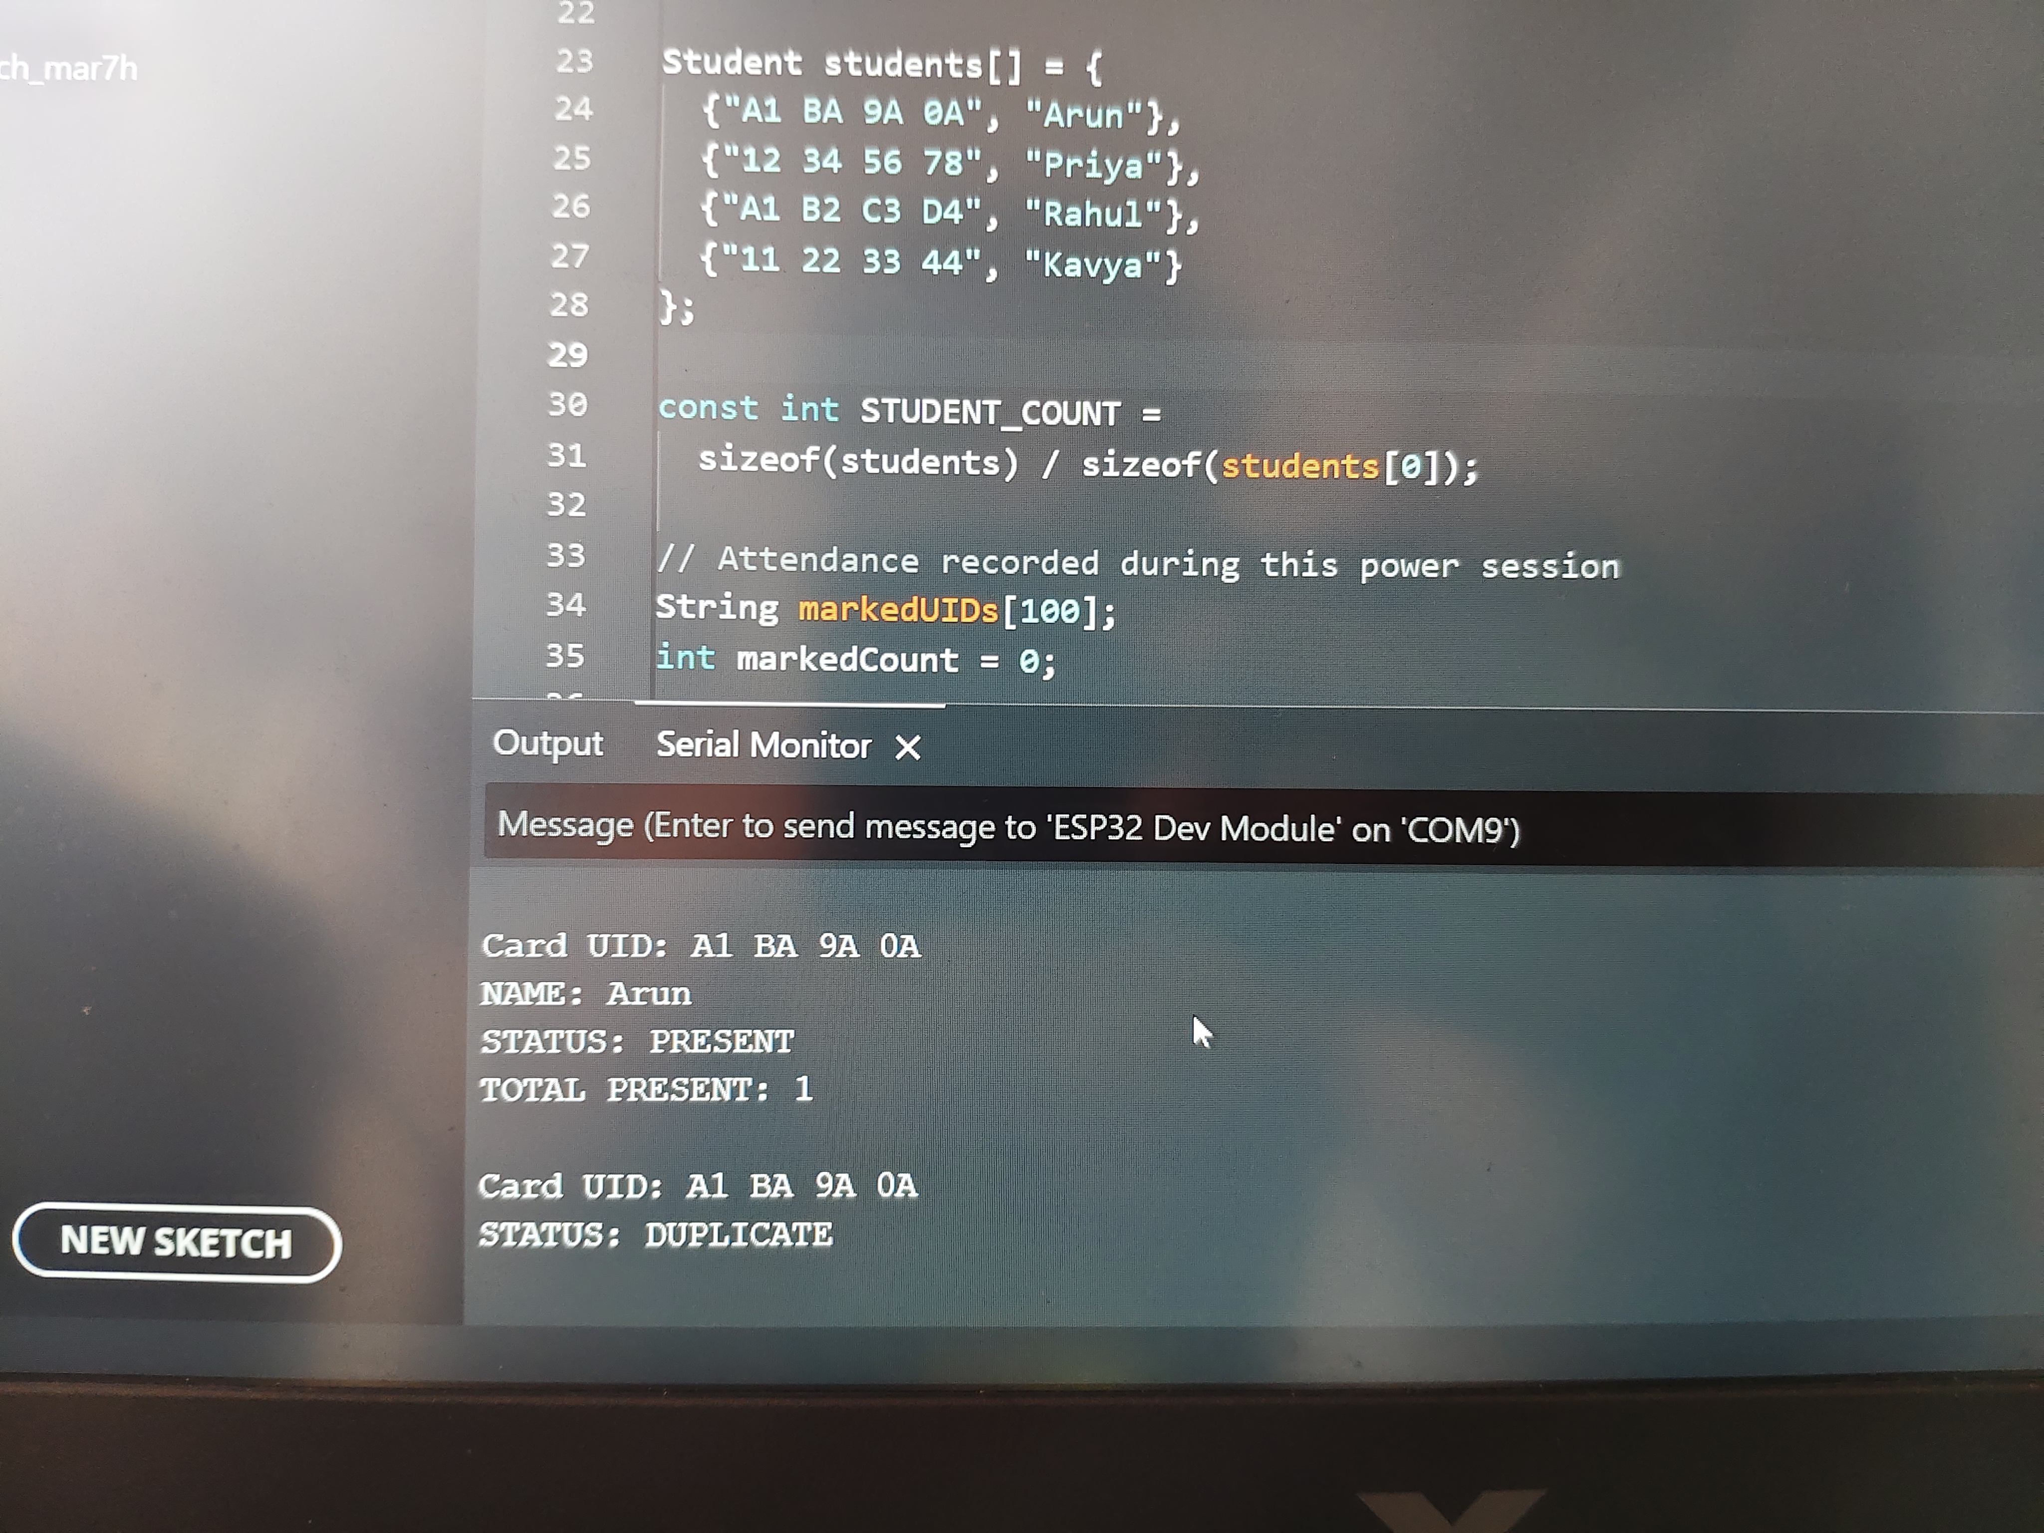

10. Testing and Results
Test | Observation / method | Result
Firmware upload | Upload log showed “Hash of data verified” and ESP32 reset message. | Upload completed successfully.
RFID UID reading | Serial Monitor repeatedly showed UID: A1 BA 9A 0A. | Reader detected the card and read its UID.
Initial registration check | The card initially returned “STATUS: NOT REGISTERED”. | Expected because its UID was not in the sample list.
UID registration update | The UID was added to the student list as Arun. | Code updated; final successful attendance confirmation should be verified on the physical prototype.
LCD, LED and buzzer | Firmware is programmed to provide these responses. | Verify each output during the final live demonstration.
Duplicate scan prevention | Implemented in RAM for the current power session. | Test by scanning a registered card twice without restarting.

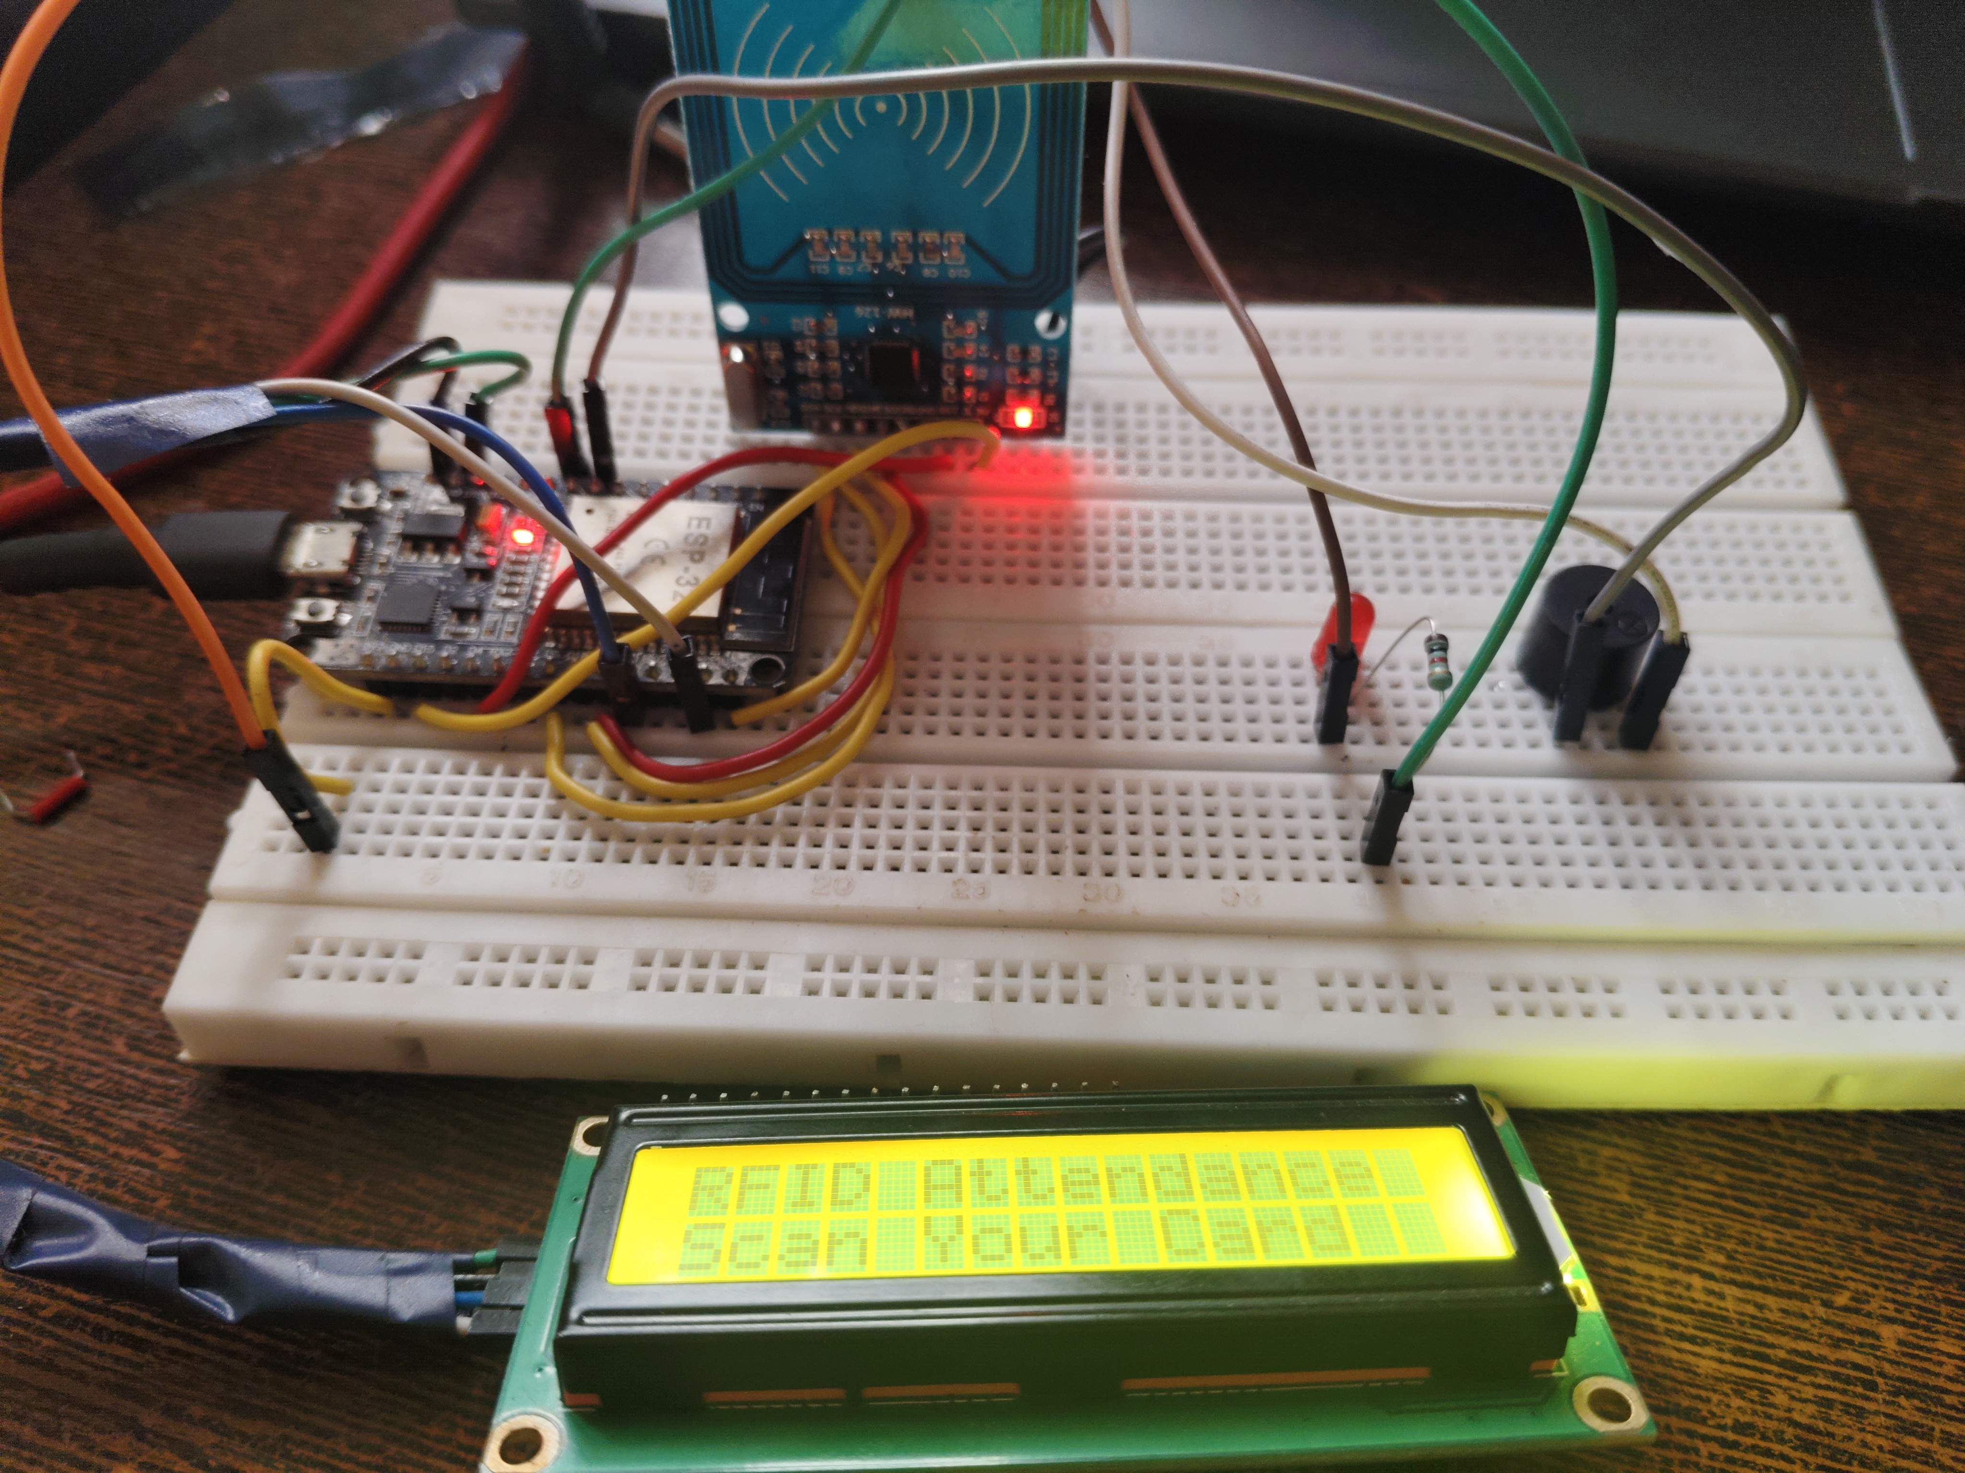

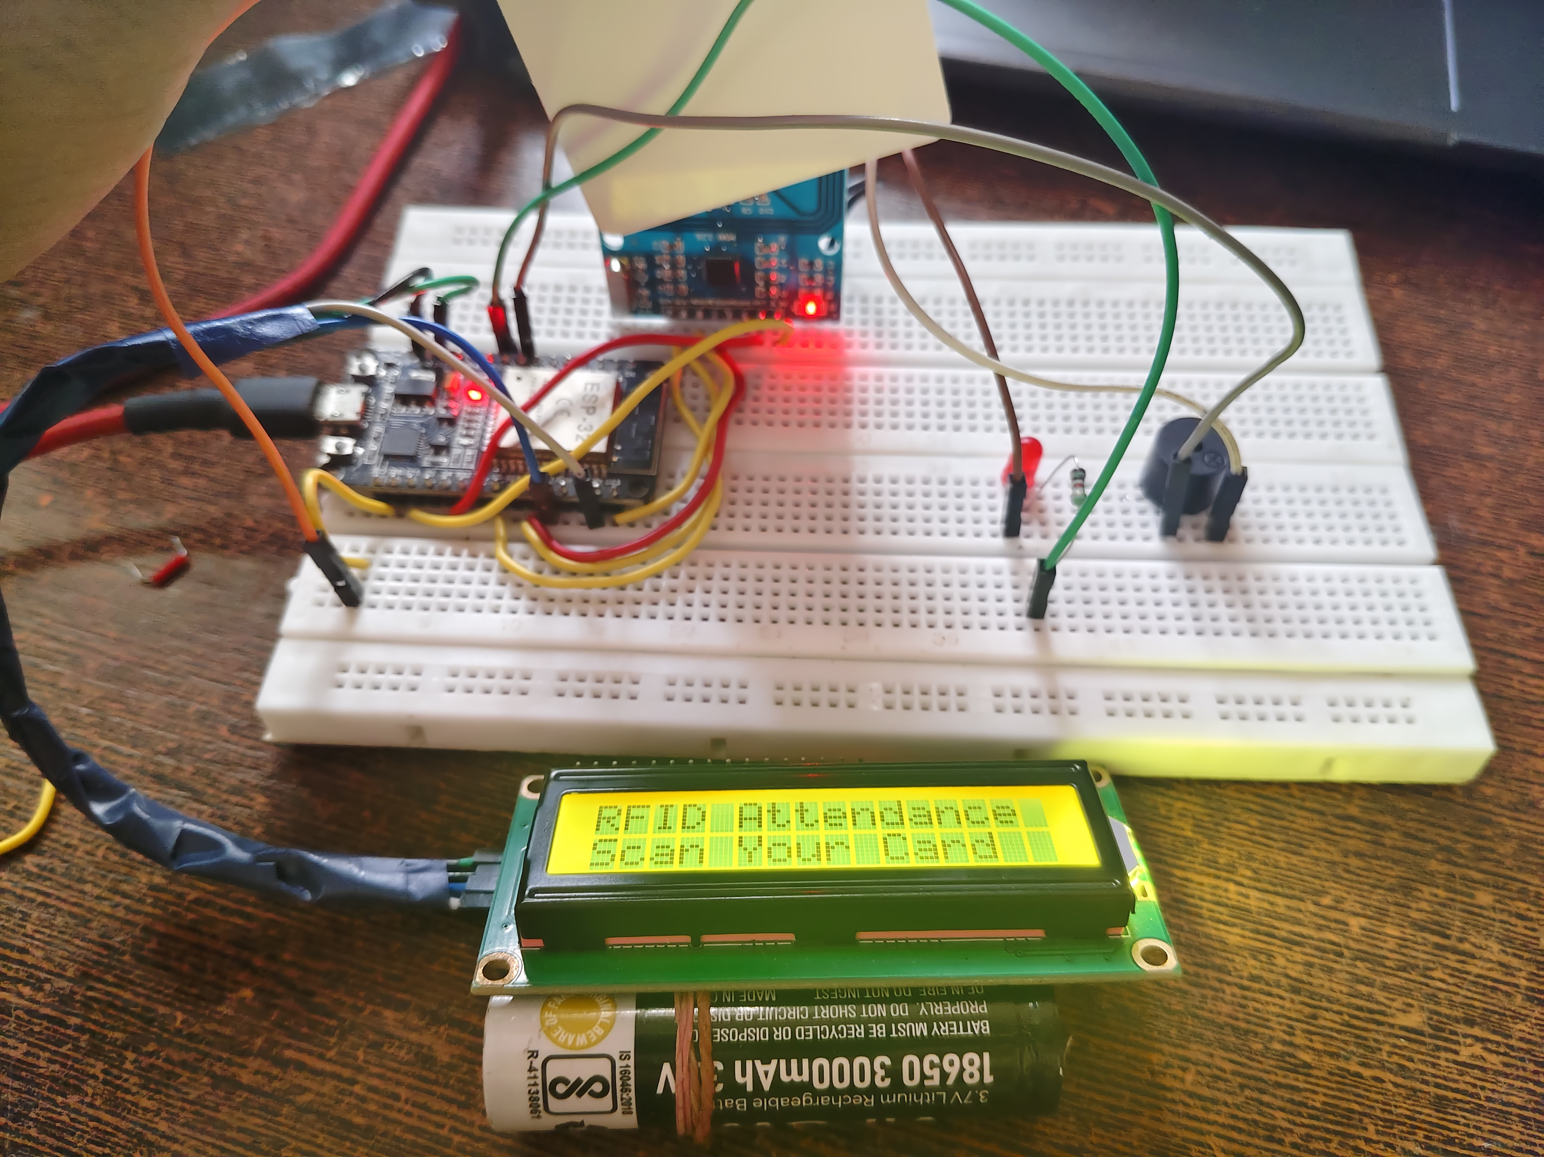

11. Limitations
- Attendance is stored only in RAM; all records are lost when power is removed or the ESP32 restarts.
- The current sketch does not capture real date/time.
- Student UIDs are hard-coded and must be maintained in the firmware.
- UID-only identification is not strong authentication and may be vulnerable to cloned cards.
- The fixed RAM log supports at most 100 unique entries per power session.
- The LCD I2C address may need to be changed from 0x27 to 0x3F if the actual module uses a different address.

12. Future Enhancements
- Add a DS3231 RTC or Wi-Fi/NTP time synchronization to record date and time.
- Add an SD card module to save attendance in CSV format across power cycles.
- Use Wi-Fi to upload records to a database or a secure institutional dashboard.
- Add an administrative interface for enrolling and removing students.
- Use stronger authentication and access controls to reduce card-sharing and cloning risks.
- Add daily reports, attendance percentage calculations and CSV export.

13. Conclusion
The Smart Attendance System Using RFID demonstrates the core process of identifying a registered RFID card with an ESP32, providing immediate LCD and buzzer/LED feedback, and recording attendance during a power session. The observed card UID A1 BA 9A 0A was read successfully by the reader; it initially appeared as unregistered until it was added to the firmware's student list. The final prototype should be demonstrated by confirming the “Attendance OK” LCD message and duplicate-scan behaviour. Adding a real-time clock and persistent storage would make the system more suitable for day-to-day institutional use.

References

- Espressif Systems, ESP32 Series Datasheet and Arduino-ESP32 documentation.
- NXP Semiconductors, MFRC522 contactless reader IC documentation.
- MFRC522 Arduino library documentation and examples.
- LiquidCrystal_I2C Arduino library documentation.

Appendix A: Evidence to Attach Before Submission
- Photograph of the assembled ESP32, RC522, LCD, LED and buzzer prototype.
- Screenshot of Arduino IDE showing successful compilation/upload.
- Serial Monitor screenshot showing the card UID A1 BA 9A 0A.
- Photograph of LCD showing the registered student name and “Attendance OK”.
- Photograph or screenshot demonstrating “Already Marked” on a repeat scan.
Submission note: replace the cover-page blanks with the actual student, register number, department, institution and academic year. Do not claim that date/time storage, SD-card logging or database logging is complete unless those features are implemented and tested.

