

**WEB TECHNOLOGY**

**Lab-DA-1**

**NAME:KATHIRAVAN.N**

**REG.NO:19MIS0097**

**Design the following greeting page.**

a.Clicking the image in the first page which redirect to second page.

b.Use hover property to change the border style of the image in the first page.

c.Move the greeting card contents from top to bottom.

d.Set the animation to your greeting content.

e.Use any flower image.

**HTML CODE:**

<html>

<head>

<title>Kathiravan</title>

</head>

<body style="background-color:blue;">

<h1><font color="red">Greatings</h1>

<img src="Screenshot 2022-02-09 083823.png" width="200" height="200" border="2"/><br></br>

</body>

</html>

**INPUT:** 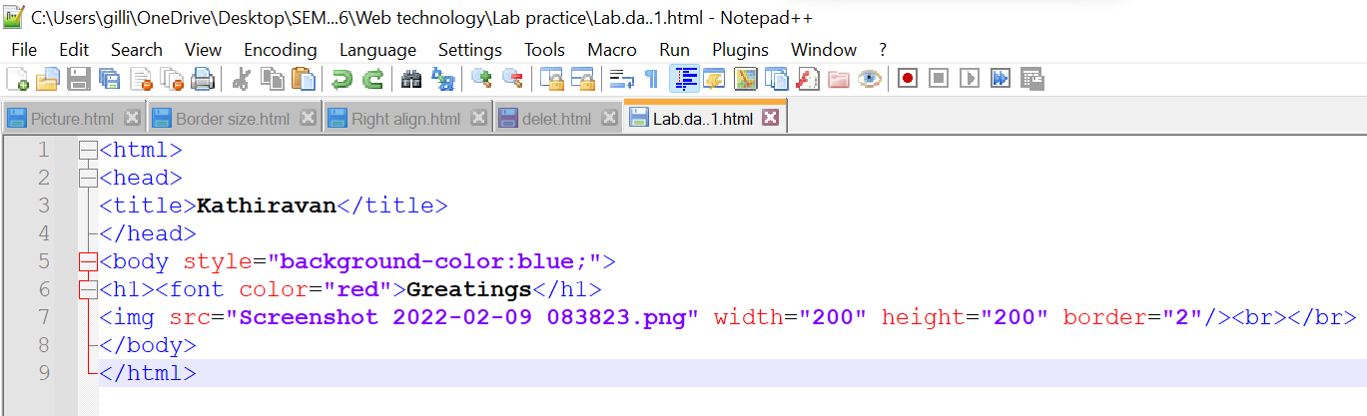

**OUTPUT:**

