I'm working on a trading strategy, i need minute level historical data for NSE, from where can i get it atleast for last 5 years,
Here's a comprehensive breakdown of your options for NSE minute-level historical data (5+ years):

🥇 Best Options for NSE 1-Min Historical Data

1. Zerodha Kite Connect API (Most Popular for Indian Algo Traders)
Zerodha's Kite Connect API now includes up to 10 years of intraday historical data for NSE/BSE, and as of early 2025, the historical data add-on has been bundled in — no separate charge. Data is available as OHLCV candles across intervals: 1, 3, 5, 10, 15, 30, and 60 minutes.
- Cost: ~₹500/month for the API (order + data)
- Access: Python/REST API via kiteconnect library
- Best for: Active traders already on Zerodha

2. Upstox / Angel One / Dhan / Fyers APIs (Free or Cheap Alternatives)
Broker APIs from Zerodha, Upstox, Dhan, and Angel One are recommended as the go-to stack for live + historical minute data for Indian retail algo traders. Most of these offer free developer APIs if you have a trading account with them. Fyers and Angel One (SmartAPI) are notably generous with historical data depth.
- Cost: Free with a trading account (some have rate limits)
- Check: fyers.in/api, smartapi.angelbroking.com, dhanhq.co/api

3. TrueData (Dedicated Data Vendor)
A well-known Indian data vendor offering clean, adjusted minute-level data going back many years across NSE equities, F&O, and indices.
- Cost: Starts ~₹500–1500/month depending on plan
- Access: REST API + CSV export
- Website: truedata.in

4. Tick Data (tickdata.com) (Institutional Grade)
Tick Data provides historical intraday data for all NSE-listed equities since January 2, 2012, including tick-by-tick trades and pre-built one-minute OHLCV bars. This is institutional quality but expensive (hundreds of dollars).

5. Kaggle Dataset (Free, Limited Scope)
There's a publicly available Kaggle dataset with Nifty 50 index data at 1, 3, 5, 15-min, and hourly intervals from January 2015 to mid-2024. Good for index-level backtesting, not for individual stocks.

6. NSE Official Data Feed (Direct, Expensive)
NSE provides snapshot data at 1, 2, or 5-minute intervals via SFTP in binary format, and also offers a 15-minute delayed snapshot feed over the internet. This is meant for institutions and requires a subscription agreement directly with NSE.

📝 Practical Recommendation
Need | Go With
Budget-friendly + good depth | Zerodha Kite Connect (₹500/month)
Completely free | Angel One SmartAPI or Fyers API (free with demat account)
Clean, vendor-managed data | TrueData
Index backtesting only | Kaggle dataset (free)
Institutional/enterprise | Tick Data
If you're in Chennai and already have a broker account, the fastest path is to open an API subscription with your broker (Zerodha, Fyers, or Angel One) and pull the data programmatically via Python. Want help writing the data-fetching script?

I’ve kite and Dhan accounts for trading, If required I can subscribe for the API’s
Perfect, ambitious setup! Let me give you a complete guide for using both Kite and Dhan together.Here's a complete data pipeline architecture for your setup — covering what to pull from each broker, how to store it, and how to use it for backtesting and live trading.Here's how to approach each layer:

Data fetching — use Kite as primary, Dhan as backup
Kite gives you up to 10 years of 1-min OHLCV for equities, F&O, and indices. The key constraint: it returns max 60 days per API call at 1-min interval, so you'll need to loop in chunks. Dhan is useful as a cross-check or fallback since it's entirely free with your account.
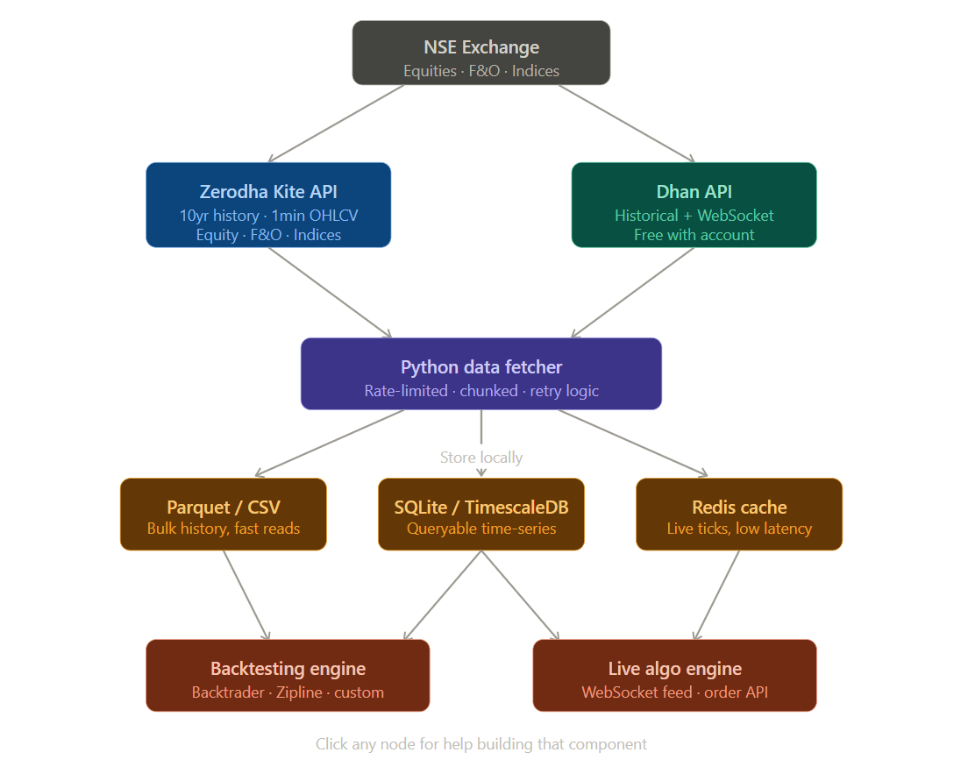
Rate limits to keep in mind:
- Kite: ~3 requests/second, so fetching 5 years for 50 stocks will take a few hours — run it overnight
- Always add retry logic with exponential backoff
Storage — pick based on your use case
For bulk historical data, Parquet files (via pandas/pyarrow) are the best balance of speed and size — a 5-year, 1-min dataset for ~50 NSE stocks typically comes to 2–5 GB compressed. For backtesting queries, SQLite works well for small universes; TimescaleDB (Postgres extension) is better if you're working with 100+ symbols. Redis is only needed if you're building a live system that needs sub-second tick access.
Key things to handle in your fetcher:
- Corporate action adjustments (splits, bonuses) — Kite's continuous=True flag handles this
- Exchange holidays — skip them in your date loop
- Pre/post-market timestamps — filter to 9:15–15:30 IST
- F&O expiry rollovers — store raw contracts, not continuous series, then build the continuous series separately
Want me to write the actual Python script for bulk-downloading the data using Kite Connect?

