Data Analytics – Final Project
Analysis of Daily Coal Stock Monitoring in Indian Power Plants


Project Title:
"Analysis of Daily Coal Stock Monitoring in Indian Power Plants" Dataset Links:
- Source: India Data Portal: India Data Portal - Ministry of Power.
- Raw Dataset Link - Daily Coal Stock
- Cleaned Dataset Link : Cleaned Dataset
- Google Colab Link :Daily Coal Stock Analysis
- Power BI Dashboard PDF Link: Daily Coal Stock Power BI
- Power Point Presentation Link: Power Point
- GitHub Link: GitHub
Stage 4: Documentation, Insights and Presentation:

  - ​Power BI Dashboard:
    - PDF Link: Daily Coal Stock Power BI
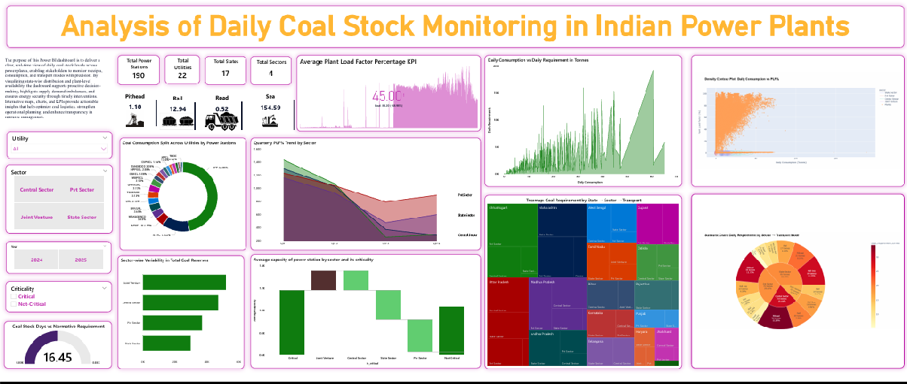
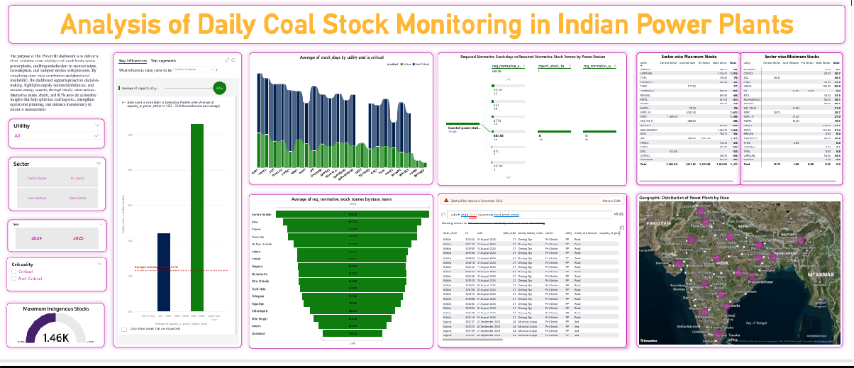

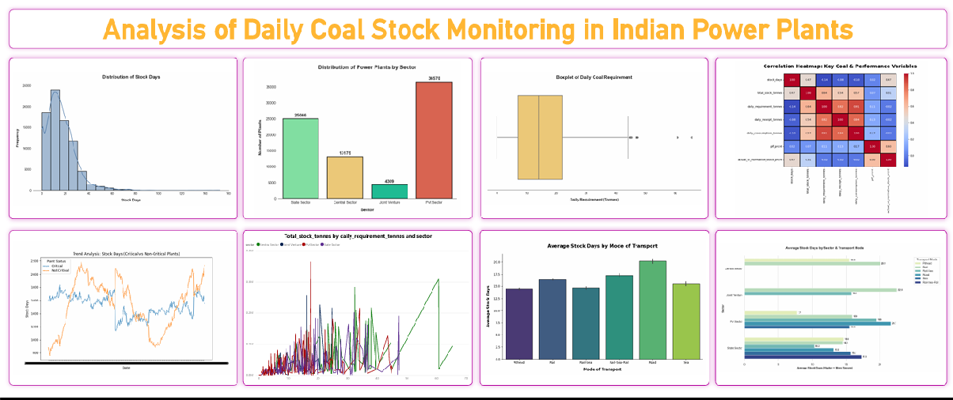

​Findings (Summary):

    - Critical vs Non-Critical Plants: Critical plants consistently show fewer stock days, making them vulnerable to outages.
    - Transport Dependency: Rail transport sustains longer stock days compared to road, highlighting logistics bottlenecks.
    - Efficiency Link: Plants with lower stock days often show reduced PLF%, meaning coal shortages directly affect generation efficiency.
    - Regional Variations: Certain states (e.g., with higher private sector share) show more frequent shortages.
    - Correlation Patterns: Strong positive correlation between receipts and total stock; weak correlation between PLF% and normative stock.

​Key Insights:

    - Stock Days Trend: Non-critical plants maintain healthier reserves, while critical plants hover dangerously close to outages.
    - Transport Bottleneck: Dependence on rail transport is evident; plants relying on road transport face shorter stock days.
    - Efficiency Drop: PLF% declines sharply when stock days fall below normative levels.
    - Sectorial Risk: Private sector plants show higher volatility in stock availability compared to central utilities.
    - Regional Clusters: Some states consistently underperform in maintaining normative stock levels.

​Business Recommendations:

- Strengthen Transport Logistics
  - Reduce reliance on road transport by investing in rail and port infrastructure.
  - Create contingency plans for plants heavily dependent on vulnerable transport modes.

Prioritize Critical Plants
  - Allocate coal preferentially to plants flagged as “critical” with consistently low stock days.
  - Implement early warning systems to monitor stock adequacy and trigger emergency supply.

Enhance Stock Management Practices
  - Encourage utilities to maintain normative stock levels through stricter compliance monitoring.
  - Introduce incentives for plants that consistently meet or exceed stock adequacy benchmarks.

Link Efficiency with Supply Planning
  - Use PLF% vs stock analysis to schedule preventive maintenance during shortage periods.
  - Align coal supply with demand forecasts to avoid efficiency drops.

Regional & Sectoral Strategy
  - Focus policy support on states and private utilities showing repeated shortages.
  - Encourage diversification of coal sources (indigenous vs imported) to reduce risk.

Adopt Real-Time Dashboards
  - Institutionalize Power BI dashboards for continuous monitoring by policymakers and plant managers.
  - Enable drill-down views from national → state → plant level for actionable decision-making.

​Final Story with the Dashboard :
Dashboard tells a clear narrative:

    - Macro View: National coal resilience trends (stock days, criticality).
    - Micro View: Plant-level vulnerabilities ( boxplots).
    - Multivariate View: Systemic dependencies (correlation heat map, pair plot).
    - Hierarchical View: Sector → Transport → Requirement breakdown (sunburst, tree map).
    - Various Power Bi Visuals: Card Visuals, KPIs, Slicers, Bar Plot, Area Chart etc.,

Together, these visuals show how coal logistics, sectorial differences, and stock management directly impact energy reliability. The story ends with actionable recommendations for policy makers, utilities, and transport planners.

