**GOVERNMENT COLLEGE OF ENGINEERING ERODE**



B.E Electronics and Communication Engineering

PRODUCT SALES ANALYSIS

**Name of the Student: University Register no:**

KATHIRIPERUMAL .S 731121106024

Under the mentor of

**Dr.M.Poongothai**

**Department of Information Technology(IT)**

**Department of Electronics and Communication Engineering**

Government College of Engineering

Erode ,PO ,near Vasavi College,TamilNadu-638316,

Affiliated to Anna University ,Chennai.

**IBM COGNOS ANALYTICS :**

IBM Cognos Analytics is a business intelligence and data analytics platform developed by IBM. It is designed to help organizations extract valuable insights from their data, make data-driven decisions, and create interactive reports and dashboards. Here are some key features and aspects of IBM Cognos Analytics.

**MAIN KEY FEATURES IBM COGNOS ANALYTICS :**

* **Data Integration:**

Cognos Analytics provides seamless integration with various data sources, making it easier to access and analyze data from different platforms.

* **Report Authoring:**

Users can create interactive and customizable reports using a user-friendly web interface, simplifying the process of report creation.

* **Dashboard Creation:**

The platform enables the development of interactive dashboards that combine multiple visualizations for a holistic view of data.

* **Ad Hoc Reporting:**

Cognos Analytics supports ad-hoc reporting, allowing users to generate reports on-the-fly without predefined templates.

* **Advanced Analytics:**

It offers advanced analytics and predictive analytics capabilities, allowing organizations to build and deploy machine learning models for data-driven insights and predictions.

**ABOUT PRODUCT SALES ANALYSIS IN IBM COGNOS ANALYTICS :**

IBM Cognos Analytics provides a range of powerful tools for visualizing product sales analysis datasets. It allows you to create interactive and insightful visualizations that can help you uncover patterns, trends, and key insights from your sales data. Here's how you can visualize a product sales analysis dataset in IBM Cognos Analytics:

* **Data Connection:**

Start by connecting your product sales dataset to IBM Cognos Analytics. This can be done by importing your data into Cognos or connecting directly to your data source.

* **Data Preparation:**

Before visualization, ensure your data is clean and structured. You may need to perform data cleaning and transformation tasks within Cognos Analytics.

* **Create Data Models:**

Build data models within Cognos Analytics to define the relationships, hierarchies, and calculations necessary for your analysis.

* **Report Authoring:**

Use Cognos Analytics' report authoring capabilities to create customized reports that display product sales data. You can add tables, charts, and other visualizations to your reports.

* **Common Visualizations:**

Cognos Analytics offers a variety of common visualization options, including bar charts, line charts, pie charts, scatter plots, and more. You can easily select and configure these visualizations to represent your sales data.

* **Interactive Dashboards:**

Assemble multiple visualizations into interactive dashboards. These dashboards can display product sales data from different perspectives, allowing users to explore and interact with the data.

* **Filters and Parameters:**

Implement filters and parameters in your visualizations to allow users to dynamically adjust the data they're viewing. For instance, users can select specific time periods or product categories for analysis.

* **Drill-Down Capabilities:**

Enable drill-down functionality in your visualizations to allow users to explore data at various levels of granularity. For example, users can drill down from yearly sales to monthly or even daily sales.

* **Trend Analysis:**

Use line charts to show sales trends over time. You can configure these charts to include multiple product lines for easy comparison.

* **Comparative Analysis:**

Create visualizations that compare the performance of different product categories, regions, or sales channels. Stacked bar charts, scatter plots, and heatmaps can be useful for this purpose.

* **Sharing and Collaboration:**

Share your reports and dashboards with colleagues and stakeholders, allowing them to access and interact with the visualizations. Cognos Analytics supports collaborative features to facilitate discussions and decision-making.

* **Scheduled Reporting:**

Set up automated schedules for reports, ensuring that stakeholders receive regular updates on product sales performance without manual intervention.

**ABOUT PRODUCT SALES ANALYSIS DATASET :**

* Order_ID : A specific ID given to each product.
* Order_Priority : Priority of the product.
* Order_Quantity : No of product items sold.
* Ship_Model : Divided in two categories - Express Air and Regular Air.
* Profit : Profit earned from the sale.
* Customer_Name : Name of the customer purchasing the products.
* Region : Region to which the customer belongs.
* Customer_Segment : Divided as per the size of business.
* Product_Category : Divided according to the usage of the product.
* Product_Sub-Category : Divided according to the usage of the product.
* Product_Name : Name of the product.
* Product_Container: Type of container in which the product is shipped.

**VISUALIZATION OF PRODUCT SALES ANALYSIS IN IBM COGNOS :**

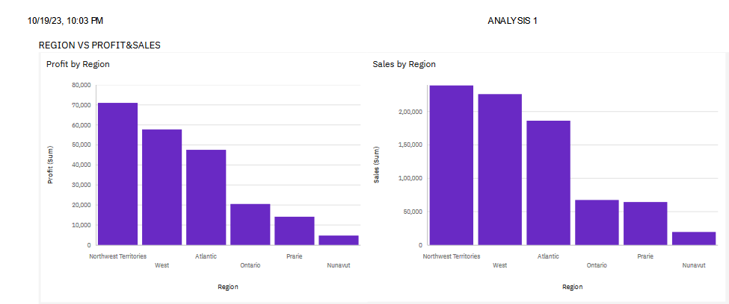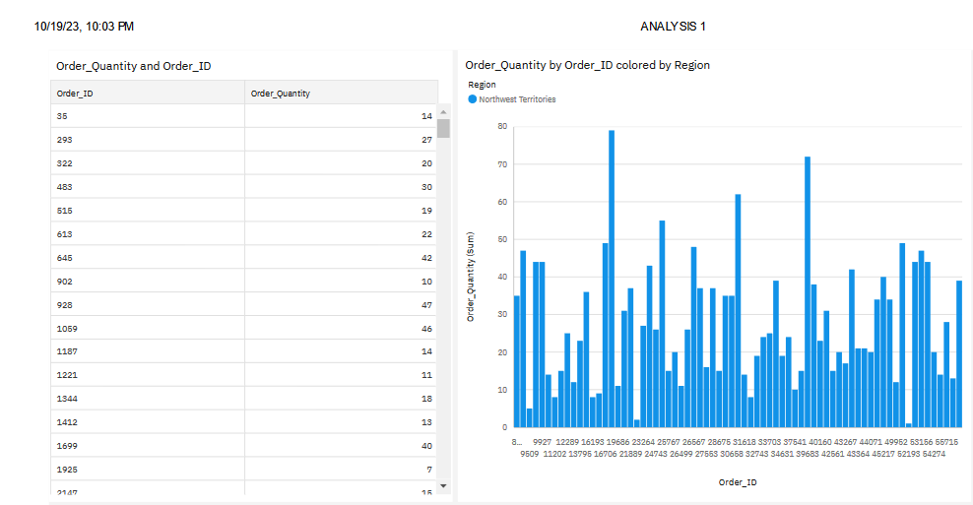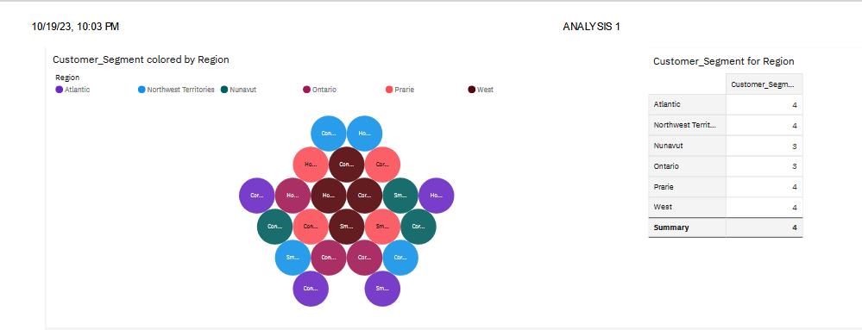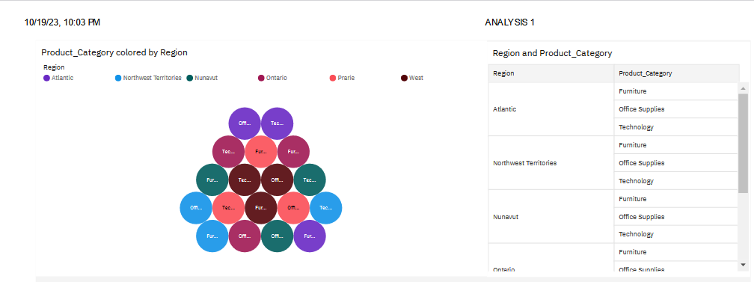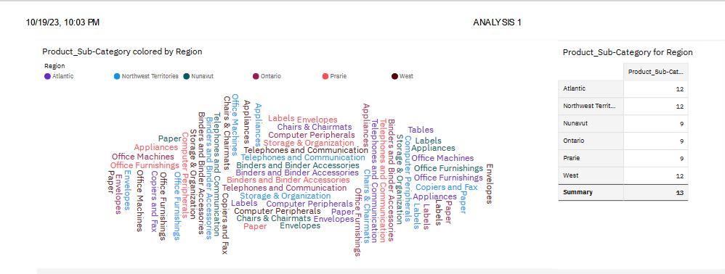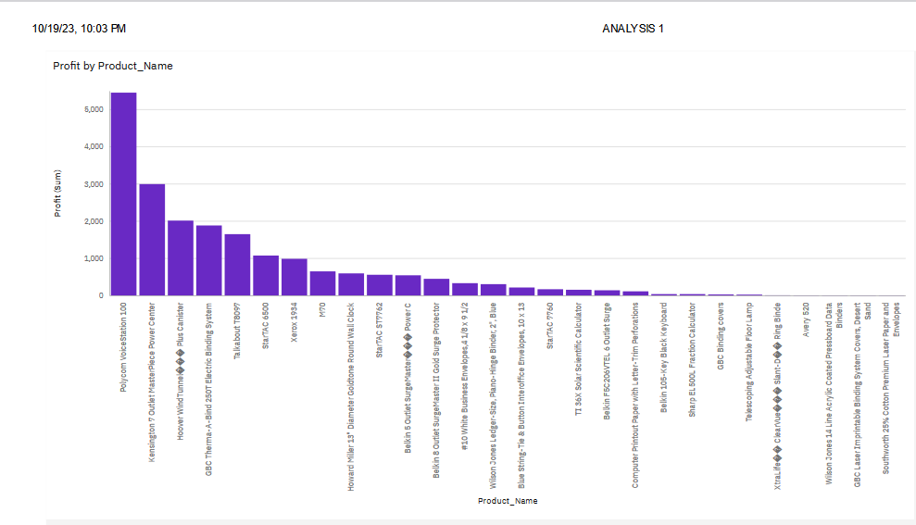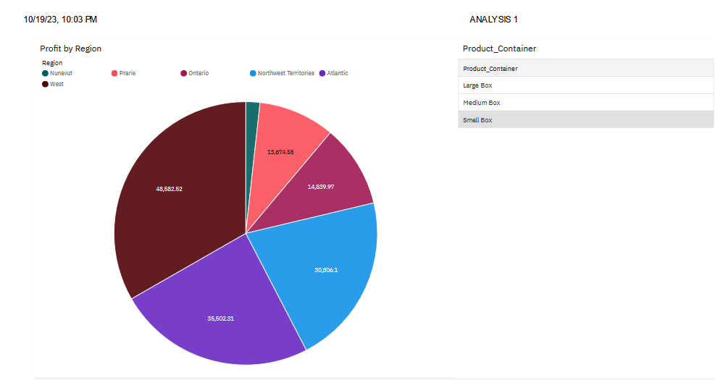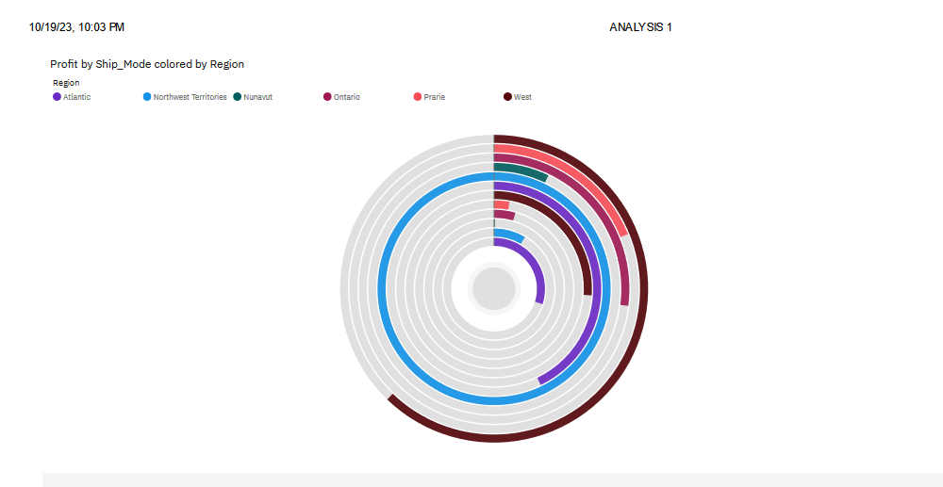

**LINK:**

[**https://us1.ca.analytics.ibm.com/bi/?perspective=dashboard&pathRef=.my_folders%2FANALYSIS%2B1&action=view&mode=dashboard&subView=model0000018b32f2bfae_00000001**](https://us1.ca.analytics.ibm.com/bi/?perspective=dashboard&pathRef=.my_folders%2FANALYSIS%2B1&action=view&mode=dashboard&subView=model0000018b32f2bfae_00000001)

**CONCLUSION :**

Thus the initial visualization of product sales analysis using IBM Cognos Analytics was done successfully.