Percentile Report for Placement Data
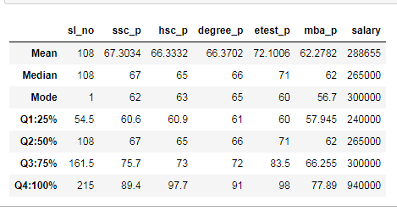
Percentile of ssc_p
25% of the data value exist between value 60
50% of the data value exist between 60 to 67
75% of the data value exist between 67 to 75
100% of the data value exist between 75 to 89
Every quadrant in between we could see 7% to 14% increments.
Percentile of hsc_p
25% of the data value exist between value 60
50% of the data value exist between 60 to 65
75% of the data value exist between 65 to 73
100% of the data value exist between 73 to 97
Every quadrant in between we could see 5% to 24% increments.
Percentile of degree_p
25% of the data value exist between value 61
50% of the data value exist between 61 to 66
75% of the data value exist between 66 to 72
100% of the data value exist between 72 to 91
Every quadrant in between we could see 5% to 19% increments.
Percentile of etest_p
25% of the data value exist between value 60
50% of the data value exist between 60 to 71
75% of the data value exist between 71 to 83
100% of the data value exist between 83 to 98
Every quadrant in between we could see 11% to 15% increments.
Percentile of mba_p
25% of the data value exist between value 57
50% of the data value exist between 57 to 62
75% of the data value exist between 62 to 66
100% of the data value exist between 66 to 77
Every quadrant in between we could see 5% to 11% increments.
Percentile of Salary
25% of the data value exist between value 240000
50% of the data value exist between 240000 to 265000
75% of the data value exist between 265000 to 300000
100% of the data value exist between 300000 to 940000
Every quadrant in between we could see 25000 to 640000 salary increments.

