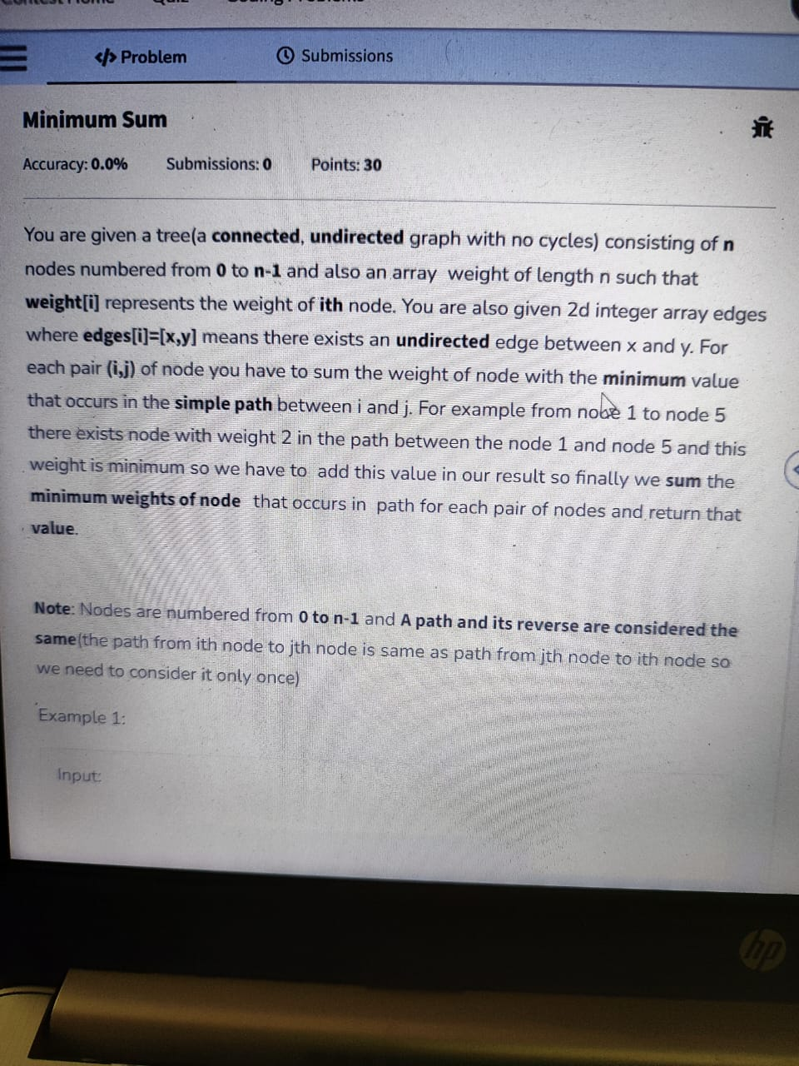
=
</>Problem
Submissions
Minimum Sum
Accuracy: 0.0%
Submissions: 0
Points: 30
You are given a tree(a connected, undirected graph with no cycles) consisting of n nodes numbered from 0 to n-1 and also an array weight of length n such that weight[i] represents the weight of ith node. You are also given 2d integer array edges where edges[i]=[x,y] means there exists an undirected edge between x and y. For each pair (i,j) of node you have to sum the weight of node with the minimum value that occurs in the simple path between i and j. For example from nobe 1 to node 5 there exists node with weight 2 in the path between the node 1 and node 5 and this weight is minimum so we have to add this value in our result so finally we sum the minimum weights of node that occurs in path for each pair of nodes and return that value.
Note: Nodes are numbered from 0 to n-1 and A path and its reverse are considered the same (the path from ith node to jth node is same as path from jth node to ith node so we need to consider it only once)
Example 1:
Input:
hp

