Placement Preparation

Note: This is based on my experience in placement season 2019-20.This one mostly useful for those who are sitting for digital and analog profile. (For more clarity on preparation contact as many seniors and friends as you can because you will get different point of view
and different understanding strategy But don’t confuse yourself by contacting more seniors))

Read each and every point in document clearly and carefully because this will be very useful.

Compulsory Reading:

1. Digital Electronics(including 8085 micro processor ) – Gate syllabus
2. Analog Electronics – Gate syllabus
3. Networks – Basics
4. C-programming(Pointers and linked lists (if you know advantage))
5. Digital Integrated circuits(Mostly for interviews)
6. Verilog HDL
7. Analog CMOS integrated circuits (For vlsi students compulsory for others it is better to know)
8. Aptitude – Gate level is fine
9.Control System Basics

Note : These are all basic knowledge that you need to know. This doesn’t mean in exams you will get questions from above topics only.

Other reading:

Books Preferred :

1.M._Morris_Mano,_Michael_D._Ciletti_Digital_Design_With_an_Introduction_to_the_Verilog_HDL

2.Samir Palnitkar-Verilog HDL-Prentice Hall

3. Digital Integrated circuits – Jan M Rabaey, Ananta chadrakasan

4.Design of Analog CMOS integrated circuits – Behzad Razavi

Websites:

1.http://www.vlsi-expert.com/2011/03/static-timing-analysis-sta-basic-timing.html?m=1 → For static timing analysis.

Video Lectures:

So many lectures are available in YouTube for each and every topic.

After completion of above reading try to solve some previous papers. Links for previous papers are given below.

Previous paper links from varies IIT’s:

1.IIT Kanpur https://drive.google.com/drive/folders/1jJBUhMPXX5UMl01XZ9mXvXrbYKcl1ULX

2. IIT Madras https://drive.google.com/drive/folders/1PzSkw8PgUlYg6YIiSy3RJrzKBPDg4mOr

3. IIT Kharagpur https://drive.google.com/drive/folders/1RWP7elz9Wx4wFvTcRHVXZUsqMRNK0SEn

4.Qualcomm
https://drive.google.com/folderview?id=1EYE4SaTF3edNpLUXdyxSPZv9naXY-ODO

Note: Most of the content in above links are same. But you will find some different papers in each link.

Try to solve previous papers as soon as you have completed your basic preparation because you have to understand and learn so many things in future after solving the previous papers and one more point is you can understand where is your standard as compared to the company requirement and questions. So that you can understand what to prepare , how to prepare and what company people are expecting from us.

Try to understand the things properly if don’t understand some concept spend time and then learn because you don’t know what they will ask in interviews(Final goal is to crack interview). So it is better to understand completely even if you study single subject. This one is important point among all because the company people will check how is your approach and whether you have understood the subject clearly or not. Final conclusion is how much concept (subject) that you actually understand clearly is matters not how much you study(without having clarity).

If you understand the concept clearly you can answer the questions to your interviewer confidently even if you are under pressure(thats what helps you).

If you don’t know something while solving the previous papers try to learn form Google and YouTube search . There are plenty of online sources are available.

Don’t get nervous while solving the previous papers if you don’t get answers because everyone is facing the same problem as you.

Mostly written test will start from first week of October So plan yourself that you have to complete basic syllabus and some companies previous papers (Intel, Qualcomm, Google, Texas Instruments, Samsung,Analog Devices, Max linear).

Note: Try to contact with your friends in other IIT’s because written test date for the companies are different for different IITs So if you got same paper you will get benefited.

Written test experience (Placement Season 2019-2020) Company Wise:

Intel(IIT kanpur)

Sections:
Aptitude : 10Q 15 Min
C : 10Q 15 Min
Core questions : 30Q 45 Min
Descriptive : 2Q 15 Min

Aptitude:
Simple questions: Ages,Loss and profit ,data interpretation, coding and decoding, partnership etc.

C:
Basic questions (Mostly from functions,operators,loops)
Core:
8085 micro processor → codes and output
Digital electronics:[Gate Standard] State diagrams,combinational circuits, J-K flip flops, Counters, JFETS, Diode circuits, Networks(Basic questions), Analog circuits.

Descriptive:

1.Digital Question:
Direct copied question form Morris Mano Book 5th edition (Example problem)(Page No:232) state reduction example problem

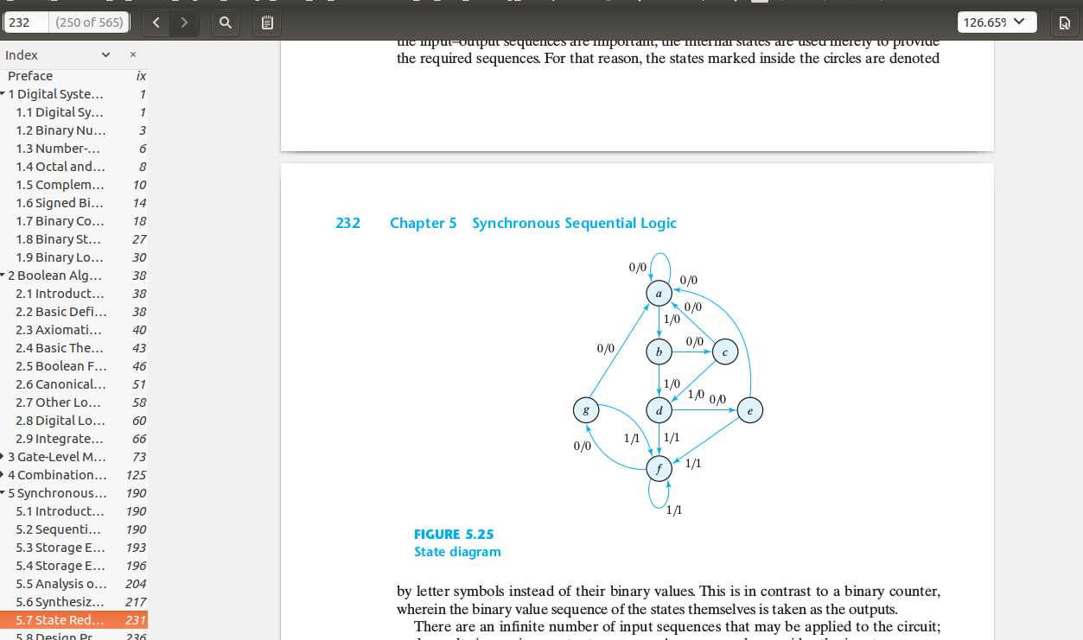

2.Analog Question:
Emitter degenerated BJT with voltage devider biasing problem.
How the stability will effect as VCC varying from 20V-18V and How Q-point changes. Values may be vary

Intel(IIT Madras)

8085
Poles and PM
SOP,POS, Static and Dynamic hazards
Current driven ADC
MOSFET I-V problems, Nortan, Thevenin equivalent circuits
Aptitude Question-→ Same as IITK
Intel 2018 Question Paper (2Q) digital
C-Basic Questions

Theory:

1.Counter design using J-K Filp-flop

2.BJT → Input power ,alpha,beta,Q-point(Ic,VcE)

Qualcomm(IIT Kanpur)

Profile offered(3):
1.Communication
2.Digital
3.----

Digital Profile

Sections:
1.Aptitude-Same as Intel Exam → Common for all profiles
2.Coding: C → Common for all profiles
3.Core: Digital → Based on profile

C:
Basic questions from loops ,if-else,switch ,pointers,linked list etc.

Digital:

State diagrams , Counters , Combinational circuits, Flipflop conversions, Static CMOS circuits etc.
8085 micro processor

Note: Some questions are repeated form previous papers.

Qualcomm(IIT M)

Same as IITK

Texas Instruments (IITK)

Sections:
1.Aptitude: Same pattern as Intel
2.Digital: Almost all questions are from previous papers
3.Analog: Almost all questions are from previous papers

So Before attending the texas written try to solve all the previous papers.

In all IIT’s written test questions are from previous papers only.

Maxlinear(IITK)

Most of the questions from previous papers.

Analog Devices
Descriptive

Sections:
1.Aptitude-→ Probability , permutations and combinations
2.Digital → State diagrams ,combinational circuits,edge detection using the digital gates, Counters,Mux based circuits, 4 bit comparator ckt using mux.
3.Signal processing → Sampling theorm, ADC, DAC etc.

Samsung (IITK):

Interview Preparation:

