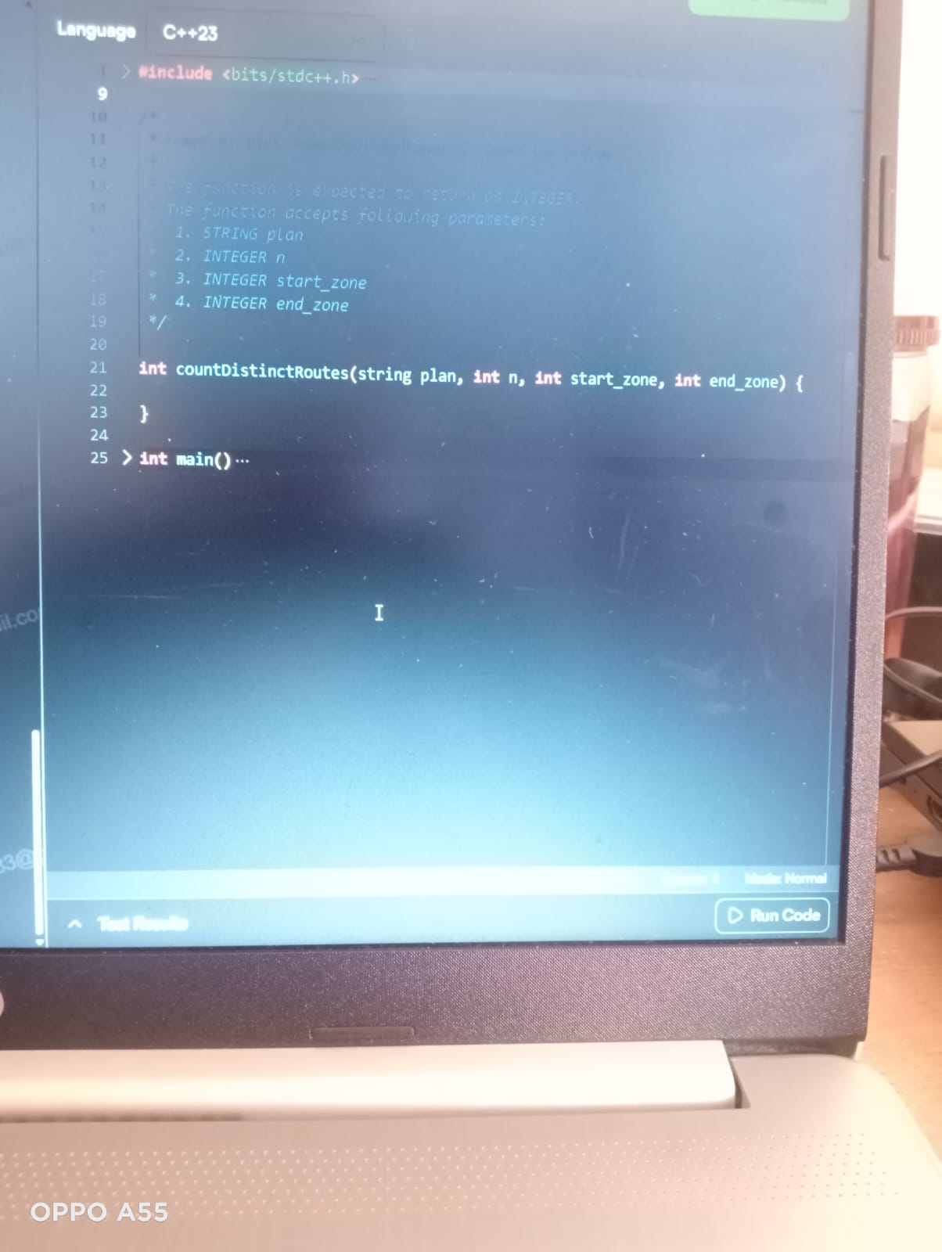
il.co
3@
Language C++23
> #include <bits/stdc++.h>
10
11
12
13
14
The Function is expected to retum of INTEGER.
The function accepts following parameters: 1. STRING plan
2. INTEGER n
3. INTEGER start_zone
18
T
4. INTEGER end_zone
19
20
21
22
int countDistinctRoutes (string plan, int n, int start_zone, int end_zone) {
23
}
24
25 > int main() ...
Mode: Normal
Test Results
Run Code
OPPO A55

