Time Series Assignment 2

Tey Yi Jie

12/9/2019

setwd("E:/Sem 5/Time Series and Forecasting Method Dr Dharini")  
library(fpp2)

## Loading required package: ggplot2

## Loading required package: forecast

## Registered S3 method overwritten by 'xts':  
## method from  
## as.zoo.xts zoo

## Registered S3 method overwritten by 'quantmod':  
## method from  
## as.zoo.data.frame zoo

## Registered S3 methods overwritten by 'forecast':  
## method from   
## fitted.fracdiff fracdiff  
## residuals.fracdiff fracdiff

## Loading required package: fma

## Loading required package: expsmooth

library(readxl)

#Importing data to R  
temp<-read_excel("Assignment.xlsx")

## Warning in read_fun(path = enc2native(normalizePath(path)), sheet_i =  
## sheet, : Expecting numeric in B1677 / R1677C2: got '***'

## Warning in read_fun(path = enc2native(normalizePath(path)), sheet_i =  
## sheet, : Expecting numeric in B1678 / R1678C2: got '***'

## Warning in read_fun(path = enc2native(normalizePath(path)), sheet_i =  
## sheet, : Expecting numeric in B1679 / R1679C2: got '***'

## Warning in read_fun(path = enc2native(normalizePath(path)), sheet_i =  
## sheet, : Expecting numeric in B1680 / R1680C2: got '***'

## Warning in read_fun(path = enc2native(normalizePath(path)), sheet_i =  
## sheet, : Expecting numeric in B1681 / R1681C2: got '***'

mytemp<-ts(temp[1321:1681,-1],start=1990,end=c(2019,12),frequency = 12)  
mytemp

## Jan Feb Mar Apr May Jun Jul Aug Sep Oct Nov Dec  
## 1990 0.41 0.41 0.77 0.55 0.46 0.38 0.43 0.31 0.29 0.41 0.46 0.41  
## 1991 0.41 0.49 0.35 0.52 0.38 0.53 0.48 0.40 0.48 0.30 0.31 0.32  
## 1992 0.44 0.42 0.48 0.24 0.32 0.25 0.12 0.07 0.00 0.09 0.03 0.22  
## 1993 0.37 0.39 0.36 0.27 0.27 0.25 0.28 0.13 0.10 0.22 0.06 0.16  
## 1994 0.27 0.02 0.27 0.40 0.28 0.42 0.30 0.21 0.29 0.41 0.46 0.36  
## 1995 0.51 0.78 0.45 0.47 0.26 0.41 0.48 0.46 0.32 0.47 0.45 0.28  
## 1996 0.25 0.48 0.32 0.36 0.27 0.25 0.35 0.49 0.25 0.19 0.41 0.40  
## 1997 0.31 0.38 0.53 0.36 0.36 0.53 0.35 0.41 0.53 0.62 0.65 0.59  
## 1998 0.60 0.90 0.63 0.63 0.69 0.77 0.68 0.66 0.42 0.44 0.49 0.56  
## 1999 0.48 0.65 0.34 0.32 0.31 0.37 0.37 0.31 0.41 0.39 0.38 0.43  
## 2000 0.23 0.56 0.57 0.57 0.36 0.41 0.38 0.42 0.40 0.28 0.32 0.29  
## 2001 0.42 0.43 0.55 0.50 0.56 0.54 0.60 0.48 0.53 0.50 0.69 0.55  
## 2002 0.75 0.75 0.89 0.56 0.63 0.55 0.61 0.53 0.62 0.55 0.58 0.43  
## 2003 0.73 0.55 0.57 0.53 0.60 0.47 0.53 0.65 0.64 0.74 0.52 0.73  
## 2004 0.58 0.72 0.64 0.62 0.38 0.42 0.24 0.43 0.50 0.64 0.70 0.51  
## 2005 0.72 0.57 0.69 0.66 0.62 0.66 0.63 0.60 0.74 0.75 0.71 0.65  
## 2006 0.56 0.69 0.62 0.50 0.46 0.64 0.52 0.70 0.61 0.67 0.70 0.73  
## 2007 0.95 0.70 0.69 0.73 0.66 0.59 0.60 0.57 0.59 0.57 0.54 0.46  
## 2008 0.23 0.34 0.73 0.51 0.47 0.46 0.59 0.44 0.62 0.63 0.64 0.53  
## 2009 0.61 0.51 0.52 0.58 0.64 0.65 0.69 0.66 0.68 0.63 0.76 0.65  
## 2010 0.73 0.79 0.91 0.85 0.73 0.62 0.59 0.63 0.59 0.69 0.77 0.46  
## 2011 0.48 0.51 0.62 0.62 0.51 0.57 0.71 0.71 0.54 0.63 0.56 0.53  
## 2012 0.45 0.48 0.56 0.68 0.75 0.63 0.53 0.62 0.72 0.74 0.73 0.52  
## 2013 0.67 0.56 0.65 0.53 0.58 0.66 0.57 0.66 0.78 0.67 0.78 0.65  
## 2014 0.73 0.52 0.76 0.77 0.85 0.66 0.56 0.81 0.88 0.81 0.66 0.77  
## 2015 0.81 0.87 0.90 0.75 0.75 0.79 0.71 0.79 0.82 1.07 1.03 1.10  
## 2016 1.15 1.35 1.31 1.07 0.91 0.77 0.82 1.00 0.88 0.90 0.91 0.83  
## 2017 0.98 1.13 1.13 0.92 0.89 0.70 0.82 0.87 0.76 0.88 0.86 0.89  
## 2018 0.77 0.85 0.91 0.87 0.81 0.74 0.78 0.73 0.76 0.99 0.78 0.89  
## 2019 0.87 0.92 1.11 0.97 0.85 0.86 0.90 NA NA NA NA NA

#Time plot  
autoplot(mytemp)+ggtitle("Estimated Global Surface Temperature Change")+xlab("Year")+ylab("Temperature Anomalities")

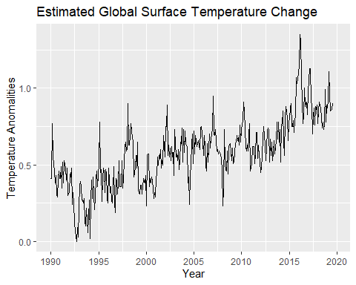

#From the time plot, we can observe the overall trend is going upward which is logical as pollution causing global warming to be more serious.   
  
#Besides, some cyclic behaviors are spotted like the surge around 2016 was the hottest year on record due to the natural El Nino event that released heat from the Pacific Ocean.  
  
#Temperatures are unlikely to set a new peak in 2017 because the El Nino has begun to stop but temperature is still high due to greenhouse gases from burning fossil fuels keep building up in the atmosphere.

#Seasonal plot  
ggseasonplot(mytemp,year.labels = TRUE,year.labels.left = TRUE)+ggtitle("Seasonal plot: Estimated Global Surface Temperature Changed")+xlab("Year")+ylab("Temperature Anomalities")

## Warning: Removed 5 rows containing missing values (geom_path).

## Warning: Removed 1 rows containing missing values (geom_text).

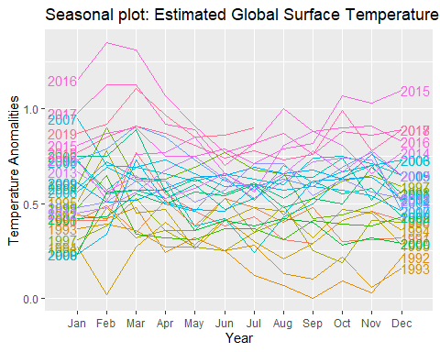

#Mostly the temperature anomalies is between 0.4ºC to 0.75ºC in June every year.  
  
#The graph also shows that there was an unusually temperature anomalies drop to 0ºC in Feb 1994 due to the western third of the country remained under the influence of mild Pacific airstream (most other years show an increase between January and February).   
  
ggseasonplot(mytemp,polar = TRUE)+ggtitle("Polar Seasonal Plot: Estimated Global Surface Temperature Changed")+xlab("Year")+ylab("Temperature Anomalities)")

## Warning: Removed 5 rows containing missing values (geom_path).

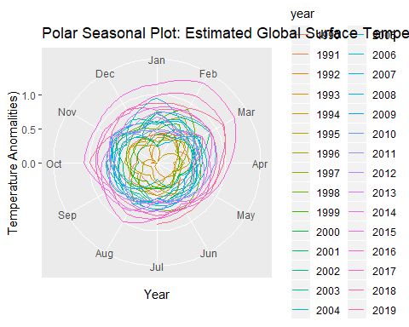

#From the seasonal plot, we observed that the data experiences not so quite regular but still predictable changes that recur every calendar year.   
#Moreover, the monthly temperature change show it has seasonality but weakly stable.

#Monthly Plot  
ggsubseriesplot(mytemp) + ggtitle("Seasonal Subseries Plot: Estimated Global Surface Temperature Changed")+xlab("Month")+ylab("Temperature Anomalities")

## Warning: Removed 5 rows containing missing values (geom_path).

## Warning: Removed 150 rows containing missing values (geom_path).

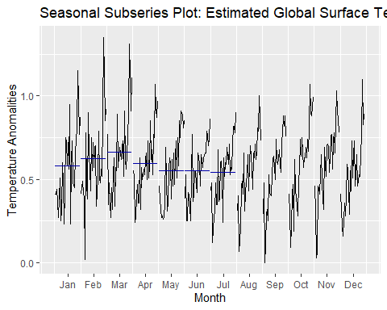

#Mean temperature anomalies is increasing from Jan until March but then proceed to decrease and staying constant until September.  
  
#From May until Sep, the mean temperature is constant due to the absorption of heat during the process of thawing that prevent the accession of temperature.  
#The increasing trend from January until March is because no land or ocean areas had record-cold temperature.  
  
#The highest mean temperature is in March because in this month especially in year 2019 the temperature across global land and ocean surfaces was 1.91ºF above the average of 54.9ºF (climate change).

#ACF Plot  
ggAcf(mytemp)+ggtitle("ACF plot: Estimated Global Surface Temperature")

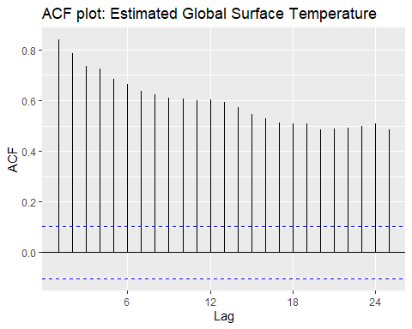

#The slow decrease in the ACF as the lags increase is due to the trend. While the “scalloped” shape is due to the present of seasonality.  
  
#From here we can clearly see that our data has trend and seasonality.

#BoxCox Transformation  
lambda<-BoxCox.lambda(mytemp)  
mytemp1<-BoxCox(mytemp,lambda)  
autoplot(mytemp1)+ggtitle("Estimated Global Surface Temperature Changed")+xlab("Year")+ylab("Temperature Anomalities")

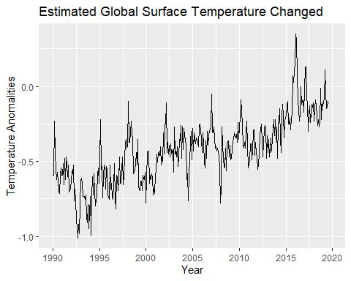

#The size of variation is fluctuating randomly. So, we could not use the box cox transformation to stabilize the variance.  
  
#There is no changes in the time plot after BoxCox transformation, since the variance of the transformed data seems to be similar to the original data. Besides, the seasonal variations changes but not in level series, so we can conclude that it is unnecessary for us to do the transformation of our data.

#STL Decomposition  
decompose<-mstl(mytemp,robust=TRUE)  
autoplot(decompose)

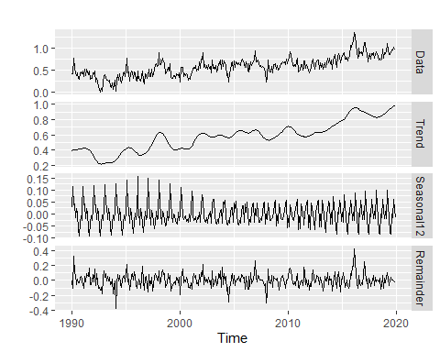

#STL decomposition splits time series into trend, seasonal and remainder component.  
  
#The data shows that it has an upward trend.  
  
#For seasonal component, the variation of series changes but not with the level of the series.  
  
#The seasonal variations are roughly constant.

#Seasonal subseries plot for decomposition  
decompose %>% seasonal() %>% ggsubseriesplot() + ggtitle("Seasonal subseries plot of STL Decomposition") + xlab("Year") + ylab("Temperature Anomalities")

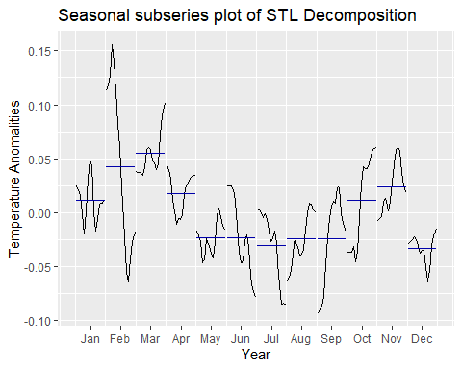

#From the seasonal subseries plot, we could only observe the highest temperature anomalies is on March which means the global surface temperature in March is the highest and it also due to the El Nino persisted across the tropical Pacific Ocean on March 2019 and the rising of ocean surfaces’ temperature.  
   
#The underlying seasonal pattern is not spotted.

#One step forecst error  
#Compare MSE  
e<-tsCV(mytemp,ses,h=1)  
mean(e^2,na.rm = T)

## [1] 0.01322502

e2<-tsCV(mytemp,holt,h=1)  
mean(e2^2,na.rm = T)

## [1] 0.01343259

e3<-tsCV(mytemp,holt, damped=T ,h=1)  
mean(e3^2,na.rm = T)

## [1] 0.01326292

e4<-tsCV(mytemp,hw,seasonal="additive",h=1)  
mean(e4^2,na.rm = T)

## [1] 0.0145187

# Exponential Smoothing produce the lowest MSE which is 0.0132  
  
#The Holt-Winters’ Additive Methods has the highest MSE which is 0.0145.  
  
#By comparing the MSE of each method we can see that Simple Exponential Smoothing Method is better.

#Compare MAE  
mean(abs(e),na.rm = T)

## [1] 0.09210444

mean(abs(e2),na.rm = T)

## [1] 0.09345289

mean(abs(e3),na.rm = T)

## [1] 0.09256465

mean(abs(e4),na.rm = T)

## [1] 0.09602602

#We can see that the MAE of each method are not too far reached from each other. This is because by using MAE, the relative error is not always obvious.  
  
#Nevertheless, we can still see that Simple Exponential Smoothing has the lowest MAE which 0.0921.

#Best method from one step forecast error is simple exponential smoothing  
  
#Best method for one step Forecast graph and its parameter  
  
best1<-ses(mytemp,h=24)

## Warning in ets(x, "ANN", alpha = alpha, opt.crit = "mse", lambda =  
## lambda, : Missing values encountered. Using longest contiguous portion of  
## time series

autoplot(best1)+xlab("Year")+ylab("Temperature Anomalities")

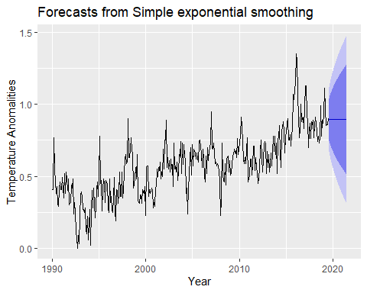

best1$model

## Simple exponential smoothing   
##   
## Call:  
## ses(y = mytemp, h = 24)   
##   
## Smoothing parameters:  
## alpha = 0.505   
##   
## Initial states:  
## l = 0.4638   
##   
## sigma: 0.1134  
##   
## AIC AICc BIC   
## 542.9158 542.9841 554.5321

#Forming training set and test set data  
mytemp1<-window(mytemp,start=1990,end=c(2017,7))  
mytemp2<-window(mytemp,start=c(2017,8))

#Forecasting Graph  
autoplot(mytemp)+  
 autolayer(ses(mytemp1,h=24),series = "Simple Exponential Smoothing",PI=FALSE)+  
 autolayer(holt(mytemp1,h=24),series = "Holt's Linear Trend",PI=FALSE)+ autolayer(holt(mytemp1,h=24,damped = T),series = "Damped Trend",PI=FALSE)+  
 autolayer(hw(mytemp1,h=24,seasonal = "additive"),series = "Holt-Winters' Additive",PI=FALSE)+  
 ggtitle("Forecast of Estimated Global Surface Temperature Changed")+  
 xlab("Year")+ylab("Temperature Anomalities")+guides(colour=guide_legend(title="Forecast"))

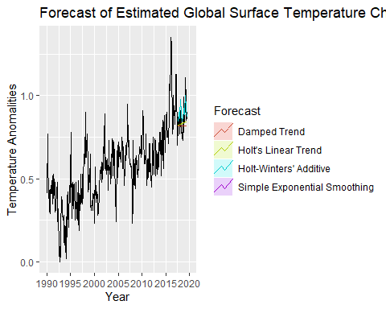

#Finding test set error  
fc<-ses(mytemp1,h=24)  
fc2<-holt(mytemp1,h=24)  
fc3<-holt(mytemp1,h=24,damped = T)  
fc4<-hw(mytemp1,h=24,seasonal = "additive")  
  
print("Exponential smoothing")

## [1] "Exponential smoothing"

accuracy(fc,mytemp2)

## ME RMSE MAE MPE MAPE MASE  
## Training set 0.002087344 0.11458587 0.09227561 -Inf Inf 0.6186616  
## Test set 0.040425027 0.09482522 0.07541945 3.799847 8.433058 0.5056496  
## ACF1 Theil's U  
## Training set 0.05807428 NA  
## Test set 0.28395076 0.9126674

print("Holt's Linear Method")

## [1] "Holt's Linear Method"

accuracy(fc2,mytemp2)

## ME RMSE MAE MPE MAPE  
## Training set 3.224934e-05 0.11457777 0.09225920 -Inf Inf  
## Test set 2.574901e-02 0.08740794 0.06907989 2.102491 7.824979  
## MASE ACF1 Theil's U  
## Training set 0.6185516 0.05864187 NA  
## Test set 0.4631460 0.24632007 0.8483322

print("Damped Holt's Linear Method")

## [1] "Damped Holt's Linear Method"

accuracy(fc3,mytemp2)

## ME RMSE MAE MPE MAPE MASE  
## Training set 0.002578576 0.11457770 0.09215174 -Inf Inf 0.6178311  
## Test set 0.040408824 0.09483145 0.07541859 3.797797 8.433011 0.5056438  
## ACF1 Theil's U  
## Training set 0.05827705 NA  
## Test set 0.28418785 0.9127381

print("Holt-Winters' additive method")

## [1] "Holt-Winters' additive method"

accuracy(fc4,mytemp2)

## ME RMSE MAE MPE MAPE  
## Training set 0.0001106728 0.11199500 0.08863040 -Inf Inf  
## Test set -0.0410556824 0.08207955 0.07024539 -5.514726 8.476422  
## MASE ACF1 Theil's U  
## Training set 0.5942223 0.1840842 NA  
## Test set 0.4709600 -0.1169478 0.8266593

#The best method is Holt’s Linear Trend method because it show the least MAE, MAPE and MASE.

#Holt's Linear Trend Graph  
best2<-holt(mytemp,h=24)

## Warning in ets(x, "AAN", alpha = alpha, beta = beta, phi = phi, damped =  
## damped, : Missing values encountered. Using longest contiguous portion of  
## time series

autoplot(best2)+xlab("Year")+ylab("Temperature Anomalities")

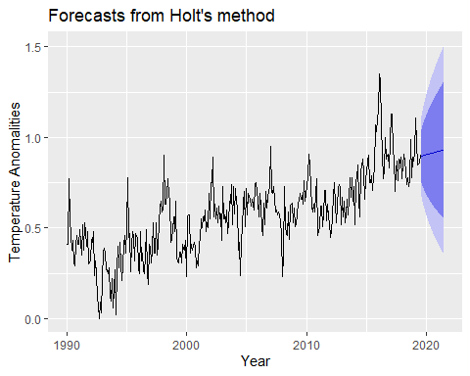

best2$model

## Holt's method   
##   
## Call:  
## holt(y = mytemp, h = 24)   
##   
## Smoothing parameters:  
## alpha = 0.4949   
## beta = 1e-04   
##   
## Initial states:  
## l = 0.4264   
## b = 0.0015   
##   
## sigma: 0.1137  
##   
## AIC AICc BIC   
## 546.9920 547.1640 566.3526

#Comparative Study: Holt Linear Trend and Drift Method  
autoplot(mytemp)+  
 autolayer(holt(mytemp1,h=24),series = "Holt's Linear Trend",PI=FALSE)+ autolayer(rwf(mytemp1,h=24,drift = TRUE),series = "Drift",PI=FALSE)+xlab("Year")+ylab("Temperature Anomalities")+guides(colour=guide_legend(title="Forecast"))

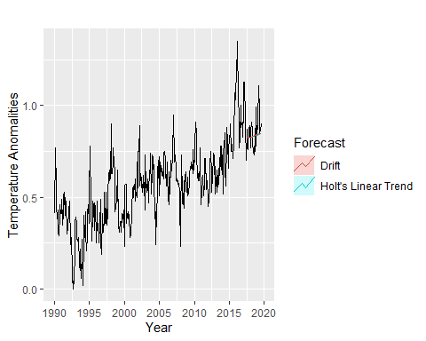

#Accuracy checking  
print("Drift")

## [1] "Drift"

accuracy(rwf(mytemp1,h=24),drift=TRUE,mytemp2)

## ME RMSE MAE MPE MAPE MASE  
## Training set 0.001242424 0.12451238 0.09863636 -Inf Inf 0.6613073  
## Test set 0.039166667 0.09429563 0.07500000 3.651993 8.394788 0.5028373  
## ACF1 Theil's U  
## Training set -0.3360632 NA  
## Test set 0.2839508 0.9080652

print("Holt's Linear Method")

## [1] "Holt's Linear Method"

accuracy(fc2,mytemp2)

## ME RMSE MAE MPE MAPE  
## Training set 3.224934e-05 0.11457777 0.09225920 -Inf Inf  
## Test set 2.574901e-02 0.08740794 0.06907989 2.102491 7.824979  
## MASE ACF1 Theil's U  
## Training set 0.6185516 0.05864187 NA  
## Test set 0.4631460 0.24632007 0.8483322

#Holt’s Linear Trend is better than Drift because it has least error.

#Advanced Comparative Study: ETS  
fit.ets<-ets(mytemp1)  
summary (fit.ets) #get parameter

## ETS(A,N,N)   
##   
## Call:  
## ets(y = mytemp1)   
##   
## Smoothing parameters:  
## alpha = 0.5159   
##   
## Initial states:  
## l = 0.4623   
##   
## sigma: 0.1149  
##   
## AIC AICc BIC   
## 492.3240 492.3974 503.7304   
##   
## Training set error measures:  
## ME RMSE MAE MPE MAPE MASE  
## Training set 0.002087344 0.1145859 0.09227561 -Inf Inf 0.6186616  
## ACF1  
## Training set 0.05807428

checkresiduals(fit.ets) #check whether have info left out

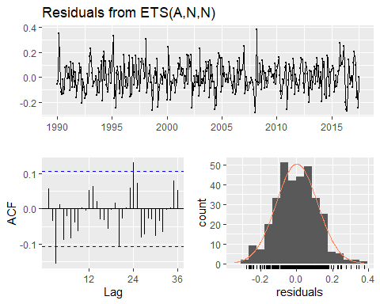

##   
## Ljung-Box test  
##   
## data: Residuals from ETS(A,N,N)  
## Q* = 33.439, df = 22, p-value = 0.05596  
##   
## Model df: 2. Total lags used: 24

#We now employ the ETS statistical framework to forecast the estimated global surface temperature changed.  
  
#The ets() function select the model by minimising the AICc.  
  
#The model selected is ETS(A,N,N).  
  
#The model has additive error, no trend and no seasonality with alpha = 0.5159

#Advanced Comparative Study: SARIMA  
fit.sarima<-auto.arima(mytemp1)  
summary(fit.sarima) #get parameter

## Series: mytemp1   
## ARIMA(1,1,1)(1,0,2)[12]   
##   
## Coefficients:  
## ar1 ma1 sar1 sma1 sma2  
## 0.3844 -0.8085 -0.4946 0.5216 0.0799  
## s.e. 0.1590 0.1118 1.9061 1.9116 0.0609  
##   
## sigma^2 estimated as 0.01287: log likelihood=252.21  
## AIC=-492.42 AICc=-492.16 BIC=-469.63  
##   
## Training set error measures:  
## ME RMSE MAE MPE MAPE MASE  
## Training set 0.004018719 0.1123994 0.09054677 -Inf Inf 0.6070706  
## ACF1  
## Training set -0.034058

checkresiduals(fit.sarima) #check info left out

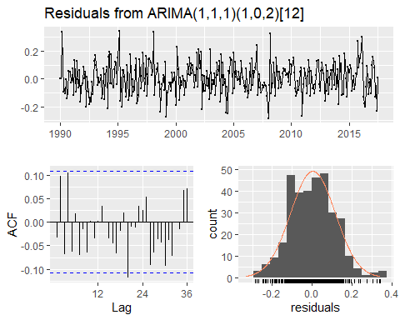

##   
## Ljung-Box test  
##   
## data: Residuals from ARIMA(1,1,1)(1,0,2)[12]  
## Q* = 22.84, df = 19, p-value = 0.2445  
##   
## Model df: 5. Total lags used: 24

#The seasonal ARIMA model incorporates both non-seasonal and seasonal factors.  
  
#The model selected is ARIMA(1,1,1)(1,0,2)[12]  
  
#The model includes a non-seasonal AR(1) term, first order non-seasonal difference, non-seasonal MA(1) term, a seasonal AR(1) term, no seasonal differencing, a seasonal MA(2) term and the seasonal period is S = 12

#Accuracy checking between ETS, SARIMA and Holt Linear  
print("ETS")

## [1] "ETS"

a1<- fit.ets%>%forecast(h=24)%>%accuracy(mytemp)  
a1[,c("RMSE","MAE","MAPE","MASE")]

## RMSE MAE MAPE MASE  
## Training set 0.11458587 0.09227561 Inf 0.6186616  
## Test set 0.09482522 0.07541945 8.433058 0.5056496

print("SARIMA")

## [1] "SARIMA"

a2 <- fit.sarima %>% forecast(h=24) %>% accuracy(mytemp)  
a2[,c("RMSE","MAE","MAPE","MASE")]

## RMSE MAE MAPE MASE  
## Training set 0.11239936 0.09054677 Inf 0.6070706  
## Test set 0.09183217 0.07125469 8.513484 0.4777269

print("Holt's Linear Method")

## [1] "Holt's Linear Method"

accuracy(fc2,mytemp2)

## ME RMSE MAE MPE MAPE  
## Training set 3.224934e-05 0.11457777 0.09225920 -Inf Inf  
## Test set 2.574901e-02 0.08740794 0.06907989 2.102491 7.824979  
## MASE ACF1 Theil's U  
## Training set 0.6185516 0.05864187 NA  
## Test set 0.4631460 0.24632007 0.8483322

#Holt’s Linear Trend model seems to be the slightly more accurate model based on the test set RMSE, MAE, MAPE and MASE.

#Prediction Interval  
predi <- predict(fc2,mytemp,interval = "prediction")  
predi

## Point Forecast Lo 80 Hi 80 Lo 95 Hi 95  
## Aug 2017 0.8209325 0.6731998 0.9686652 0.5949949 1.046870  
## Sep 2017 0.8220182 0.6558121 0.9882243 0.5678279 1.076209  
## Oct 2017 0.8231038 0.6402754 1.0059323 0.5434918 1.102716  
## Nov 2017 0.8241895 0.6261232 1.0222559 0.5212732 1.127106  
## Dec 2017 0.8252752 0.6130570 1.0374934 0.5007154 1.149835  
## Jan 2018 0.8263608 0.6008723 1.0518494 0.4815058 1.171216  
## Feb 2018 0.8274465 0.5894215 1.0654715 0.4634187 1.191474  
## Mar 2018 0.8285322 0.5785943 1.0784700 0.4462852 1.210779  
## Apr 2018 0.8296178 0.5683054 1.0909303 0.4299749 1.229261  
## May 2018 0.8307035 0.5584871 1.1029199 0.4143845 1.247023  
## Jun 2018 0.8317892 0.5490852 1.1144932 0.3994307 1.264148  
## Jul 2018 0.8328748 0.5400547 1.1256949 0.3850451 1.280705  
## Aug 2018 0.8339605 0.5313586 1.1365624 0.3711708 1.296750  
## Sep 2018 0.8350462 0.5229653 1.1471270 0.3577596 1.312333  
## Oct 2018 0.8361318 0.5148480 1.1574156 0.3447706 1.327493  
## Nov 2018 0.8372175 0.5069837 1.1674513 0.3321685 1.342267  
## Dec 2018 0.8383032 0.4993523 1.1772540 0.3199225 1.356684  
## Jan 2019 0.8393888 0.4919363 1.1868414 0.3080060 1.370772  
## Feb 2019 0.8404745 0.4847202 1.1962288 0.2963952 1.384554  
## Mar 2019 0.8415601 0.4776903 1.2054299 0.2850693 1.398051  
## Apr 2019 0.8426458 0.4708346 1.2144570 0.2740096 1.411282  
## May 2019 0.8437315 0.4641419 1.2233210 0.2631994 1.424264  
## Jun 2019 0.8448171 0.4576026 1.2320317 0.2526236 1.437011  
## Jul 2019 0.8459028 0.4512077 1.2405979 0.2422687 1.449537

plot(predi)

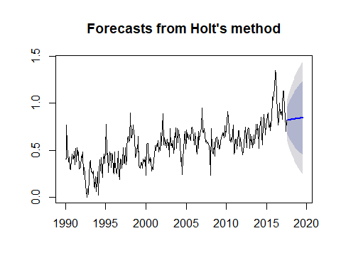

#Residuals Checking  
best2<-holt(mytemp,h=24)

## Warning in ets(x, "AAN", alpha = alpha, beta = beta, phi = phi, damped =  
## damped, : Missing values encountered. Using longest contiguous portion of  
## time series

autoplot(best2,PI=TRUE)+xlab("Year")+ylab("Temperature Anomalities")



checkresiduals(best2)

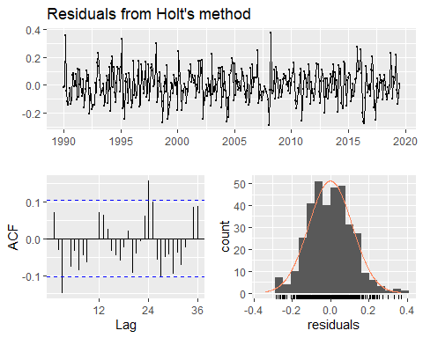

##   
## Ljung-Box test  
##   
## data: Residuals from Holt's method  
## Q* = 39.119, df = 20, p-value = 0.006444  
##   
## Model df: 4. Total lags used: 24

#The residuals are correlated because the p-value is less than 0.05. So, the Null hypothesis is clearly rejected. We can also see a significant two spike which is lag 3 and 24 on the Holt’s in the ACF.  
  
#The residuals do not appear to be too far from normally distributed.