RNX2DB
  - INSTRUCTIONS TO INSTALL AND RUN

Copying RNX2DB package

- Uncompress the rnx2db-main.zip file in C:\Projects such that we have the following file structure…
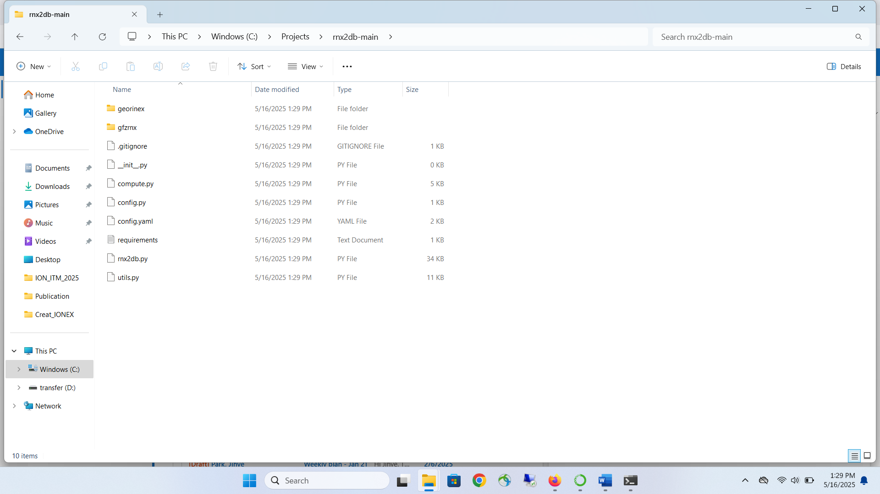
Figure 1: rnx2db file structure
- Before we could run rnx2db, we need to install supporting packages. We use Anaconda, a package manager to install the necessary supporting packages.

- Please note the path of requirements file in Figure 1
C:\Projects\rnx2db-main\requirements.txt
We will use this path in the next section to specify and install the supporting packages

Installing supporting packages via Anaconda

- Install Anaconda by following the steps given in https://www.anaconda.com/docs/getting-started/anaconda/install
- Open Anaconda Navigator and click on “Environments” (shown in red ellipse in Figure 2 )

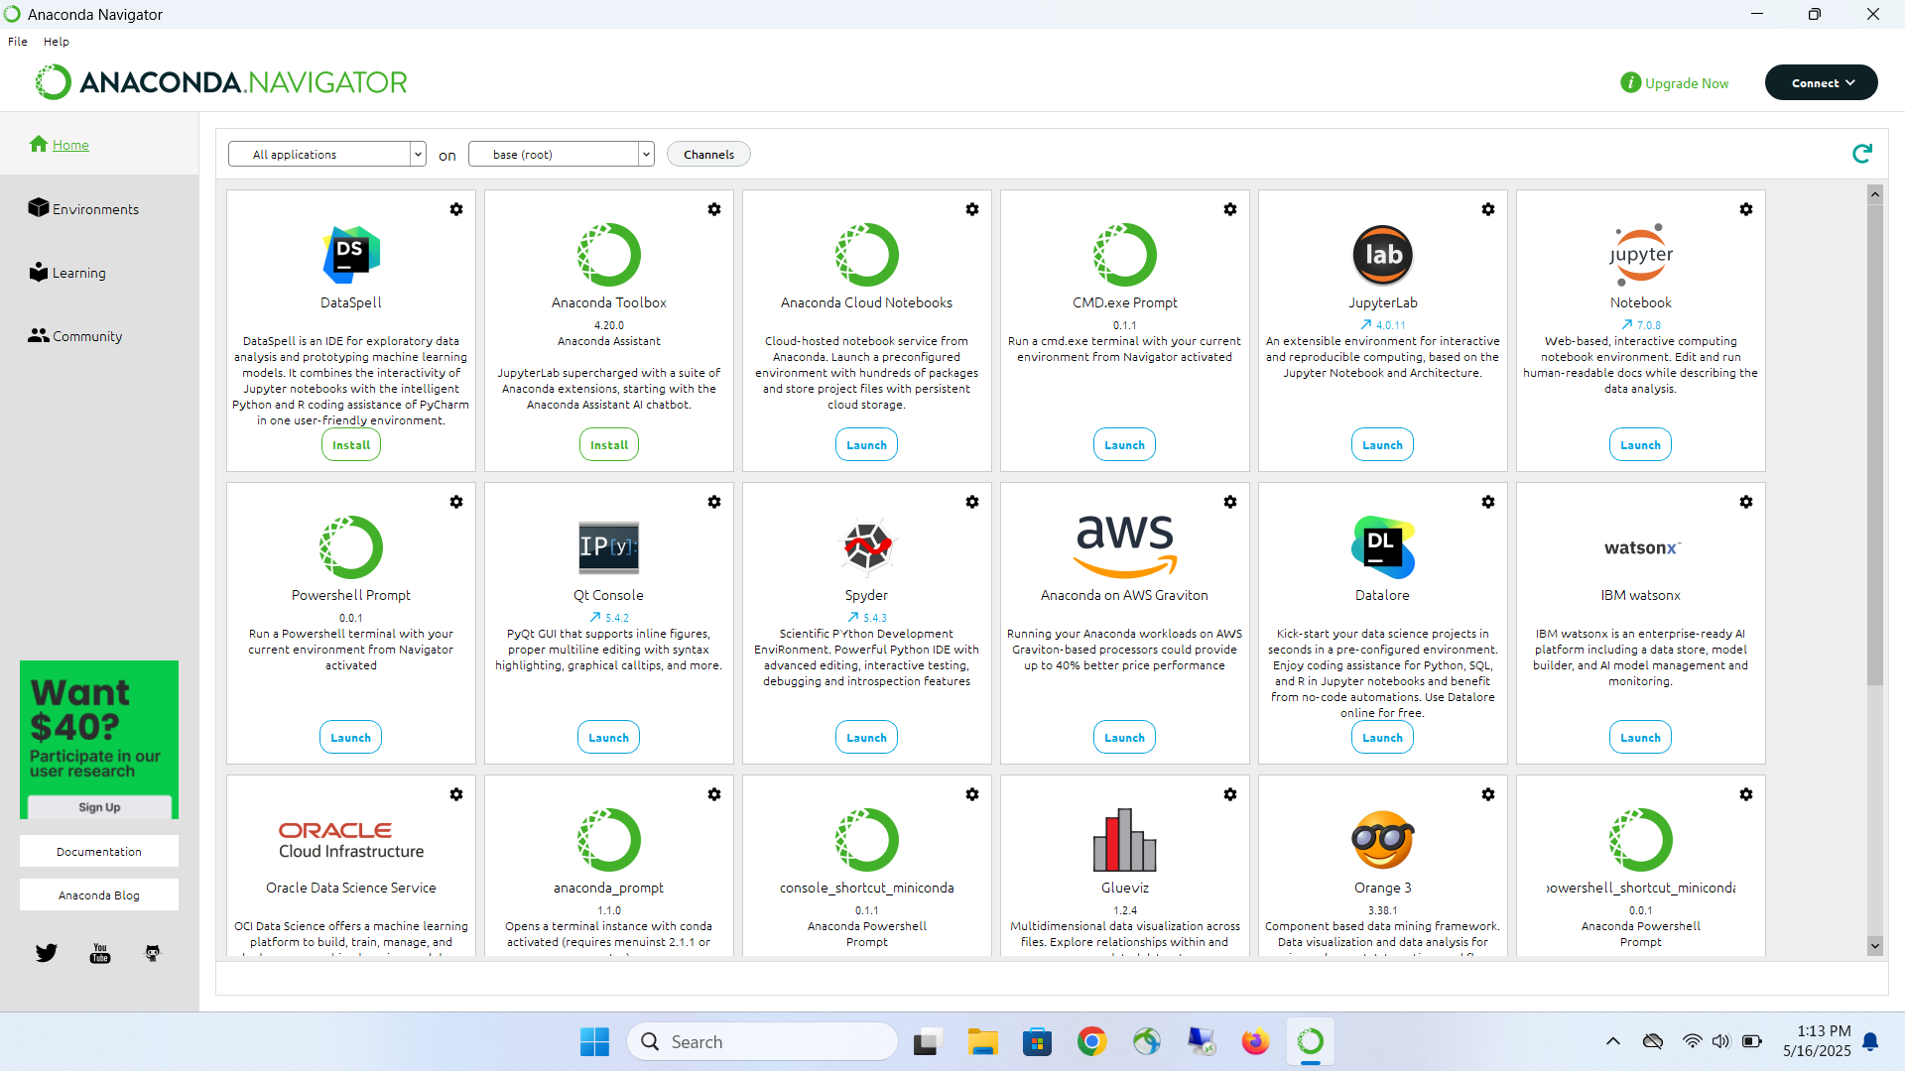 Figure 2: Anaconda Navigator main screen

- Click on “Create” shown in Figure 3

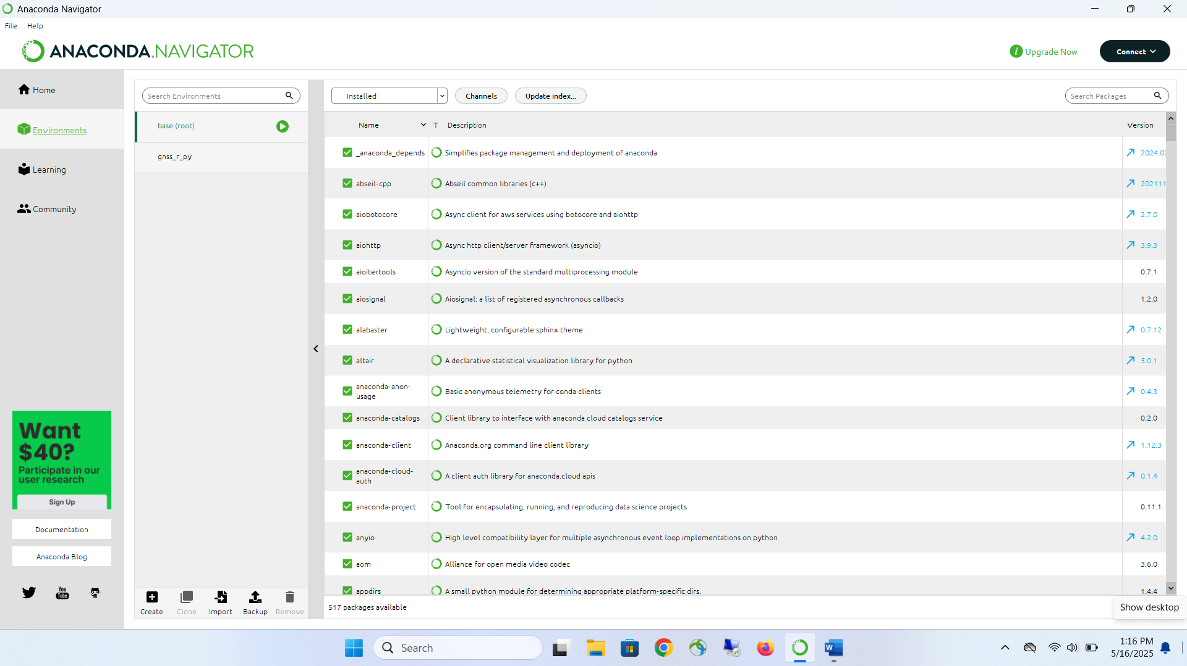
Figure 3: Environment screen

- Fill in the dialog box shown in Figure 4
Name: rnx2db_env
Python: 3.8.X (where X in this case is 20)

and, click on “Create”

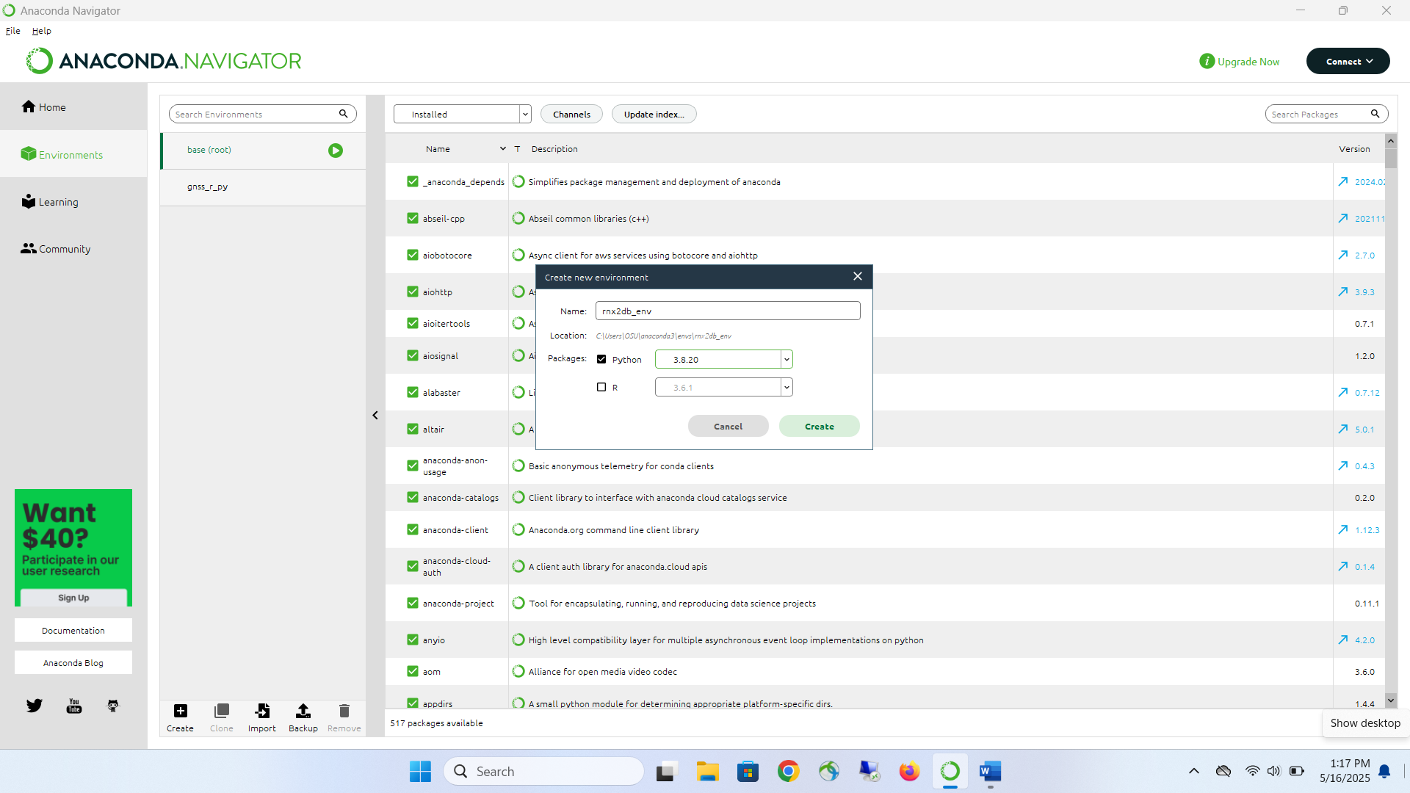 Figure 4: Create a new environment

- Left click on the green triangle and click on “Open terminal”

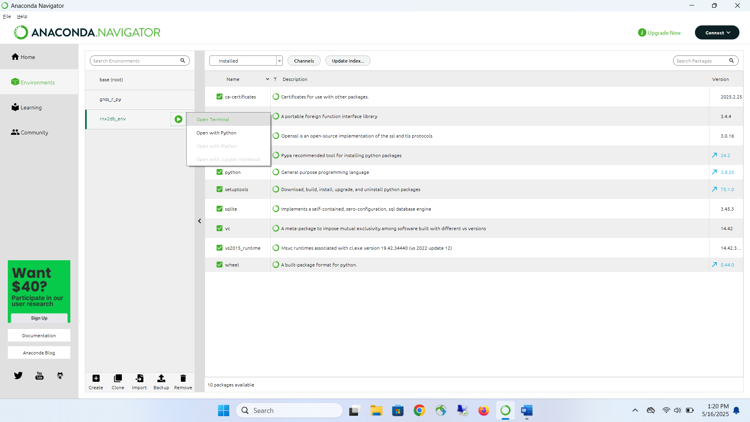
Figure 5: Open a terminal with new environment activated

- Once the terminal is opened as shown in Figure 6, type in
- pip cache purge

This clears the cache which sometimes becomes necessary to solve corrupted packages.

- pip install -r C:\Projects\rnx2db-main\requirements.txt and press “Enter” to install the supporting packages

Note: path to requirements.txt should match the path shown in Figure 1
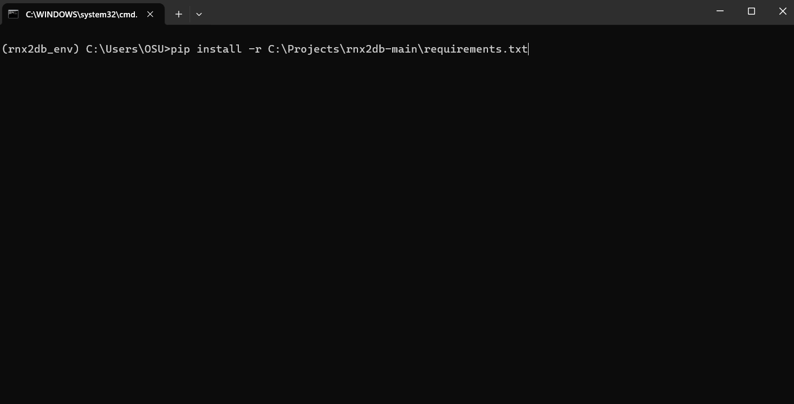
Figure 6: Installing support packages in rnx2db_env environment
- Once installed, all the supporting packages will be visible in Anaconda Navigator as shown in Figure 7

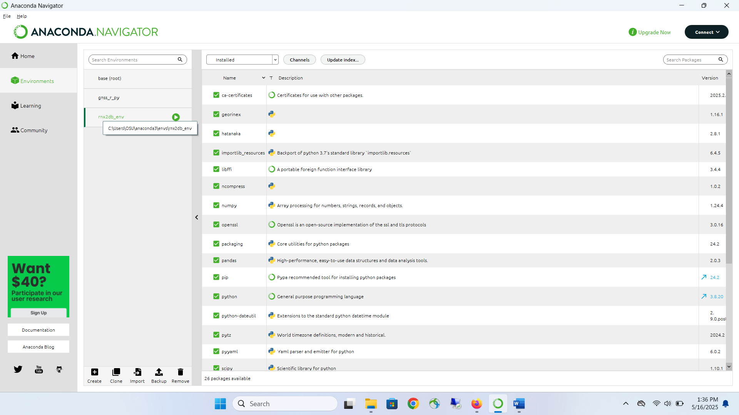
Figure 7: New packages installed in rnx2db_env environment.

Running RNX2DB to process rinex files

Specify rinex input files in config.yaml

- For processing a single day’s rinex observation and navigation file, set the following headers:
rinex:
multiday: # options for multiday process
enabled: false # if true, it will read obs_location directory and try to process all data
singlefile:
date: '2024-07-10'
observation:
- rnx2db_testdata/one_day/QRTR1920.24O
navigation:
- rnx2db_testdata/one_day/QRTR1920.24P

Invoke rnx2db_env and run
- In order to run rnx2db.py in C:\Projects\rnx2db-main, invoke the rnx2db_env environment by opening Anaconda Navigator, and clicking on “Open Terminal” as shown in Figure 8

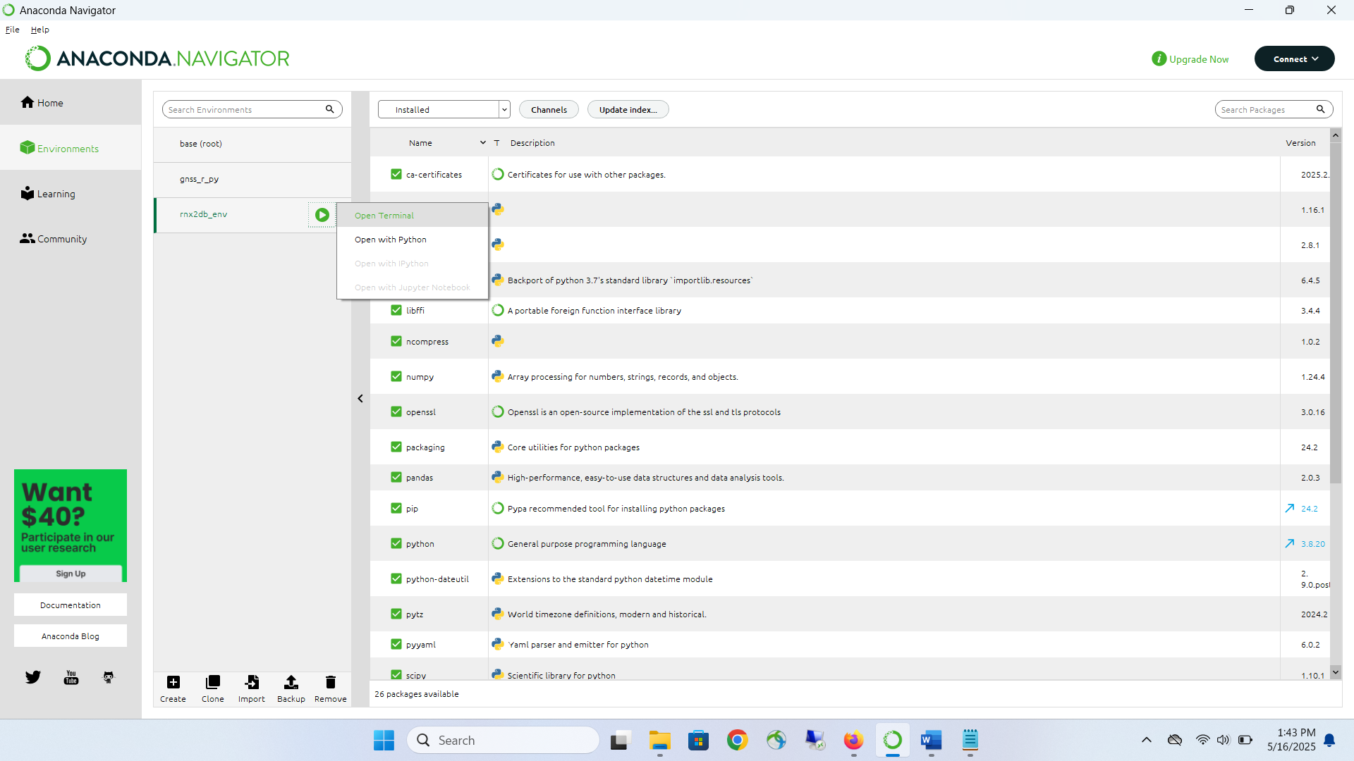
Figure 8: Invoke the rnx2db_env in terminal

- Navigate to rnx2db-main folder as shown in Figure 9, and run “python rnx2db.py”
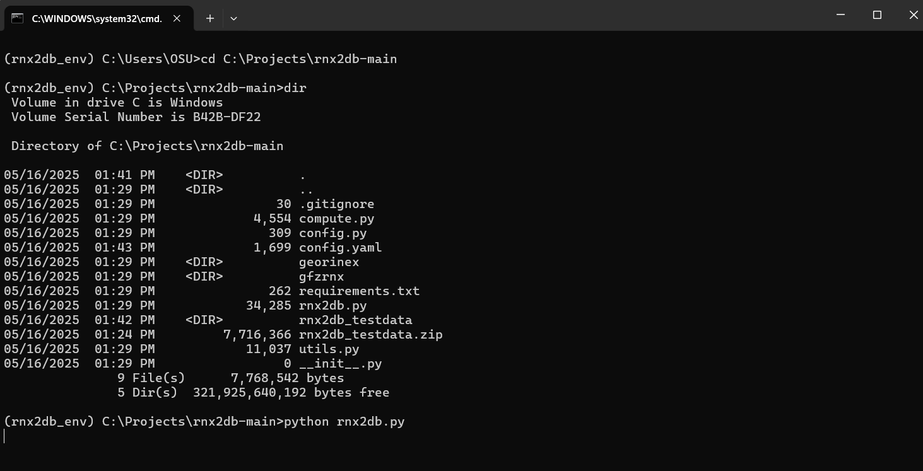 Figure 9: Run rnx2b.py

