HERA-Prototype Staging

**David DeBoer**

**2014 December 12**

This document describes the staging of the HERA-19 Prototype project, which will deploy 19 elements on the southwest corner of the existing PAPER circle along with the co-located initial infrastructure for the eventual complete HERA telescope. **H19** denotes the area in which the HERA-19 prototype will be built, which is an 85-m circle centered at 540916 E, 6601096 N. *H19.1*, *H19.2*, … *H19.19* denote the individual elements proceeding in a raster scan fashion.

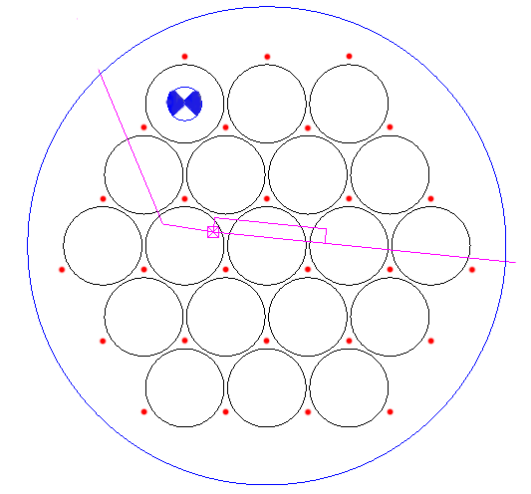This drawing shows the various locations. The large round blue circle is **H19** and the blue target is *H19.1*. The black circles are the 19 elements’ perimeters and the small red circles are the pole locations. The cyan lines are the trench line, with the cyan ‘X’ being the one node within **H19**. Note the cyan rectangle coming off from the node, which is the air-cooling trenching loop.

The sections below provide a high-level description of the activities in order of occurrence:

* Location of elements
* Install 27 poles
* Install 3 hubs for *H19.1-.3*
* Install pole-supports for *H19.1-.3*
* Install rim and post/post-supports for *H19.1-.3*
* Install PVC and surface mesh for *H19.1-.3*
* Install node infrastructure within **H19**
* Install remaining hubs etc including any refinements (*H19.4-.19*)

# 1 – Location of elements

A survey was conducted to locate the positions of the 27 poles, as well as the center of *H19.1*. The pole positions are marked with a large nail pushed into the ground through a small (~30mm) red or orange round bicycle reflector. Tall (roughly 1-m) rebar stakes mark the western edge of each of the 6 rows of poles.

*H19.1* is similarly located and has some short metal stakes around it with a small square piece of plywood to indicate that it is not a pole location, but served as the survey station. This picture of the strapping young man shows the Total Station set up over *H19.1*.

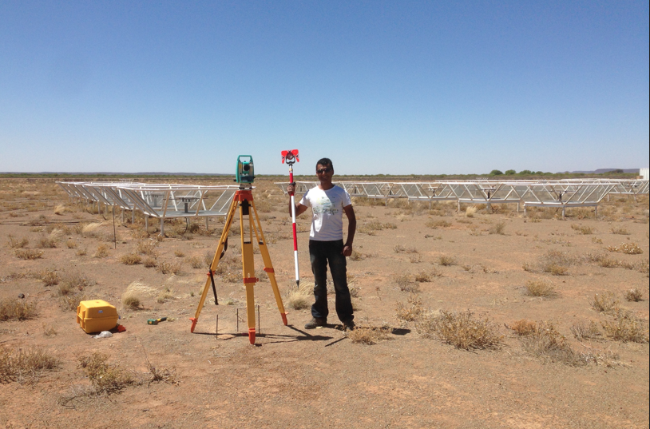

This activity is complete.

# 2 – Install 27 poles

A contractor will procure and install the poles, per the drawing currently being generated. As mentioned above, the 27 pole locations are the small red circles in the first figure. Although they have been surveyed, for purposes of the contract they will be specified as offsets from the *H19.1* survey location.

The poles should be 200±50 mm in diameter and 6m of pole should be above grade. The installation depth will be approximately 1m, so the poles must exceed 7m in length.

# 3 – Install 3 hubs (*H19.1, H19.2, H19.3*)

As a first pass, we will install three elements to allow for a small prototyping and refinement cycle. Installing the hubs requires:

* theodolite (or Total Station)
* centering jig
* hub jig
* bracing pieces, stakes, etc
* two outer hub pieces (2)
* inner hub piece (1)
* ~3m long horizontal support pvc pieces (12)
* the ~30cm long spar hub sleeves (12)
* the spar/sleeve nails (48)
* interior rebar set (1)
* concrete (~“1 yard”)

The detailed procedure is set out in the procedure guide, but a high-level description is given here.

Using the theodolite, three small eyebolts are placed in the poles at a constant height and the centering jig is stretched between them. This locates the center and the hub pieces and hub jig is centered on this point and then leveled. The spars and sleeves are then inserted and pegged into place with the nails. The concrete is then added. After it has cured for 12? hours, the jigs may be removed.

# 4 – Install pole-supports *(H19.1-.3)*

When the hub has cured for 24? hours, the rest of the supporting structure may be installed. Needed for this step are:

* Total Station/ladder
* wood support “vertical” pieces (3 pole sets)
* wood support “horizontal” pieces (3 pole sets)
* support endcaps (3)
* endcap targets (3)
* fastening hardware

The detailed procedure is set out in the procedure guide, but a high-level description is given here.

The Total Station is set up at a prescribed height above the hub and set to the prescribed angle. The wood support “vertical” pieces are then sequentially installed on the poles. The “horizontal” pieces and endcaps are mated and the targets installed. The Total Station is used to place and fix this assembly at the prescribed positions. When fixed, the targets may be removed.

# 5 – Install rim and post/post-supports for *(H19.1-.3)*

This is one of the trickier steps in the process. For this stage you will need:

* Total Station/ladders
* horizontal rim pieces (12)
* vertical posts (7, 8, or 9, depending if some are already there from existing adjacent elements)
* wood support pieces (9 post sets)
* support endcaps (9)
* endcap targets (3 or more)
* base forms (9)
* base rebar (9 sets)
* bracing pieces, stakes etc
* concrete

The detailed procedure is set out in the procedure guide, but a high-level description is given here.

Using the (1) horizontal rim pieces, (2) vertical posts, (3) wood support pieces, (4) endcaps, and (5) base forms (if necessary at this point, depending on how they are done) for three locations between two poles, the three assemblies are “roughed in”. Note that the needed wood support pieces will vary based on which post location you are at, per the following:

1. If the post is already there – use both the horizontal and vertical pieces since the post is fixed. Note that you will need the Total Station to be set up as before to locate the endcap target and fix the piece. Do these first.
2. if the post is not there (that is, you are not using a post already installed as part of a previous element) – use the “vertical” pieces only. This is because you can move the post as needed for the “horizontal” positioning.

You will now have the three posts and four rim pieces between each pair of poles roughly in location and loosely braced, with any posts previously installed fixed (which helps). With the Total Station set up as before and using the targets, you will then position the post assemblies to the prescribed locations, firmly brace them in and concrete them into place (using the rebar to help fix them to the ground).

# 6 – Install PVC and surface mesh for *(H19.1-.3)*

This is one of the more time-consuming steps (installing the mesh). Needed items are:

* level/ladder
* vertical support pvc assembly (12 sets)
* cross-spar pvc assembly (12 sets)
* pvc full spar (12)
* pvc partial spar (12)
* mesh panels

The detailed procedure is set out in the procedure guide, but a high-level description is given here.

Install the vertical support pvc assembly onto the end of each support spar coming from the hub, making sure it is upright. Put the pvc full spar into the hub sleeve and rest on the pole/post endcaps. Using the ladder, look through the bolt hole in the pvc and see if it lines up to the proper place on the endcap – “seeing wood is good”. Fix the spar at the end. Fix the spar on the end of the vertical support pvc assembly. The 12 full-length spars are now in place.

Install the cross-spar pvc assemblies by lining up the pre-drilled holes and bolting into place. Install the pvc partial spar into the cross-spar assembly and attach to the bracket in the middle of the rim piece. The pvc is now fully in place.

Install the mesh panels.

# 7 – Install node infrastructure within H19

While HERA will not use the node configuration for a year or more, the infrastructure that goes in under the elements must be put in before the elements themselves. This comprises one node plinth and the trenching and conduit for that node plus the other nodes after then in the line. However, the first three elements do not get in the way, so this can wait until they are in or be installed in parallel.

The node infrastructure comprises the following:

* foundation (~100 x 140 x 15 cm, cast in place)
* fibre pull-box (accommodate 100mm in/out & 50mm out)
* power pull-box (accommodate 50mm in/out & 50 mm out)
* grounding assembly
* 150mm conduit (about 50m with 4 sweeps)
* 100mm conduit (about 100m)
* 50mm conduit (about 100 m with 2+ sweeps)

The pictures below show the node with and without the ground, then zoomed out to see the forced air loop. The ends of the conduits will just be capped and marked for now until they are connected to the full system when implemented.

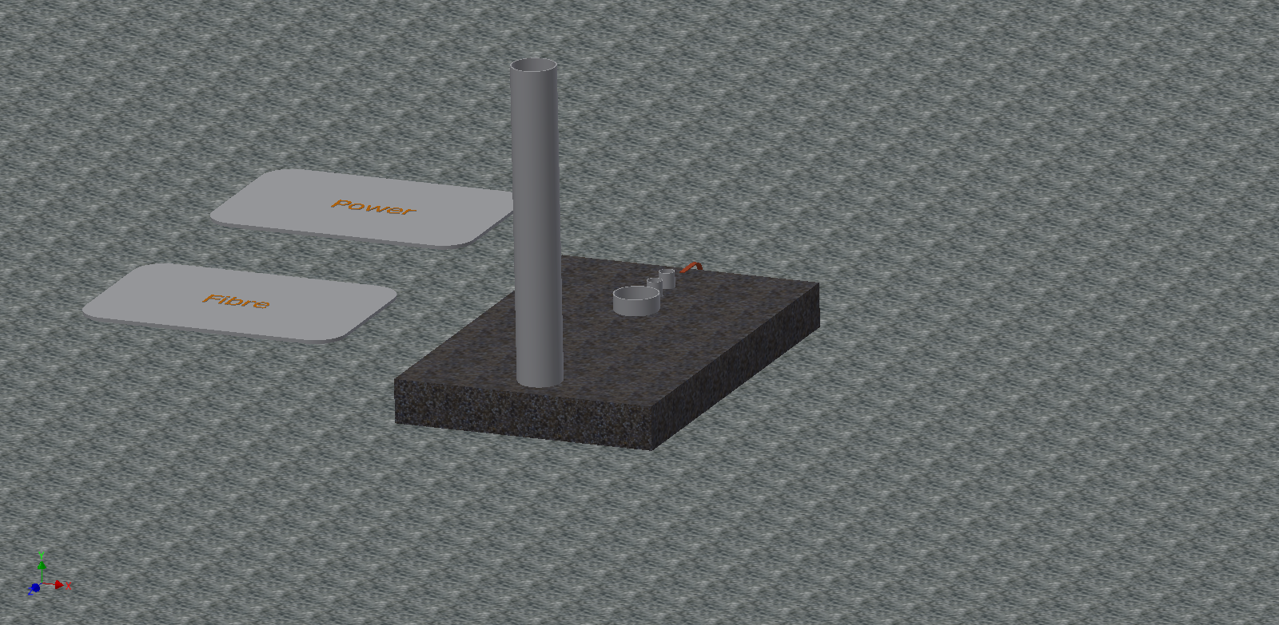

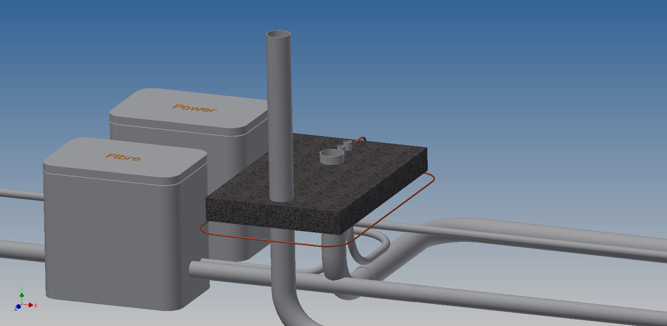

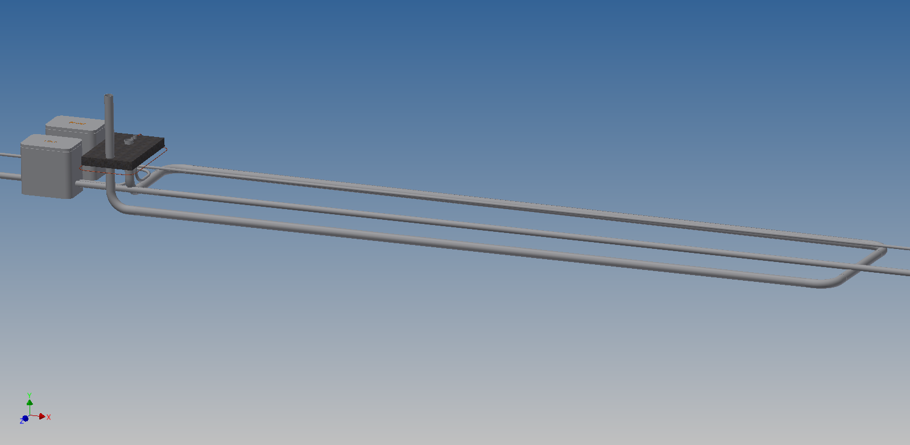

# 8 – Install remaining, including any refinements (*H19.4-.19*)

Follow steps 3-6 for the rest of the elements.