Surface Installation Notes

17 May 2015

The surface comprises 5 rings of mesh (or screen) panels labeled A-E (inner-to-outer). There are 12 panel A and 24 panels in B-E. One panel in rings B and C are used as access to the hub. Figure 1 shows the panel layout and Table I lists some of the ring parameters.

**Table I:** Ring parameters.

|  |  |  |  |
| --- | --- | --- | --- |
| **Ring letter** | **Color in Figure 1** | **Number/ring** | **Access hatch** |
| A | blue | 12 | no |
| B | red | 24 | yes |
| C | magenta | 24 | possibly |
| D | cyan | 24 | no |
| E | green | 24 | no |

…

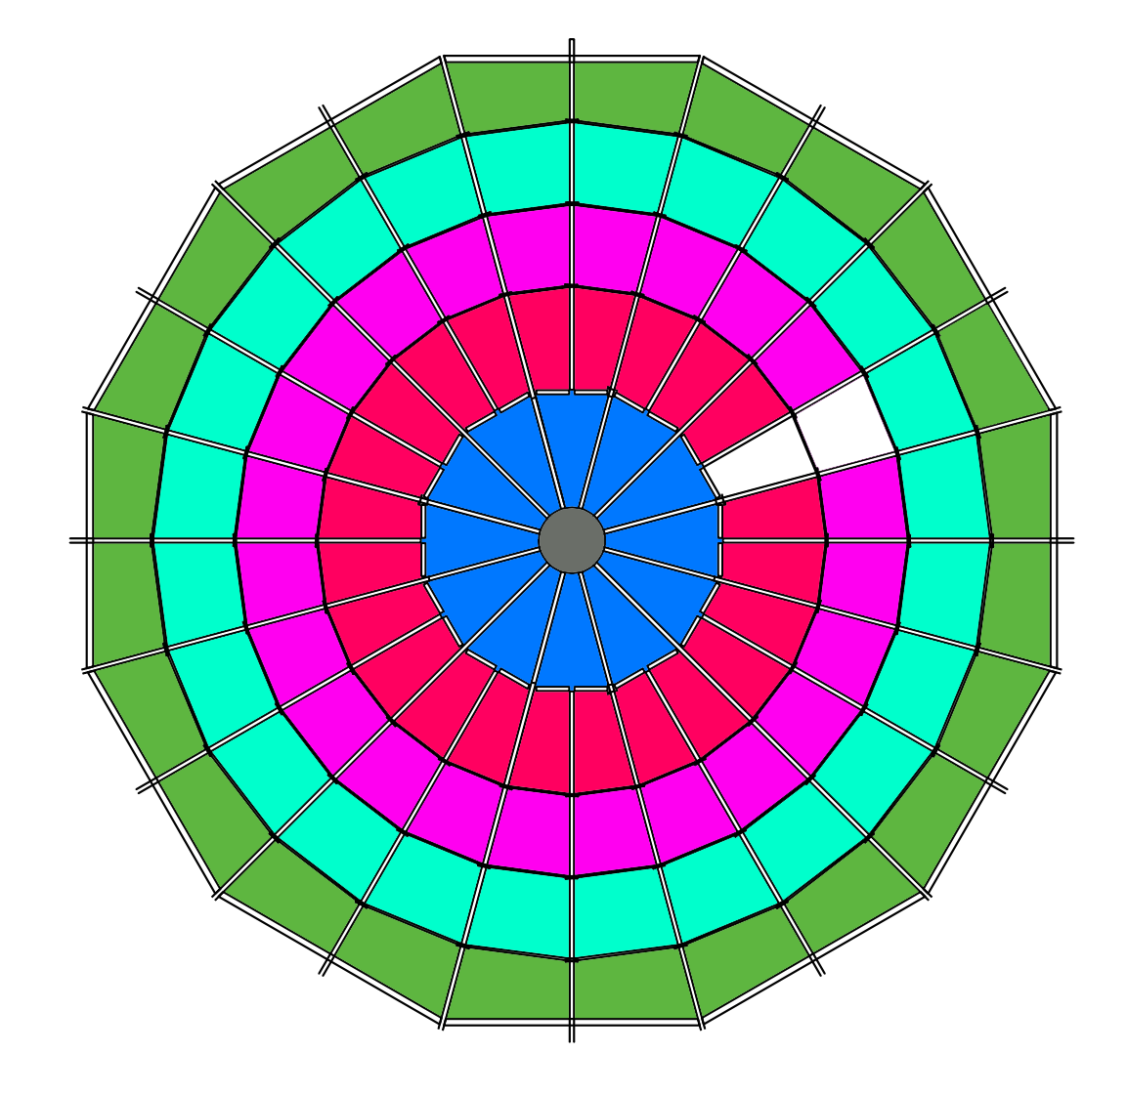

Segment 23 (or 11 for ring A)

Segment 1

Segment 0

**Figure 1:** Layout of HERA element panels.

The panels overlap by about 4 inches. The overlap occurs either along a PVC beam or a metal strip. The overlapped panels should be solidly sandwiched to those beams by multiple screws. More screws along the overlaps are better than fewer, so place as necessary, even if there is no pre-drilled hole at the location.

Figure 2 shows a cross-section of the overlap at one of the metal strips. The yellow rectangle is a piece of wood. Note that at a spar/strip junction there will be a small section of four overlapping panels. At the metal strip overlaps, the mesh gets pulled down slightly through to the strips, as shown in the Figure 2.

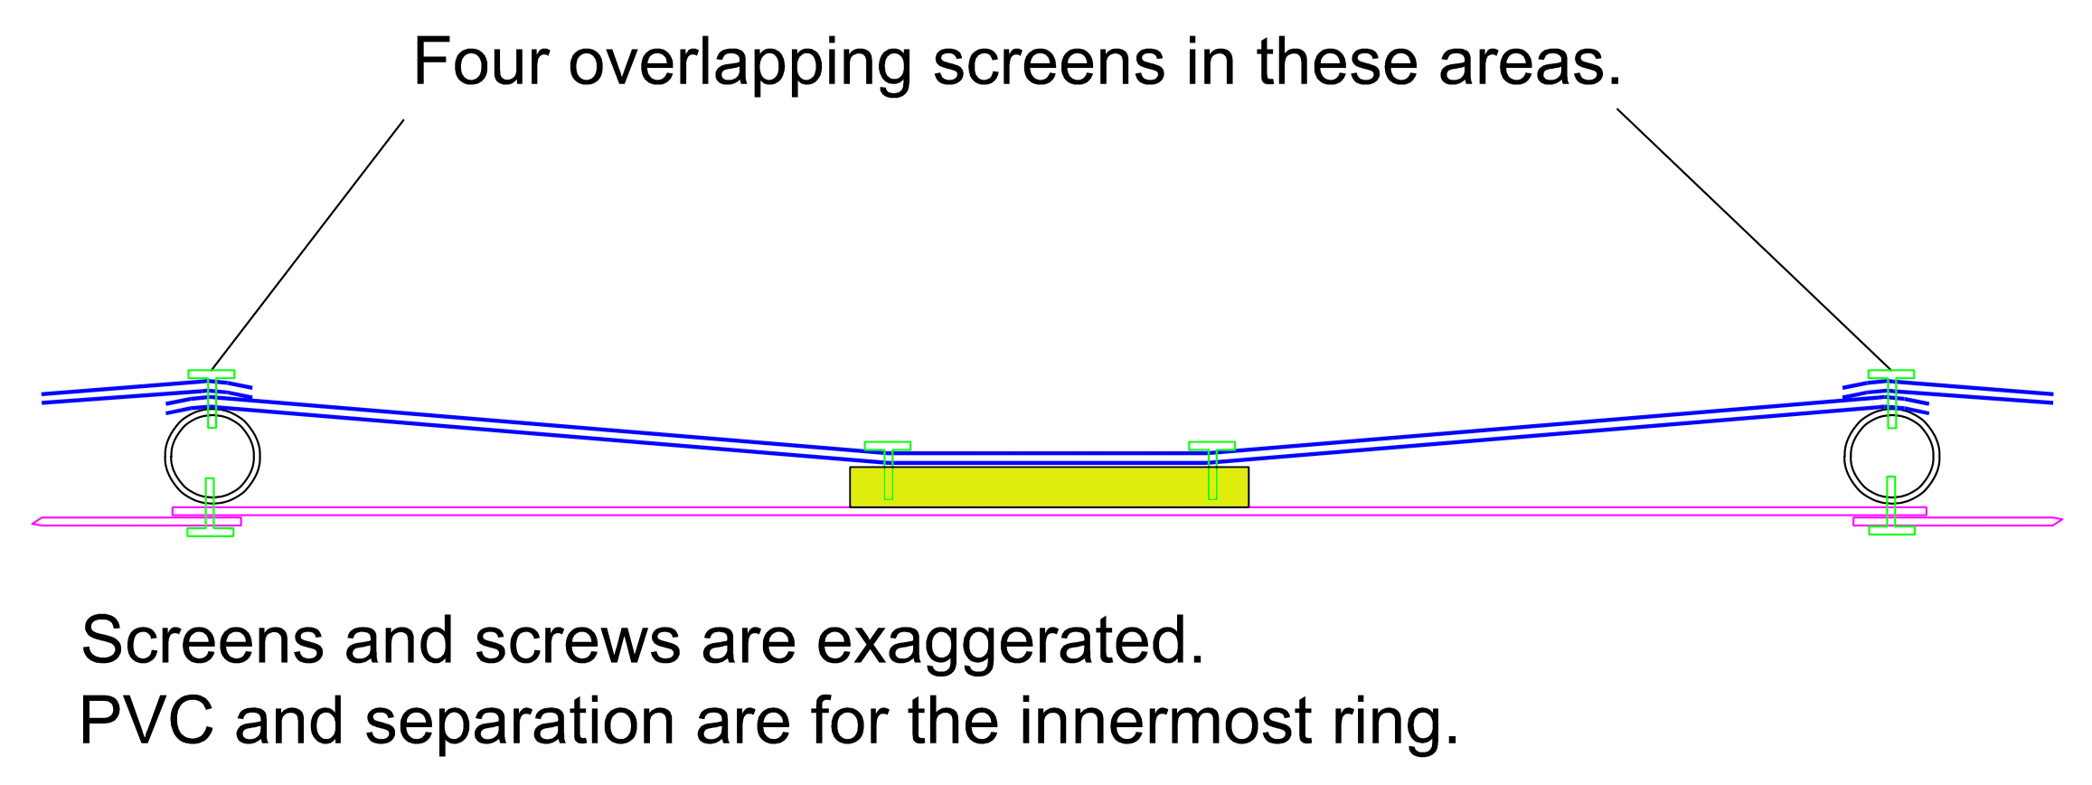

**Figure 2:** Cross-section of mesh/strip overlap.

**Installation**

The mesh panels go on after the spars and strips are all installed. The spars have pre-drilled holes roughly every 12” along the top to aid in installation. Ideal screws are ½” #8 self-piercing lath screws.

*Determine Segment 0 (door)*

1. Identify the location that will be the access panels (generally pointed towards a useful direction, such as the hut). This is labeled ‘segment 0’ in Figure 1, with B-0 and C-0 shown blank.

*Ring A*

1. Install all of ring A along the radial spars. The process is to fully attach one side along the radial spar (*i.e.* using all of the pre-drilled holes) then 2-3 screws on the other side to keep it taut. Then on the adjacent segment panel, you overlap the mesh and put in the rest of the screws to hold it.
2. Don’t put any screws into the PVC cross-assembly piece (the A-B overlap) at this time.
3. Note that a wooden step at the appropriate height and angled will be needed to step onto the hub for the last panel installation, as well as afterwards.

*Ring B*

1. Standing in the B-0 area, install the B-1 panel along the edge of the segment 0 spar. Use all of the ~12” pre-drilled holes.
2. Standing in the B-2 area, attach the panel at 2 or 3 points along that radial spar.
3. Screw through the panel A-B overlap along the cross-assembly spar.
4. Don’t screw through the B-C overlap strips at this point.
5. For segments *i*=2-23, stand in the *i*+1 and lean across to install the screws on the far side and continue this pattern around the element for the remainder of ring B.

*Ring C*

1. Proceed around as per ring B, however now put in the two screws in the overlap strip between rings B-C and not those at C-D

*Ring D-E*

1. Same as per B and C, however you don’t have a clear segment 0 area to start from and the distances are quite far to lean across from the other side to put in the screws (as might be the case for C if the access area is not needed). The panels however are shorter radially and you will lean in from the next outer ring. You may also need to do this in part for the ring C installation.
2. For panel E, let the mesh follow the spar as far as possible, then bend out to attach to the wooden rim.