HERA-Prototype Staging

**David DeBoer**

**2014 December 11**

This document describes the staging of the HERA-19 Prototype project, which will deploy 19 elements on the southwest corner of the existing PAPER circle along with the co-located initial infrastructure for the eventual complete HERA telescope. **H19** denotes the area in which the HERA-19 prototype will be built, which is an 85-m circle centered at 540916 E, 6601096 N. *H19.1*, *H19.2*, … *H19.19* denote the individual elements proceeding in a raster scan fashion.

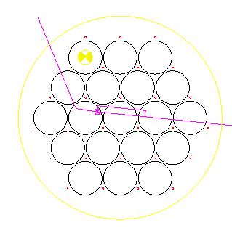This drawing shows the various locations. The round yellow circle is **H19** and the yellow target is *H19.1*. The black circles are the 19 elements’ perimeters and the small red circles are the pole locations. The cyan lines are the trench line, with the cyan ‘X’ being the one node within H19. Note the cyan rectangle, which is air-cooling trenching.

The sections below provide a high-level description of the activities in order of occurrence:

* Location of elements
* Install 27 poles
* Install 3 hubs for *H19.1-.3*
* Install pole-supports for *H19.1-.3*
* Install rim and post/post-supports for *H19.1-.3*
* Install PVC and surface mesh for *H19.1-.3*
* Install node infrastructure within **H19**
* Install remaining hubs etc including any refinements (*H19.4-.19*)

# 1 – Location of elements

A survey was conducted to locate the positions of the 27 poles, as well as the center of *H19.1*. The pole positions are marked with a large nail pushed into the ground through a small (~30mm) red or orange round bicycle reflector. Tall (roughly 1-m) rebar stakes mark the western edge of each of the 6 rows of poles.

*H19.1* is similarly located and has some short metal stakes around it with a small square piece of plywood to indicate that it is not a pole location, but served as the survey station. This picture of the strapping young man shows the Total Station set up over *H19.1*.

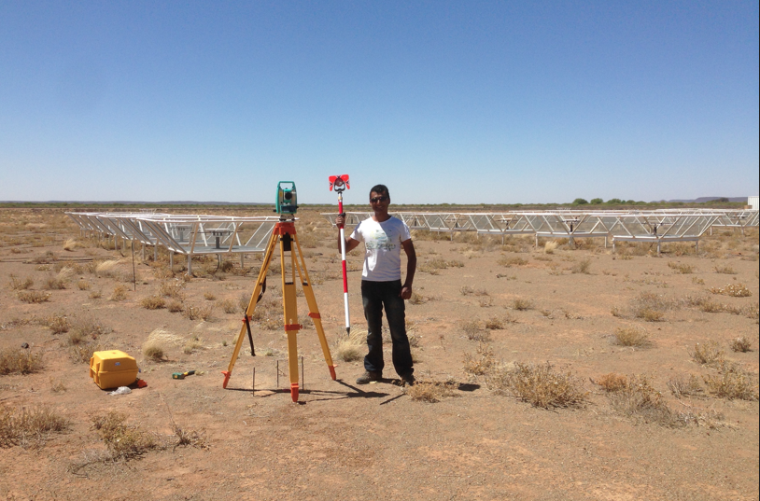

This activity is complete.

# 2 – Install 27 poles

A contractor will procure and install the poles, per the drawing currently being generated. As mentioned above, the 27 pole locations are the small red circles in the first figure. Although they have been surveyed, for purposes of the contract they will be specified as offsets from the *H19.1* survey location.

The poles should be 200±50 mm in diameter and 6m of pole should be above grade. The installation depth will be approximately 1m, so the poles must exceed 7m in length.

# 3 – Install 3 hubs (*H19.1, H19.2, H19.3*)

As a first pass, we will install three elements to allow for a small prototyping and refinement cycle. Installing the hubs requires:

* theodolite (or Total Station)
* centering jig
* hub jig
* bracing pieces, stakes, etc
* two outer hub pieces (2)
* inner hub piece (1)
* ~3m long horizontal support pvc pieces (12)
* the ~30cm long spar hub sleeves (12)
* the spar/sleeve nails (48)
* interior rebar set (1)
* concrete (~“1 yard”)

The detailed procedure is set out in the procedure guide, but a high-level description is given here.

Using the theodolite, three small eyebolts are placed in the poles at a constant height and the centering jig is stretched between them. This locates the center and the hub pieces and hub jig is centered on this point and then leveled. The spars and sleeves are then inserted and pegged into place with the nails. The concrete is then added. After it has cured for 12? hours, the jigs may be removed.

# 4 – Install pole-supports *(H19.1-.3)*

When the hub has cured for 24? hours, the rest of the supporting structure may be installed. Needed for this step are:

* Total Station
* ladder
* wood support “vertical” pieces (3 pole sets)
* wood support “horizontal” pieces (3 pole sets)
* support endcaps (3)
* endcap targets (3)
* fastening hardware

The detailed procedure is set out in the procedure guide, but a high-level description is given here.

The Total Station is set up at a prescribed height above the hub and set to the prescribed angle. The wood support “vertical” pieces are then sequentially installed on the poles. The “horizontal” pieces and endcaps are mated and the targets installed. The Total Station is used to place and fix this assembly at the prescribed positions. When fixed, the targets may be removed.

# 5 – Install rim and post/post-supports for *(H19.1-.3)*

This is one of the trickier steps in the process. For this stage you will need:

* Total Station
* ladders
* horizontal rim pieces (12)
* vertical posts (7, 8, or 9, depending if some are already there from existing adjacent elements)
* wood support pieces (9 post sets)
* support endcaps (9)
* endcap targets (3 or more)
* base forms (9)
* base rebar (9 sets)
* bracing pieces, stakes etc
* concrete

The detailed procedure is set out in the procedure guide, but a high-level description is given here.

Using the (1) horizontal rim pieces, (2) vertical posts, (3) wood support pieces, (4) endcaps, and (5) base forms (if necessary at this point, depending on how they are done) for three locations between two poles, the three assemblies are “roughed in”. Note that the needed wood support pieces will vary based on which post location you are at, per the following:

1. If the post is already there – use both the horizontal and vertical pieces since the post is fixed. Note that you will need the Total Station to be set up as before to locate the endcap target and fix the piece. Do these first.
2. if the post is not there (that is, you are not using a post already installed as part of a previous element) – use the “vertical” pieces only. This is because you can move the post as needed for the “horizontal” positioning.

You will now have the three posts and four rim pieces between each pair of poles roughly in location and loosely braced, with any posts previously installed fixed (which helps). With the Total Station set up as before and using the targets, you will then position the post assemblies to the prescribed locations, firmly brace them in and concrete them into place (using the rebar to help fix them to the ground).

6 – Install PVC and surface mesh for *(H19.1-.3)*

7 – Install node infrastructure within **H19**

8 – Install remaining hubs etc including any refinements (*H19.4-.19*)