Day 11 - 30th July 2026

Task 1:
What is an Actuator in Spring boot?
Actuator in Spring Boot is a feature that helps you monitor and manage your Spring Boot application while it is running. It provides useful information like the application's health, performance, memory usage, and other details through ready-made endpoints. This makes it easier for developers to check if the application is working properly and troubleshoot issues. In simple words, Actuator acts like a health check and monitoring tool for your application.

Task 2:
Advantages of Actuator
- It increases customer satisfaction.
- It reduces downtime.
- It boosts productivity.
- It improves Cybersecurity Management.
- It increases the conversion rate.

Task 3:
What are the commonly used Actuator end points?

EndpointID | Description
beans | Displays a complete list of all the Spring beans in your application.
caches | Exposes available caches.
conditions | Shows conditions evaluated on configuration and auto-configuration classes.
health | Shows application health information.
httptrace | Displays HTTP trace information (last 100 requests).
loggers | Shows and modifies the configuration of loggers in the application.
mappings | Displays a collated list of all @RequestMapping paths.
sessions | Retrieves and deletes user sessions (requires Spring Session).
threaddump | Performs a thread dump.

Task 4:
Create a Small demo of Actuator to know the functionality

ActuatordemoApplication.java
package main.java.com.example.actuatordemo;

import org.springframework.boot.SpringApplication;
import org.springframework.boot.autoconfigure.SpringBootApplication;

@SpringBootApplication
public class ActuatordemoApplication {

public static void main(String[] args) {
SpringApplication.run(ActuatordemoApplication.class, args);
}

}

HelloController.java
package main.java.com.example.actuatordemo;

import org.springframework.web.bind.annotation.GetMapping;
import org.springframework.web.bind.annotation.RestController;

@RestController
public class HelloController {

@GetMapping("/")
public String home() {
return "Welcome to Spring Boot Actuator Demo!";
}
}

application.properties
server.port=8080

management.endpoints.web.exposure.include=*

management.endpoint.health.show-details=always

pom.xml Dependency
<dependency>
<groupId>org.springframework.boot</groupId>
<artifactId>spring-boot-starter-web</artifactId>
</dependency>

<dependency>
<groupId>org.springframework.boot</groupId>
<artifactId>spring-boot-starter-actuator</artifactId>
</dependency>

Task 5:
What is Spring Security Architecture?
Spring Security Architecture defines the components and workflow used to authenticate users and authorize access to application resources. It secures web applications by processing requests through a chain of security filters before they reach the application.
- Secures web applications using a filter chain.
- Handles authentication and authorization.
- Supports multiple login methods (Form, JWT, OAuth2, LDAP).
Spring Security Architecture
This diagram shows how an HTTP request is processed through the Spring Security filter chain to handle authentication and authorization before returning the response.
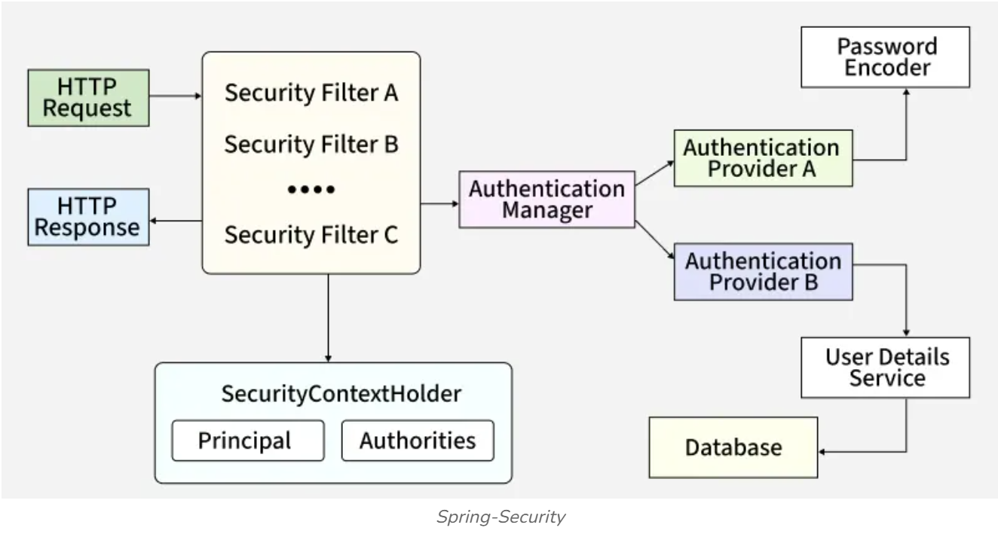
Task 6:
What are the core components of Spring security architecture
Core Components of Spring Security Architecture
1. Security Filter Chain
- Acts as the entry point for all incoming HTTP requests in Spring Security
- Every request passes through a chain of filters such as UsernamePasswordAuthenticationFilter and BasicAuthenticationFilter
- Handles authentication, authorization, CSRF protection, and session management
- Ensures a modular and customizable security flow
2. Authentication Manager
- Core component responsible for handling user authentication
- Delegates authentication requests to one or more AuthenticationProvider instances
- Follows the Strategy design pattern, allowing multiple authentication mechanisms such as DB, LDAP, JWT, and OAuth2
3. Authentication Providers
- Authentication Providers are the components responsible for validating user credentials
- They process authentication requests coming from the AuthenticationManager
- Different providers support different authentication mechanisms
4. UserDetailsService
- Loads user-specific data (username, password, roles) from a data source like a database.
- Returns a UserDetails object.
- Used primarily by providers like DaoAuthenticationProvider.
5. Password Encoder
- Ensures secure password storage and validation.
- Encodes raw passwords into secure hashes before saving/validation.
6. SecurityContextHolder
Stores the SecurityContext for the current request/thread. And holds the Authentication object, which contains:
- Principal: Represents the logged-in user (username or user object).
- Authorities: Roles/permissions granted to the user.

Task 7:
Can you create a diagrammatic representation of Spring Security architecture
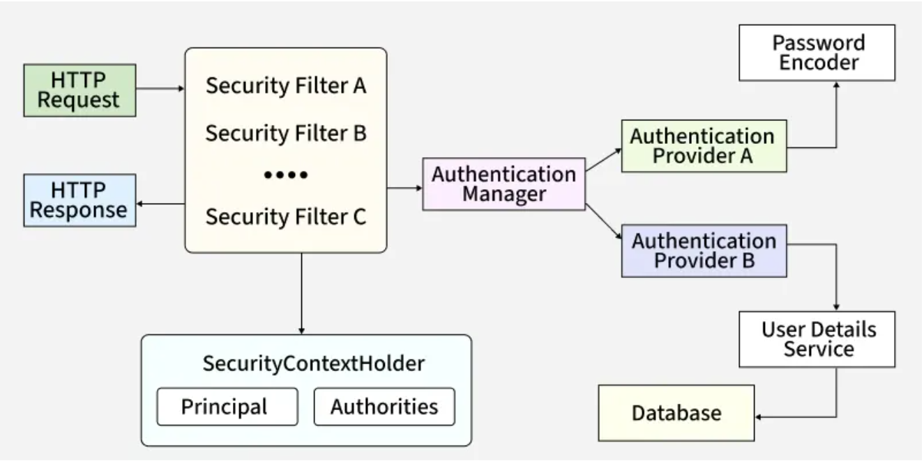

Task 8:
What is a Security filter chain? Give example code
- Acts as the entry point for all incoming HTTP requests in Spring Security
- Every request passes through a chain of filters such as UsernamePasswordAuthenticationFilter and BasicAuthenticationFilter
- Handles authentication, authorization, CSRF protection, and session management
- Ensures a modular and customizable security flow

@Configuration
public class SecurityConfig {

@Bean
public SecurityFilterChain
securityFilterChain(HttpSecurity http) throws Exception
{

http.csrf(
csrf
-> csrf.disable()) // Disable CSRF for APIs
.authorizeHttpRequests(
auth
-> auth.requestMatchers("/public/**")
.permitAll()
.anyRequest()
.authenticated())
.httpBasic(); // Enable Basic Authentication

return http.build();
}
}

Task 9:
What is an Authentication Manager? Give example code
Authentication Manager
- Core component responsible for handling user authentication
- Delegates authentication requests to one or more AuthenticationProvider instances
- Follows the Strategy design pattern, allowing multiple authentication mechanisms such as DB, LDAP, JWT, and OAuth2
@Configuration
public class AuthManagerConfig {

@Bean
public AuthenticationManager authenticationManager(
AuthenticationConfiguration configuration)
throws Exception
{

return configuration.getAuthenticationManager();
}
}

Task 10:
What are Authentication Proividers? Give example and code
- Authentication Providers are the components responsible for validating user credentials
- They process authentication requests coming from the AuthenticationManager
- Different providers support different authentication mechanisms
Examples:
- DaoAuthenticationProvider -> Uses database authentication with UserDetailsService and PasswordEncoder
- JwtAuthenticationProvider -> Validates JWT tokens
@Configuration
public class ProviderConfig {

@Bean
public DaoAuthenticationProvider authenticationProvider(
UserDetailsService userDetailsService,
PasswordEncoder passwordEncoder)
{

DaoAuthenticationProvider provider
= new DaoAuthenticationProvider();
provider.setUserDetailsService(userDetailsService);
provider.setPasswordEncoder(passwordEncoder);

return provider;
}
}

Task 11:
What is USerDeatilsService? Give example
- Loads user-specific data (username, password, roles) from a data source like a database.
- Returns a UserDetails object.
- Used primarily by providers like DaoAuthenticationProvider.
Example:
@Configuration
public class UserConfig {

@Bean
public UserDetailsService userDetailsService(PasswordEncoder encoder) {
return new InMemoryUserDetailsManager(
User.withUsername("john")
.password(encoder.encode("password"))
.roles("USER")
.build(),
User.withUsername("admin")
.password(encoder.encode("admin123"))
.roles("ADMIN")
.build()
);
}
}

Task 12:
What is Password encoder? Give example
- Ensures secure password storage and validation.
- Encodes raw passwords into secure hashes before saving/validation.
Example:
@Configuration
public class PasswordConfig {

@Bean
public PasswordEncoder passwordEncoder() {
return new BCryptPasswordEncoder(); // Strong hashing
}
}

Task 13:
What is SecurityContextHeader?
SecurityContextHeader is a SOAP header used in web services to carry security-related information with a SOAP message. It is defined by the WS-Security specification and helps ensure secure communication between a client and a server.
The SecurityContextHeader (or WS-Security Security header) can include information such as:
- Authentication credentials (for example, a username and password)
- Security tokens (such as X.509 certificates, SAML tokens, or Kerberos tokens)
- Digital signatures to verify message integrity and authenticity
- Encryption information to protect sensitive data
- Timestamps to prevent replay attacks
Purpose
- Authenticates the sender.
- Ensures the message has not been altered (integrity).
- Protects confidential information through encryption.
- Prevents unauthorized access to web services.

Task 14:
Finally give the security Architecture internal functionality? How actually it works internally… step by step if you can explain
How It Works Internally
- A client sends an HTTP request to the application.
- The request passes through the Security Filter Chain where multiple security filters are applied.
- The Authentication Manager receives the request and delegates authentication to the appropriate Authentication Provider.
- The Authentication Provider validates credentials using UserDetailsService and PasswordEncoder (if required).
- On successful authentication, user details are stored in SecurityContextHolder.
- Authorization is performed using the stored principal and authorities to check access permissions.
- If all checks pass, the request reaches the controller and an HTTP response is returned.

Task 15:
What is Thymeleaf? Explain? Why is it used?
Thymeleaf is a server-side Java-based template engine for both web and standalone environments, capable of processing HTML, XML, JavaScript, CSS and even plain text. It is more powerful than JPS and responsible for dynamic content rendering on UI. The engine allows a parallel work of the backend and frontend developers on the same view. It can directly access the java object and spring beans and bind them with UI. And it is mostly used with spring MVC when we create any web application

Task 16:
Create a demo on thymeleaf .
ThymeleafdemoApplication.java
package com.example.thymeleafdemo;

import org.springframework.boot.SpringApplication;
import org.springframework.boot.autoconfigure.SpringBootApplication;

@SpringBootApplication
public class ThymeleafdemoApplication {

public static void main(String[] args) {
SpringApplication.run(ThymeleafdemoApplication.class, args);
}

}

HomeController.java
package com.example.thymeleafdemo;

import org.springframework.stereotype.Controller;
import org.springframework.ui.Model;
import org.springframework.web.bind.annotation.GetMapping;

@Controller
public class HomeController {

@GetMapping("/")
public String home(Model model) {

model.addAttribute("name", "Karthik");
model.addAttribute("course", "Spring Boot with Thymeleaf");

return "home";
}
}

application.properties
spring.application.name=thymeleafdemo

server.port=8080

spring.thymeleaf.cache=false
<dependency>
<groupId>org.springframework.boot</groupId>
<artifactId>spring-boot-starter-thymeleaf</artifactId>
</dependency>

Task 17:
What do you think are the advantages of using thymeleaf?
Thymeleaf is a simple and powerful template engine used for creating dynamic web pages in Java applications.
It works well with Spring Boot and allows developers to easily connect backend data with HTML pages.
Its syntax is easy to understand and the templates can be viewed directly in a browser.
It provides good support for form handling, security, and reusable components, making development faster and cleaner.

Task 18:
What is Caching in Springboot?
Caching in Spring Boot is a technique used to store frequently used data temporarily, so it can be accessed faster.
Instead of fetching the same data repeatedly from the database, the application retrieves it from the cache.
It helps improve application performance, reduce database load, and provide faster responses.
Spring Boot provides easy caching support using annotations like @Cacheable, @CachePut, and @CacheEvict.

Task 19:
What are the features of Caching ?
- Easy Configuration
  - Spring Boot provides simple caching configuration using annotations without writing complex code.
- Improved Performance
  - Frequently used data is stored in the cache, which helps reduce response time and makes applications faster.
- Reduced Database Load
  - Caching avoids repeated database calls by storing previously fetched data temporarily.
- Multiple Cache Provider Support
  - Spring Boot supports different caching providers like EhCache, Caffeine, Redis, and Hazelcast.
- Annotation-Based Caching
  - It provides easy-to-use annotations like @Cacheable, @CachePut, and @CacheEvict to manage cache operations.
- Automatic Cache Management
  - Spring Boot automatically handles storing, retrieving, and updating cached data.
- Flexible Cache Control
  - Developers can control when to add, update, or remove data from the cache based on application requirements.

Task 20:
What are the types of Caching ?explain each type.
Types of Caching:
- In-Memory Cache
  - Data is stored in the application's memory (RAM), which makes data retrieval very fast.
  - Example: EhCache, Caffeine, Redis (with memory storage).
- Database Cache
  - Frequently used database queries or results are stored temporarily to reduce repeated database calls.
  - It improves database performance and reduces load.

- Distributed Cache
  - Cache data is stored on a separate server and can be shared by multiple application instances.
  - It is useful for large-scale applications running on multiple servers.
  - Example: Redis, Hazelcast.
- Application-Level Cache
  - Data is cached within the application itself to avoid repeated processing or calculations.
  - It helps improve application response time.
- Web Cache
  - Stores web resources like HTML pages, images, and API responses to reduce server requests.
  - It helps websites load faster for users.
- HTTP Cache
  - Browser or proxy servers store HTTP responses and reuse them when the same request is made again.
  - It reduces network traffic and improves performance.

Task 21:
List down annotations of Caching with usage.
Caching Annotations in Spring Boot:
- @EnableCaching
  - Enables caching support in a Spring Boot application. It is usually added to the main configuration class.
- @Cacheable
  - Stores the method result in the cache, so the next time the same request comes, data is fetched from the cache instead of executing the method again.

- @CachePut
  - Updates the cache with new data while also executing the method every time.
- @CacheEvict
  - Removes specific data from the cache when it is no longer needed or updated.
- @Caching
  - Allows using multiple caching annotations together on a single method.
- @CacheConfig
  - Provides common cache configuration settings at the class level, reducing repeated configuration in methods.

BankApplication
**********************************************************************************
Adding JUnit and Mockito dependencies
<dependency>
<groupId>org.springframework.boot</groupId>
<artifactId>spring-boot-starter-web</artifactId>
</dependency>
<!-- JUnit 5 -->
<dependency>
<groupId>org.junit.jupiter</groupId>
<artifactId>junit-jupiter</artifactId>
<version>5.10.2</version>
<scope>test</scope>
</dependency>

<!-- Mockito -->
<dependency>
<groupId>org.mockito</groupId>
<artifactId>mockito-core</artifactId>
<version>5.12.0</version>
<scope>test</scope>
</dependency>

<!-- Mockito JUnit 5 integration -->
<dependency>
<groupId>org.mockito</groupId>
<artifactId>mockito-junit-jupiter</artifactId>
<version>5.12.0</version>
<scope>test</scope>
</dependency>

<!-- Spring Web -->

</dependencies>

BankRepository.java
package com.bank;

public interface BankRepository {

BankAccount findByAccountNumber(String accountNumber);

void save(BankAccount account);
}

BankAccount.java
package com.bank;

public class BankAccount {

private String accountNumber;
private double balance;

public BankAccount(String accountNumber, double balance) {
this.accountNumber = accountNumber;
this.balance = balance;
}

public String getAccountNumber() {
return accountNumber;
}

public double getBalance() {
return balance;
}

public void setBalance(double balance) {
this.balance = balance;
}
}

BankService.java
package com.bank;

public class BankService {

private BankRepository repository;

public BankService(BankRepository repository) {
this.repository = repository;
}

public void deposit(String accountNumber, double amount) {

BankAccount account = repository.findByAccountNumber(accountNumber);

account.setBalance(
account.getBalance() + amount);

repository.save(account);
}

public void withdraw(String accountNumber, double amount) {

BankAccount account = repository.findByAccountNumber(accountNumber);

if (account.getBalance() < amount) {
throw new IllegalArgumentException(
"Insufficient funds");
}

account.setBalance(
account.getBalance() - amount);

repository.save(account);
}
}

BankServiceTest.java
package com.bank;

import org.junit.jupiter.api.Test;
import org.mockito.Mockito;

import static org.junit.jupiter.api.Assertions.*;
import static org.mockito.Mockito.*;

class BankServiceTest {

@Test
void testDeposit() {

BankRepository mockRepo = Mockito.mock(BankRepository.class);

BankAccount account = new BankAccount("123", 500);

when(mockRepo.findByAccountNumber("123"))
.thenReturn(account);

BankService service = new BankService(mockRepo);

service.deposit("123", 200);

assertEquals(700,
account.getBalance());

verify(mockRepo)
.save(account);
}

@Test
void testWithdrawSuccess() {

BankRepository mockRepo = Mockito.mock(BankRepository.class);

BankAccount account = new BankAccount("123", 500);

when(mockRepo.findByAccountNumber("123"))
.thenReturn(account);

BankService service = new BankService(mockRepo);

service.withdraw("123", 300);

assertEquals(300,
account.getBalance());

verify(mockRepo)
.save(account);
}

@Test
void testWithdrawInsufficientFunds() {

BankRepository mockRepo = Mockito.mock(BankRepository.class);

BankAccount account = new BankAccount("123", 100);

when(mockRepo.findByAccountNumber("123"))
.thenReturn(account);

BankService service = new BankService(mockRepo);

Exception ex = assertThrows(
IllegalArgumentException.class,
() -> service.withdraw("123", 200));

assertEquals(
"Insufficient funds",
ex.getMessage());

verify(mockRepo, never())
.save(account);
}
}

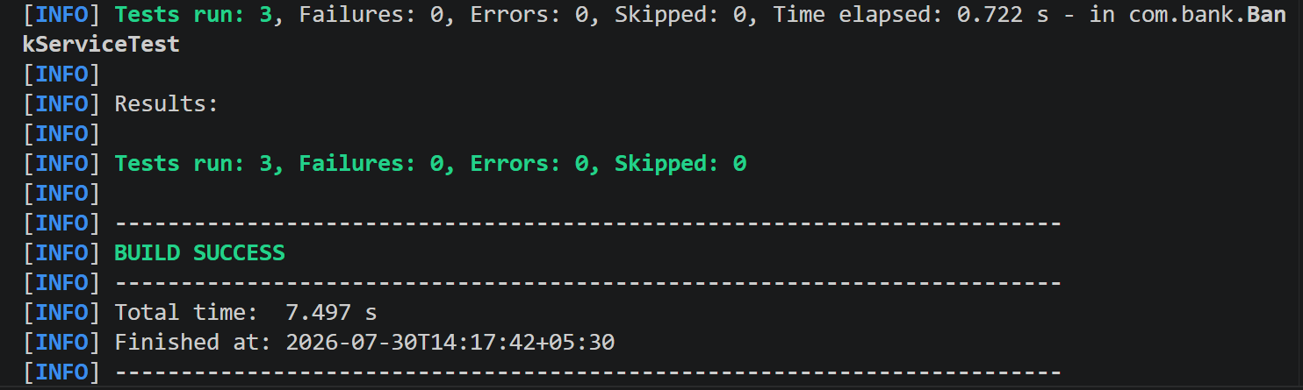
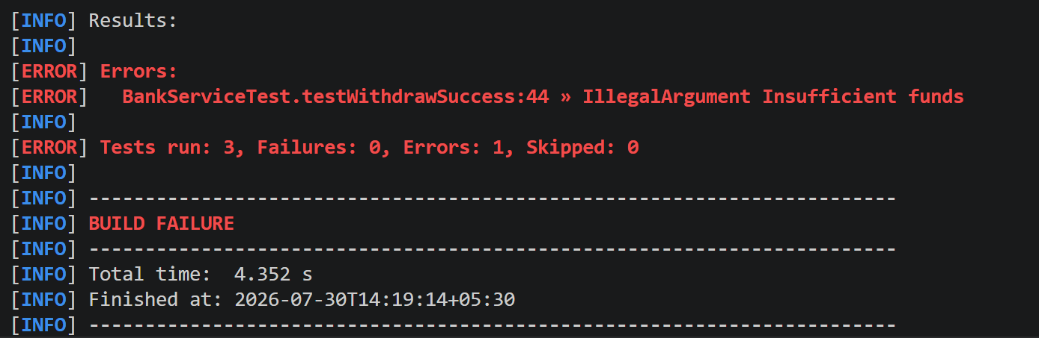

Task 22:
What do you think is @InjectMocks annotation does?
@InjectMocks is a Mockito annotation used to create an object of the class being tested and automatically inject its mock dependencies.
It works together with @Mock to replace real objects with mock objects during unit testing.
This helps test the class in isolation without depending on actual database or external services.
It also reduces the need to manually create and inject dependencies in test code.
Using @InjectMocks makes unit tests cleaner, easier to write, and easier to maintain.

Task 23:
Write about @spy annotation and explain the functionality in a small piece of code
@Spy is a Mockito annotation used to create a partial mock of a real object.
Unlike @Mock, a spy calls the actual methods of the object by default, but you can override specific methods when needed.
It is useful when you want to test a real object's behavior while mocking only a few methods.
This helps keep most of the original functionality while giving you control over selected parts during testing.
@Spy List
<String> list = new ArrayList<>();
@Test
public void testSpy() {
list.add("Java");
System.out.println(list.size()); // Output: 1 (real method is called)
}
In this example, list is a real ArrayList, so methods like add() and size() work normally. With @Spy, you can still mock specific methods if required for your test.

Task 24:
Why is @Mock annotation used?
@Mock is a Mockito annotation used to create a mock object for testing.
It replaces real dependencies with fake objects, so the test focuses only on the class being tested.
Mock objects do not execute the actual method logic unless you define their behavior using when() or thenReturn().
This makes unit tests faster, more reliable, and independent of databases or external services.
Using @Mock also helps isolate the code, making it easier to identify and fix issues during testing.

Task 25:
What is Partial mocking? Which annotation is used for partial mocking?
Partial mocking is a testing technique where some methods of a real object are executed normally, while specific methods are mocked.
It is useful when you want to test the actual behavior of a class but override only a few methods.
In Mockito, the @Spy annotation is used for partial mocking.
A spy object calls real methods by default, but you can mock selected methods when needed.
This makes testing more flexible while still using most of the original object's functionality.

Task 26:
For the code given what is @verify annotation used for and why do we use it?
verify() is a Mockito method used to check whether a specific method on a mock object was called during a test.
It helps confirm that the expected interaction between objects actually happened.
You can also use it to verify how many times a method was called, such as times(1) or never().
This makes unit tests more reliable by ensuring the correct methods are executed.
We use verify() to test the behavior of the code, not just the returned result, making tests more accurate and meaningful.

Task 27:
List down few more annotations that we use for mocking ..
Common Mockito Annotations Used for Mocking
- @Mock
  - Creates a mock object that replaces the real dependency during testing.
- @Spy
  - Creates a partial mock where real methods are called by default, but specific methods can be mocked.
- @InjectMocks
  - Creates an instance of the class under test and automatically injects the mock or spy objects into it.
- @Captor
  - Captures method arguments passed to mock objects, making it easy to verify the values used in method calls.
- @ExtendWith(MockitoExtension.class) (JUnit 5)
  - Enables Mockito annotations like @Mock, @Spy, and @InjectMocks without manual initialization.
- @MockBean (Spring Boot)
  - Creates a mock bean and adds it to the Spring application context, replacing the actual bean during testing.
- @SpyBean (Spring Boot)
  - Creates a spy bean in the Spring application context, allowing you to use the real bean while mocking selected methods.

