Day 24 - 18th Aug 2026

Demo 1

java
@Entity
public class Author {
@Id
@GeneratedValue(strategy = GenerationType.IDENTITY)
private Long id;
private String name;

// Books are loaded only when accessed
@OneToMany(mappedBy = "author", fetch = FetchType.LAZY)
private List<Book> books;
}

java
Author author = entityManager.find(Author.class, 1L);
// No SQL for books yet
System.out.println(author.getBooks().size());
// Triggers SQL: SELECT * FROM book WHERE author_id = 1;

And

Demo2

java
@Entity
public class Author {
@Id
@GeneratedValue(strategy = GenerationType.IDENTITY)
private Long id;
private String name;

// Books are loaded immediately with Author
@OneToMany(mappedBy = "author", fetch = FetchType.EAGER)
private List<Book> books;
}

java
Author author = entityManager.find(Author.class, 1L);
// SQL joins Author + Books in one query

1. First example = Lazy Loading
This part makes it Lazy:
@OneToMany(mappedBy = "author", fetch = FetchType.LAZY)
private List<Book> books;
The important part is:
fetch = FetchType.LAZY

What happens?
When you write:
Author author = entityManager.find(Author.class, 1L);
Hibernate gets the Author first.
Database
│
│ SELECT author WHERE id = 1
↓
Author
├── id
└── name

Books ❌ Not loaded yet
At this point, Hibernate says:
"I have the Author. I'll get the Books only if you ask me for them."
Then you write:
System.out.println(author.getBooks().size());
Now you are accessing the books.
Hibernate says:
"Okay, you need the books. I'll fetch them now."
So it executes something like:
SELECT * FROM book WHERE author_id = 1;
Therefore:
find(Author)
↓
Author loaded
↓
Books NOT loaded
↓
getBooks()
↓
Books loaded
That's Lazy Loading.

2. Second example = Eager Loading
This part makes it Eager:
@OneToMany(mappedBy = "author", fetch = FetchType.EAGER)
private List<Book> books;
The important part is:
fetch = FetchType.EAGER
When you write:
Author author = entityManager.find(Author.class, 1L);
Hibernate gets the Author AND Books immediately.
Conceptually:
Database
│
│ Get Author
│
├──────────────┐
↓ ↓
Author Books
├── id ├── Book 1
└── name ├── Book 2
└── Book 3
You haven't even written:
author.getBooks();
but the books have already been loaded.
That's Eager Loading.

1. How does ORM bridge the gap between object-oriented programming and relational databases, and what role does JPA play?
Simple answer
ORM (Object-Relational Mapping) acts as a bridge between Java objects and database tables.
In Java, we work with:
Java Object → Class → Object
In a relational database, we work with:
Table → Rows → Columns
ORM maps them:
Java Class → Database Table
Java Object → Database Row
Class Variable → Table Column
For example:
@Entity
class Employee {
Long id;
String name;
}
can be mapped to:
Employee Table
--------------------
id | name
1 | Karthik
2 | Rahul
JPA is a specification/standard that defines how Java objects should be mapped to relational databases.
Hibernate is one of the popular implementations of JPA.
Remember:
ORM = concept/bridge
JPA = rules/specification
Hibernate = implementation of those rules

2. Why is Hibernate considered a powerful JPA implementation, and how does caching improve performance?
Hibernate is powerful because it handles many database-related tasks automatically.
Instead of writing SQL for every operation:
SELECT * FROM employee WHERE id = 1;
we can write:
Employee employee = entityManager.find(Employee.class, 1L);
Hibernate handles the database interaction.
It provides features such as:
- Automatic object-table mapping
- Lazy/Eager loading
- Relationship management
- JPQL/HQL
- Transaction management support
- Caching
- Dirty checking
How does caching help?
Suppose we request the same employee multiple times.
Without cache:
Application → Database
Application → Database
Application → Database
With Hibernate's cache:
Application → Cache → Employee found ✅
So Hibernate can avoid unnecessary database queries.
Caching improves performance by reducing repeated database access and reducing database load.

3. How do One-to-One, One-to-Many and Many-to-Many relationships affect database design and query complexity?
The relationship determines how data is connected in the database.
One-to-One
One person has one passport.
Person ───── Passport
1 1
Usually implemented using a foreign key.

One-to-Many
One author can have many books.
Author
|
├── Book 1
├── Book 2
└── Book 3
Usually the book table contains:
book
----------------
id
title
author_id ← FK
This is common in real applications.

Many-to-Many
Students can enroll in many courses, and a course can have many students.
Student
↕
Course
This normally requires a junction/join table:
student
course
student_course
The more complex the relationship, the more carefully we need to handle joins and queries.
Easy way to remember
1:1 → one record connected to one record
1:N → one record connected to many records
N:M → many records connected to many records, usually through a join table

4. JPQL vs Criteria API vs Native SQL
The easiest way to understand them:
 | JPQL | Criteria API | Native SQL
Style | Query as string | Java code | Database SQL
Readability | ⭐⭐⭐⭐ | ⭐⭐ | ⭐⭐⭐⭐
Dynamic queries | Moderate | Excellent | Good
Database independent | Yes | Yes | Usually no
Complex DB-specific features | Limited | Limited | Excellent
JPQL
Example:
SELECT e FROM Employee e WHERE e.salary > 50000
Good when the query is relatively straightforward and readable.
Criteria API
Builds the query using Java objects/methods.
Useful when the query needs to be highly dynamic, for example:
If name provided → add name condition
If salary provided → add salary condition
If department provided → add department condition
Native SQL
You directly write:
SELECT * FROM employee WHERE salary > 50000;
Useful when you need database-specific features or very complex SQL.
Interview answer
JPQL is usually preferred for readable object-oriented queries, Criteria API is useful for dynamically building complex queries, and Native SQL provides maximum database-specific flexibility but reduces portability.

5. How does Spring Data JPA simplify repository implementation, and what risks come with heavily relying on derived query methods?
Spring Data JPA removes a lot of boilerplate repository code.
Instead of writing an implementation like:
class EmployeeRepositoryImpl {
// manually write database logic
}
we can simply write:
public interface EmployeeRepository
extends JpaRepository<Employee, Long> {

List<Employee> findByDepartment(String department);
}
Spring Data JPA generates the implementation for us.
Why is this useful?
We get methods like:
save()
findById()
findAll()
delete()
without implementing them manually.
But there is a risk
If derived method names become too long:
findByDepartmentAndSalaryGreaterThanAndAgeLessThanAndNameContaining(...)
the code becomes:
- Difficult to read
- Difficult to maintain
- Difficult to understand
- Easy to make mistakes
For complex queries, it's often better to use:
@Query
JPQL
Criteria API
Specification
Easy answer
Spring Data JPA reduces boilerplate by generating repository implementations and queries from method names. However, overusing derived queries can make method names very long and difficult to maintain, so complex queries should use more appropriate query mechanisms.

6. When does LazyInitializationException occur? Lazy or Eager?
Very important: It occurs with Lazy Loading. ✅
LazyInitializationException generally occurs when:
- An entity is loaded.
- Its relationship is configured as LAZY.
- The Hibernate session/transaction is closed.
- Later, we try to access the lazy relationship.
Example:
@OneToMany(fetch = FetchType.LAZY)
private List<Book> books;
Then:
Author author = repository.findById(1L).get();
At this point:
Author ✅
Books ❌
Suppose the transaction/session ends.
Then later:
author.getBooks();
Hibernate says:
"You want the Books, but my session is already closed. I can't go to the database and fetch them."
Therefore:
LazyInitializationException
Flow
Transaction starts
↓
Get Author
↓
Author loaded
Books → LAZY
↓
Transaction ends
↓
Hibernate Session CLOSED
↓
author.getBooks()
↓
❌ LazyInitializationException
What about Eager?
With:
@OneToMany(fetch = FetchType.EAGER)
the related data is supposed to be fetched as part of loading the entity, so this particular lazy-initialization problem generally doesn't occur for that relationship.

Task 1:
Step 1:
Open docker – running mode on
Step 2:
Keep redis ready
Step 3:
Pick any of your banking app demo .. to integrate redis in it
Step 4:
Add dependencies in pom.xml
<dependencies>
<dependency>
<groupId>org.springframework.boot</groupId>
<artifactId>spring-boot-starter-web</artifactId>
</dependency>

<dependency>
<groupId>org.springframework.boot</groupId>
<artifactId>spring-boot-starter-data-jpa</artifactId>
</dependency>

<dependency>
<groupId>org.springframework.boot</groupId>
<artifactId>spring-boot-starter-validation</artifactId>
</dependency>

<dependency>
<groupId>com.h2database</groupId>
<artifactId>h2</artifactId>
<scope>runtime</scope>
</dependency>

<dependency>
<groupId>org.springframework.boot</groupId>
<artifactId>spring-boot-starter-data-redis</artifactId>
</dependency>

<dependency>
<groupId>org.springframework.boot</groupId>
<artifactId>spring-boot-starter-cache</artifactId>
</dependency>

<dependency>
<groupId>org.projectlombok</groupId>
<artifactId>lombok</artifactId>
<optional>true</optional>
</dependency>

<dependency>
<groupId>org.springframework.boot</groupId>
<artifactId>spring-boot-starter-test</artifactId>
<scope>test</scope>
</dependency>
</dependencies>

Step 5:
Configure redis in your application.properties file
# ================================
# Server
# ================================
server.port=8080

# ================================
# Application
# ================================
spring.application.name=banking-app

# ================================
# Datasource (H2 in-memory, for quick local dev/testing)
# Swap this out for MySQL/Postgres when you're ready for a real DB.
# ================================
spring.datasource.url=jdbc:h2:mem:bankingdb;DB_CLOSE_DELAY=-1
spring.datasource.driver-class-name=org.h2.Driver
spring.datasource.username=sa
spring.datasource.password=

spring.h2.console.enabled=true
spring.h2.console.path=/h2-console

# ================================
# JPA / Hibernate
# ================================
spring.jpa.hibernate.ddl-auto=update
spring.jpa.show-sql=true
spring.jpa.properties.hibernate.format_sql=true

# ================================
# Redis connection details
# NOTE: Spring Boot 3.x renamed "spring.redis.*" to "spring.data.redis.*"
# (spring.redis.* is silently ignored on Boot 3, so we use the current key)
# ================================
spring.data.redis.host=localhost
spring.data.redis.port=6379

# Enable Redis as cache provider
spring.cache.type=redis
spring.cache.redis.time-to-live=600000

Step 6:
In your main bankingapp.java file enable cacheing
@enableCaching
package com.example.banking;

import org.springframework.boot.SpringApplication;
import org.springframework.boot.autoconfigure.SpringBootApplication;
import org.springframework.cache.annotation.EnableCaching;

@SpringBootApplication
@EnableCaching // Enables Spring's Cache abstraction (backed by Redis here)
public class BankingApplication {

public static void main(String[] args) {
SpringApplication.run(BankingApplication.class, args);
}

}

Step 7:
Ensure you have accounts.java
package com.example.banking.entity;

import jakarta.persistence.*;
import jakarta.validation.constraints.NotBlank;
import jakarta.validation.constraints.NotNull;
import jakarta.validation.constraints.PositiveOrZero;
import java.io.Serializable;
import java.math.BigDecimal;
import java.time.LocalDateTime;

@Entity
@Table(name = "accounts")
public class Account implements Serializable {
@Id
@GeneratedValue(strategy = GenerationType.IDENTITY)
private Long id;

@NotBlank(message = "Account holder name is required")
@Column(nullable = false)
private String accountHolderName;

@Column(nullable = false, unique = true)
private String accountNumber;

@NotNull(message = "Balance is required")
@PositiveOrZero(message = "Balance cannot be negative")
@Column(nullable = false)
private BigDecimal balance;

@Column(nullable = false)
private LocalDateTime createdAt;

@Column
private LocalDateTime updatedAt;

public Account() {
}

public Account(String accountHolderName, String accountNumber, BigDecimal balance) {
this.accountHolderName = accountHolderName;
this.accountNumber = accountNumber;
this.balance = balance;
}

@PrePersist
protected void onCreate() {
this.createdAt = LocalDateTime.now();
this.updatedAt = LocalDateTime.now();
}

@PreUpdate
protected void onUpdate() {
this.updatedAt = LocalDateTime.now();
}

// Getters and Setters

public Long getId() {
return id;
}

public void setId(Long id) {
this.id = id;
}

public String getAccountHolderName() {
return accountHolderName;
}

public void setAccountHolderName(String accountHolderName) {
this.accountHolderName = accountHolderName;
}

public String getAccountNumber() {
return accountNumber;
}

public void setAccountNumber(String accountNumber) {
this.accountNumber = accountNumber;
}

public BigDecimal getBalance() {
return balance;
}

public void setBalance(BigDecimal balance) {
this.balance = balance;
}

public LocalDateTime getCreatedAt() {
return createdAt;
}

public void setCreatedAt(LocalDateTime createdAt) {
this.createdAt = createdAt;
}

public LocalDateTime getUpdatedAt() {
return updatedAt;
}

public void setUpdatedAt(LocalDateTime updatedAt) {
this.updatedAt = updatedAt;
}
}

Step 8:
repository .java file
package com.example.banking.repository;

import com.example.banking.entity.Account;
import org.springframework.data.jpa.repository.JpaRepository;
import org.springframework.stereotype.Repository;

import java.util.Optional;

@Repository
public interface AccountRepository extends JpaRepository<Account, Long> {

Optional<Account> findByAccountNumber(String accountNumber);

boolean existsByAccountNumber(String accountNumber);
}

Step 9:
Use @cachable in service layer java file for write - through, chache -aside, chache evict.
Like
// Cache-Aside: full list cached under a single fixed key ("accounts::all").
// Any write operation below evicts this so it's rebuilt fresh on next read.
@Cacheable(value = "accounts", key = "'all'")
public List<Account> getAllAccounts() {
System.out.println("Fetching all accounts from DB...");
return accountRepository.findAll();
}

// Cache-Aside: first call hits DB, result is stored in Redis under "accounts::<id>".
// Subsequent calls for the same id are served from Redis until evicted/expired.
@Cacheable(value = "accounts", key = "#id")
public Account getAccountById(Long id) {
System.out.println("Fetching from DB... id=" + id);
return accountRepository.findById(id)
.orElseThrow(() -> new AccountNotFoundException("Account not found with id: " + id));
}

public Account getAccountByNumber(String accountNumber) {
return accountRepository.findByAccountNumber(accountNumber)
.orElseThrow(() -> new AccountNotFoundException(
"Account not found with account number: " + accountNumber));
}
@CacheEvict(value = "accounts", key = "'all'")
@Transactional
public Account createAccount(Account account) {
if (account.getAccountNumber() == null || account.getAccountNumber().isBlank()) {
account.setAccountNumber(generateAccountNumber());
}
if (account.getBalance() == null) {
account.setBalance(BigDecimal.ZERO);
}
return accountRepository.save(account);
}

// Write-Through: updates the DB and, since the return value is re-cached under
// the same key, Redis is refreshed in the same call instead of just evicted.
@CachePut(value = "accounts", key = "#id")
@CacheEvict(value = "accounts", key = "'all'")
@Transactional
public Account updateAccount(Long id, Account updatedAccount) {
Account existing = accountRepository.findById(id)
.orElseThrow(() -> new AccountNotFoundException("Account not found with id: " + id));
existing.setAccountHolderName(updatedAccount.getAccountHolderName());
existing.setBalance(updatedAccount.getBalance());
return accountRepository.save(existing);
}

// Explicit Invalidation: removes this account's entry from Redis, and the
// now-stale "all accounts" list, once it's deleted from the DB.
@Caching(evict = {
@CacheEvict(value = "accounts", key = "#id"),
@CacheEvict(value = "accounts", key = "'all'")
})
@Transactional
public void deleteAccount(Long id) {
Account existing = accountRepository.findById(id)
.orElseThrow(() -> new AccountNotFoundException("Account not found with id: " + id));
accountRepository.delete(existing);
}

// Write-Through: balance changes, so re-cache this id's entry with the fresh value.
@CachePut(value = "accounts", key = "#id")
@CacheEvict(value = "accounts", key = "'all'")
@Transactional
public Account deposit(Long id, BigDecimal amount) {
validateAmount(amount);
Account account = accountRepository.findById(id)
.orElseThrow(() -> new AccountNotFoundException("Account not found with id: " + id));
account.setBalance(account.getBalance().add(amount));
return accountRepository.save(account);
}

@CachePut(value = "accounts", key = "#id")
@CacheEvict(value = "accounts", key = "'all'")
@Transactional
public Account withdraw(Long id, BigDecimal amount) {
validateAmount(amount);
Account account = accountRepository.findById(id)
.orElseThrow(() -> new AccountNotFoundException("Account not found with id: " + id));
if (account.getBalance().compareTo(amount) < 0) {
throw new InsufficientBalanceException("Insufficient balance for account id: " + id);
}
account.setBalance(account.getBalance().subtract(amount));
return accountRepository.save(account);
}

// Transfer touches two accounts, so both individual cache entries are evicted
// (simplest correct approach — next read for either id repopulates via cache-aside).
@Caching(evict = {
@CacheEvict(value = "accounts", key = "#fromId"),
@CacheEvict(value = "accounts", key = "#toId"),
@CacheEvict(value = "accounts", key = "'all'")
})
@Transactional
public void transfer(Long fromId, Long toId, BigDecimal amount) {
validateAmount(amount);
Account from = accountRepository.findById(fromId)
.orElseThrow(() -> new AccountNotFoundException("Account not found with id: " + fromId));
Account to = accountRepository.findById(toId)
.orElseThrow(() -> new AccountNotFoundException("Account not found with id: " + toId));

if (from.getBalance().compareTo(amount) < 0) {
throw new InsufficientBalanceException("Insufficient balance for account id: " + fromId);
}

from.setBalance(from.getBalance().subtract(amount));
to.setBalance(to.getBalance().add(amount));

accountRepository.save(from);
accountRepository.save(to);
}

private void validateAmount(BigDecimal amount) {
if (amount == null || amount.compareTo(BigDecimal.ZERO) <= 0) {
throw new IllegalArgumentException("Amount must be greater than zero");
}
}

private String generateAccountNumber() {
String candidate;
do {
candidate = "ACC" + UUID.randomUUID().toString().replace("-", "").substring(0, 10).toUpperCase();
} while (accountRepository.existsByAccountNumber(candidate));
return candidate;
}
}

Step 11:
Verify by using these commands
redis-cli
keys *
get accounts::101
C:\Users\KARTHIKS>docker exec -it my-redis redis-cli
127.0.0.1:6379> ping
PONG
127.0.0.1:6379> docker exec -it my-redis redis-cli
(error) ERR unknown command 'docker', with args beginning with: 'exec' '-it' 'my-redis' 'redis-cli'
127.0.0.1:6379> keys *
1) "accounts::1"
127.0.0.1:6379> get "accounts::1"
"\xac\xed\x00\x05sr\x00\"com.example.banking.entity.Account:-\xefi\xae\xc1Vp\x02\x00\x06L\x00\x11accountHolderNamet\x00\x12Ljava/lang/String;L\x00\raccountNumberq\x00~\x00\x01L\x00\abalancet\x00\x16Ljava/math/BigDecimal;L\x00\tcreatedAtt\x00\x19Ljava/time/LocalDateTime;L\x00\x02idt\x00\x10Ljava/lang/Long;L\x00\tupdatedAtq\x00~\x00\x03xpt\x00\tKarthik St\x00\rACCF5898675D8sr\x00\x14java.math.BigDecimalT\xc7\x15W\xf9\x81(O\x03\x00\x02I\x00\x05scaleL\x00\x06intValt\x00\x16Ljava/math/BigInteger;xr\x00\x10java.lang.Number\x86\xac\x95\x1d\x0b\x94\xe0\x8b\x02\x00\x00xp\x00\x00\x00\x02sr\x00\x14java.math.BigInteger\x8c\xfc\x9f\x1f\xa9;\xfb\x1d\x03\x00\x06I\x00\bbitCountI\x00\tbitLengthI\x00\x13firstNonzeroByteNumI\x00\x0clowestSetBitI\x00\x06signum[\x00\tmagnitudet\x00\x02[Bxq\x00~\x00\n\xff\xff\xff\xff\xff\xff\xff\xff\xff\xff\xff\xfe\xff\xff\xff\xfe\x00\x00\x00\x01ur\x00\x02[B\xac\xf3\x17\xf8\x06\bT\xe0\x02\x00\x00xp\x00\x00\x00\x03\a\xa1 xxsr\x00\rjava.time.Ser\x95]\x84\xba\x1b\"H\xb2\x0c\x00\x00xpw\x0e\x05\x00\x00\a\xea\b\x12\x0c\n\n\x0e\x12~Hxsr\x00\x0ejava.lang.Long;\x8b\xe4\x90\xcc\x8f#\xdf\x02\x00\x01J\x00\x05valuexq\x00~\x00\n\x00\x00\x00\x00\x00\x00\x00\x01sq\x00~\x00\x11w\x0e\x05\x00\x00\a\xea\b\x12\x0c\n\n\x0e\x12~Hx"
127.0.0.1:6379>
Zist of the story
Ensure
Docker is up and running..
Redis is up
Postgres /mysql / or any db has a table that needs to be integrated with spring application
Run the spring application…
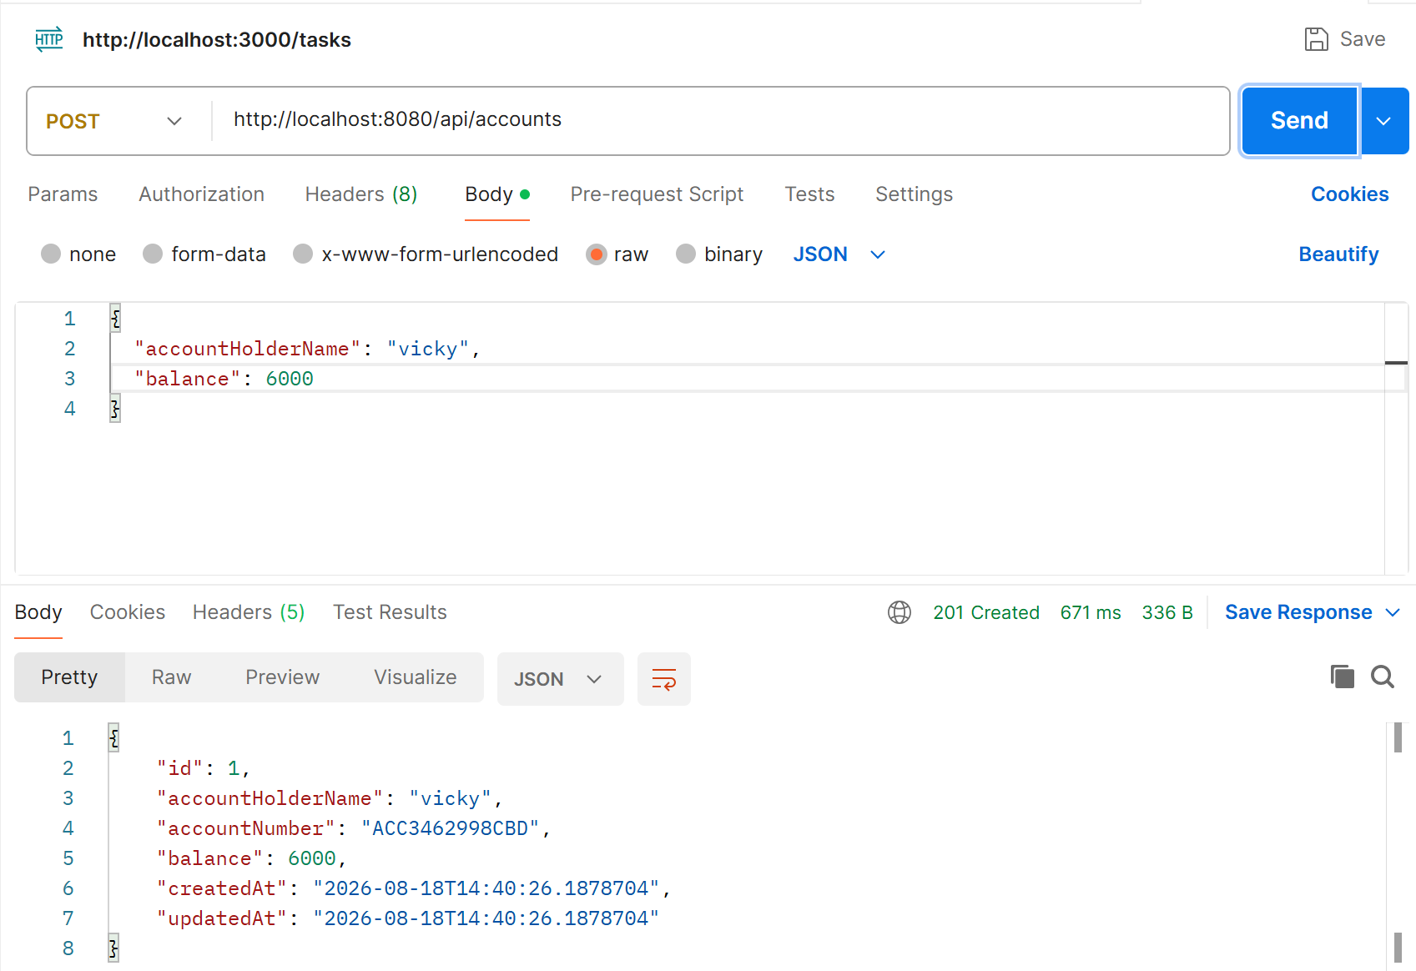

1st time hitting the data base for information
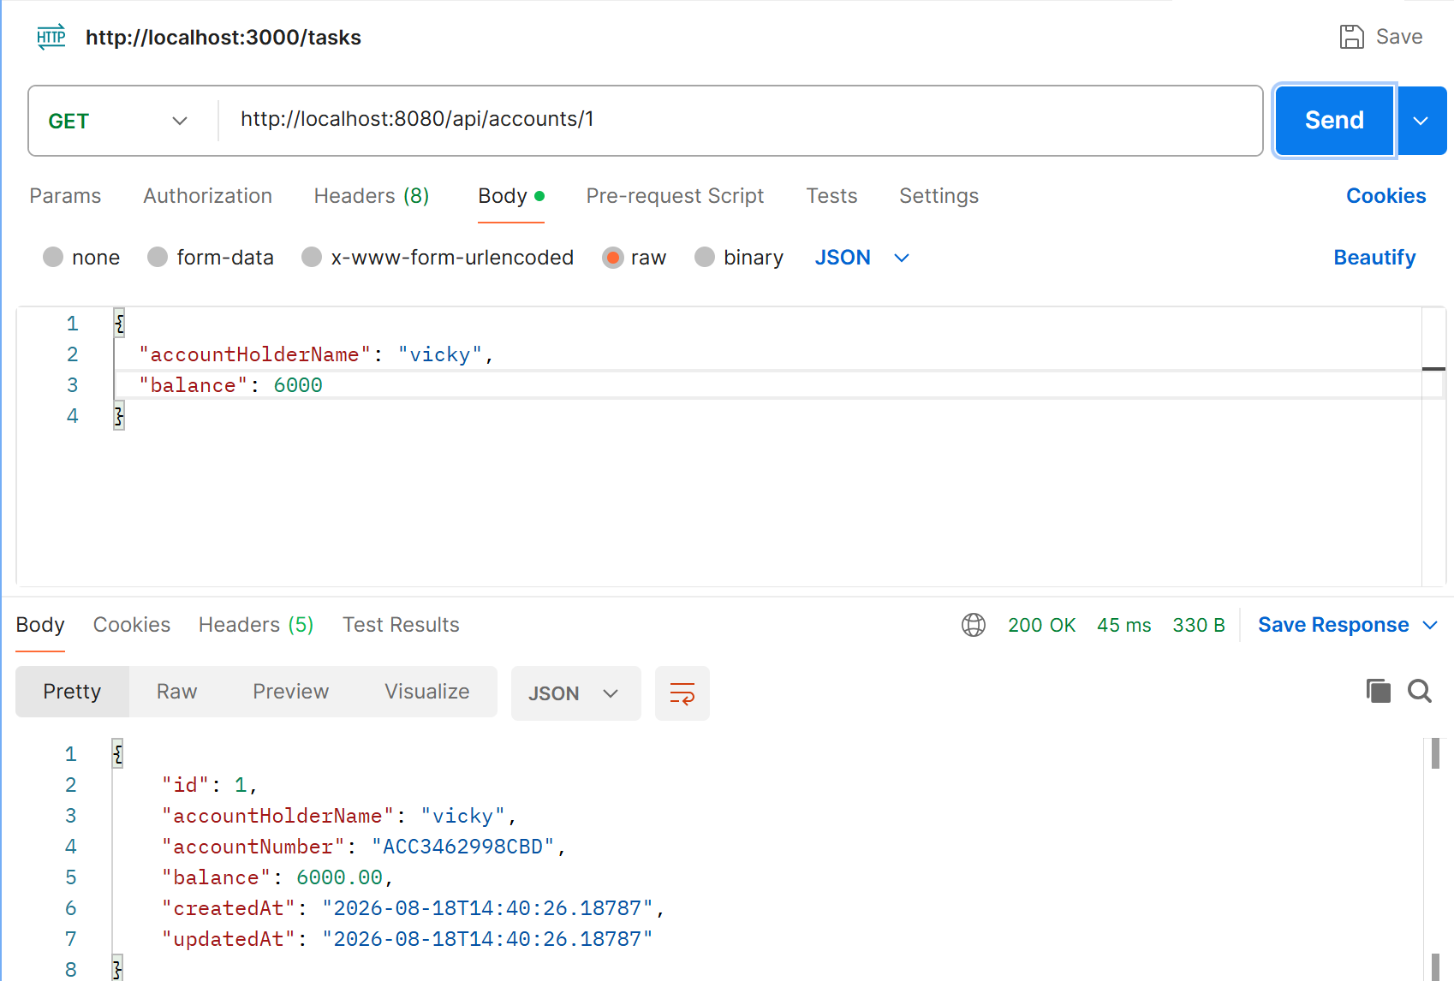
While data come from cache (redis)
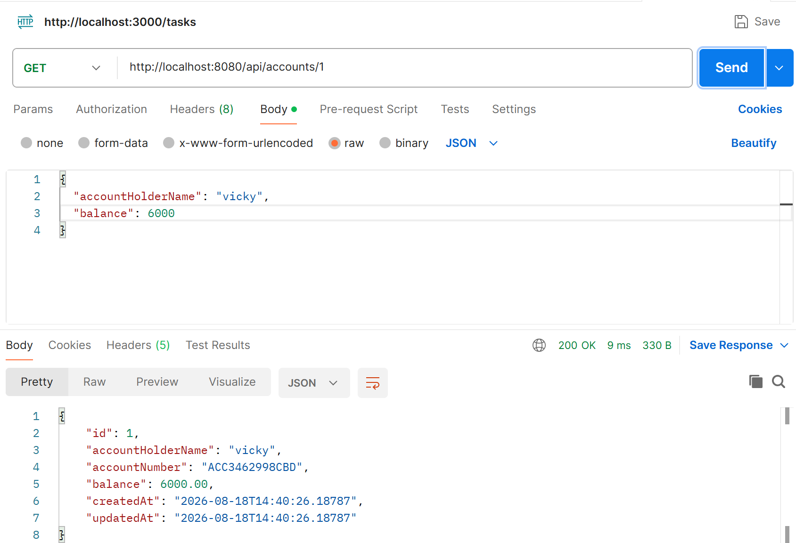
Task 02
Distributed Caching Considerations
Q: How does replication lag in a distributed Redis cluster affect consistency, and what strategies can mitigate its impact on read-heavy applications?
Replication lag occurs when data written to the Redis primary node takes some time to reach its replica nodes.
For example:
Application
|
v
Primary Redis
|
| replication lag
v
Replica Redis
If the application writes:
Balance = ₹10,000
to the primary and immediately reads from a replica, the replica might still contain:
Balance = ₹8,000
This can result in stale or inconsistent data.
Strategies to reduce the impact
- Read from the primary after important writes
For critical data, read directly from the primary to get the latest value.
- Use read-after-write consistency
After updating data, route subsequent reads temporarily to the primary.
- Use appropriate replication configuration
Monitor replication lag and ensure replicas are healthy.
- Use caching with TTL
Set an expiration time so stale data does not remain in the cache indefinitely.
- Use cache invalidation
When data changes, update or delete the corresponding cache entry.
- Use replicas for non-critical read-heavy operations
Replicas are useful for data where slightly stale information is acceptable, such as product lists or dashboards.
In short: Replication improves availability and read scalability, but replication lag can cause stale reads. Critical reads should use the primary, while replicas can handle read-heavy, less-sensitive workloads.
Task 03
Redis for Session Management
Q: Why is Redis preferred over traditional databases for session management in high-traffic web applications, and what risks arise if persistence is not configured?
Redis is commonly preferred for session management because it is an in-memory key-value store, making session read/write operations extremely fast.
Why Redis is preferred
- High performance
Redis stores data in RAM, so retrieving a session is much faster than accessing a traditional disk-based database.
- Low latency
Login sessions can be retrieved quickly even when there are thousands of concurrent users.
- Scalability
Redis can support large numbers of sessions and can be scaled using replication and clustering.
- Built-in expiration
Sessions can automatically expire using TTL.
Example:
session:user123 → {
userId: 123,
role: "CUSTOMER"
}

TTL → 30 minutes
- Works well with multiple application servers
┌── Application Server 1
│
Users ────────┼── Application Server 2
│
└── Application Server 3
|
v
Redis Session Store
All application servers can access the same session data.
Risk if Redis persistence is not configured
If Redis is running without persistence and Redis crashes or restarts, session data stored only in memory can be lost.
This can cause:
- Users to be logged out.
- Active sessions to disappear.
- Increased login requests.
- Poor user experience.
- Additional load on authentication services.
Redis persistence options such as RDB snapshots and AOF (Append Only File) can reduce this risk.
In short: Redis provides fast, centralized, scalable session storage, but without persistence, a Redis failure can result in loss of active sessions.
Task 04
Common Pitfalls: Stale Data & Cache Stampede
Q: What is a cache stampede, and how can techniques like request coalescing or probabilistic early expiration help prevent it?
A cache stampede occurs when a popular cache entry expires and many users request the same data at almost the same time.
Example
Suppose a banking application caches:
account:101 → Account Details
TTL = 60 seconds
After 60 seconds, the cache expires.
Now 1,000 users request the same account information simultaneously:
Cache MISS
|
┌───────────┼───────────┐
↓ ↓ ↓
User 1 User 2 User 3 ... User 1000
| | |
└───────────┼───────────┘
↓
Database
All requests may query the database at the same time, creating a sudden load spike.
This is called a cache stampede or thundering herd problem.
1. Request Coalescing
With request coalescing, only one request is allowed to refresh the missing cache value.
100 requests
|
v
Cache MISS
|
v
One request → Database → Redis
|
└── Other requests use the refreshed value
This prevents hundreds of identical database queries.
2. Probabilistic Early Expiration
Instead of waiting until the exact expiration time, the application randomly refreshes a cache entry slightly before it expires.
For example:
Normal expiration: 60 seconds

Early refresh:
Request A → refresh at 56 sec
Request B → refresh at 58 sec
Request C → use existing cache
Because different requests may refresh the value at different times, many requests don't hit the database simultaneously.
Managing Migrations Across Environments
1. Q: Why is it critical to apply the same migration scripts sequentially across Dev, Test, Staging, and Production, and what risks arise if environments drift?
Database migrations should be applied in the same order and using the same scripts across all environments.
For example:
Dev → Test → Staging → Production
V1 → V2 → V3 → V4
If Dev has migrations V1–V5 but Production only has V1–V3, the environments have schema drift.
Why sequential migrations are important
- Consistency – All environments have the same database structure.
- Predictability – Code tested in Test/Staging works the same way in Production.
- Traceability – Every database change has a clear migration history.
- Easy troubleshooting – Developers can identify which migration introduced a problem.
- Safer deployments – Application code and database schema remain compatible.
Risks of environment drift
- Application may work in Dev but fail in Production.
- Missing tables, columns, indexes, or constraints.
- Data corruption or unexpected behavior.
- Deployment failures.
- Difficult debugging.
- Inconsistent application behavior between environments.
In short: Sequential, identical migrations prevent schema drift and ensure that Dev, Test, Staging, and Production remain consistent.

🔄 Rolling Back and Handling Failed Migrations
2. Q: In what scenarios is a rollback preferable to a fix-forward approach, and how do Liquibase and Flyway differ in supporting rollback strategies?
Rollback
A rollback means undoing a database change and returning to the previous schema state.
It is preferable when:
- A migration causes serious production problems.
- Incorrect database changes were deployed.
- The application cannot work with the new schema.
- Data integrity or security is at risk.
- The previous version needs to be restored quickly.
Example:
V1 → V2 → V3
↓
Problem
↓
Rollback V3
↓
V1 → V2
Fix-forward
Fix-forward means keeping the problematic migration and applying another migration that fixes the problem.
Example:
V1 → V2 → V3
↓
Problem
↓
V4
(Fix V3)
Fix-forward is often preferred when the change has already been applied to production and reversing it could cause data loss or additional complexity.
Liquibase vs Flyway
Feature | Liquibase | Flyway
Migration style | XML, YAML, JSON, SQL | Mainly SQL/Java migrations
Rollback support | Built-in rollback commands | More limited; rollback depends on edition/version and migration approach
Migration tracking | DATABASECHANGELOG | flyway_schema_history
Versioned migrations | Yes | Yes
Best known for | Flexible migration and rollback management | Simple, SQL-focused migration workflow
Liquibase provides explicit rollback functionality through changesets and rollback definitions.
Flyway traditionally emphasizes forward-only migrations. In practice, teams commonly handle rollback by writing a new corrective migration or using supported undo features where available.
In short
- Rollback: Go back to the previous database state.
- Fix-forward: Apply a new migration to correct the problem.
- Liquibase: Stronger built-in rollback model.
- Flyway: Simpler forward-migration approach; corrective migrations are commonly used.

⚡ Zero-Downtime Schema Changes – Expand/Contract Pattern
3. Q: How does the expand/contract pattern ensure application availability during schema evolution, and what are the trade-offs of delaying the contract phase?
The expand/contract pattern allows database changes to happen without suddenly breaking the currently running application.
It has two main phases:
Phase 1 – Expand
Add the new database structure without removing the old structure.
Example:
Old:
users
└── name

Expand:
users
├── name
└── first_name
The application continues using name while the new first_name column is introduced.
The application can then be gradually updated to use the new column.
Phase 2 – Contract
After all application instances are using the new structure and the old structure is no longer required, remove the old column.
Before:
users
├── name ← old
└── first_name ← new

Contract:

users
└── first_name
How this provides zero downtime
EXPAND
↓
Add new column
↓
Old + New supported
↓
Deploy updated application
↓
Migrate/backfill data
↓
Verify everything works
↓
CONTRACT
↓
Remove old column
There is no point where the database suddenly becomes incompatible with the running application.
Example
Suppose we want to rename:
customer_name → name
Instead of immediately renaming the column:
❌ Rename customer_name → name
we can:
1. Add name
2. Application writes to both columns
3. Copy existing data
4. Application starts reading name
5. Verify the new version
6. Stop using customer_name
7. Remove customer_name later
Trade-offs of delaying the contract phase
The main disadvantage is that the database temporarily contains old and new structures.
This can cause:
- Additional storage usage.
- More complicated application code.
- Dual-write logic.
- More complex migrations.
- Longer period of maintaining backward compatibility.
- Risk of forgetting to remove obsolete columns or tables.
However, delaying the contract phase is usually safer because it gives the team time to verify that the new schema works correctly.

1. Q: What role does data validation (row counts, checksums, referential integrity) play in ETL-based migrations, and how can automation reduce human error?
Data validation ensures that data has been transferred from the source database to the target database completely, accurately, and consistently during an ETL migration.
ETL means:
Source Database
↓
Extract
↓
Transform
↓
Load
↓
Target Database
Important validation techniques
1. Row count validation
Compare the number of records in the source and target.
Source: 1,000,000 rows
Target: 1,000,000 rows
✓
If the target has fewer rows, some data may have been lost.
2. Checksum / hash validation
Calculate hashes for selected data in both databases and compare them.
Source Hash = ABC123
Target Hash = ABC123
✓ Match
This helps detect differences in the actual data, not just the number of rows.
3. Referential integrity
Verify that relationships between tables are still valid.
For example:
Customer
|
└── customer_id = 101
|
↓
Account
The migration should not create accounts referring to non-existent customers.
How automation helps
Instead of manually checking thousands or millions of records, automated migration scripts can:
- Compare row counts.
- Generate and compare checksums.
- Detect duplicate records.
- Validate NULL and datatype rules.
- Check foreign-key relationships.
- Generate validation reports.
- Fail the migration automatically when validation rules are violated.
In short: Validation detects missing, corrupted, duplicated, or inconsistent data. Automation makes these checks repeatable, faster, and less dependent on manual verification.

🔄 Migrating Between Database Engines
2. Q: Why is datatype mapping a critical challenge when migrating between heterogeneous database engines, and how can mismatches impact application performance?
Different database engines may represent the same type of data using different datatypes, sizes, precision, and behavior.
For example:
MySQL PostgreSQL
--------------------------------
TINYINT SMALLINT
DATETIME TIMESTAMP
TEXT TEXT
ENUM VARCHAR / custom type
A datatype that exists in one database may not have a direct equivalent in another.
Why datatype mapping is important
Suppose a source database stores:
price → DECIMAL(10,2)
If it is incorrectly migrated as:
price → FLOAT
precision problems can occur.
For example, financial values may be represented inaccurately due to floating-point behavior.
Impact of datatype mismatches
Incorrect mapping can cause:
- Data loss – values may be truncated.
- Precision errors – especially with financial/decimal data.
- Conversion overhead – frequent datatype conversion can increase CPU usage.
- Poor index performance – incompatible or inappropriate types can reduce index efficiency.
- Larger storage requirements – unnecessarily large datatypes consume more space.
- Application errors – application code may expect a particular datatype.
- Slower queries – implicit conversions can prevent efficient index usage.
Example
Source:
account_balance → DECIMAL(15,2)

↓ Migration

Target:
account_balance → VARCHAR
Now every calculation may require conversion:
VARCHAR → DECIMAL → Calculation
This can negatively affect both correctness and performance.
In short: Correct datatype mapping preserves data accuracy and allows the target database to use indexes, storage, and query processing efficiently.

✅ Validating Data Integrity Post-Migration
3. Q: Beyond row count comparisons, what advanced techniques can be used to validate data integrity after migration, and why are application-level tests essential?
Row counts only tell us how many records exist. They don't prove that the records contain the correct information.
Therefore, additional validation techniques are required.
Advanced validation techniques
1. Checksums and cryptographic hashes
Calculate hashes for records or data batches and compare source vs. target.
Source → SHA-256 → ABC123
Target → SHA-256 → ABC123
✓
This can detect changes to the actual data.
2. Referential integrity validation
Check foreign-key relationships.
Customer → Account → Transaction
Every relationship should remain valid after migration.
3. Duplicate detection
Check whether the migration accidentally created duplicate records.
Source: 100 customers
Target: 100 customers
The row counts match, but the target could still contain duplicates and missing customers.
4. Aggregate validation
Compare calculations such as:
- Total account balance.
- Total transaction amount.
- Average transaction value.
- Minimum/maximum values.
- Number of active customers.
Example:
Source total balance = ₹50,00,000
Target total balance = ₹50,00,000
✓
5. NULL and constraint validation
Check:
- NULL values.
- Unique constraints.
- Foreign keys.
- NOT NULL constraints.
- Default values.
6. Sampling
Select random records from the source and compare them with the corresponding records in the target.
7. Application-level testing
This is extremely important because database-level validation cannot verify whether the application behaves correctly with the migrated data.
For example, after migrating a banking application, tests should verify:
Login
↓
Account details
↓
Balance calculation
↓
Money transfer
↓
Transaction history
The database may have the correct number of rows and matching checksums, but the application could still fail because of:
- Incorrect datatype mapping.
- Changed date formats.
- Incorrect business relationships.
- Different NULL behavior.
- Incorrect queries.
- Changed stored procedure behavior.
Why application-level tests are essential
They validate the migration from the user's/business perspective, not just the database perspective.
Database Validation
↓
"Is the data physically correct?"

Application Testing
↓
"Does the application behave correctly?"

Home Task:
1. Why is the Persistence Context crucial in managing transactions?
A Persistence Context is like a temporary workspace managed by JPA/Hibernate where the entities being used in a transaction are tracked.
It keeps track of:
- New entities
- Modified entities
- Deleted entities
- Existing entities
Real-time example
Suppose in a banking application you transfer ₹5,000:
Account A: ₹20,000
Account B: ₹10,000
The transaction performs:
Account A → -₹5,000
Account B → +₹5,000
The persistence context tracks both changes.
If everything succeeds:
COMMIT
↓
Both changes saved
If something fails:
ROLLBACK
↓
Both changes cancelled
So you don't end up with:
Account A → ₹15,000 ❌
Account B → ₹10,000 ❌
instead, both operations remain consistent.
Simple definition
Persistence Context acts as a first-level cache and tracks entity changes within a transaction, allowing Hibernate to synchronize those changes with the database consistently when the transaction is committed.

2. Lazy vs Eager Loading and the N+1 Problem
Lazy Loading
Data is loaded only when required.
Get 1 Author
↓
Author loaded
↓
Books not loaded
↓
getBooks()
↓
Books loaded
This can improve performance when related data is large and not always required.
Eager Loading
Related data is loaded immediately.
Get Author
↓
Author + Books loaded
This can be useful when the related data is small and almost always needed.
However, eager loading can unnecessarily load large amounts of data.

What is the N+1 Problem?
Suppose you have 10 authors, and each author has books.
You execute:
List<Author> authors = repository.findAll();
Hibernate executes:
1 query → Get all authors

Then:

10 additional queries → Get books for each author
So:
1 + 10 = 11 queries
That's the N+1 problem.
Why does it happen?
Usually because of lazy relationships being accessed inside a loop.
for (Author author : authors) {
author.getBooks();
}
Each getBooks() can trigger another SQL query.
Real-world impact
If you have:
1000 Authors
you could potentially get:
1 + 1000 = 1001 database queries
which can seriously affect performance.
Simple definition
N+1 occurs when one query retrieves the main entities and then an additional query is executed for each entity to retrieve its related data.
Important point
Don't think:
Lazy = bad, Eager = good
That's incorrect.
The real goal is:
Load only the data you actually need, using an efficient query strategy.

3. Why is Database Schema Versioning important?
Database Schema Versioning means keeping track of changes made to the database structure over time.
For example:
V1 → Create employee table
V2 → Add email column
V3 → Add department column
V4 → Create salary table
Instead of manually changing every environment, we keep these changes as migration files.
Real-time example
Imagine your application is running in:
Developer → Testing → Staging → Production
A developer adds:
ALTER TABLE employee ADD COLUMN phone VARCHAR(20);
Without schema versioning, someone has to manually remember to apply this change to every environment.
With schema versioning:
Migration V4
↓
Developer
↓
Testing
↓
Staging
↓
Production
The same database change can be applied consistently.
How does it help CI/CD?
When a new application version is deployed:
Code Deployment
+
Database Migration
↓
Updated Application
The deployment pipeline can automatically run pending migrations.
Simple definition
Schema versioning tracks database structure changes as ordered migrations, ensuring that development, testing, and production environments stay synchronized and making database changes safer to automate through CI/CD.

4. Flyway: Versioned vs Repeatable Migrations
Flyway provides a way to manage database migrations.
There are two important types:
Versioned Migration
A versioned migration runs once and has a unique version.
For example:
V1__Create_employee_table.sql
V2__Add_email_column.sql
V3__Create_department_table.sql
Flyway records that these migrations have already been executed.
So:
V1 → Run once ✅
V2 → Run once ✅
V3 → Run once ✅
When do we use it?
Use versioned migrations for structural changes such as:
- Creating tables
- Adding columns
- Removing columns
- Adding indexes
- Changing constraints

Repeatable Migration
A repeatable migration can run again when its contents change.
Example:
R__Create_views.sql
R__Create_stored_procedures.sql
If you modify the SQL file, Flyway detects that its checksum has changed and runs it again.
When do we use it?
Useful for objects where you may frequently update the definition:
Views
Stored procedures
Functions
Triggers
Easy comparison
Versioned | Repeatable
Runs once per version | Runs again when changed
Has version number | Doesn't have a version number
V1__... | R__...
Table/column changes | Views/procedures/functions
Memory trick
Versioned = "This change happened once."
Repeatable = "Run again whenever the definition changes."

5. Liquibase: Changelogs and Changesets
Liquibase manages database changes using changelogs and changesets.
Changelog
A changelog is like a master file that tells Liquibase which database changes need to be applied.
For example:
db.changelog-master.xml
|
├── changeset 1
├── changeset 2
└── changeset 3
Changeset
A changeset represents one specific database change.
For example:
Changeset 1
→ Create employee table

Changeset 2
→ Add email column

Changeset 3
→ Add index
Liquibase records which changesets have already been executed.

Why is this flexible across environments?
Suppose you have:
Development
Testing
Staging
Production
The same Liquibase changelog can be applied to each environment.
Changelog
↓
┌──────────┼──────────┐
↓ ↓ ↓
Dev Testing Production
Liquibase knows which changesets have already been executed and applies only the pending ones.
It can also support different database environments through features such as contexts, labels, and environment-specific configuration.
Real-time example
Suppose you add:
Changeset 5
→ Add customer_phone column
Development runs it:
Changeset 5 ✅
Later, when production deployment happens:
Liquibase checks database
↓
Changeset 5 not found
↓
Executes Changeset 5
↓
Records it as executed
This makes database changes repeatable, trackable, and consistent across environments.
Simple definition
Liquibase uses changelogs to organize database changes and changesets to define individual changes. It tracks executed changesets, allowing the same database changes to be safely managed and promoted across different environments.

