Day 2 Task
Task 1:
What is the default permission for a newly created file and a directory?
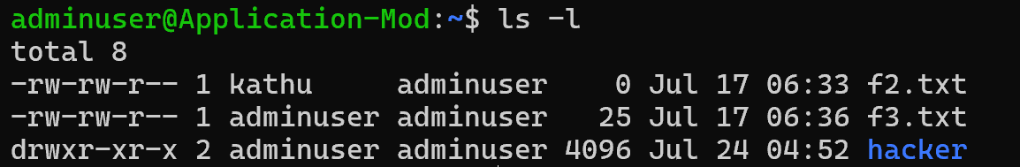

Task 2:
Create a user using linux
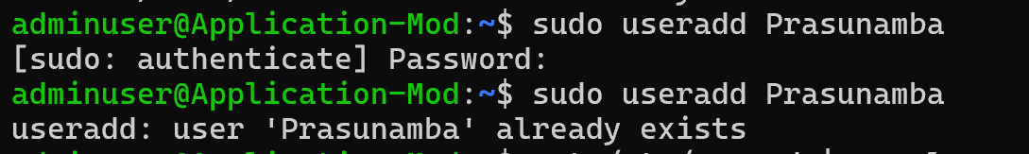

Task 3:
Delete the above user
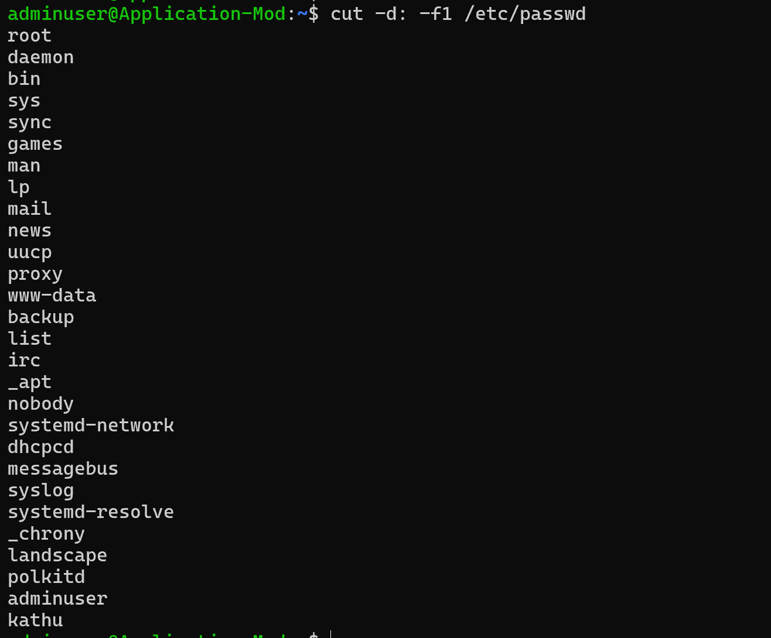
Task 4:
Create another user
Change the password
Create a third user and switch to 2nd user
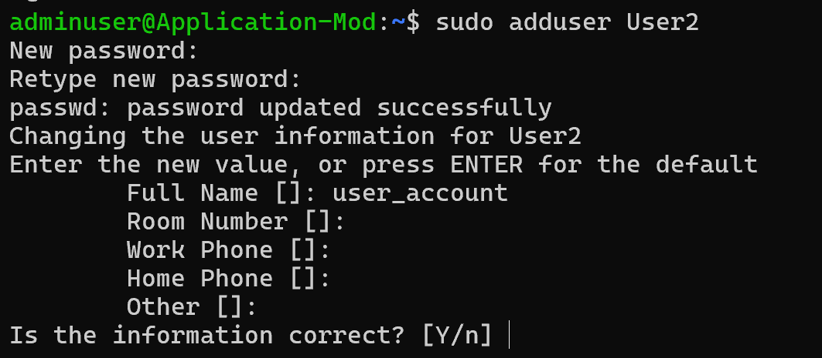
sudo passwd User2
Task 5:
Find your system’s current time.
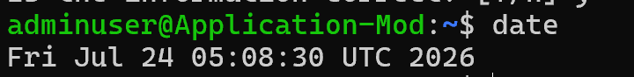

Task 6:
What is the chown command used for?
chown is used to change the owner and/or group ownership of a file or directory.
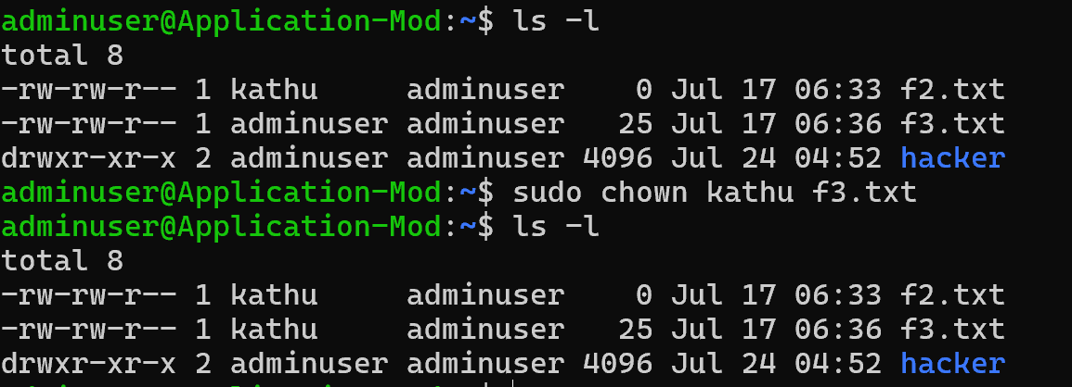
Task 7:
What is grep used for ?
grep is used to search for text or patterns in files
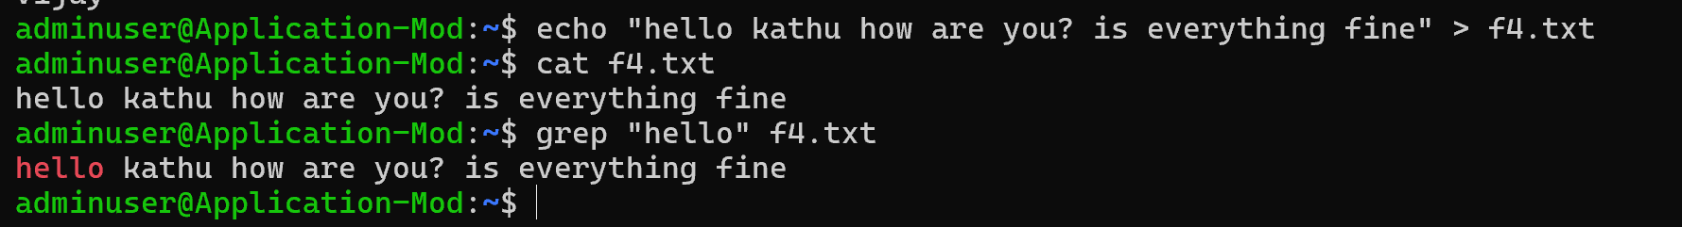

Task 8:
How to use Redirecting in linux?
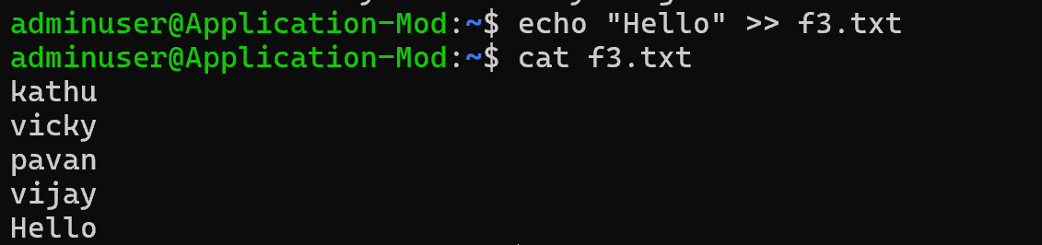

Task 9:
Try to open any file using vi command..
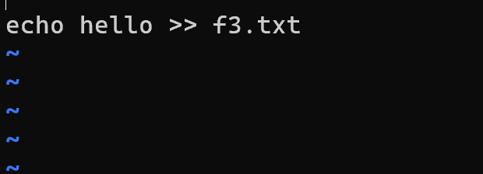

Task 10:
Try to use hostname command
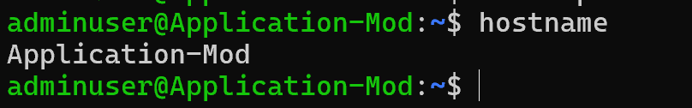

Task 11:
Try to use uname -a to display detailed system information including the kernel version.

Task 12:
Try to use Sudo command (write any command here )
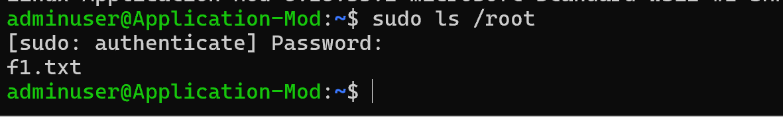

Task 13:
What do you understand by HTTP and HTTPs?
HTTP is a way for your browser and a website to communicate and exchange information over the internet.
HTTPS is the secure version of HTTP, where the data is protected using encryption.
When you see HTTPS with a lock icon, it means your connection to the website is safer and private.

Task 14:
What are methods in HTTP protocols
HTTP methods are the actions that tell a server what we want to do with the data.
For example, GET is used to get information, POST is used to send new data, and DELETE removes data.
Other methods like PUT and PATCH are used to update existing information.

Task 15:
Give few status codes in Http protocols
200 OK – The request was successful, and the server returned the required data.
201 Created – A new resource or data was successfully created.
301 Moved Permanently – The requested page has been permanently moved to a new URL.
400 Bad Request – The server cannot understand the request due to incorrect input.
401 Unauthorized – Authentication is required or the user is not authorized.

Task 16:
What do you understand by Headers in Http..
HTTP headers are extra information sent between a browser and a server along with a request or response.
They provide details like the type of data being sent, user information, security settings, and server details.
Home
Task 1: AWK – AWK is a Linux command used to search, filter, and process text or data from files.
Task 2: SED – SED is a text-processing command used to find, replace, edit, and modify file content.
Task 3: Piping – Piping (|) is used to pass the output of one command as input to another command.

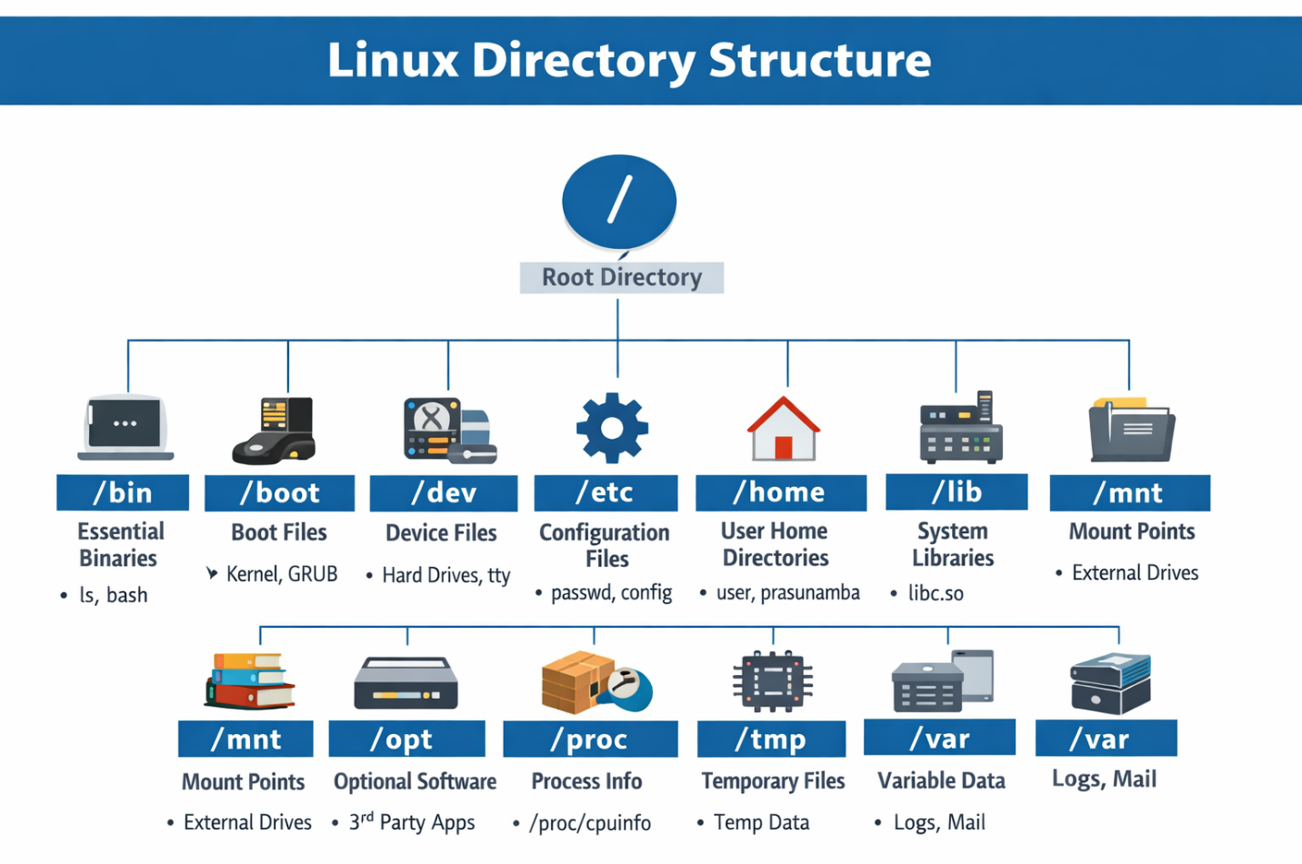

Directory | Purpose | Examples
/bin | Essential user commands and binaries | ls, cp, bash
/boot | Boot loader and kernel files | vmlinuz, grub.cfg
/dev | Device files (interfaces to hardware) | /dev/sda1, /dev/tty
/etc | System-wide configuration files | passwd, resolv.conf
/home | Personal directories for users | /home/prasunamba
/lib | Shared libraries for binaries | libc.so
/media | Mount points for removable media | USB drives, CDs
/mnt | Temporary mount points | External disks
/opt | Optional software packages | Third-party apps
/proc | Virtual files for kernel and process info | /proc/cpuinfo, /proc/meminfo
/root | Home directory for root user | /root/.bashrc
/sbin | System administration binaries | ifconfig, shutdown
/srv | Data for services (web, FTP) | /srv/www
/tmp | Temporary files (auto-cleaned) | Session data
/usr | User applications, docs, libraries | /usr/bin, /usr/share/doc
/var | Variable data (logs, cache, mail) | /var/log, /var/tmp

Linux quick reference cheat sheet
1. File System Navigation:
- pwd: Print the current working directory.
- ls: List files and directories in the current directory.
  - ls -l: Display detailed information about files and directories.
  - ls -a: Include hidden files and directories in the list.
- cd directory: Change the current directory to the specified directory.
  - cd ..: Go up one level in the directory hierarchy.
  - cd ~: Go to the home directory.
- mkdir directory: Create a new directory with the specified name.
- rm file: Remove a file.
  - rm -r directory: Remove a directory and its contents recursively.
- cp source destination: Copy a file or directory.
  - cp -r source destination: Copy a directory and its contents recursively.
- mv source destination: Move or rename a file or directory.

2. File Manipulation:
- cat file: Display the contents of a file.
- less file: View the contents of a file with pagination.
- head file: Display the first few lines of a file.
- tail file: Display the last few lines of a file.
- grep pattern file: Search for a pattern in a file.
  - grep -r pattern directory: Recursively search for a pattern in files within a directory.
9.59 to 10.10
3. File Permissions:
- chmod permissions file: Change the permissions of a file or directory.
  - chmod +x file: Add executable permission to a file.
  - chmod -w file: Remove write permission from a file.
- chown user:group file: Change the owner and group of a file or directory.
- chgrp group file: Change the group of a file or directory.
10.15 to 10.25
4. Process Management:
- ps: Display information about active processes.
  - ps -ef: Display detailed information about all processes.
- kill process_id: Terminate a process with the specified process ID.
  - killall process_name: Terminate all processes with the specified name.
- top: Display real-time information about system processes.
- bg: Put a process in the background.
- fg: Bring a background process to the foreground.
5. System Information:
- uname: Print system information.
  - uname -a: Print detailed system information.
- whoami: Display the current user.
- df: Show disk space usage.
- free: Display memory usage.
- uptime: Show system uptime.
- ifconfig: Display network interface information.
- ping host: Send ICMP echo requests to a host for network connectivity testing.
6. Text Editing:
- nano file: Open a file for editing with the Nano editor.
- vi file: Open a file for editing with the Vi editor.
- grep pattern file: Search for a pattern in a file.
  - grep -r pattern directory: Recursively search for a pattern in files within a directory.
- sed 's/old/new/g' file: Replace occurrences of a pattern with a new value in a file
7. Compression and Archiving:
- tar cf archive.tar files: Create a tar archive of specified files.
- tar xf archive.tar: Extract files from a tar archive.
- gzip file: Compress a file using gzip compression.
  - gzip -d file.gz: Decompress a file compressed with gzip.
8. Networking:
- ssh user@host: Connect to a remote host using SSH.
- scp source destination: Securely copy files between local and remote hosts.
- wget url: Download a file from a specified URL.
- curl url: Transfer data to or from a server using various protocols.
9. User Management:
- useradd username: Create a new user account.
- userdel username: Delete a user account.
- passwd username: Set or change the password for a user account.
- su username: Switch to another user account.
- sudo command: Execute a command with superuser (root) privileges.
10. Package Management:
- apt-get install package: Install a package using the Advanced Package Tool (APT) package manager.
- apt-get update: Update the local package index to retrieve the latest package information.
- apt-get upgrade: Upgrade all installed packages to their latest versions.
- apt-get remove package: Uninstall a package.
- apt-cache search keyword: Search for packages based on a keyword.
11. File Transfer:
- scp source destination: Securely copy files between local and remote hosts using the SSH protocol.
- rsync source destination: Synchronize files and directories between local and remote hosts efficiently.
- sftp user@host: Start an interactive secure file transfer session with a remote host.
12. System Monitoring and Maintenance:
- top: Monitor system processes and resource usage in real-time.
- htop: Interactive process viewer and system monitor.
- du -sh directory: Display the total size of a directory.
- df -h: Show disk space usage of mounted file systems.
- reboot: Reboot the system.
- shutdown: Shutdown the system.
13. Networking and Connectivity:
- ifconfig: Configure and display network interface information.
- ping host: Send ICMP echo requests to a host for network connectivity testing.
- netstat: Display network connection information, routing tables, and interface statistics.
- ssh user@host: Connect to a remote host using SSH.
- nc host port: Open a TCP or UDP connection to a remote host on a specified port.
14. System Information:
- uname -a: Display detailed system information including the kernel version.
- lsb_release -a: Show distribution-specific information about the Linux distribution.
- hostname: Print or set the system's hostname.
- date: Display the current date and time.
15. File Permissions and Ownership:
- chmod permissions file: Change the permissions of a file or directory.
- chown user:group file: Change the owner and group of a file or directory.
- chgrp group file: Change the group of a file or directory.
- ls -l: List files and directories with detailed permission and ownership information.

