Task 1 :
What do you understand by Big (O) notation
= the big O notation is used to represent the worst case scenarios while analysing the Algorithms time and space complexity
Task 2
arrays
arrays are used to store the homogenies elements which is of same type, and it store the data in contiguous memory allocation.
Types of arrays:
- Single dimensional array
- Two-dimensional arrays
- Multi-dimensional arrays
Task 3 :
strings
String is class in java used to store the 1 or more number of the characters at once and it is called the objects of the string class
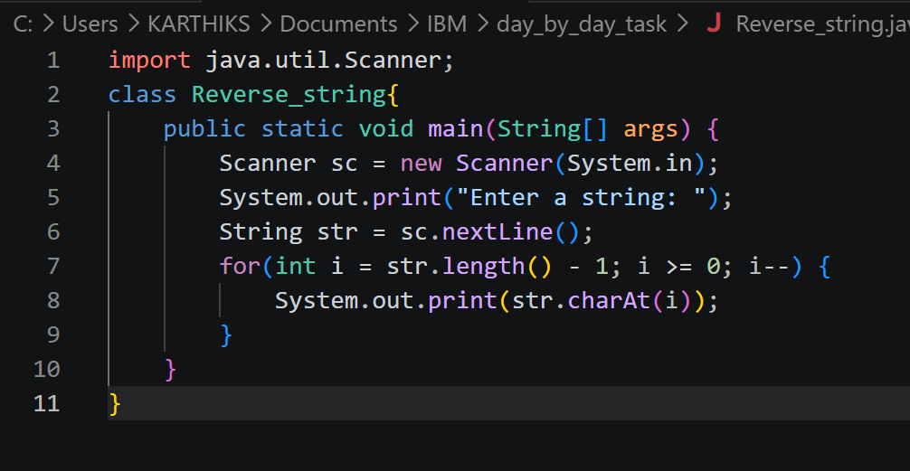

Task 6:
Static and normal instance Variables
class Variables{
int normal_variable = 10;

static int static_variable = 20;

void increament(){
normal_variable++;
static_variable++;

System.out.println("Normal variable: " + normal_variable);
System.out.println("Static variable: " + static_variable);
System.out.println();

}
}
class Main{
public static void main(String[] args) {
Variables obj1 = new Variables();
Variables obj2 = new Variables();

System.out.println("object 1 increments: ");
obj1.increament();
System.out.println("object 2 increments: ");
obj2.increament();
}
}
Task 7: print the numbers
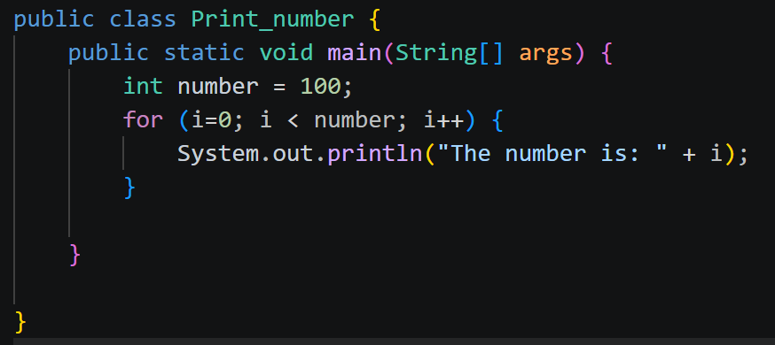

Task 8:
Program to accept the login id and password and is it is correct than display the welcome massage
import java.util.Scanner;
public class Wellcome {
public static void main(String[] args) {
Scanner sc=new Scanner (System.in);
String loginid="Kathu@ibm.com";
String pass="kathu@2003";
System.out.println("Enter Login ID :");
String loginId=sc.nextLine();
System.out.println("Enter Password :");
String password=sc.nextLine();
if (loginId==loginid && password==pass){
System.out.println("****Login Successful************** wellome ***********");
}
else{
System.out.println("Login Failed");
}
}

}

Task 9 :
Using while and do while condition

Task 10
program which using
if condition , if else and nested if condition

Task 11:
Display the use of switch case
import java.util.Scanner;
class Switch_case {
public static void main(String[] args) {
Scanner sc = new Scanner(System.in);
System.out.println("Enter a number (1-7) to get the corresponding day of the week:");
int day = sc.nextInt();
switch (day) {
case 1:
System.out.println("Monday");
break;
case 2:
System.out.println("Tuesday");
break;
case 3:
System.out.println("Wednesday");
break;
case 4:
System.out.println("Thursday");
break;
case 5:
System.out.println("Friday");
break;
case 6:
System.out.println("Saturday");
break;
case 7:
System.out.println("Sunday");
break;
default:
System.out.println("Invalid day");
}
}

}

Task 12
access modifiers in java and give the proper explanation
Access modifiers are used in java for authorise the access to the class, methods and also the variables in the class
public : if the class or methods or the variables are defined with the public access modifiers than the everyone can access this
Private : if the variable is defined with the private access modifiers than within that method or the class only we can use
Protected : we can access through the same class and also with the derived class
Default : this access modifier is used to give the access thorough out the package which is the defined

Task 13 :
Break and continue
public class Break_and_continue {
public static void main(String[] args) {
Scanner sc = new Scanner(System.in);
System.out.print("Enter a number: ");
int n = sc.nextInt();
for (int i = 1; i <= n; i++) {
if (i == 5) {
continue; // Skip the rest of the loop when i is 5
}
else if (i == 10) {
break;
}
System.out.println(i);
}
System.out.println("Loop completed.");
}

}

