Day 4 - 21st July 2026

Task 1:
Wap to display the functionality of method overloading
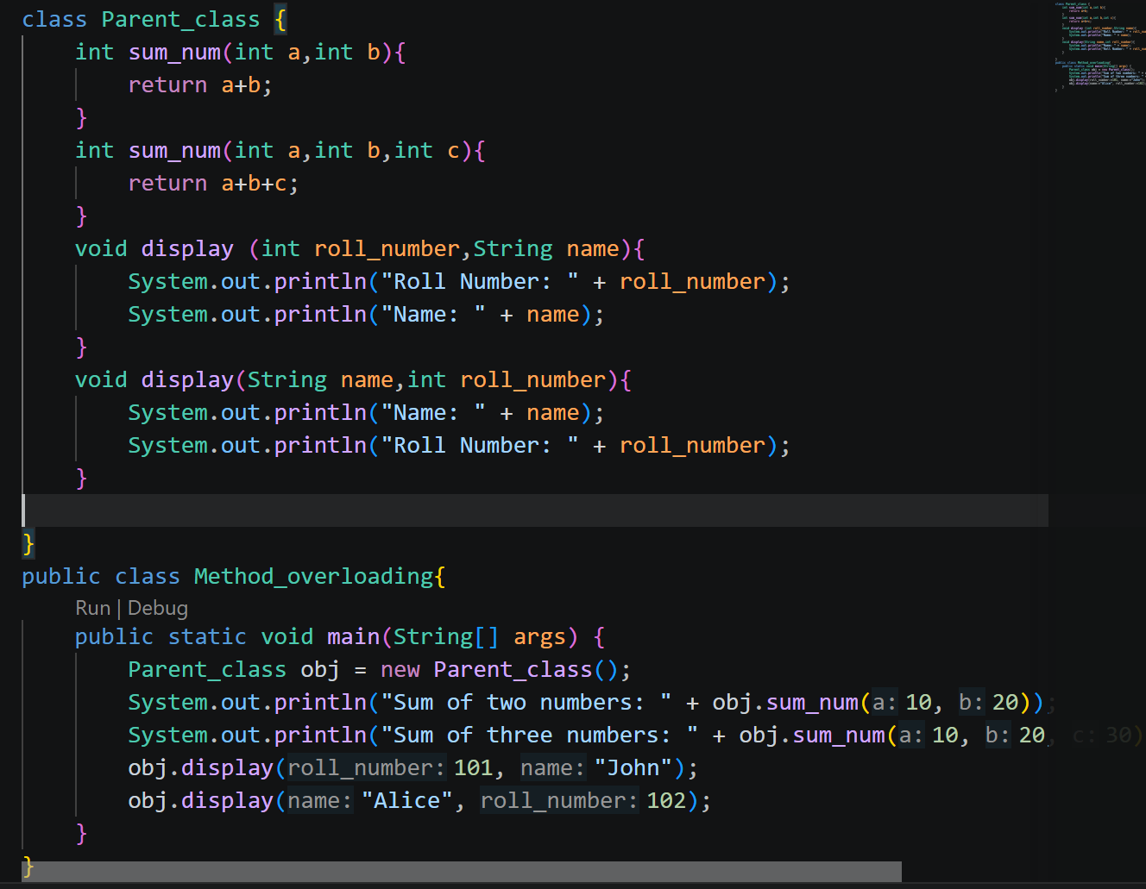
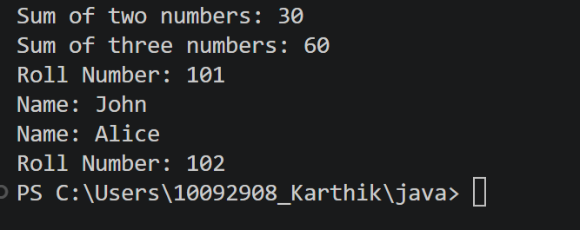
Task 2:
Write a brief history of Java
Java Is high level object oriented language, and because of the security, re-usability of the code still java is in use,

Task 3:
Wap to dislay Linked list using
Package
Import java.util.Linkedlist
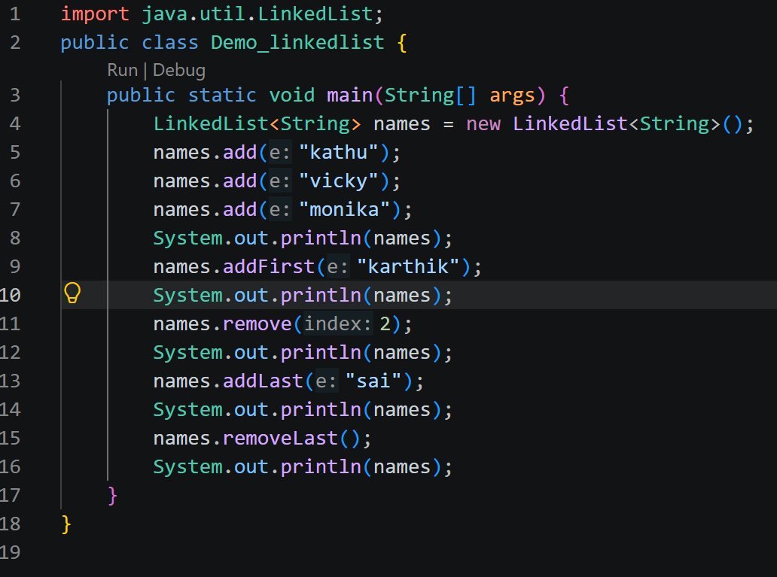
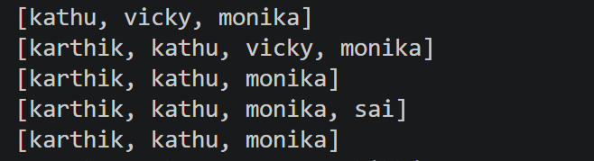
Task 4:
Wap to show how custom defined Linked list work
Create a node
Then add elements
Display
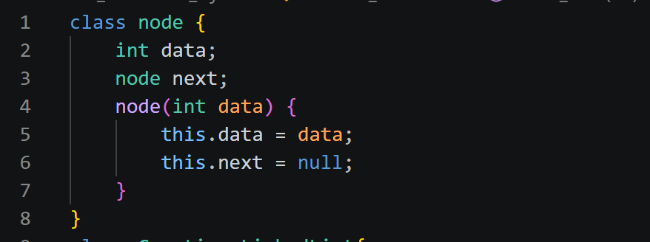
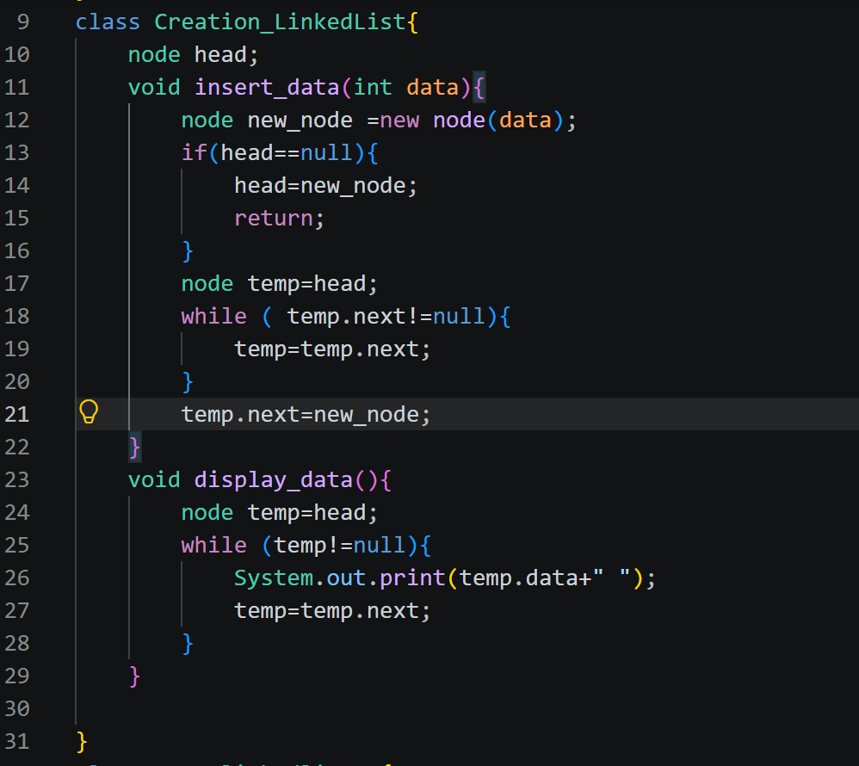
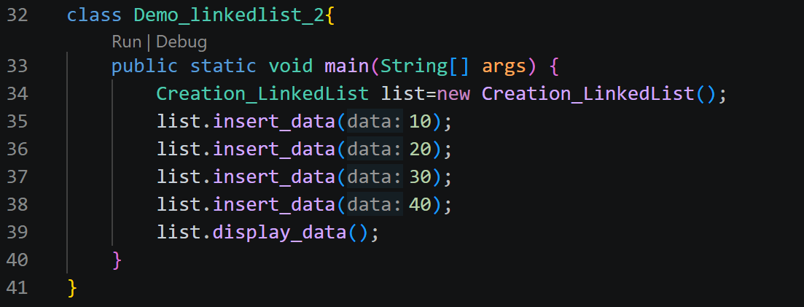
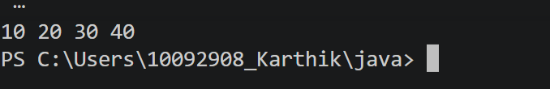

Task 5:
Wap to add and display elements in a built in stack
Import java.util.Deque;
Import java.util.Arraydeque;

No stack — legacy code
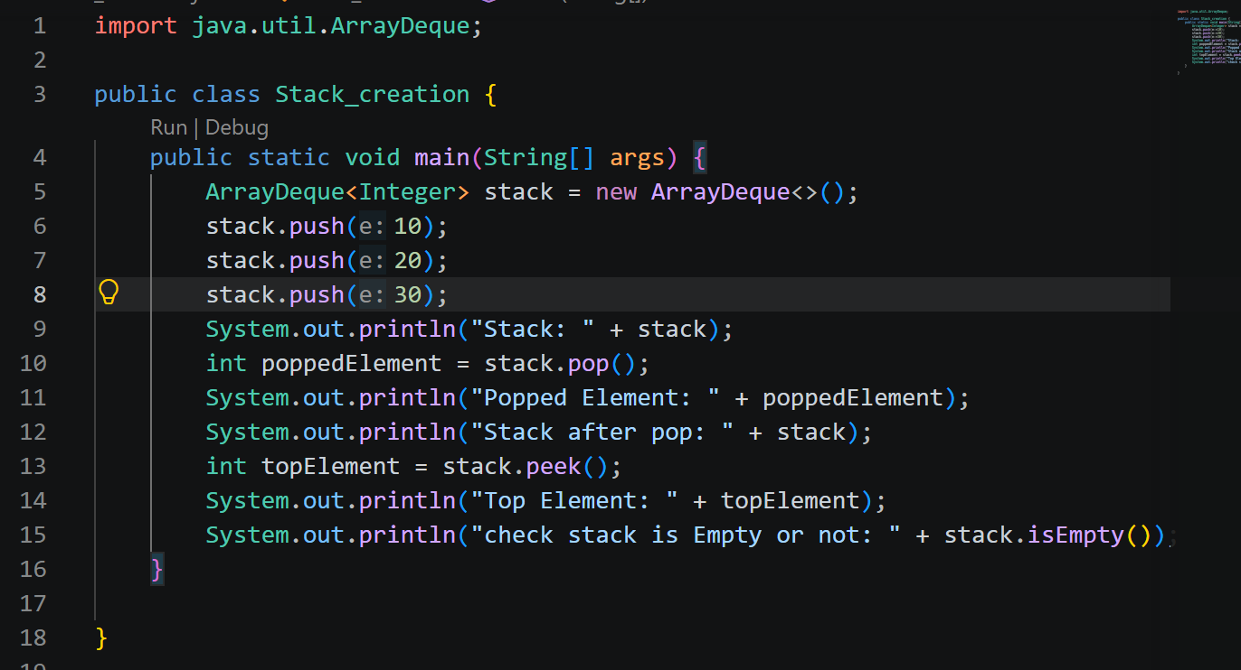
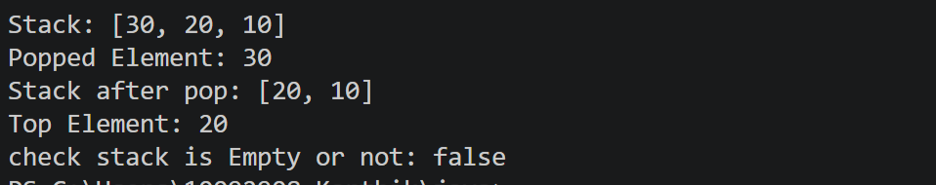

Task 6:

Wap to create a builtin Queue and display the elements
Import java.util.LinkedList
Import java.util.Queue;
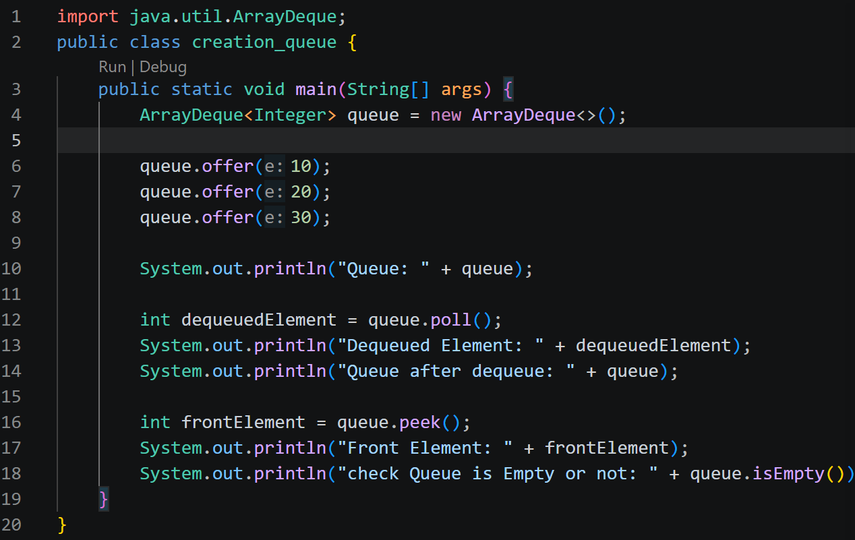
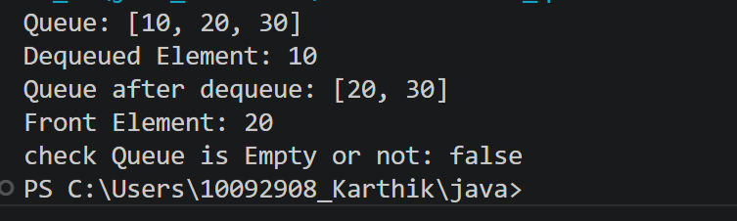
Task 7:

Wap to demonstrate Method overriding
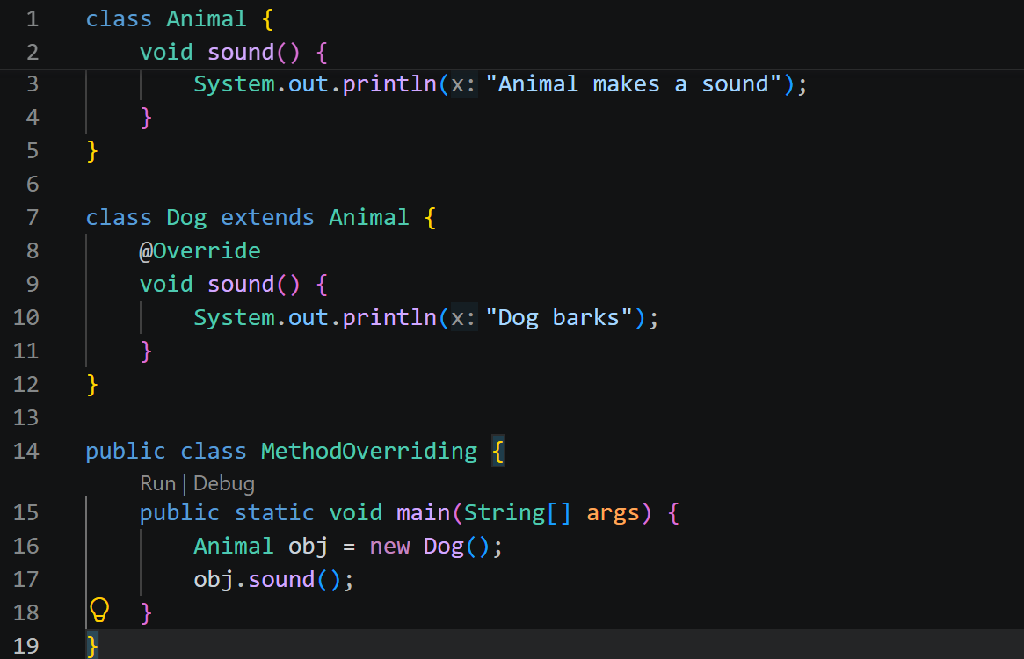

Task 8:
What are the advantages of Polymorphism.. Brief it
In Polymorphism we use the same method name and do the different task
from this we can reuse the code any number of time the it is flexible

Task 9:

Wap to show the encapsulation feature in java
Use getters and setters
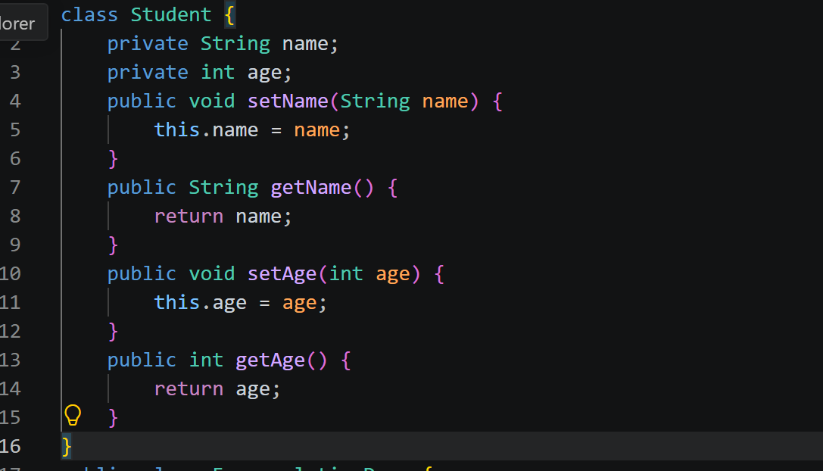
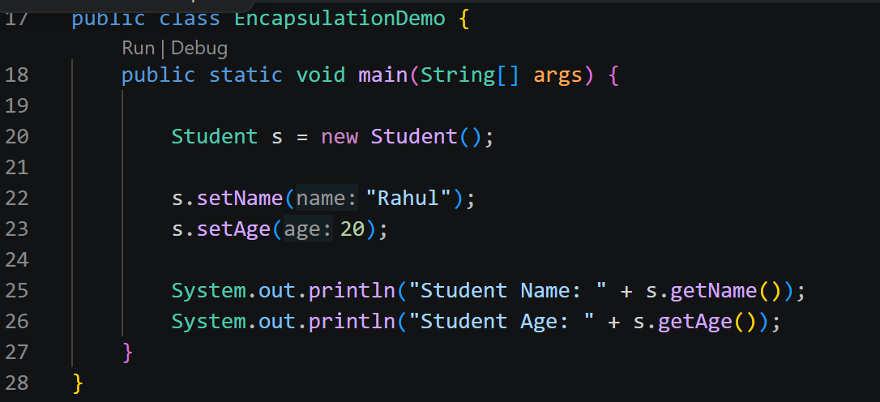

Task 10:
What are the advantages and disadvantages of encapsulation
Encapsulation is an important feature of object-oriented programming that helps create secure, organized, and maintainable code. Although it may increase code size and development effort, its benefits make programs easier to manage and less prone to errors.

Task 11:
Wap to use the concept of type casting:
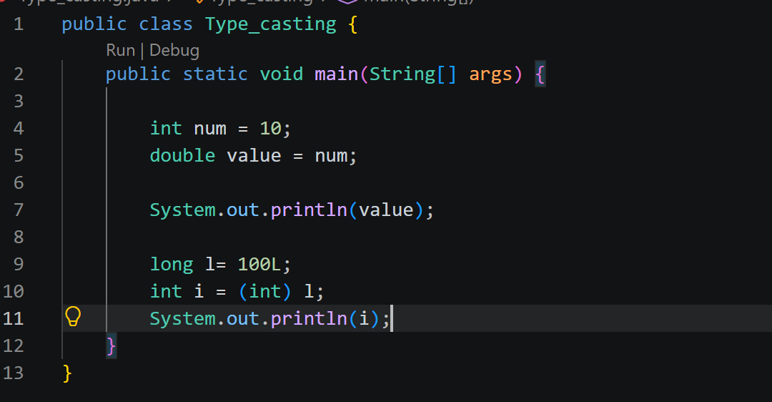

Task 12:
What is auto boxing and auto unboxing
