Day 5 task

Task 1:
Wap to run 3 threads running simultaneously
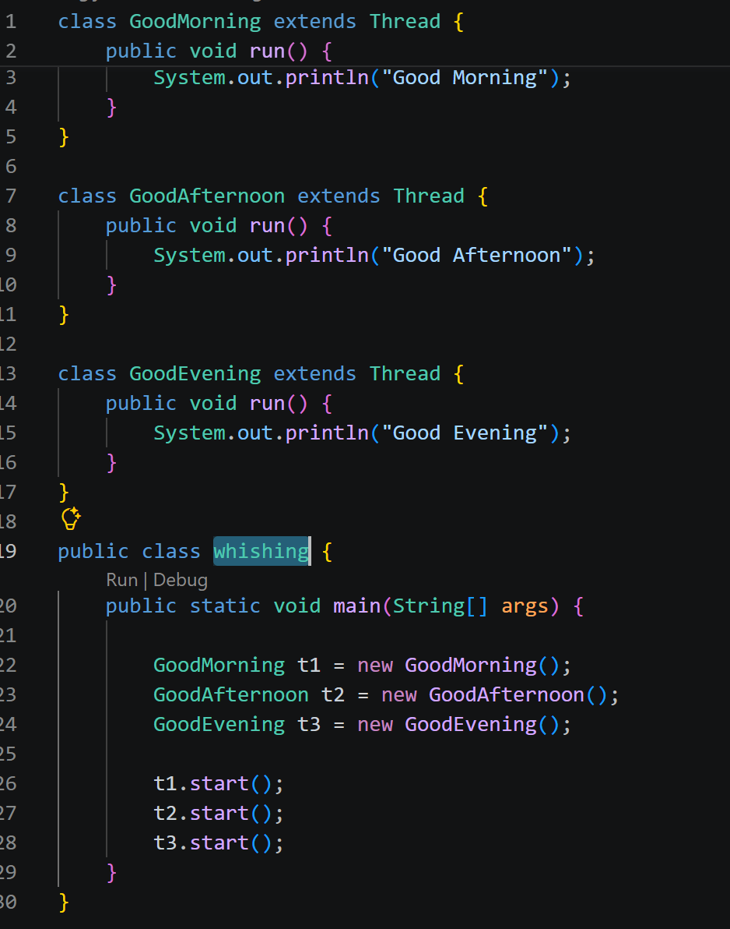

Task 2:
In the above program make
T1 → sleep for 2 sec
T2 → sleep for 1 sec
T3 → sleep for 0 sec
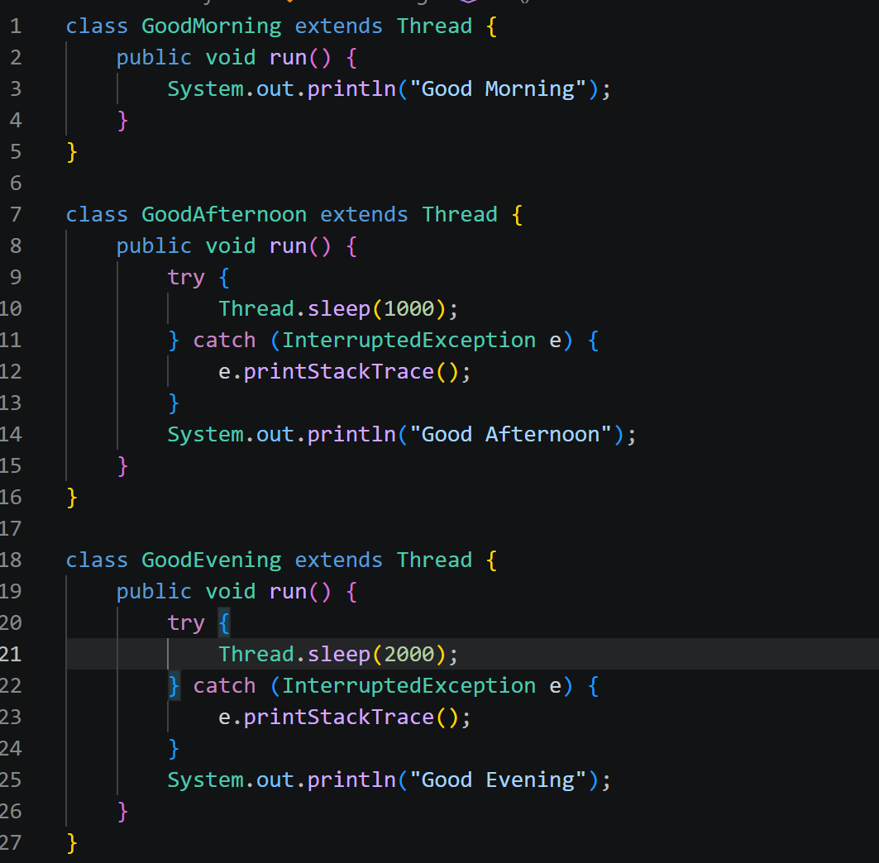
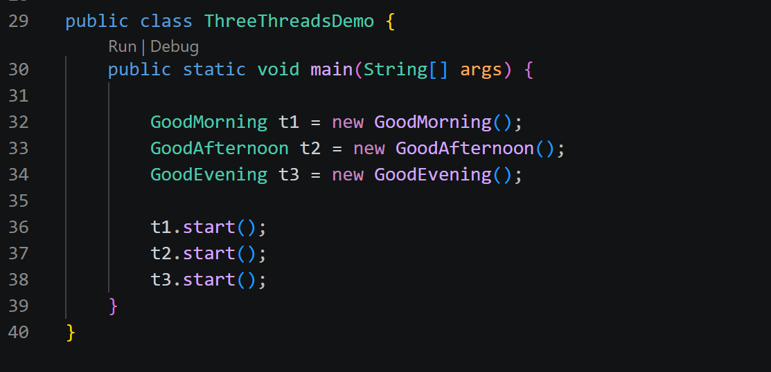

Task 3:
In the same prog
Give the names as
T1 → Morning
T2 → afternoon
T3 → evening
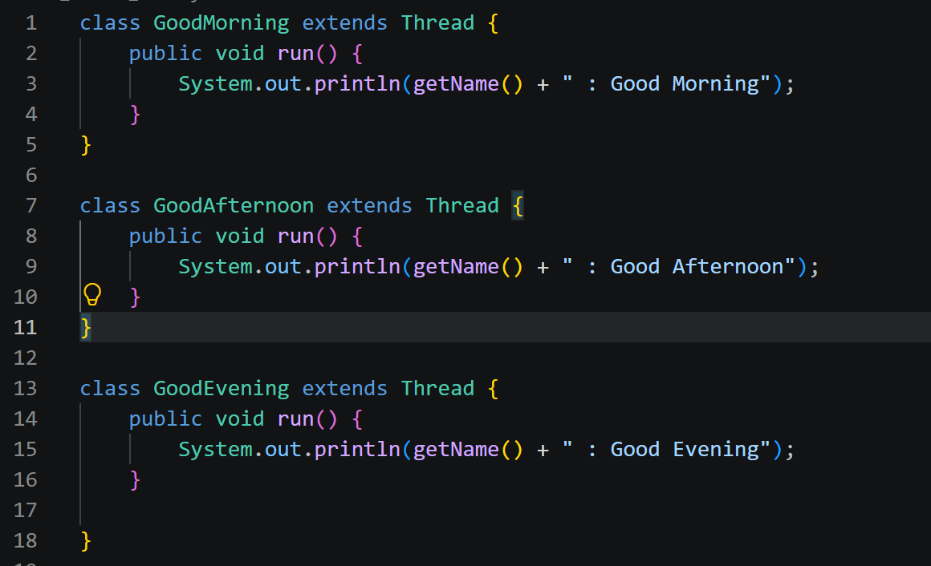
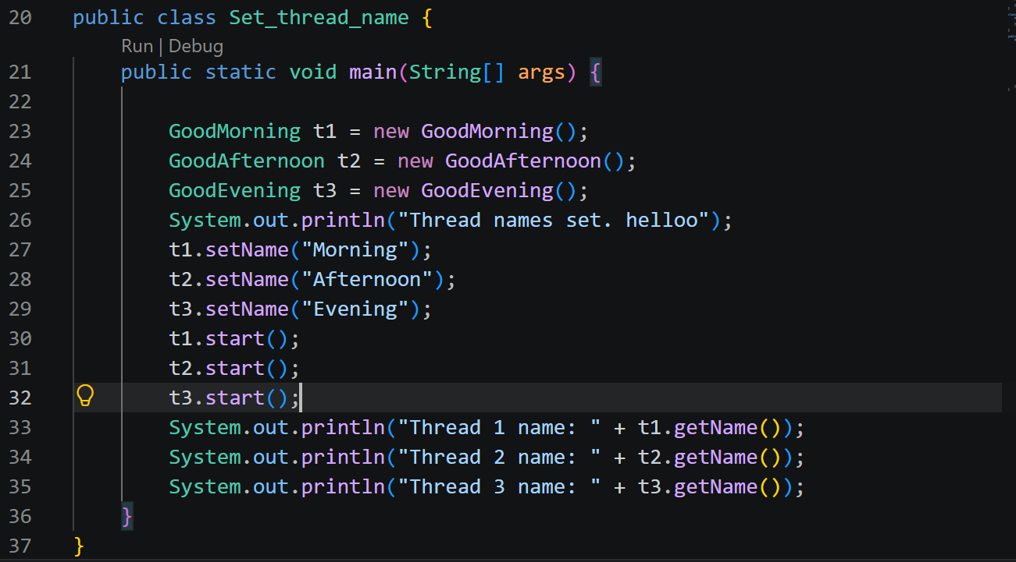

Task 4:

In the same code
T1 → max priority
T2 → normal priority
T3 → min priority
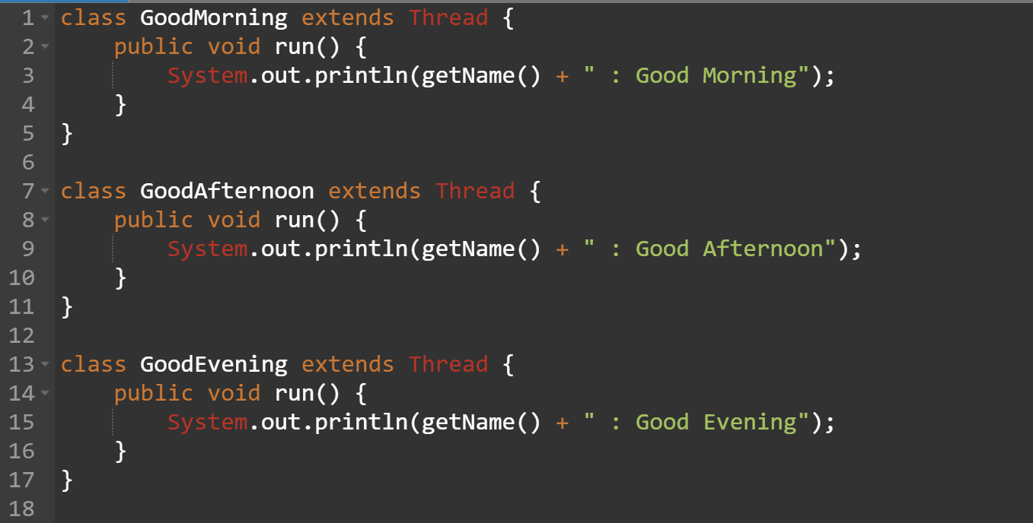
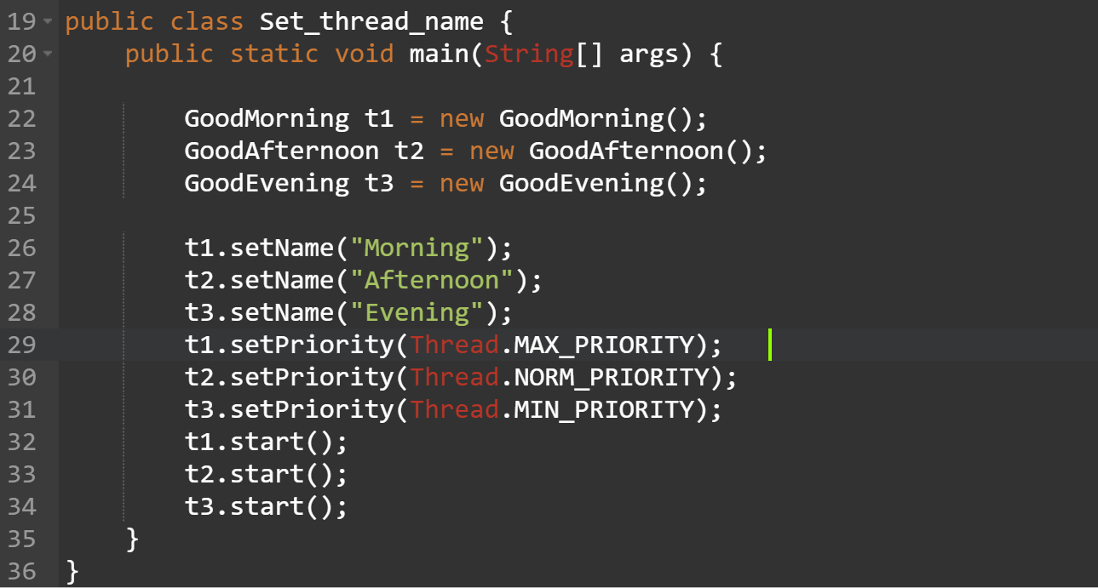

Task 5:
Wap to run threads in a loop.. of 1 to 20..
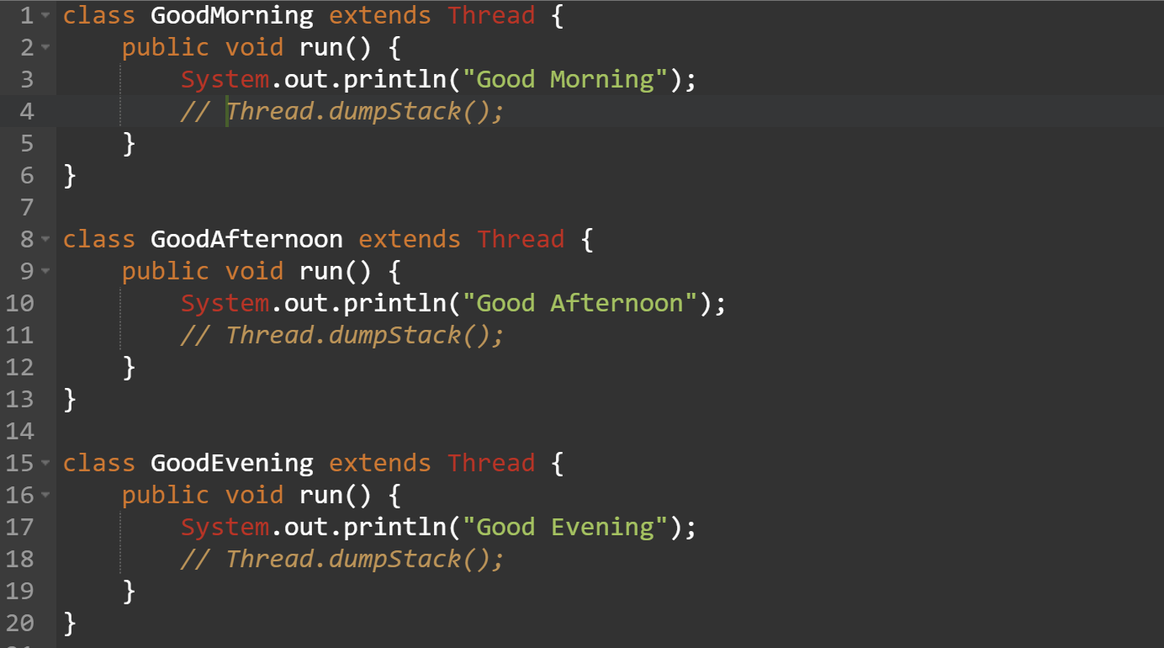
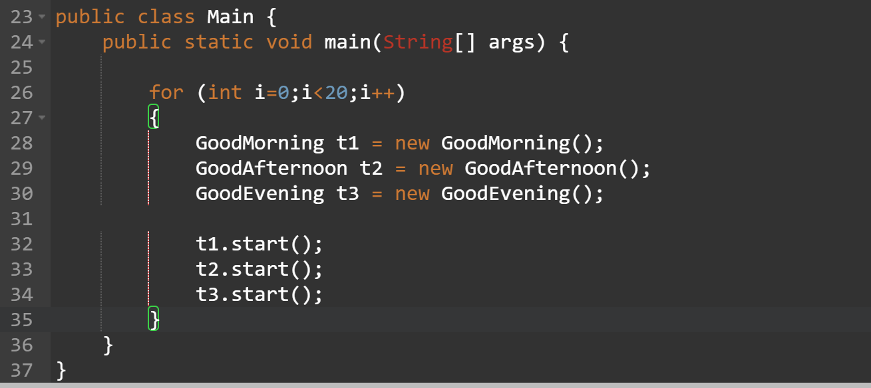

Task 6:
Check for isalive status of a thread..
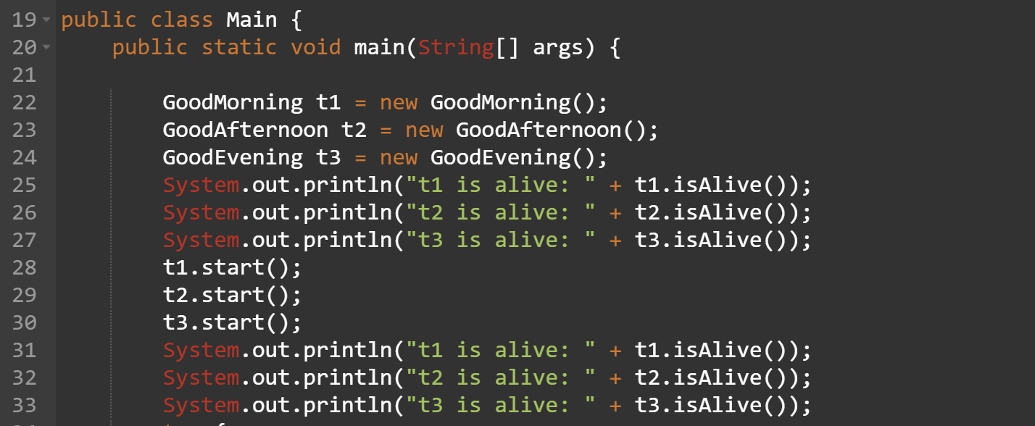
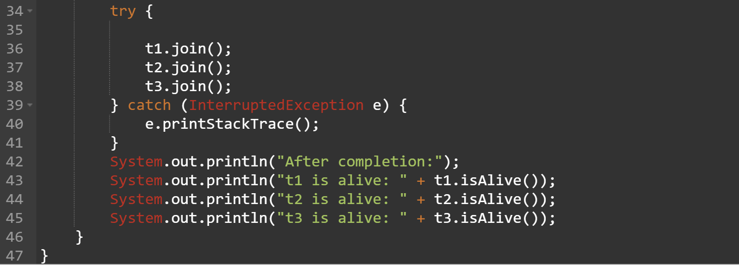

Task 7:
Check the same code with synchronized keyword
class Counter {
int count = 0;
void synchronized increment() {
count++;
}
}
class MyThread extends Thread {
Counter c;
MyThread(Counter c) {
this.c = c;
}
public void run() {
for(int i = 0; i < 1000; i++) {
c.increment();
}
}
}

public class Main {
public static void main(String[] args) throws Exception {
Counter c = new Counter();
MyThread t1 = new MyThread(c);
MyThread t2 = new MyThread(c);
t1.start();
t2.start();
t1.join();
t2.join();
System.out.println(c.count);
}
}
Task 8:
Wap to display the exception handling concept..
Try , catch , finally..

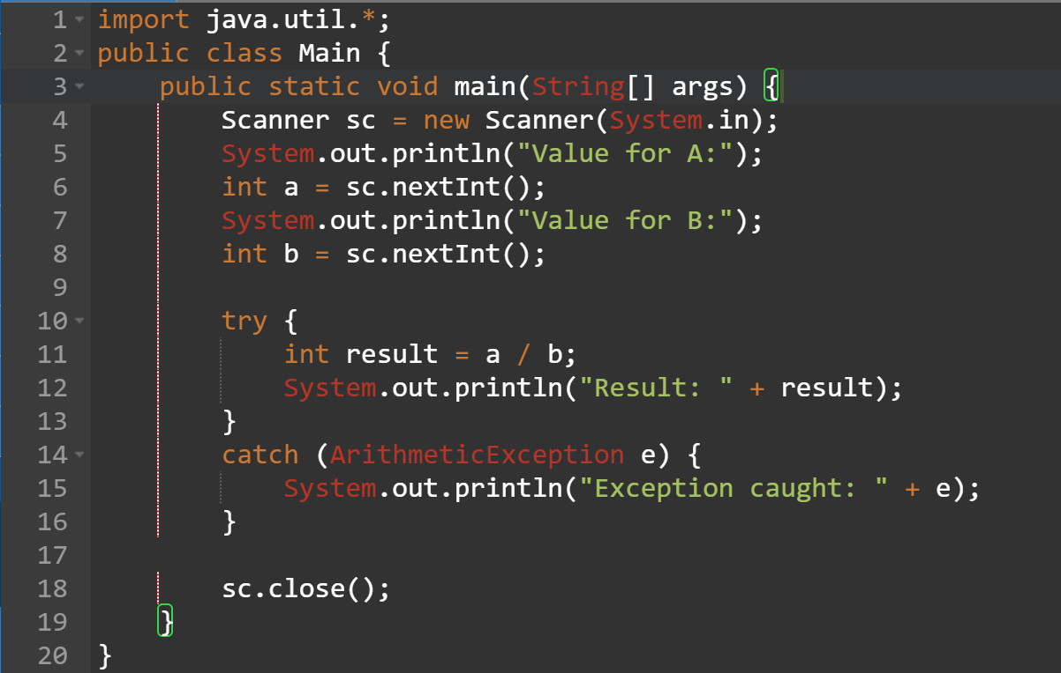
import java.util.*;
public class Main {
public static void main(String[] args) {
Runnable r1=new Runnable(){
public void run(){
System.out.println("before:hello");
}
};

Runnable r2=()->System.out.println("after: hello");

List<String> names=Arrays.asList("vicky","kathu");
names.forEach(name-> System.out.println("name:"+name));

r1.run();
r2.run();
}
}
@functionalInterface
interface Calculator {
int calculate(int a, int b);
}

public class Main {
public static void main(String[] args) {

Calculator add = (a, b) -> a + b;
Calculator multiply = (a, b) -> a * b;

System.out.println("Addition: " + add.calculate(10, 20));
System.out.println("Multiplication: " + multiply.calculate(10, 20));
}
}
@FunctionalInterface
interface InputOutput {
float takeInput(int a, int b);
}

public class Main {
public static void main(String[] args) {

InputOutput input = (a, b) -> (float) (a + b) ;

float result = input.takeInput(10, 20);

System.out.println(result);
}
}
@FunctionalInterface
interface CheckVowel {
boolean check(char ch);
}

public class FunctionalInterfaceDemo {

public static void main(String[] args) {

// Lambda expression for checking vowels
CheckVowel isVowel = ch ->
ch == 'a' || ch == 'e' || ch == 'i' ||
ch == 'o' || ch == 'u' ||
ch == 'A' || ch == 'E' || ch == 'I' ||
ch == 'O' || ch == 'U';

char ch1 = 'A';
char ch2 = 'B';

System.out.println(ch1 + " is vowel: " + isVowel.check(ch1));
System.out.println(ch2 + " is vowel: " + isVowel.check(ch2));
}
}

