Day 17 - 07th Aug 2026

Task 1:
What is data binding?
Data binding is the process of connecting data with the user interface (UI) so that data can be displayed and updated easily.
In React, data binding is mainly one-way, meaning data flows from the component (state/props) to the UI. When the data changes, React automatically updates the displayed content.

Task 2:
What do you understand by one way data binding and two way data binding?
One-way data binding:
Data flows in only one direction—from the component (state/props) to the UI. When the data changes, the UI updates automatically. This makes the application easier to understand and debug. React uses one-way data binding.
Two-way data binding:
Data flows in both directions—changes in the UI update the data, and changes in the data update the UI automatically. This keeps the UI and data synchronized. Frameworks like Angular support two-way data binding.

Task 3:
When do you use one way data binding and when to use two way data binding?give examples.
Use one-way data binding when you want to display data in the UI and keep the data flow simple and predictable.
Example: Showing a user's profile, product details, or a list of bank transactions in a React application.
Use two-way data binding when users need to enter or edit data, and the UI and data should stay synchronized automatically.
Example: Registration forms, login forms, or profile edit forms in Angular, where changes in the input fields update the data automatically.
Task 4:
What is the state in react?
State in React is a built-in object used to store and manage data that can change during the lifetime of a component. It holds dynamic information such as user input, counters, or API data. Whenever the state changes, React automatically re-renders the component so the UI always shows the latest data.
Example:
If a button click increases a counter from 0 to 1, the counter value is stored in the state. When the state updates, React automatically updates the displayed counter on the screen.
Task 5:
Can you explain SPA?
A Single Page Application (SPA) is a web application that loads a single HTML page and updates only the necessary content without reloading the entire page, resulting in faster performance and a better user experience.

Task 6:
What is DOM?
DOM (Document Object Model) is a tree-like structure created by the browser from an HTML document. It represents all the elements on a web page as objects, allowing JavaScript to access, modify, add, or remove elements dynamically.
Example:
If you click a button and the text on the page changes without refreshing the page, JavaScript is updating the DOM.
Task 7:
What is virtual DOM?
Virtual DOM is a lightweight copy of the real DOM maintained by React. When the state or props change, React first updates the Virtual DOM, compares it with the previous version (a process called diffing), and then updates only the changed parts in the real DOM. This makes React applications faster and more efficient.
Example:
If you update a counter from 0 to 1, React updates only the counter value in the real DOM instead of reloading the entire page.
Task 8:
What are props in react ? can you explain about prop drilling?
Props in React
Props (Properties) are used to pass data from a parent component to a child component. They are read-only, which means a child component cannot modify the props it receives.
Example:
A parent component passes a user's name to a child component, and the child displays it.
<Welcome name="Karthik" />
Here, name is a prop.
Prop Drilling
Prop drilling is the process of passing props through multiple intermediate components just to send data from a parent component to a deeply nested child component.
This can make the code difficult to manage because components that don't need the data still have to pass it along.
Example:
App
↓
Parent
↓
Child
↓
GrandChild

Task 9:
Why do we use react?give importance and describe in detail.
React is a JavaScript library used for building fast, interactive, and reusable user interfaces, especially for Single Page Applications (SPAs).

Importance of React
- Component-Based Architecture
  - Applications are divided into reusable components.
  - Makes development faster and code easier to maintain.
- Virtual DOM
  - Updates only the changed parts of the UI.
  - Improves application performance.
- One-Way Data Binding
  - Data flows in one direction.
  - Makes debugging easier.
- Reusable Components
  - Write once and use multiple times.
- Fast Rendering
  - React efficiently updates the UI using the Virtual DOM.
- Easy to Learn
  - Simple syntax and large community support.
- Supports Single Page Applications (SPA)
  - Provides smooth navigation without page reloads.
- Large Ecosystem
  - Works well with Redux, React Router, Firebase, and many other libraries.

Task 10:
What do you understand by Component-Based Architecture?
Component-Based Architecture is a design approach where the user interface is divided into small, reusable, and independent components. This improves code reusability, maintainability, and makes application development easier.

Example
An e-commerce website can be divided into:
- Header
- Navigation Bar
- Product Card
- Shopping Cart
- Footer

Task 11:
Explain the Lifecycle of a React Component.
The React component lifecycle consists of three main phases: Mounting (component is created and added to the DOM), Updating (component re-renders when state or props change), and Unmounting (component is removed from the DOM).
Diagram :
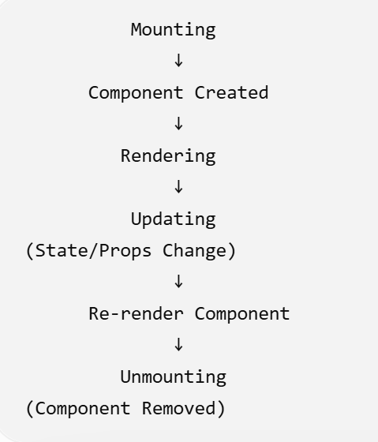
1. Mounting
Mounting is the phase when a component is created and added to the DOM.
Example:
<App />
React creates the component and displays it on the screen.

2. Updating
Updating occurs whenever state or props change.
React compares the Virtual DOM with the Real DOM and updates only the changed parts.
Example:
A counter changes from 5 to 6.

3. Unmounting
Unmounting is when the component is removed from the DOM.
Example:
Closing a popup or navigating to another page removes the component.
Task 12:
What are Hooks in React? Why do we use Hooks? What are different types of Hooks?
What are Hooks?
Hooks are special functions introduced in React 16.8 that allow functional components to use features like state, lifecycle methods, and context without writing class components.
Why do we use Hooks?
- Manage state in functional components.
- Handle lifecycle events.
- Share reusable logic.
- Make code cleaner and easier to maintain.
- Reduce the need for class components.
Common React Hooks
1. useState()
Used to manage state.
Example:
const [count, setCount] = useState(0);
2. useEffect()
Used for side effects like API calls, timers, or event listeners.
3. useContext()
Used to access data from React Context without prop drilling.
4. useRef()
Used to access DOM elements or store mutable values without re-rendering.
5. useMemo()
Optimizes performance by memoizing expensive calculations.
6. useCallback()
Memoizes functions to avoid unnecessary re-creation.
7. useReducer()
Manages complex state using reducer functions.

8. Custom Hooks
Reusable hooks created by developers.
Example:
useAuth()

Task 13:
What is React Redux Architecture? Explain in detail.
Redux is a state management library used with React to manage and share application state across multiple components.
Instead of storing data separately in each component, Redux stores all shared data in a single centralized store.
Redux Architecture
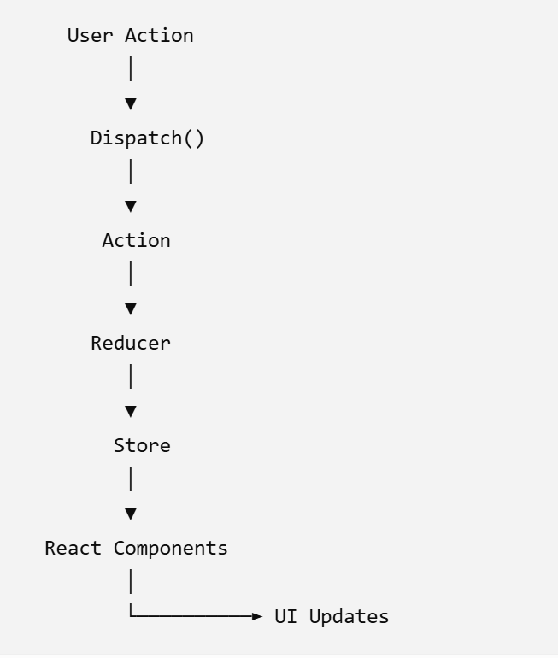
Main Parts of Redux
1. Store
- The central place where the application's state is stored.
- Only one store is typically used.
2. Action
- A plain JavaScript object that describes what happened.
- Example: { type: "ADD_ITEM" }
3. Dispatch
- Sends an action to the Redux store.
- Triggers state updates.
4. Reducer
- A pure function that receives the current state and an action.
- Returns the updated state.
5. React Components
- Read data from the Redux store and display it.
- Can dispatch actions when users interact with the application.
Advantages of Redux
- Centralized state management.
- Easy data sharing between components.
- Predictable state updates.
- Easier debugging.
- Better for large applications.
- Reduces prop drilling.

Demo1

Step 1:
Create the root app —> app.jsx – with h1 tag in the function app
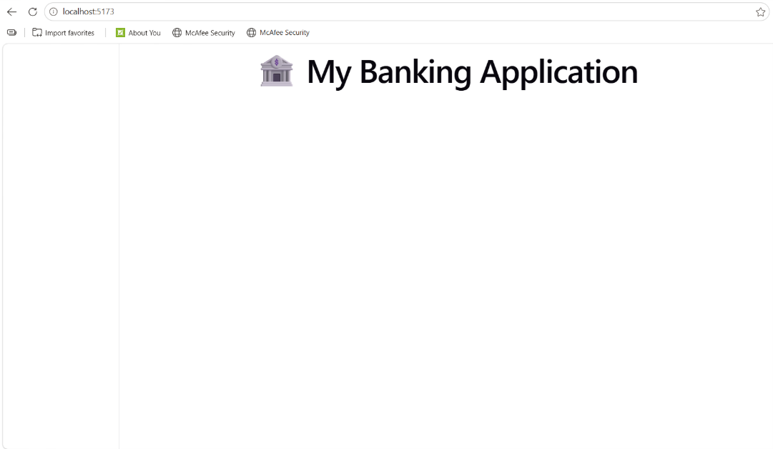

Step 2:
In src..
Create a components folder and add a function component.
Like dashboard.jsx
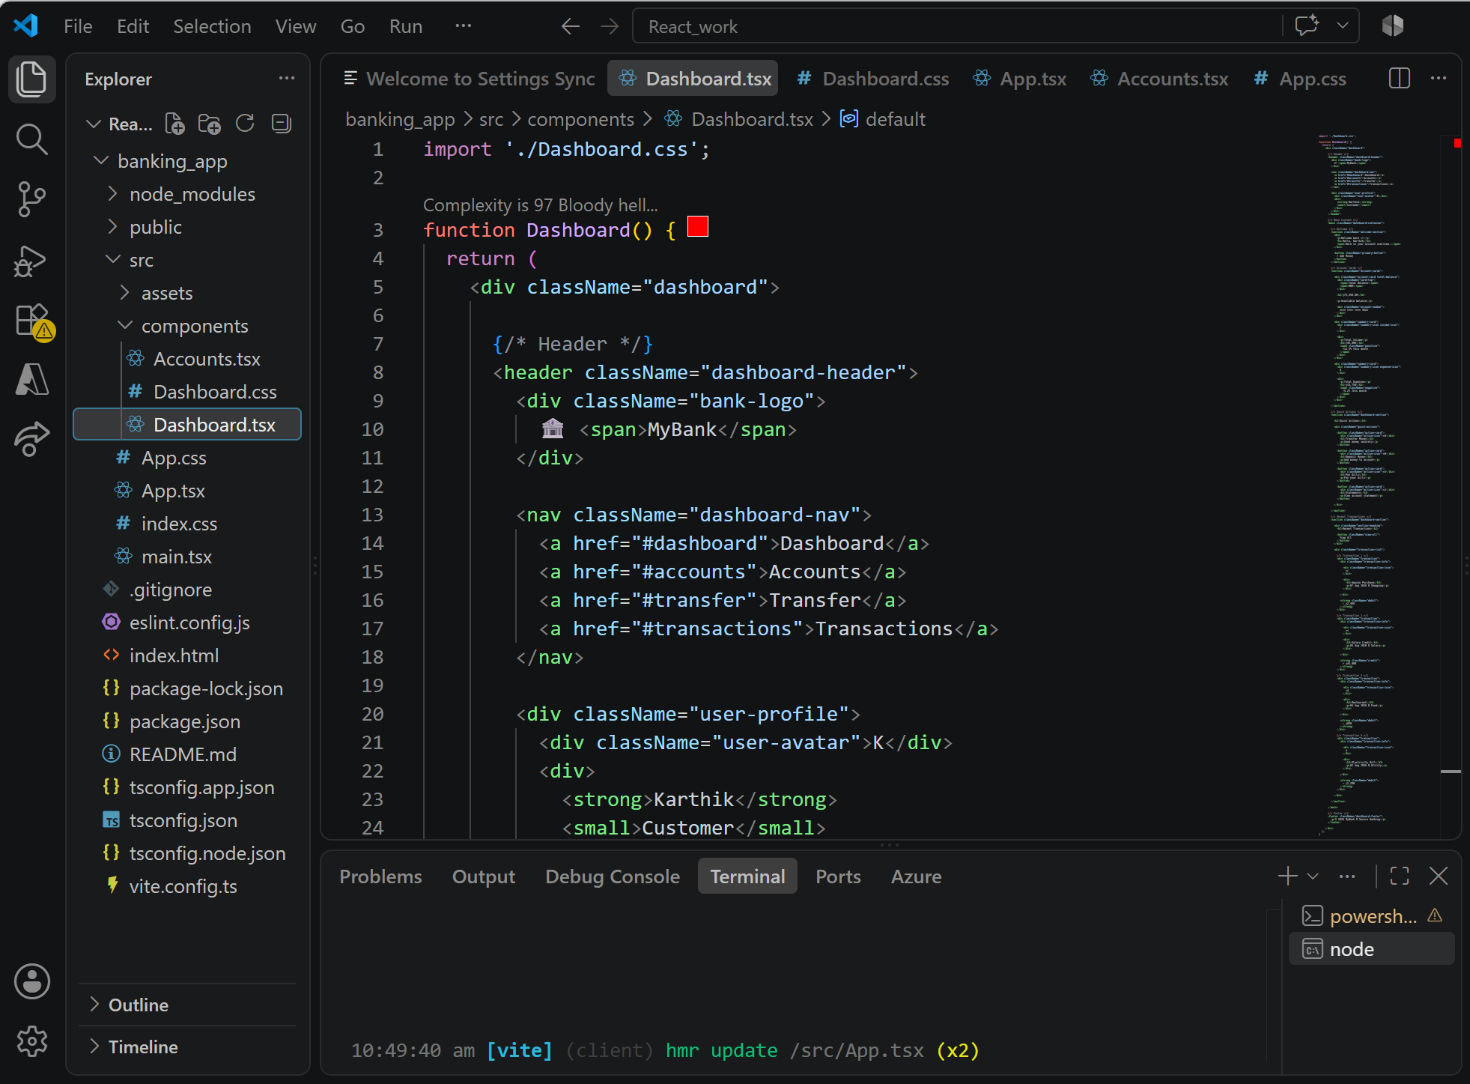
Step 3:
In components/ create Accounts.jsx
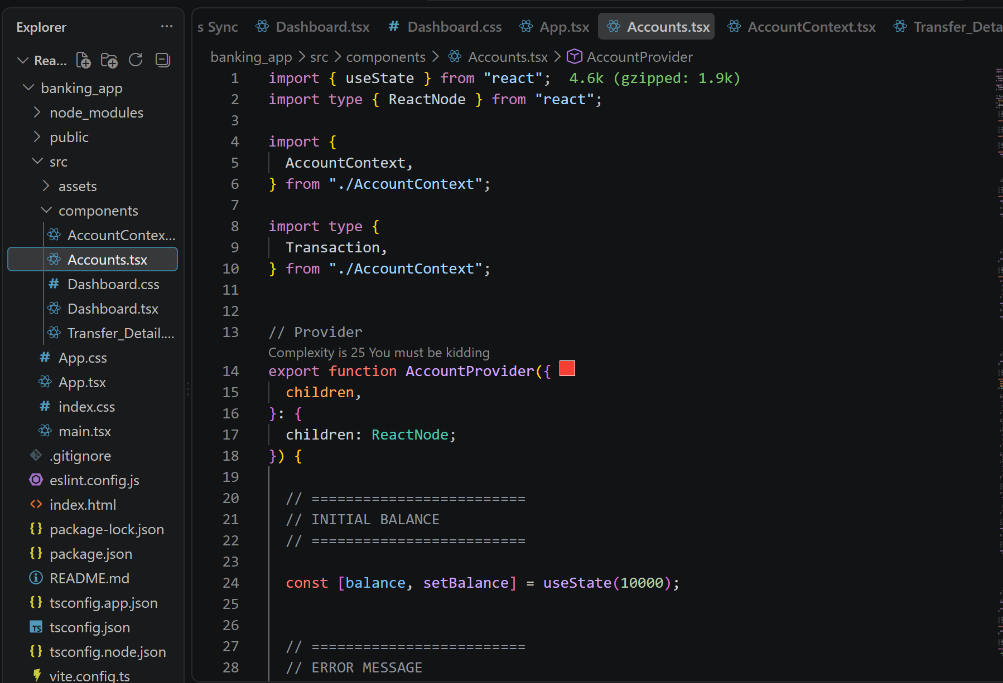

Step 4:
Create a usestate … initialize and use it to display the current balance
import { useState } from "react";
import type { ReactNode } from "react";

import {
AccountContext,
} from "./AccountContext";

import type {
Transaction,
} from "./AccountContext";
// Provider
export function AccountProvider({
children,
}: {
children: ReactNode;
}) {
const [balance, setBalance] = useState(10000);
const [error, setError] = useState("");

=
const [transactions, setTransactions] =
useState<Transaction[]>([
{
id: 1,

type: "credit",

description: "Initial Balance",

amount: 10000,

date: new Date().toLocaleString(),
},
]);

const credit = () => {

setBalance(
(currentBalance) =>
currentBalance + 100
);
setTransactions(
(currentTransactions) => [

{
id: Date.now(),

type: "credit",

description: "Amount Credited",

amount: 100,

date: new Date().toLocaleString(),
},

...currentTransactions,
]
);

setError("");
};
const debit = () => {

if (balance < 100) {

setError(
"Insufficient balance!"
);

return;
}

Step 4:
Conditional rendering
const handleTransaction = (type, amount) => {
let newBalance = balance;
if (type === "Deposit") newBalance += amount;
if (type === "Withdraw") newBalance -= amount;
setBalance(newBalance);

Step 5:
In components / create TransactionForm.jsx
Now
Step 6:
Can you implement use state hook in TransactionForm.jsx

import { useState } from "react";
import { useAccount } from "./AccountContext";
import "./Dashboard.css";

interface TransferDetailProps {
onBack: () => void;
}

function Transfer_Detail({
onBack,
}: TransferDetailProps) {

const {
balance,
transferMoney,
error,
clearError,
} = useAccount();

const [accountNumber, setAccountNumber] = useState("");

const [receiverName, setReceiverName] = useState("");

const [amount, setAmount] = useState("");

const handleTransfer = () => {

const transferAmount = Number(amount);

const success = transferMoney(
accountNumber,
receiverName,
transferAmount
);

if (success) {

setAccountNumber("");
setReceiverName("");
setAmount("");

alert("Amount transferred successfully!");

onBack();
}
};

return (
<div className="transfer-page">

{/* Header */}

<header className="dashboard-header">

<div className="bank-logo">
🏦 MyBank
</div>

<div className="user-profile">

<div className="user-avatar">
K
</div>

<div>
<strong>Karthik</strong>

<small>
Customer
</small>
</div>

</div>

</header>

{/* Transfer Container */}

<main className="transfer-container">

<button
className="back-button"
onClick={onBack}
>
← Back to Dashboard
</button>

<div className="transfer-card">

<div className="transfer-title">

<h1>
Transfer Money
</h1>

<p>
Send money securely to another account.
</p>

</div>

{/* Current Balance */}

<div className="transfer-balance">

<span>
Available Balance
</span>

<strong>
₹{balance.toLocaleString("en-IN")}
</strong>

</div>

{/* Error */}

{error && (

<div className="error-message">

⚠️ {error}

<button onClick={clearError}>
✕
</button>

</div>

)}

{/* Account Number */}

<div className="form-group">

<label>
Receiver Account Number
</label>

<input
type="text"
inputMode="numeric"
maxLength={9}
placeholder="Enter 9 digit account number"
value={accountNumber}
onChange={(e) => {

const value = e.target.value;

// Only digits allowed
if (/^\d*$/.test(value)) {
setAccountNumber(value);
}

}}
/>

<small>
Account number must contain exactly 9 digits.
</small>

</div>

{/* Receiver Name */}

<div className="form-group">

<label>
Receiver Name
</label>

<input
type="text"
placeholder="Enter receiver name"
value={receiverName}
onChange={(e) => {

const value = e.target.value;

// Only characters and spaces
if (/^[A-Za-z ]*$/.test(value)) {
setReceiverName(value);
}

}}
/>

<small>
Only characters are allowed.
</small>

</div>

{/* Amount */}

<div className="form-group">

<label>
Amount to Transfer
</label>

<input
type="number"
min="1"
placeholder="Enter amount"
value={amount}
onChange={(e) =>
setAmount(e.target.value)
}
/>

</div>

{/* Transfer Button */}

<button
className="transfer-submit-button"
onClick={handleTransfer}
>
Transfer Money
</button>

</div>

</main>

</div>
);
}

export default Transfer_Detail;

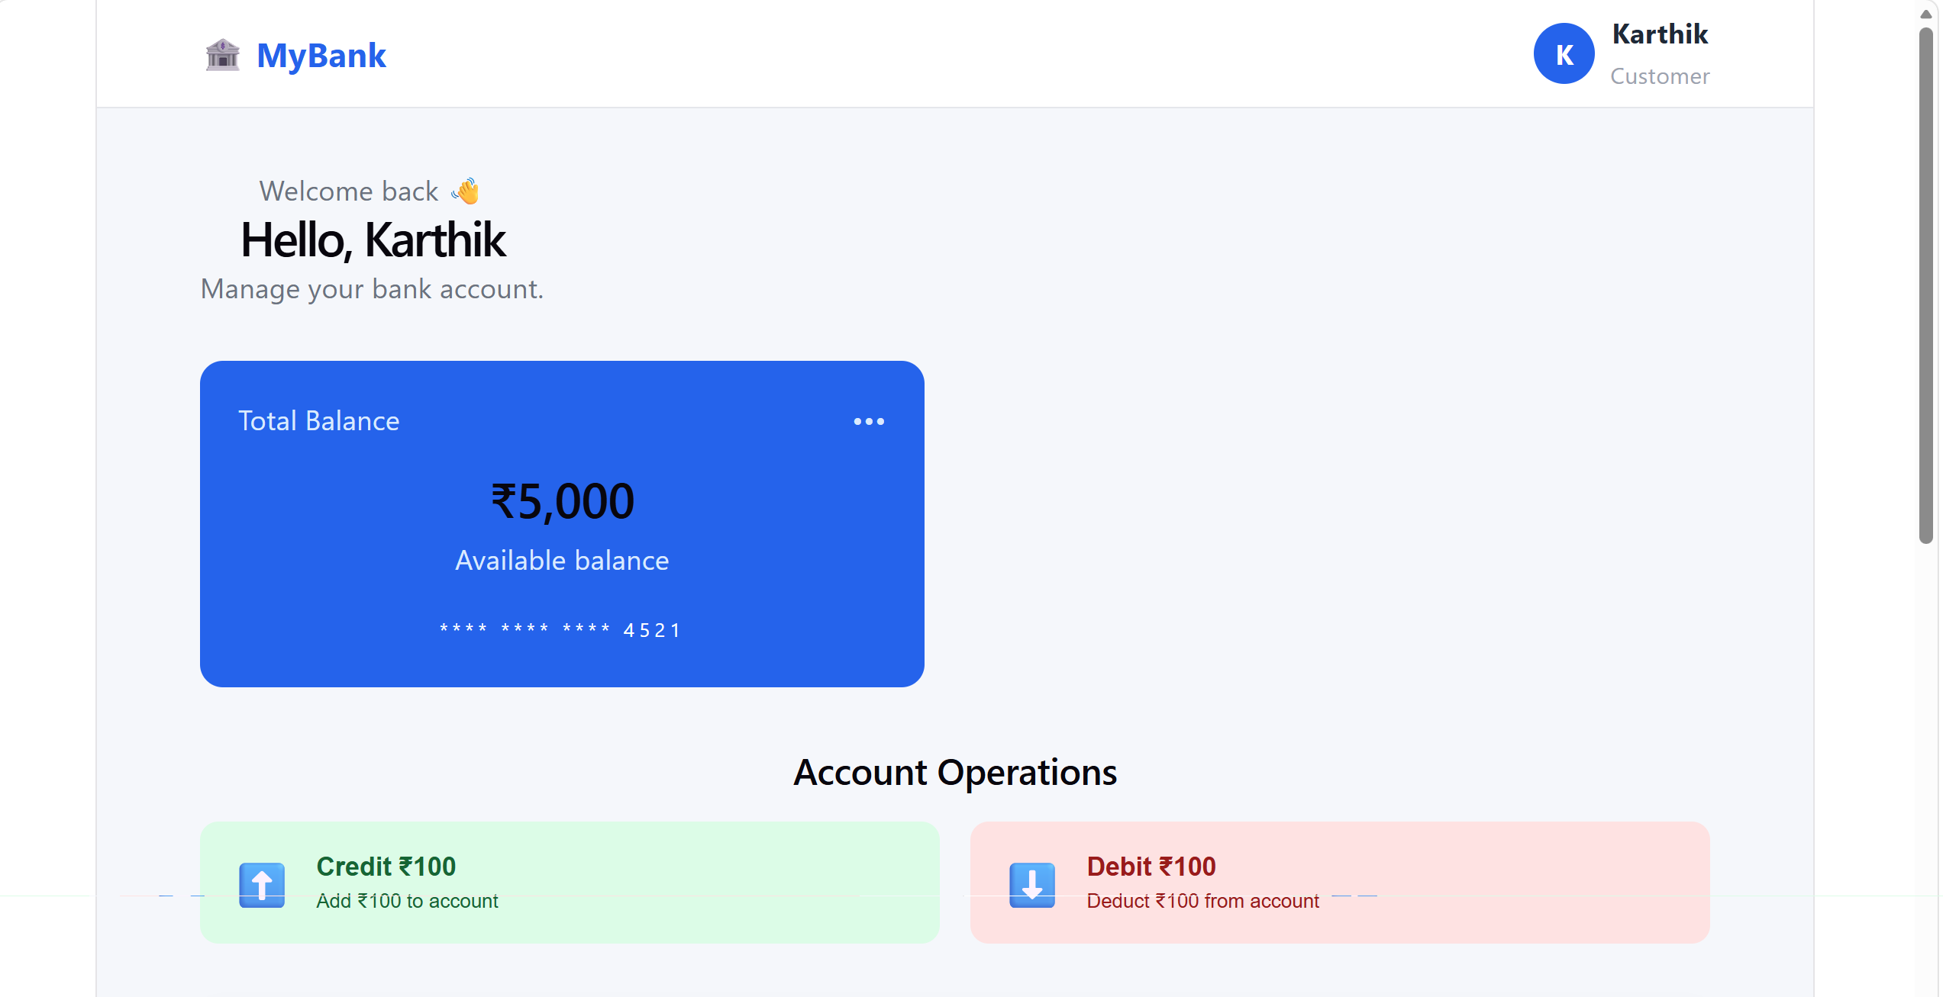
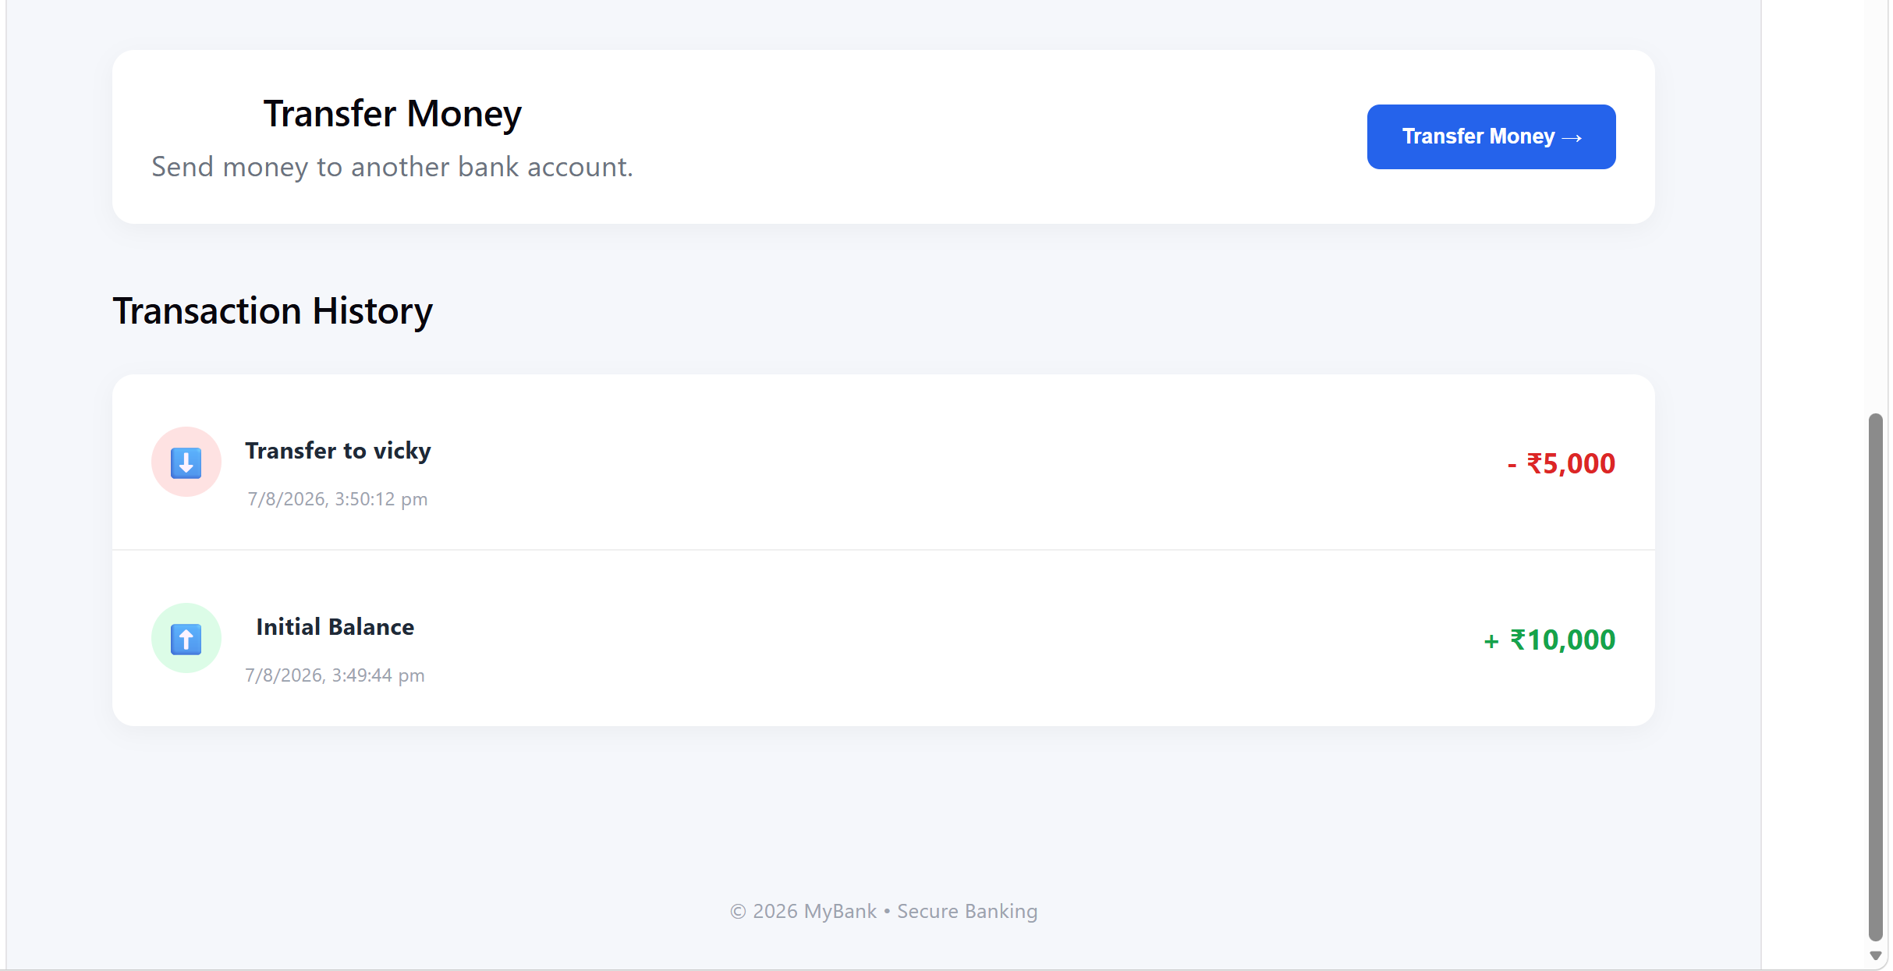
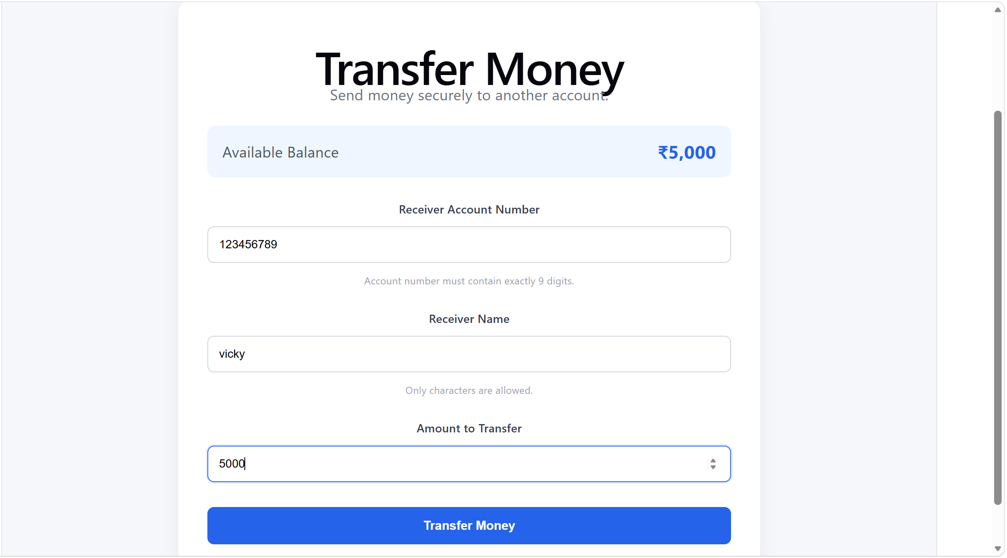

Step 8:

As you have already implemented state hooks..

Eg :useState - -> Declares a state variable and updater function.

const [count, setCount] = useState(0);

Can you try to implement one more state hook .. useReducer?

Like eg:
useReducer -> → Manages complex state logic with a reducer function.

const [state, dispatch] = useReducer(reducer, initialState);

Step 9:

Effect Hooks:

useEffect → Handles side effects (API calls, subscriptions, DOM updates).
Like example
useEffect(() => {
document.title = `Count: ${count}`;
}, [count]);

Step 10:
useLayoutEffect → Runs before the browser repaints (for layout measurements).

useInsertionEffect → Used mainly by libraries to inject styles before DOM updates.

Step 11:
Use contextHooks:

useContext → Accesses values from React Context without prop drilling.

Like eg

const theme = useContext(ThemeContext);

Step 12:
Ref Hooks:

useRef → Stores mutable values (like DOM nodes or timers) without causing re-renders.

const inputRef = useRef(null);

Step 13:
Performance Hooks
useMemo → Memoizes expensive calculations.

useCallback → Memoizes functions to avoid unnecessary re-renders.

useTransition → Manages concurrent rendering for smoother UI.

useDeferredValue → Defers updating non-critical UI parts.

Step 14:
useId → Generates unique IDs for accessibility.

useDebugValue → Labels custom hooks for debugging.

