Day 13 - 03rd Aug 2026

Task 1:
What is an ER diagram? Draw an entity relationship diagram with datatypes .
An Entity-Relationship (ER) Diagram is a graphical representation of a database that shows the entities, their attributes, and the relationships between them. It is used to design and understand the structure of a database before creating it.

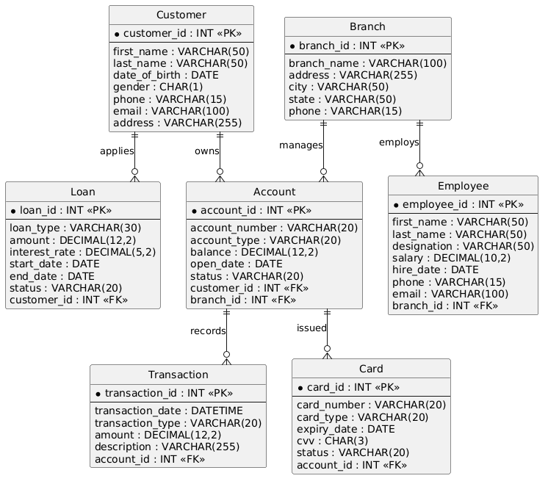

Task 2:
What do you understand by indexing in DBMS? How does it work?
Indexing in DBMS is a technique used to speed up data retrieval from a database without searching every row in a table.
- It creates a separate data structure that stores the values of selected columns along with pointers to the actual records.
- When a query is executed, the DBMS first searches the index instead of scanning the entire table.
- It quickly locates the required record and retrieves the data from the table.
- Indexing improves the performance of SELECT queries, although it may slightly slow down INSERT, UPDATE, and DELETE operations because the index must also be updated.

Task 3:
Do you think Indexing strategy improve the query performance ? explain .
Yes, indexing significantly improves query performance in a DBMS because it allows the database to find records quickly without scanning the entire table.
- An index works like the index of a book, helping the database locate the required data faster.
- It reduces the time needed to execute SELECT queries, especially when working with large tables.
- Indexing improves the performance of operations such as searching, filtering, sorting, and joining data.
- However, indexes require extra storage and can slightly slow down INSERT, UPDATE, and DELETE operations because the index must also be updated.

Task 4:
What are the ACID properties in RDBMS? Explain.
ACID is a set of four properties that ensure database transactions are accurate, reliable, and consistent, even if a system failure occurs.
- A – Atomicity: A transaction is treated as a single unit. Either all operations are completed successfully, or none of them are applied.
- C – Consistency: A transaction moves the database from one valid state to another, ensuring that all rules and constraints are maintained.
- I – Isolation: Multiple transactions can run at the same time without affecting each other, preventing data conflicts.
- D – Durability: Once a transaction is committed, the changes are permanently saved in the database, even if there is a power failure or system crash.

Task 5:
Alter a table to add a column with unique key
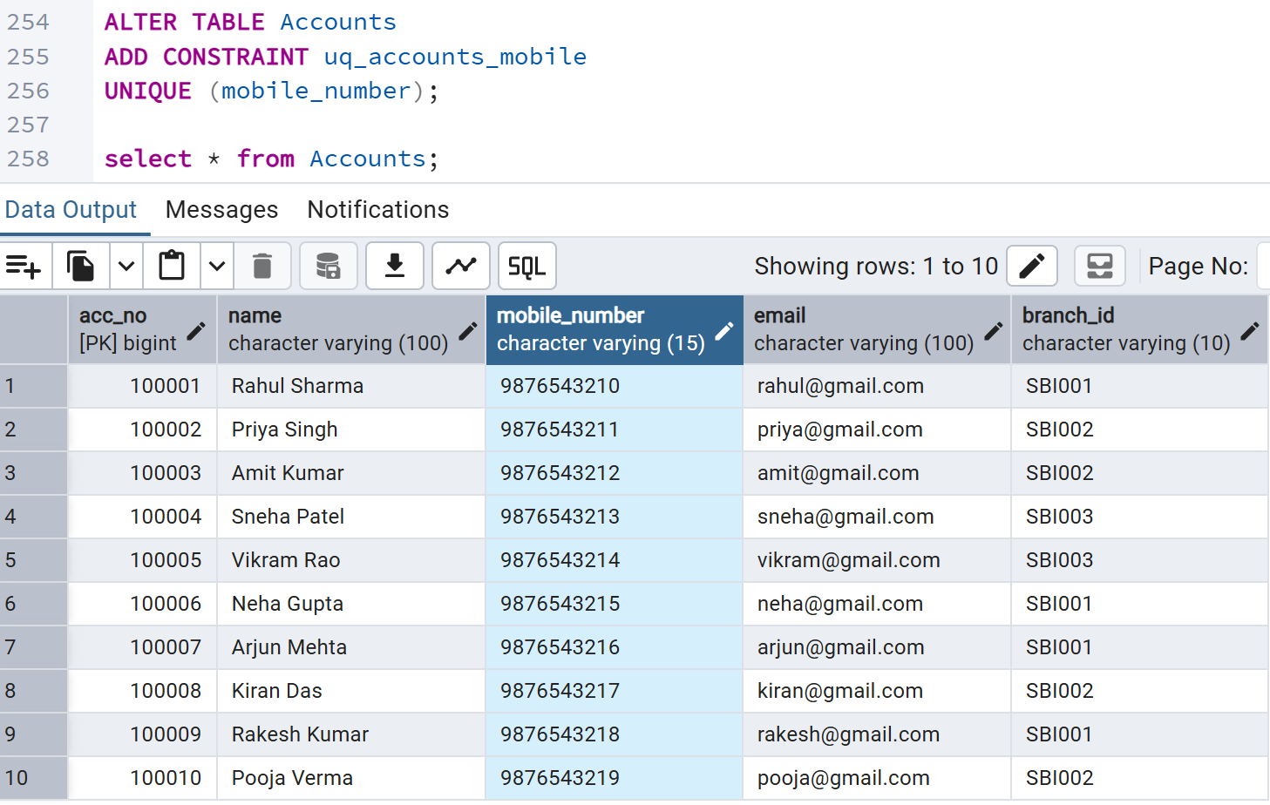
Accounts table
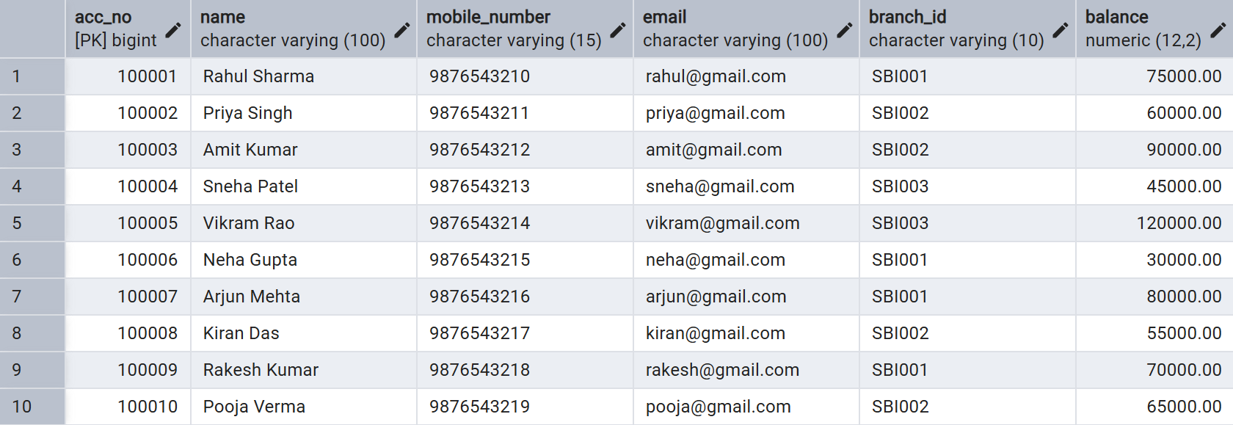
Task 6:
Add a check constraint to your column (eg: balance > 500)
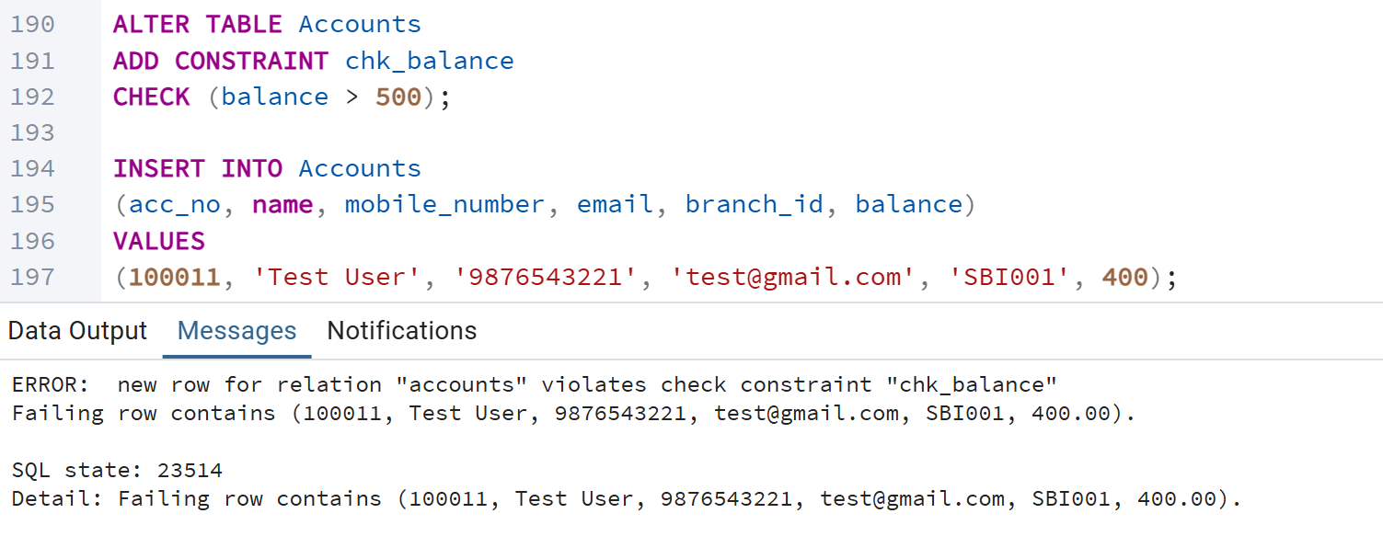
Task 7:
use where clause and check if it works
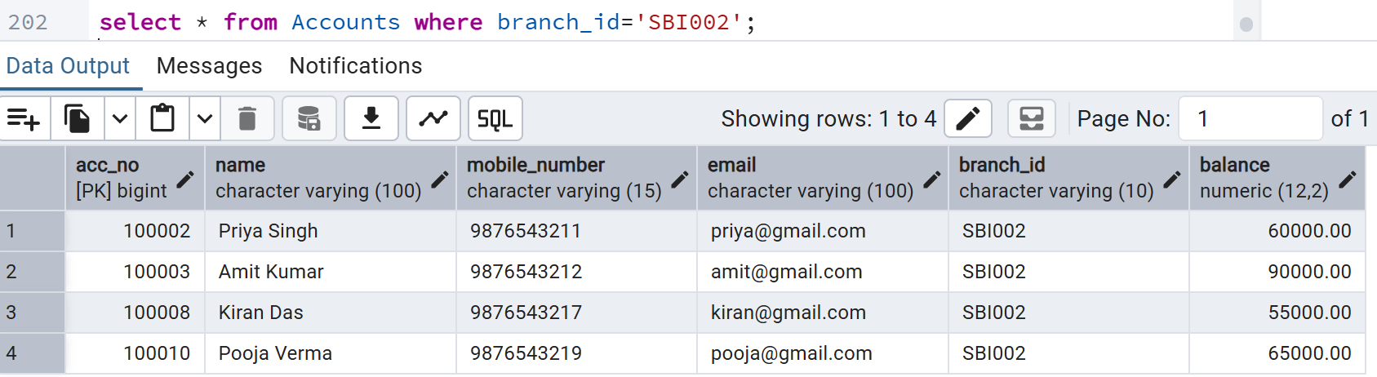

Task 8: ORDER BY
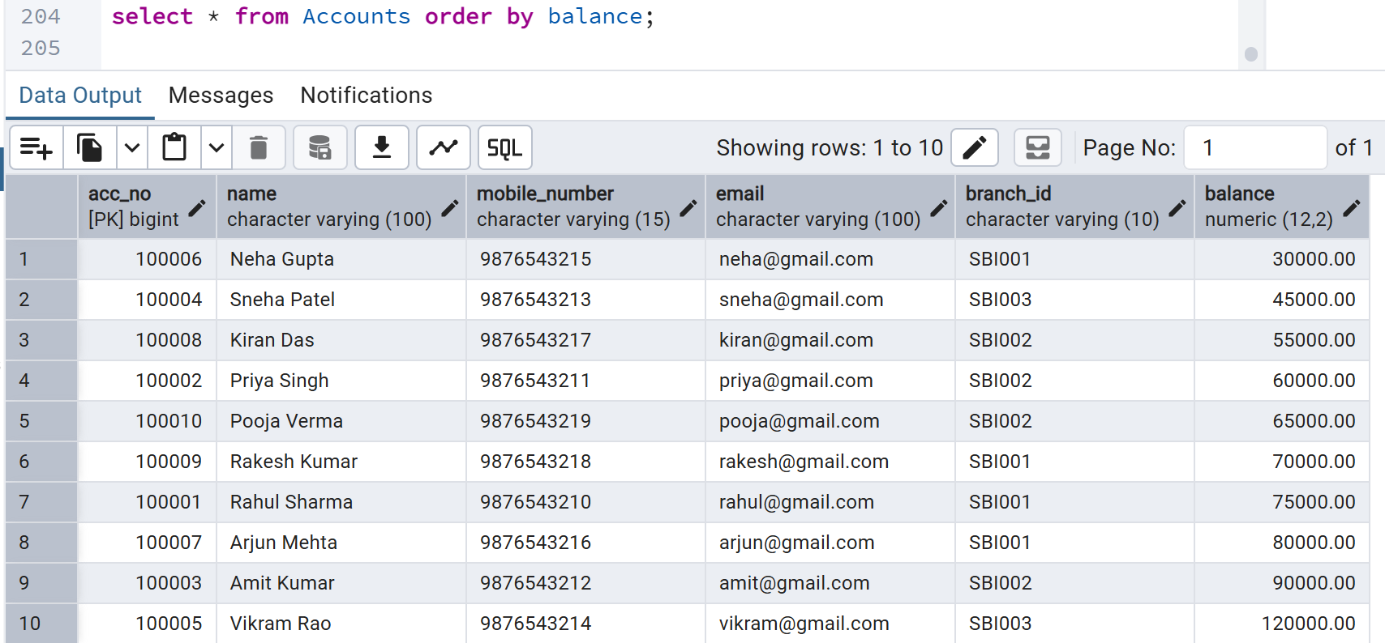
ORDER BY [DESC]
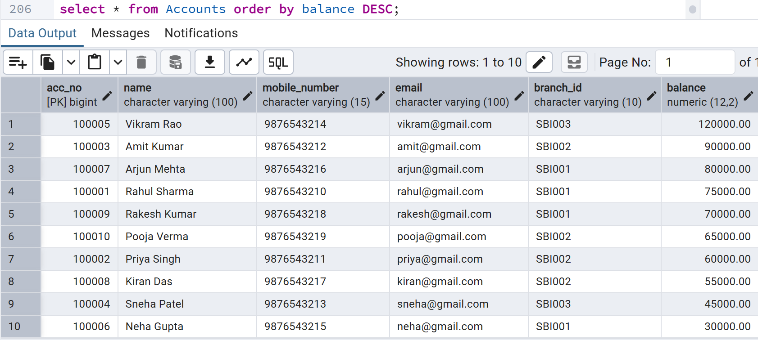

Task 9:
use limit
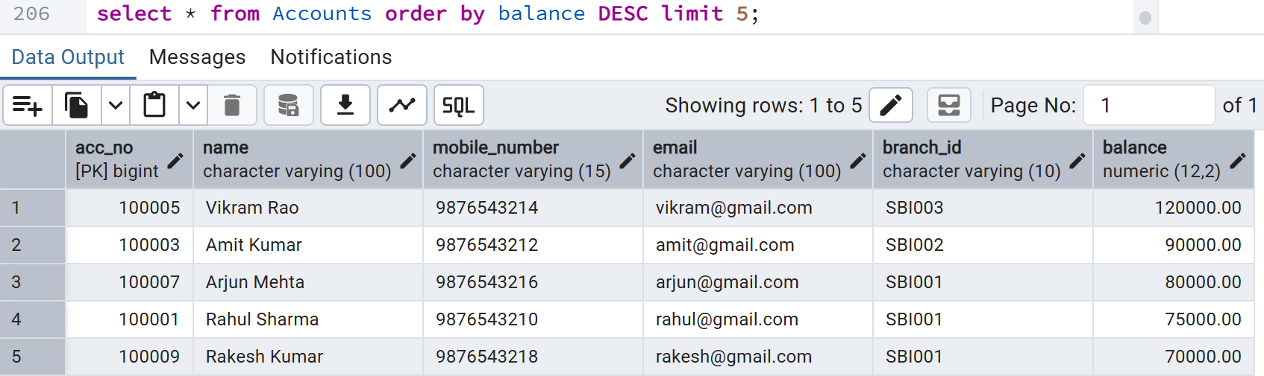

Inner Join
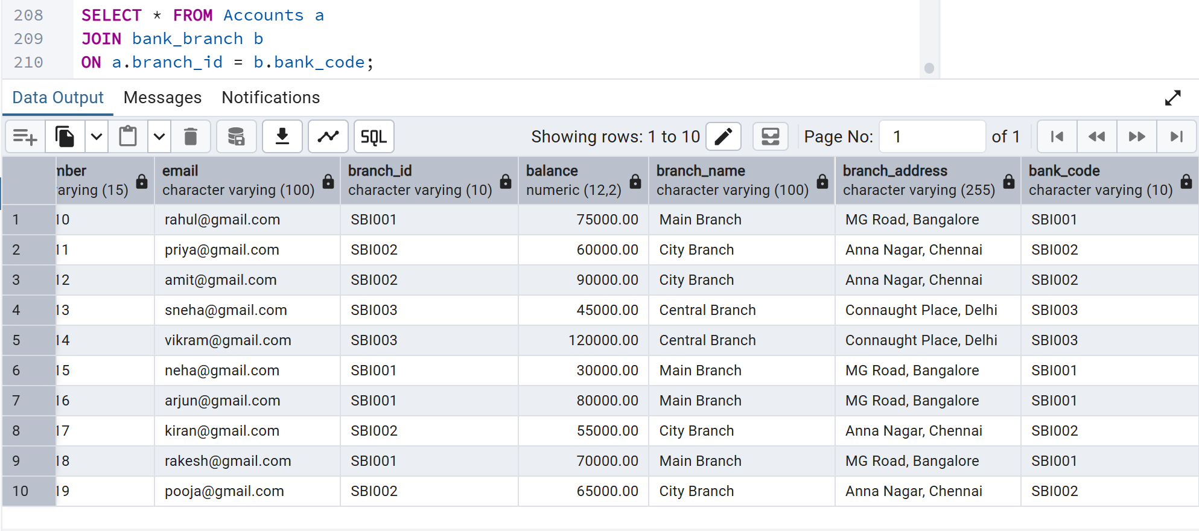
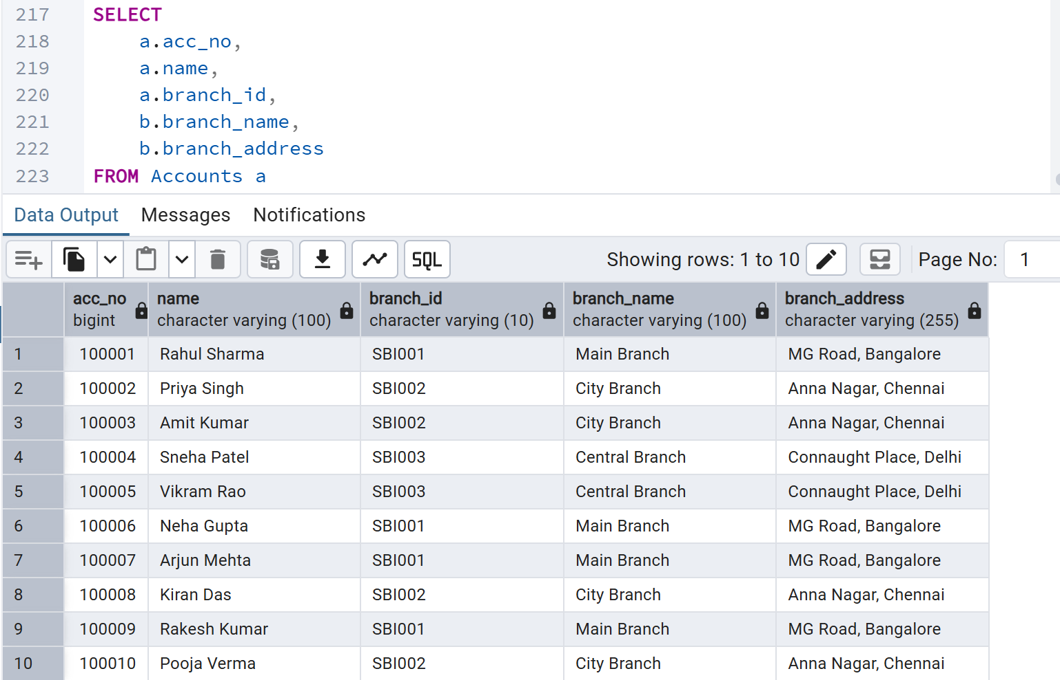
Task 10 : INNER JOIN
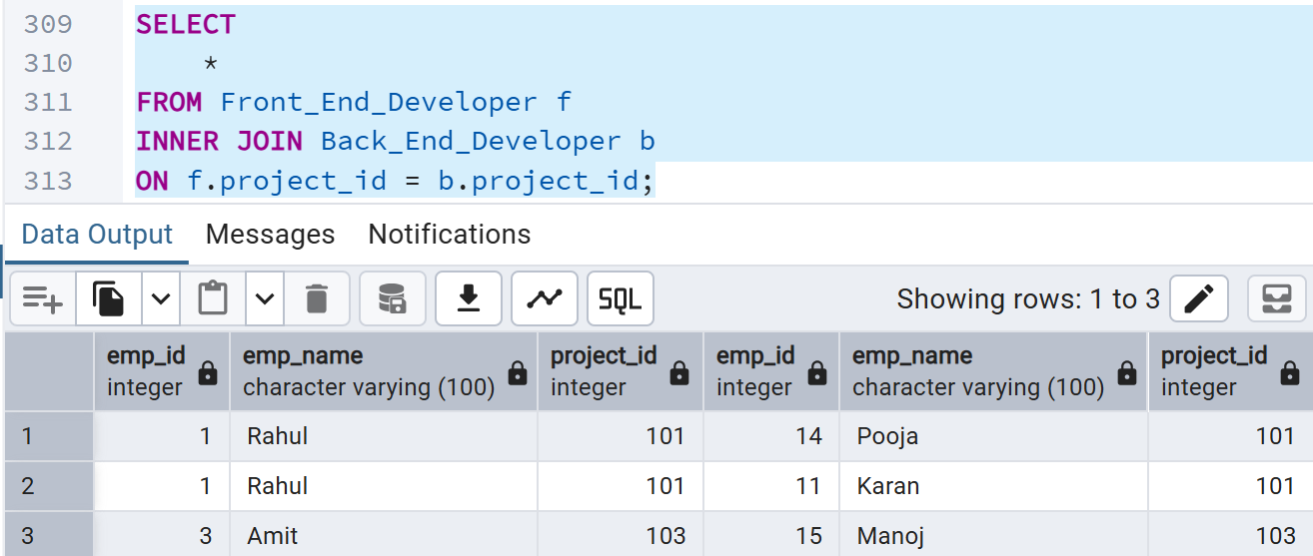
Task 10 : LEFT OUTER JOIN
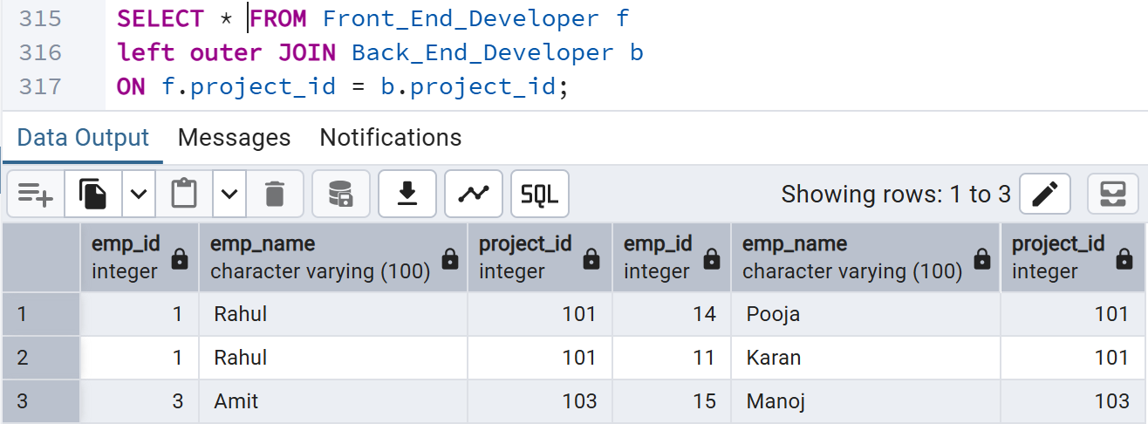
Task 10 : RIGHT OUTER JOIN
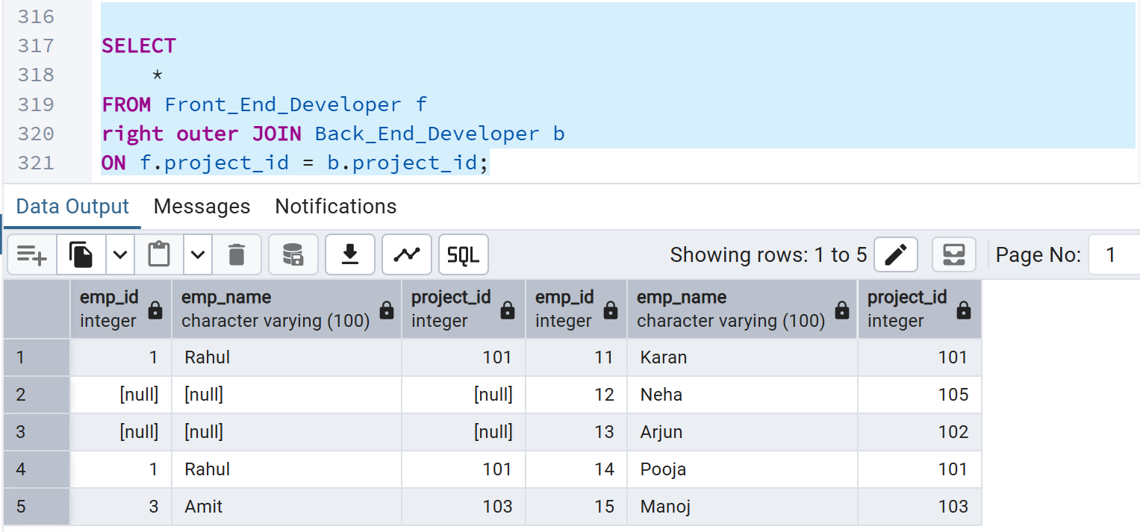
Task 10 : CROSS JOIN
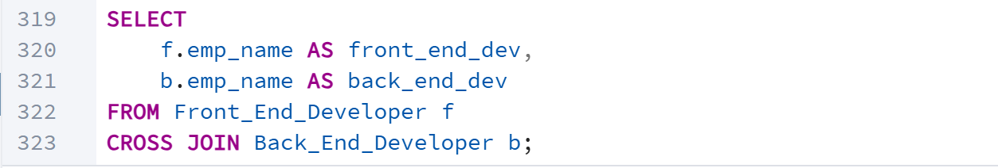
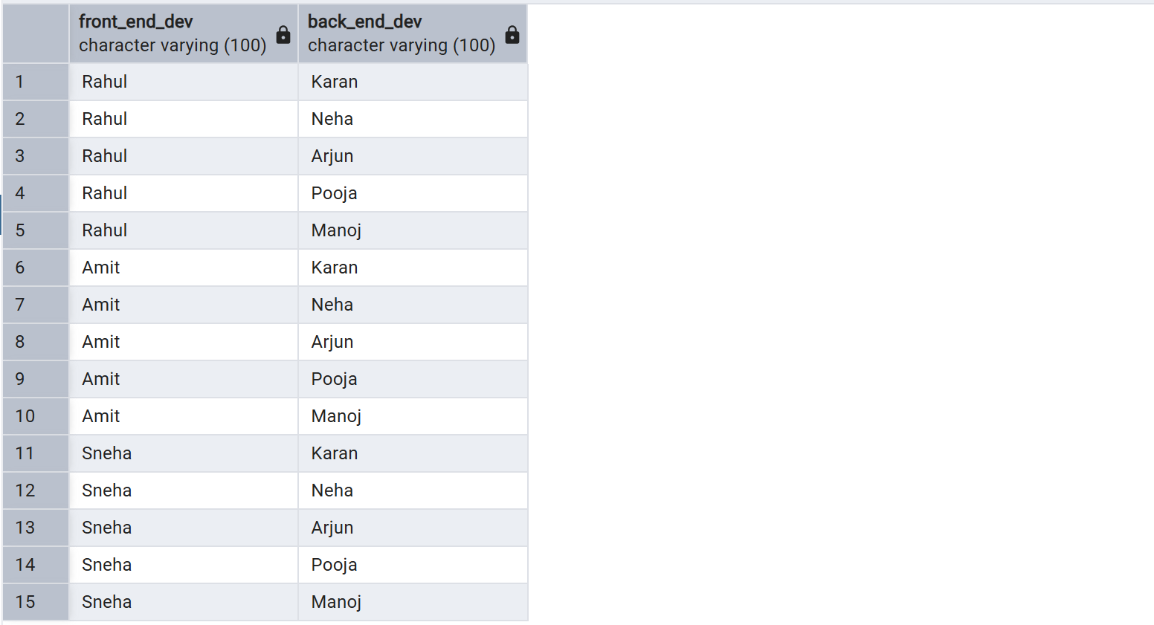

CREATING INDEXING
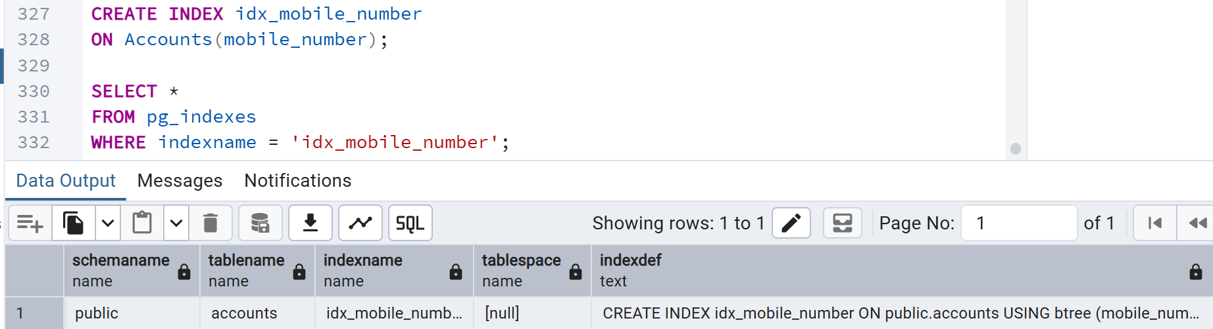
CREATING PARTIAL INDEXING
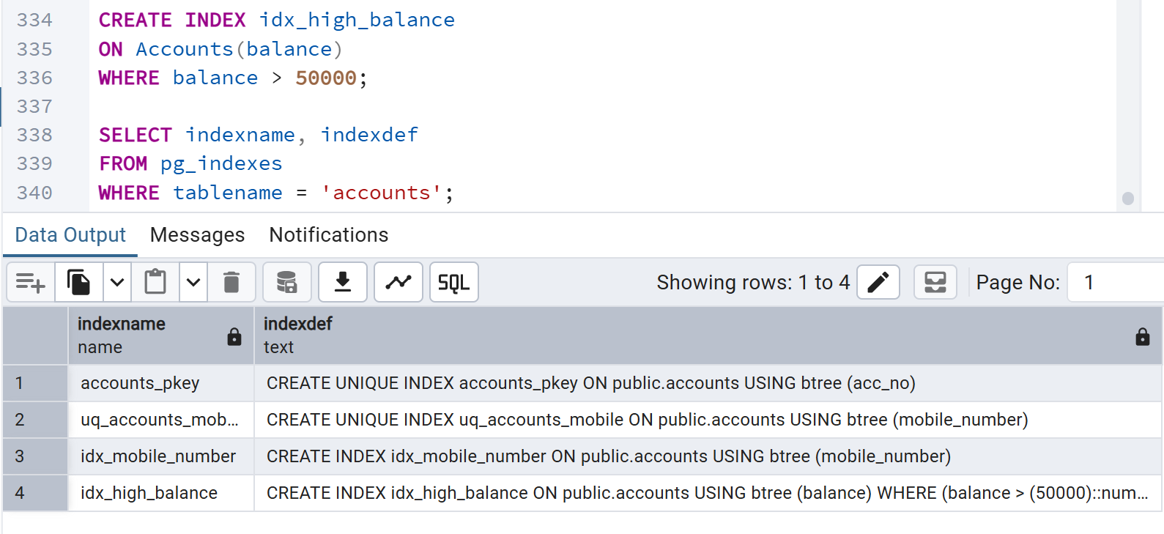

TASK ON SCHEMA :
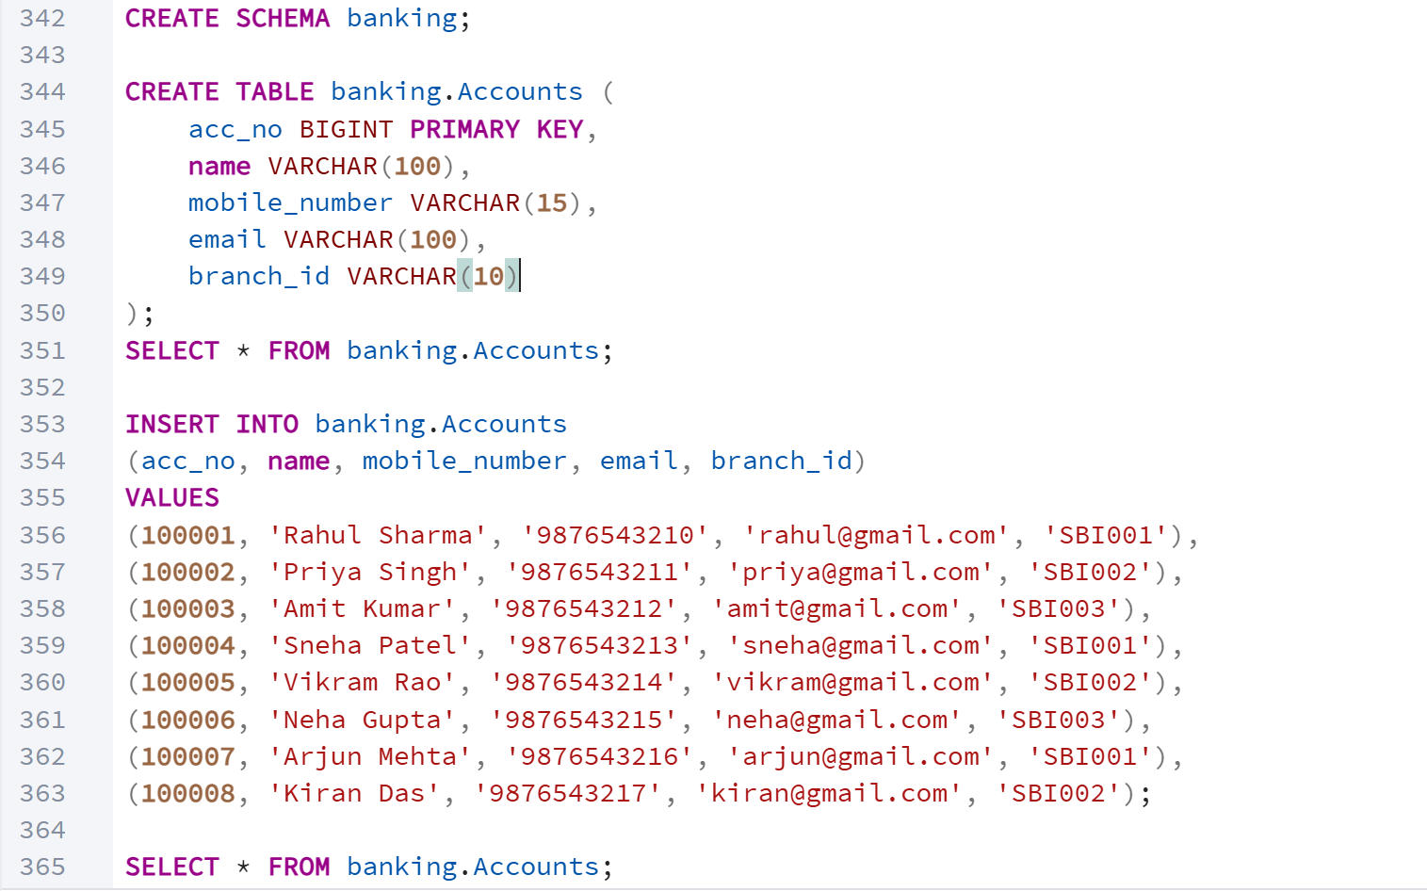
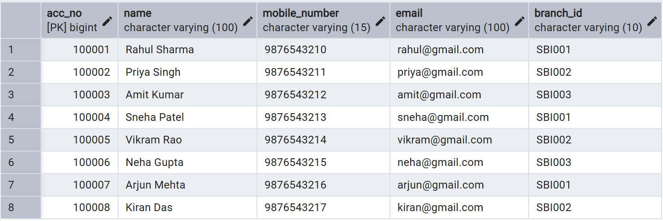

Task 13:
Can you create a java code and connect with the postgresql
application.properties
spring.datasource.url=jdbc:postgresql://localhost:5432/bank_DB
spring.datasource.username=postgres
spring.datasource.password=Password

spring.jpa.hibernate.ddl-auto=none

spring.jpa.show-sql=true

spring.jpa.properties.hibernate.dialect=org.hibernate.dialect.PostgreSQLDialect

Account.java
package com.example.bank.entity;

import jakarta.persistence.*;

@Entity
@Table(name = "accounts")
public class Account {

@Id
private Long accNo;

private String name;

private String mobileNumber;

private String email;

private String branchId;

public Account() {
}

public Long getAccNo() {
return accNo;
}

public void setAccNo(Long accNo) {
this.accNo = accNo;
}

public String getName() {
return name;
}

public void setName(String name) {
this.name = name;
}

public String getMobileNumber() {
return mobileNumber;
}

public void setMobileNumber(String mobileNumber) {
this.mobileNumber = mobileNumber;
}

public String getEmail() {
return email;
}

public void setEmail(String email) {
this.email = email;
}

public String getBranchId() {
return branchId;
}

public void setBranchId(String branchId) {
this.branchId = branchId;
}
}

BankBranch.java
package com.example.bank.entity;

import jakarta.persistence.*;

@Entity
@Table(name = "bank_branch")
public class BankBranch {

@Id
@Column(name = "bank_code")
private String bankCode;

@Column(name = "branch_name")
private String branchName;

@Column(name = "branch_address")
private String branchAddress;

public BankBranch() {
}

public String getBankCode() {
return bankCode;
}

public void setBankCode(String bankCode) {
this.bankCode = bankCode;
}

public String getBranchName() {
return branchName;
}

public void setBranchName(String branchName) {
this.branchName = branchName;
}

public String getBranchAddress() {
return branchAddress;
}

public void setBranchAddress(String branchAddress) {
this.branchAddress = branchAddress;
}
}

AccountRepository.java
package com.example.bank.repository;

import com.example.bank.entity.Account;
import org.springframework.data.jpa.repository.JpaRepository;

public interface AccountRepository extends JpaRepository<Account, Long> {
}

BankBranchRepository.java
package com.example.bank.repository;

import com.example.bank.entity.Account;
import org.springframework.data.jpa.repository.JpaRepository;

public interface AccountRepository extends JpaRepository<Account, Long> {
}

pom.xml
<parent>
<groupId>org.springframework.boot</groupId>
<artifactId>spring-boot-starter-parent</artifactId>
<version>3.5.0</version>
</parent>

<dependencies>

<!-- Spring Boot Web -->
<dependency>
<groupId>org.springframework.boot</groupId>
<artifactId>spring-boot-starter-web</artifactId>
</dependency>

<!-- Spring Data JPA -->
<dependency>
<groupId>org.springframework.boot</groupId>
<artifactId>spring-boot-starter-data-jpa</artifactId>
</dependency>

<!-- PostgreSQL -->
<dependency>
<groupId>org.postgresql</groupId>
<artifactId>postgresql</artifactId>
</dependency>

</dependencies>
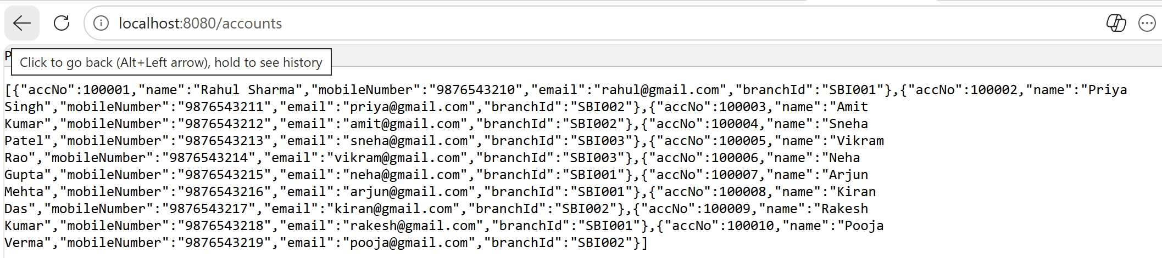
Home Tasks:
Task 1: What are Window Functions in PostgreSQL?
Window functions are SQL functions that perform calculations across a set of rows related to the current row without grouping them into a single result. Unlike GROUP BY, they return one result for each row while preserving all rows in the output. They are mainly used for ranking, running totals, moving averages, and comparing rows. Window functions are used with the OVER() clause.

Task 2: What are the keywords used in Window Functions?
The main keywords used in window functions are OVER(), PARTITION BY, ORDER BY, ROWS, RANGE, and GROUPS. The OVER() clause is mandatory as it defines the window. PARTITION BY divides rows into groups, while ORDER BY specifies the order of rows within each partition. ROWS, RANGE, and GROUPS define the window frame for calculations.

Task 3: What are the types of Window Functions in PostgreSQL?
Window functions are mainly classified into four types: Ranking Functions, Aggregate Functions, Value Functions, and Distribution Functions. Ranking functions include ROW_NUMBER(), RANK(), and DENSE_RANK(). Aggregate functions include SUM(), AVG(), COUNT(), MIN(), and MAX(). Value functions include LAG(), LEAD(), FIRST_VALUE(), and LAST_VALUE(), while distribution functions include NTILE(), PERCENT_RANK(), and CUME_DIST().

Task 4: What are the rules while working on Window Functions?
Window functions must always be used with the OVER() clause. They can be used only in the SELECT and ORDER BY clauses, not in WHERE, GROUP BY, or HAVING. They do not reduce the number of rows like GROUP BY; instead, they return a value for every row. PARTITION BY is optional, while ORDER BY is required for ranking-related functions. Window functions are executed after filtering and grouping operations.

Task 5: Do we have JSON/JSONB data types in PostgreSQL? What is the difference?
Yes, PostgreSQL supports both JSON and JSONB data types. JSON stores data as plain text and preserves formatting, whitespace, and key order. JSONB stores data in a binary format, making it faster for searching and indexing. JSONB removes duplicate keys and supports indexing, making it more efficient for most applications. Therefore, JSONB is generally recommended for better performance.

Task 6: What is Full Text Search in PostgreSQL? Explain briefly.
Full Text Search (FTS) is a PostgreSQL feature used to efficiently search large amounts of textual data. It analyzes text by breaking it into searchable words called lexemes and ignores common words like "the" and "is". It also supports stemming, where related word forms are treated as the same word. Full Text Search provides faster and more accurate search results than simple pattern matching using LIKE.

Task 7: What do you understand by Full Text Search in PostgreSQL?
Full Text Search is a technique used to perform intelligent searches on text data. It converts documents into searchable tokens and compares them with search queries to find relevant matches. PostgreSQL uses functions like to_tsvector() and to_tsquery() for this purpose. It also ranks results based on relevance, making it useful for search engines, blogs, and document management systems.

Task 8: What does SAVEPOINT do in PostgreSQL?
A SAVEPOINT creates a checkpoint within a transaction that allows partial rollback. If an error occurs after a savepoint, only the changes made after that savepoint can be undone instead of rolling back the entire transaction. This helps preserve successful operations performed earlier in the transaction. SAVEPOINT is useful in complex transactions where multiple operations need better error handling and recovery.

