Day 18 - 10th Aug 2026
Redirecting Output (> and >>)
ls > files.txt
cat files.txt
ls > files.txt saves the list of files into files.txt.
cat files.txt displays the contents of files.txt.
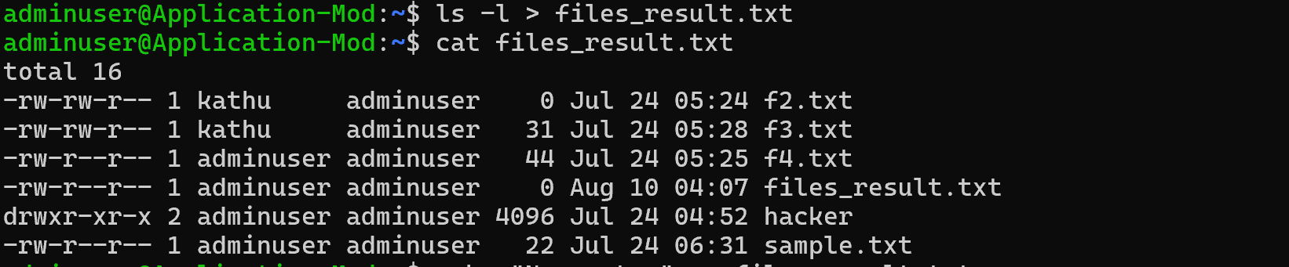

Append instead of overwrite
echo "New entry" >> files.txt
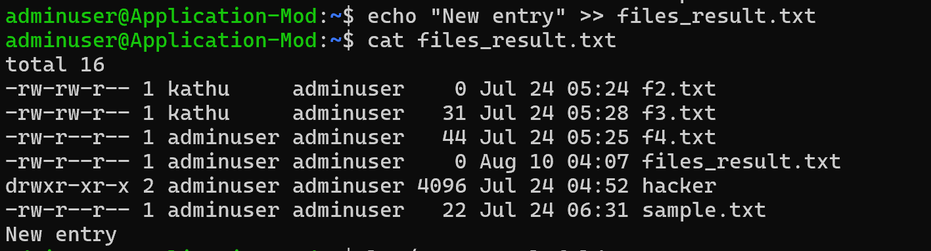

Redirecting Input (<)
echo -e "banana\napple\ncherry" > fruits.txt
-e interprets escape characters..
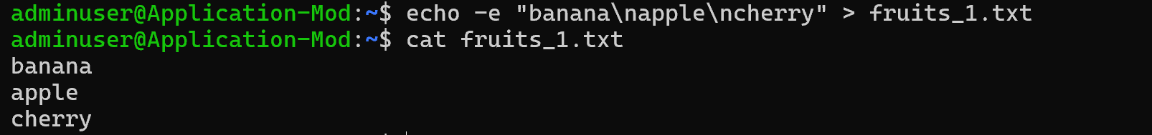
Redirecting Errors (2>)
ls /not_a_real_folder 2> errors.txt

Pipes (|)
ls | wc -l
counts the number of lines in the output of ls

Filter processes
ps aux | grep bash
shows the running processes and filters the output to display processes related to bash.
Check with
Ps a
Shows processes running on the terminal
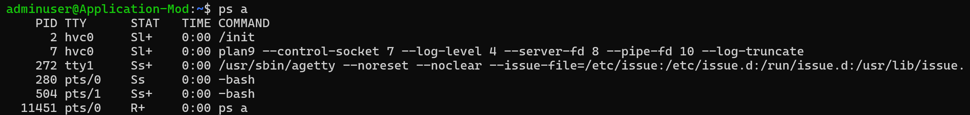
Ps au : Shows processes with more details, including the user.
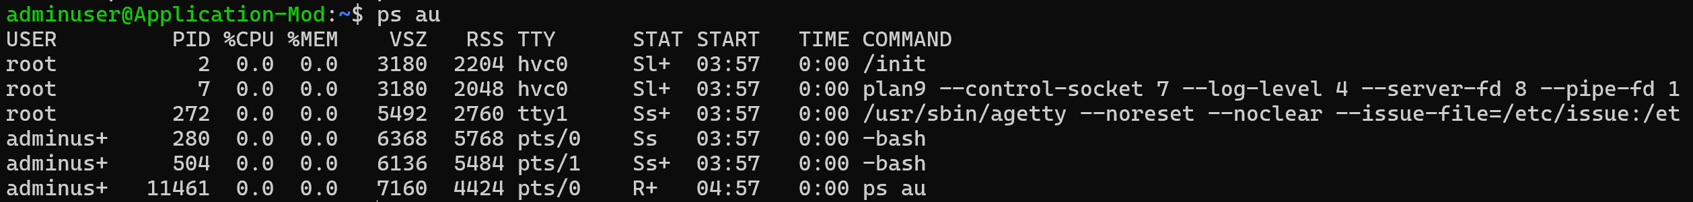
Ps aux : Shows all running processes with detailed information.
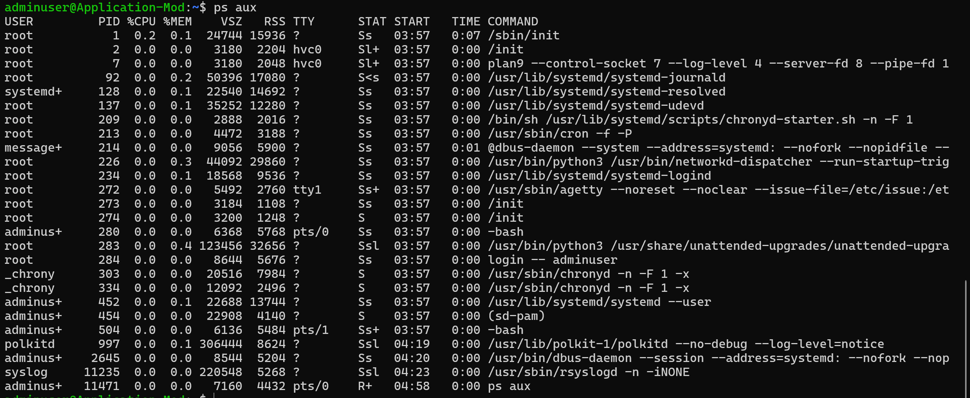

Multi-stage Pipeline

du -sh * | sort -rh | head -5
Shows the 5 largest files/directories in the current directory.
- du -sh * → Gets the size of each file/directory.
- sort -rh → Sorts them from largest to smallest.
- head -5 → Shows only the top 5.
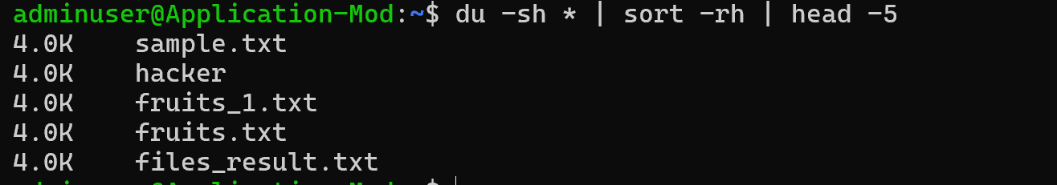

Du -sh *
Shows the size of each file and directory in the current directory.
- du → disk usage
- -s → summary (total size for each item)
- -h → human-readable sizes (KB, MB, GB)
- * → all items in the current directory
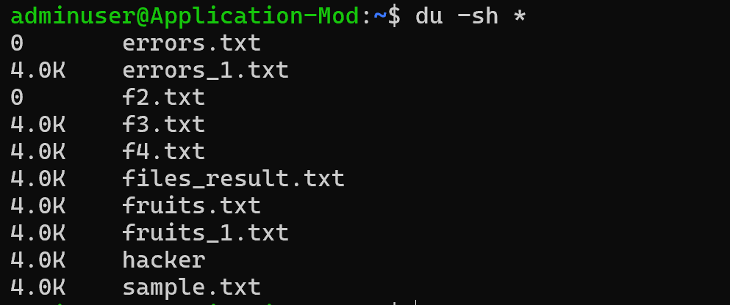

du -sh * | sort -rh
Shows all files/directories sorted from largest to smallest by size.
- du -sh * → Gets the size of each item.
- | → Sends the output to the next command.
- sort -rh → Sorts by size, largest first.
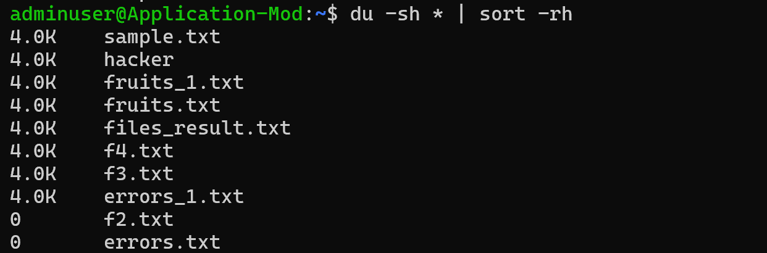

du -sh * | sort | head -5
Shows the first 5 entries after sorting the output alphabetically/lexicographically, not necessarily the 5 largest.
- du -sh * → Shows sizes of files/directories.
- sort → Sorts the output alphabetically.
- head -5 → Shows the first 5 lines.
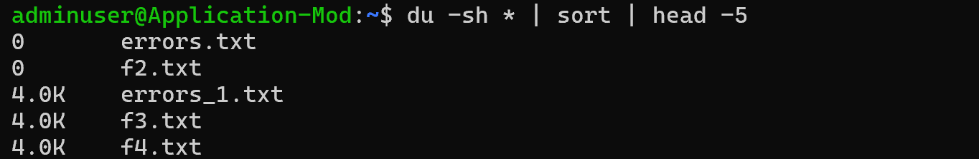

./script.sh > /dev/null 2>&1
Runs script.sh and hides both normal output and error messages.
- > /dev/null → Hides normal output.
- 2>&1 → Sends error output to the same place (also hidden).
Result: The script runs silently with no output shown on the screen.

Task 1:
Sed
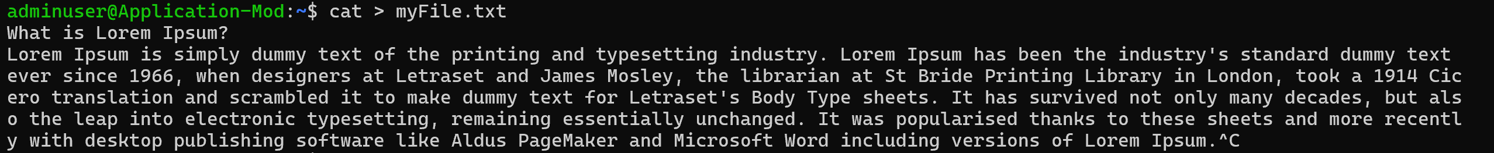
What will this command do
Sed myFile.txt
This command will give an error because sed normally requires a command (such as -n 'p') to tell it what to do with the file.

sed '' myFile.txt

Can you replace a word with another
S → search for 1st occurrence of any old keyword and change it with new in your file..
sed 's/old/new/' filename
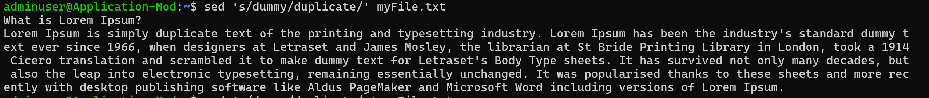

G flag → for all occurrences of the word and change it to new word.
sed 's/old/new/g' filename
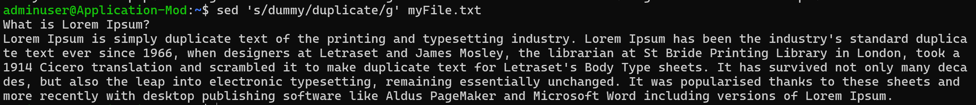
Try with delete flag
sed '/dummy/d' myFile.txt
Find every line containing dummy and delete that line from the output.


Print specific line numbers line line 3 of your file
sed -n '3p' myFile.txt

Print range of lines
Like from line 2 to 4
sed -n '2,5p' filename

Task 2:
Awk (used for pattern scanning and processing)

- Now try same with awk
awk '{print}' filename
Read the file line by line and print every line.


- Print specific column
awk '{print $2}' filename
Read each line, split it into fields (columns), and print the second field.


Print multiple columns
awk '{print $1, $3}' filename


Filter rows by giving condition
Like print 1st nd 3rd column only if 3rd column value is > 50 fo example..

awk '$3 > 50 {print $1, $3}' filename
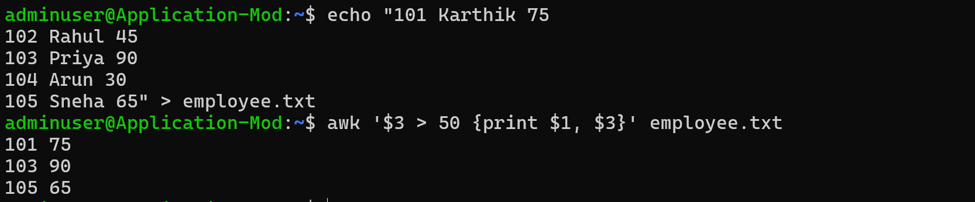

Use custom delimiter (comma , is a delimiter operator) and print first 2 fields..
awk -F',' '{print $1, $2}' employees.csv
It reads employees.csv and prints the first and second columns.
- -F',' → Uses comma , as the separator.
- $1 → First column.
- $2 → Second column.
- print $1, $2 → Prints both columns separated by a space.
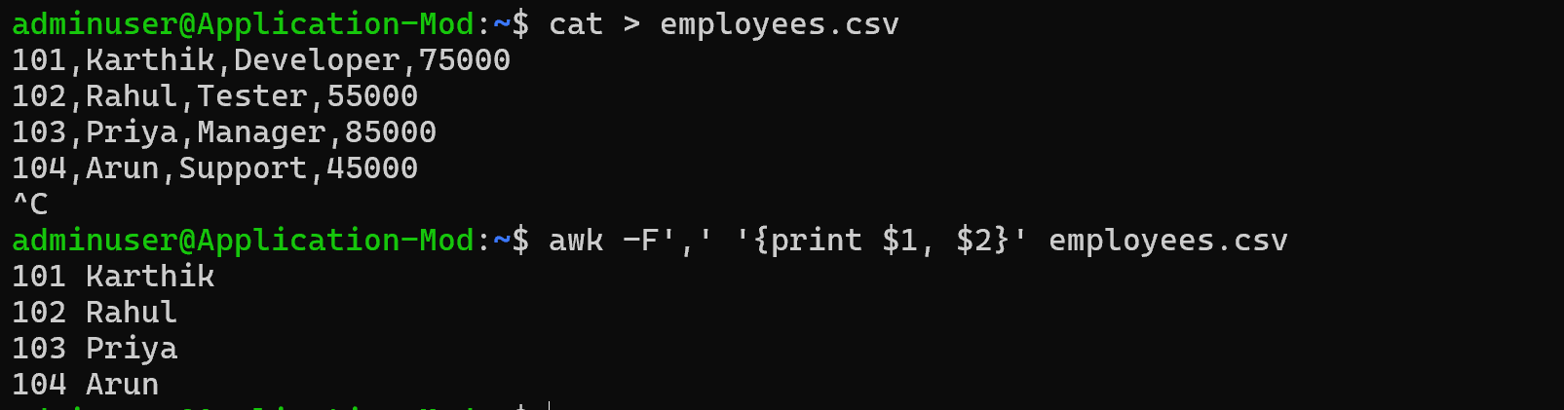

Now count lines
awk 'END {print NR}' filename (nr is no of records..)

awk 'END {print NR}' employees.csv

Task 3:
Ping google.com
adminuser@Application-Mod:~$ ping google.com
PING google.com (142.251.167.100) 56(84) bytes of data.
64 bytes from ww-in-f100.1e100.net (142.251.167.100): icmp_seq=1 ttl=100 time=3.71 ms
64 bytes from ww-in-f100.1e100.net (142.251.167.100): icmp_seq=2 ttl=100 time=4.83 ms
64 bytes from ww-in-f100.1e100.net (142.251.167.100): icmp_seq=3 ttl=100 time=3.08 ms
64 bytes from ww-in-f100.1e100.net (142.251.167.100): icmp_seq=4 ttl=100 time=3.03 ms
64 bytes from ww-in-f100.1e100.net (142.251.167.100): icmp_seq=5 ttl=100 time=2.94 ms
64 bytes from ww-in-f100.1e100.net (142.251.167.100): icmp_seq=6 ttl=100 time=2.94 ms
64 bytes from ww-in-f100.1e100.net (142.251.167.100): icmp_seq=7 ttl=100 time=2.91 ms
64 bytes from ww-in-f100.1e100.net (142.251.167.100): icmp_seq=8 ttl=100 time=3.43 ms
64 bytes from ww-in-f100.1e100.net (142.251.167.100): icmp_seq=9 ttl=100 time=3.20 ms
64 bytes from ww-in-f100.1e100.net (142.251.167.100): icmp_seq=10 ttl=100 time=3.10 ms
64 bytes from ww-in-f100.1e100.net (142.251.167.100): icmp_seq=11 ttl=100 time=3.06 ms
64 bytes from ww-in-f100.1e100.net (142.251.167.100): icmp_seq=12 ttl=100 time=2.95 ms
64 bytes from ww-in-f100.1e100.net (142.251.167.100): icmp_seq=13 ttl=100 time=3.27 ms
64 bytes from ww-in-f100.1e100.net (142.251.167.100): icmp_seq=14 ttl=100 time=2.96 ms
64 bytes from ww-in-f100.1e100.net (142.251.167.100): icmp_seq=15 ttl=100 time=3.34 ms
64 bytes from ww-in-f100.1e100.net (142.251.167.100): icmp_seq=16 ttl=100 time=3.03 ms
64 bytes from ww-in-f100.1e100.net (142.251.167.100): icmp_seq=17 ttl=100 time=3.22 ms
64 bytes from ww-in-f100.1e100.net (142.251.167.100): icmp_seq=18 ttl=100 time=3.07 ms
64 bytes from ww-in-f100.1e100.net (142.251.167.100): icmp_seq=19 ttl=100 time=3.26 ms
64 bytes from ww-in-f100.1e100.net (142.251.167.100): icmp_seq=20 ttl=100 time=3.22 ms
64 bytes from ww-in-f100.1e100.net (142.251.167.100): icmp_seq=21 ttl=100 time=4.12 ms
64 bytes from ww-in-f100.1e100.net (142.251.167.100): icmp_seq=22 ttl=100 time=2.91 ms
64 bytes from ww-in-f100.1e100.net (142.251.167.100): icmp_seq=23 ttl=100 time=3.41 ms
64 bytes from ww-in-f100.1e100.net (142.251.167.100): icmp_seq=24 ttl=100 time=3.01 ms
64 bytes from ww-in-f100.1e100.net (142.251.167.100): icmp_seq=25 ttl=100 time=2.95 ms
64 bytes from ww-in-f100.1e100.net (142.251.167.100): icmp_seq=26 ttl=100 time=2.90 ms
64 bytes from ww-in-f100.1e100.net (142.251.167.100): icmp_seq=27 ttl=100 time=2.92 ms
64 bytes from ww-in-f100.1e100.net (142.251.167.100): icmp_seq=28 ttl=100 time=3.50 ms
64 bytes from ww-in-f100.1e100.net (142.251.167.100): icmp_seq=29 ttl=100 time=3.78 ms
64 bytes from ww-in-f100.1e100.net (142.251.167.100): icmp_seq=30 ttl=100 time=2.97 ms
64 bytes from ww-in-f100.1e100.net (142.251.167.100): icmp_seq=31 ttl=100 time=2.98 ms
64 bytes from ww-in-f100.1e100.net (142.251.167.100): icmp_seq=32 ttl=100 time=3.18 ms
64 bytes from ww-in-f100.1e100.net (142.251.167.100): icmp_seq=33 ttl=100 time=3.13 ms
64 bytes from ww-in-f100.1e100.net (142.251.167.100): icmp_seq=34 ttl=100 time=2.83 ms
64 bytes from ww-in-f100.1e100.net (142.251.167.100): icmp_seq=35 ttl=100 time=2.97 ms
64 bytes from ww-in-f100.1e100.net (142.251.167.100): icmp_seq=36 ttl=100 time=3.09 ms
64 bytes from ww-in-f100.1e100.net (142.251.167.100): icmp_seq=37 ttl=100 time=2.85 ms
64 bytes from ww-in-f100.1e100.net (142.251.167.100): icmp_seq=38 ttl=100 time=3.34 ms
64 bytes from ww-in-f100.1e100.net (142.251.167.100): icmp_seq=39 ttl=100 time=2.90 ms
64 bytes from ww-in-f100.1e100.net (142.251.167.100): icmp_seq=40 ttl=100 time=3.28 ms
64 bytes from ww-in-f100.1e100.net (142.251.167.100): icmp_seq=41 ttl=100 time=2.87 ms
64 bytes from ww-in-f100.1e100.net (142.251.167.100): icmp_seq=42 ttl=100 time=2.98 ms
64 bytes from ww-in-f100.1e100.net (142.251.167.100): icmp_seq=43 ttl=100 time=2.97 ms
64 bytes from ww-in-f100.1e100.net (142.251.167.100): icmp_seq=44 ttl=100 time=2.94 ms
64 bytes from ww-in-f100.1e100.net (142.251.167.100): icmp_seq=45 ttl=100 time=3.03 ms
^C
--- google.com ping statistics ---
45 packets transmitted, 45 received, 0% packet loss, time 44067ms
rtt min/avg/max/mdev = 2.827/3.162/4.828/0.362 ms
adminuser@Application-Mod:~$ Curl https://google.com
It fetches the webpage content from Google and displays it in the terminal.
- curl → Transfers data from a URL.
- https://google.com → The website to access.

Command 'Curl' not found, did you mean:
command 'curl' from snap curl (8.21.0)
command 'yurl' from snap yurl (v0.6.3)
command 'surl' from snap surl (0.8.0)
command 'zurl' from deb zurl (1.12.0-3build1)
command 'hurl' from deb hurl (7.1.0-1)
command 'curl' from deb curl (8.18.0-1ubuntu2.2)
See 'snap info <snapname>' for additional versions.

Task 4:
Install open ssl in your system

Step 2 Generate a certificate signing request (CSR)
openssl genrsa -out localhost.key 2048
Step 3:
Generate a self-signed certificate
In bash
openssl x509 -req -days 365 -in localhost.csr -signkey localhost.key -out localhost.crt

Step 4:
Now Start a Simple HTTPS Server
Use Python: `python -m http.server 4443 --bind 127.0.0.1 --ssl-certfile cert.pem --ssl-keyfile key.pem`.
Step 5:
Now Test with Browser or Curl
Visit https://localhost:4443 or run `curl -k https://localhost:4443` to see encrypted communication.
Step 6:
Did u Observe TLS Handshake
Use Wireshark or `openssl s_client -connect localhost:4443` to watch how TLS negotiates keys and ciphers.
Step 7:
Verify Certificate Trust
Browsers will warn about self-signed certs; in real deployments, use CA-issued certificates for trust.
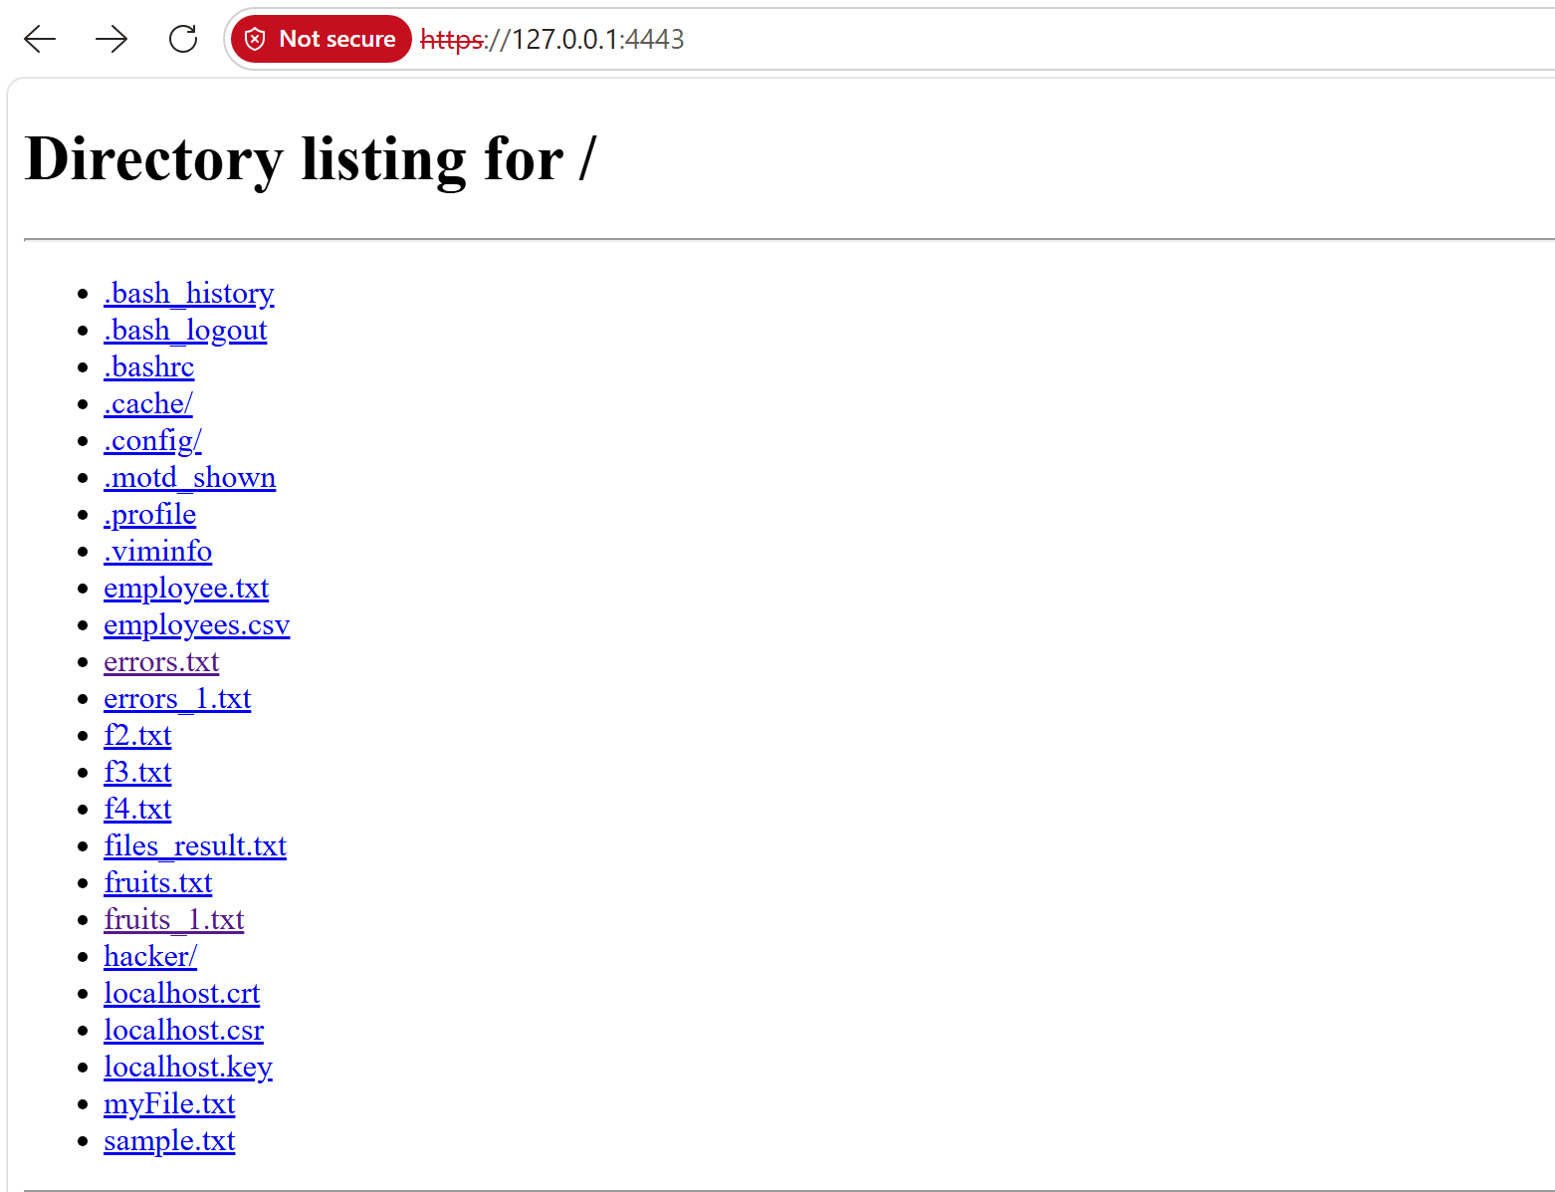
Trees and Graphs
Task 5:
What are Trees? Where do you implement them?
A tree is a non-linear hierarchical data structure consisting of nodes connected by edges. It has a root node, and each node can have child nodes. Unlike a graph, a tree does not contain cycles.
Trees are used when data has a hierarchical relationship. They are implemented in file systems, HTML DOM, database indexing, organizational structures, and searching algorithms.
For example, a file system can be represented as a tree where folders are parent nodes and files/subfolders are child nodes.

Task 6:
Can you give types of Trees?
Yes. Some common types of trees are:
- Binary Tree – Each node can have at most two children.
- Binary Search Tree (BST) – A binary tree where the left child contains smaller values and the right child contains larger values.
- AVL Tree – A self-balancing Binary Search Tree that maintains a balanced height.
- Heap – A complete binary tree used mainly for priority queues.
- B-Tree / B+ Tree – Used mainly in databases and file systems for efficient searching and indexing.
- Trie – Used for storing and searching strings, such as autocomplete and dictionaries.

Task 7:
What is a Binary Search Tree?
A Binary Search Tree, or BST, is a binary tree where each node follows an ordering rule: all values in the left subtree are smaller than the node, and all values in the right subtree are greater than the node.
This property makes searching, insertion, and deletion efficient, with an average time complexity of O(log n) when the tree is balanced. However, in the worst case, a BST can become skewed and these operations can take O(n) time.
For example:
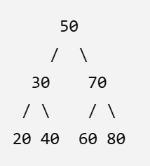
Task 8:
Can you create a simple binary tree using a node and insert values in it?
Like in java
class Node {
int val;
Node left, right;
Node(int val) { this.val = val; }
}
Insert values in left side and right side of the nodes and display the tree values
class Node {
int val;
Node left, right;
Node(int val) {
this.val = val;
}
}
public class Tree_Creation {
public static void main(String[] args) {
// Create root node
Node root = new Node(10);
// Insert values
root.left = new Node(20);
root.right = new Node(30);
root.left.left = new Node(40);
root.left.right = new Node(50);
root.right.left = new Node(60);
root.right.right = new Node(70);

// Display tree values
System.out.println("Inorder Traversal:");
inorder(root);
}
// Inorder: Left -> Root -> Right
static void inorder(Node root) {
if (root == null)
return;
inorder(root.left);
System.out.print(root.val + " ");
inorder(root.right);
}
}

Output
Tree created
10
/ \
20 30
/ \ / \
40 50 60 70

Task 9
Now extend the above code to search a no in your list.
class Node {
int val;
Node left, right;

Node(int val) {
this.val = val;
}
}

public class Search_N0_In_Tree {

public static void main(String[] args) {

// Create the tree
Node root = new Node(10);

root.left = new Node(20);
root.right = new Node(30);

root.left.left = new Node(40);
root.left.right = new Node(50);

root.right.left = new Node(60);
root.right.right = new Node(70);

// Display tree values
System.out.println("Inorder Traversal:");
inorder(root);

// Search for a number
int searchValue = 50;

if (search(root, searchValue)) {
System.out.println("\n" + searchValue + " is found in the tree.");
} else {
System.out.println("\n" + searchValue + " is not found in the tree.");
}
}

// Inorder Traversal: Left -> Root -> Right
static void inorder(Node root) {

if (root == null) {
return;
}

inorder(root.left);
System.out.print(root.val + " ");
inorder(root.right);
}

// Search for a value in the Binary Tree
static boolean search(Node root, int value) {

// If tree is empty or value is not found
if (root == null) {
return false;
}

// If current node contains the value
if (root.val == value) {
return true;
}

// Search in the left subtree
if (search(root.left, value)) {
return true;
}

// Search in the right subtree
return search(root.right, value);
}
}
Out put
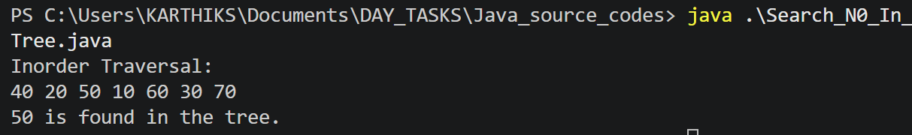

Task 10:
Now can you do inorder traversal in your bst?
class Node {
int val;
Node left, right;

Node(int val) {
this.val = val;
}
}
public class Tree_Creation {
public static void main(String[] args) {
// Create root node
Node root = new Node(10);
// Insert values
root.left = new Node(20);
root.right = new Node(30);
root.left.left = new Node(40);
root.left.right = new Node(50);
root.right.left = new Node(60);
root.right.right = new Node(70);

// Display tree values
System.out.println("Inorder Traversal:");
inorder(root);
}
// Inorder: Left -> Root -> Right
static void inorder(Node root) {
if (root == null)
return;
inorder(root.left);
System.out.print(root.val + " ");
inorder(root.right);
}
}

Out put
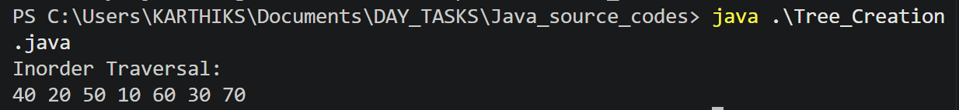

Task 11: What is the fundamental difference between BFS and DFS?
BFS (Breadth-First Search) and DFS (Depth-First Search) are graph traversal techniques used to visit all the nodes of a graph.
BFS | DFS
Traverses level by level | Traverses as deep as possible
Uses a Queue | Uses a Stack or recursion
Visits nearby nodes first | Goes deep into one path first
Useful for shortest path in an unweighted graph | Useful for cycle detection, path exploration, etc.
Requires more memory in wide graphs | Usually requires less memory for wide graphs
Example:
A
/ \
B C
/ \ \
D E F
BFS: A → B → C → D → E → F
DFS: A → B → D → E → C → F
"The fundamental difference is that BFS explores a graph level by level using a queue, whereas DFS explores as deeply as possible along one path before backtracking, using a stack or recursion."
Task 12:
Which underlying data structures are used to implement BFS and DFS?
BFS → Queue
BFS uses a Queue, which follows FIFO (First In, First Out).
Insert → [A B C] → Remove A first
This allows BFS to process nodes in the order they were discovered.
DFS → Stack
DFS uses a Stack, which follows LIFO (Last In, First Out).
DFS can also be implemented using recursion, because the function call stack works like a stack.
Algorithm | Data Structure | Principle
BFS | Queue | FIFO
DFS | Stack / Recursion | LIFO
Short answer:
"BFS is implemented using a queue because it needs to process nodes in the order they are discovered. DFS uses a stack, either explicitly or through recursion, to go deeper into the graph before backtracking."
Task 13:
How do you find the shortest path in an unweighted graph?
For an unweighted graph, we use BFS (Breadth-First Search) to find the shortest path.
BFS visits nodes level by level. Therefore, the first time we reach a node, we have reached it using the minimum number of edges.
Example:
A
/ \
B C
| |
D---E
To find the shortest path from A to E:
A → C → E
This path has 2 edges, which is shorter than:
A → B → D → E
Steps:
- Start BFS from the source node.
- Put the source into a queue.
- Mark it as visited.
- Visit its neighboring nodes.
- Store the distance or parent of each newly visited node.
- Continue until the destination is reached.
- Use the parent information to reconstruct the shortest path.
Time Complexity: O(V + E)
where:
- V = number of vertices
- E = number of edges
Short answer:
"To find the shortest path in an unweighted graph, we use BFS. Since BFS explores nodes level by level, the first time we reach the destination, we have found the path with the minimum number of edges."
Task 14:
How do you detect a cycle in a graph?
Cycle detection depends on whether the graph is directed or undirected.
Undirected Graph
We can use DFS with a parent node.
While traversing:
- If we find an unvisited node, continue DFS.
- If we find an already visited neighbor that is not the parent, a cycle exists.
Example:
A ----- B
\ /
\ /
C
Here, A → B → C → A forms a cycle.
Directed Graph
For a directed graph, we commonly use DFS with a recursion stack.
If during DFS we reach a node that is already present in the current recursion stack, a cycle exists.
Graph Type | Common Method
Undirected | DFS + Parent
Directed | DFS + Recursion Stack
Short answer:
"To detect a cycle, the approach depends on the graph type. In an undirected graph, we can use DFS and track the parent node. If we encounter a visited neighbor that is not the parent, there is a cycle. In a directed graph, we can use DFS with a recursion stack and detect a back edge to a node already in the current recursion path."

Task 15: Explain the internal working of a HashMap.
A HashMap stores data in the form of key-value pairs.
For example:
Key Value
----------------
101 Karthik
102 Rahul
103 Arun
When we insert a key-value pair, the HashMap performs these main steps:
1. Calculate the hash
The HashMap calculates a hash value from the key using its hashCode() method.
Key → hashCode() → hash value
2. Find the bucket
The hash value is used to determine the bucket/index where the entry should be stored.
Hash → Bucket Index
3. Handle collisions
Sometimes two different keys can map to the same bucket. This is called a collision.
Java's HashMap handles collisions by storing multiple entries in the same bucket. In modern Java, a heavily populated bucket can be converted from a linked structure into a balanced tree to improve lookup performance.
4. Compare keys
When retrieving a value, HashMap uses the hash first and then checks key equality using equals() to find the exact key.
map.get(key)
↓
calculate hash
↓
find bucket
↓
compare keys
↓
return value
Example
HashMap<Integer, String> map = new HashMap<>();

map.put(101, "Karthik");
map.put(102, "Rahul");

System.out.println(map.get(101));
Output:
Karthik
Time Complexity
Operation | Average | Worst Case
put() | O(1) | O(log n)*
get() | O(1) | O(log n)*
remove() | O(1) | O(log n)*
*For a treeified bucket under the relevant conditions; collision behavior and implementation details matter.
In Short answer:
"HashMap stores key-value pairs using hashing. It calculates the key's hash, uses it to locate a bucket, and stores the entry there. When multiple keys map to the same bucket, a collision occurs, which HashMap handles using a linked structure and, in modern Java, can use a balanced tree for heavily populated buckets. During retrieval, it uses the hash and then equals() to identify the correct key. Average get and put operations are O(1)."

Task 16:
Which property of a HashMap is used to find the intersection of two arrays?
The main property used is fast key lookup.
A HashMap stores elements as keys, and checking whether a key exists using containsKey() is, on average, O(1).
Example
Given:
Array 1 = [1, 2, 3, 4, 5]
Array 2 = [3, 4, 5, 6, 7]
First, store the elements of Array 1 in a HashMap:
HashMap:
1 → present
2 → present
3 → present
4 → present
5 → present
Then check every element of Array 2 using containsKey():
3 → found ✓
4 → found ✓
5 → found ✓
6 → not found
7 → not found
Therefore:
Intersection = [3, 4, 5]
In Short answer:
"The key property of a HashMap used for finding the intersection of two arrays is fast key lookup. We store the elements of one array as keys and use containsKey() to check the elements of the second array. HashMap provides average O(1) lookup, making the process efficient."

Task 17: What is a collision in HashMap?
A collision occurs when two or more different keys produce the same bucket/index in a HashMap.
For example:
Key A ──┐
├──→ Same Bucket
Key B ──┘
Even though the keys are different, their hash values may result in the same bucket.
How does Java handle collisions?
Java's HashMap stores multiple entries in the same bucket. Initially, entries can be maintained using a linked structure. If a bucket becomes heavily populated, Java can convert it into a balanced tree structure to improve lookup performance.
When retrieving a value, HashMap:
- Calculates the key's hash.
- Finds the bucket.
- Compares the keys using equals().
- Returns the matching value.
Important point
A collision does not mean that two keys are considered equal.
Different keys
↓
Same bucket
↓
Collision
In short answer:
"A collision in HashMap occurs when two different keys map to the same bucket. Java handles collisions by storing multiple entries in that bucket and, for heavily populated buckets, can use a balanced tree. During lookup, HashMap uses the hash and equals() to identify the correct key."

Task 18:
How do Java's Capacity and Size of HashMap differ?
Capacity and size represent two different things in a HashMap.
Feature | Capacity | Size
Meaning | Number of buckets available | Number of key-value entries stored
Represents | Storage structure | Actual data
Changes when | HashMap is resized | Elements are added/removed
Example | 16 buckets | 5 entries
Related to | Performance and resizing | Number of stored mappings
Example
HashMap<Integer, String> map = new HashMap<>();

map.put(1, "A");
map.put(2, "B");
map.put(3, "C");
Here:
Size = 3
The default initial capacity of a Java HashMap is 16 buckets (unless constructed with a different initial capacity).
So conceptually:
Capacity = 16
Size = 3
When the number of entries reaches the threshold determined by capacity × load factor, the HashMap resizes and increases its bucket capacity. Java's default load factor is 0.75.
For a capacity of 16:
Threshold = 16 × 0.75
= 12
When resizing occurs, the capacity is typically doubled.
Simple way to remember
Capacity = How much space is available

Size = How much data is currently stored
In short answer:
"Capacity is the number of buckets allocated internally by a HashMap, while size is the number of key-value pairs currently stored. For example, a HashMap can have a capacity of 16 but a size of only 3. When the number of entries crosses the threshold based on the load factor, the HashMap resizes to maintain efficient performance."

Task 19: Does HashMap allow null values?
Answer: Yes. Java HashMap allows multiple null values and only one null key.
import java.util.*;
import java.io.*;

public class InterviewBit {
public static void main(String[] args) {
HashMap hmap = new HashMap();
hmap.put(1, "Program to store null value");
hmap.put(null, "InterviewBit");
System.out.println(hmap);
}
}

Can you predict the output and also explain.. I or 2 lines

Task 20:
HashMaps in Java are not thread-safe. Can you justify?
HashMap is not thread-safe because it does not provide synchronization for concurrent access. If multiple threads modify a HashMap at the same time, it can cause race conditions and inconsistent data.
For thread-safe operations, use ConcurrentHashMap or proper synchronization.

Task 21:
Can you store multiple keys with the same value in a HashMap?
Yes. A HashMap allows multiple keys to have the same value, because keys must be unique, but values do not have to be unique.
Example:
map.put(1, "Java");
map.put(2, "Java");
Here, keys 1 and 2 have the same value "Java".

Task 22:
Differences between HashMap and Hashtable in Java
HashMap | Hashtable
Not synchronized / not thread-safe | Synchronized / thread-safe
Allows one null key and multiple null values | Does not allow null keys or values
Generally faster | Generally slower due to synchronization
Introduced in Java 1.2 | Legacy class from Java 1.0
Preferred for non-threaded use | Mostly replaced by ConcurrentHashMap for concurrent applications
Sorting Algorithms
Task 23:
Java Program for Bubble Sort

public class BubbleSort {

public static void main(String[] args) {

int[] arr = {5,6,1,3};
int n = arr.length;

// Bubble Sort
for (int i = 0; i < n - 1; i++) {

for (int j = 0; j < n - i - 1; j++) {

// Swap if elements are in the wrong order
if (arr[j] > arr[j + 1]) {

int temp = arr[j];
arr[j] = arr[j + 1];
arr[j + 1] = temp;
}
}
}

// Display sorted array
System.out.println("Sorted Array:");

for (int value : arr) {
System.out.print(value + " ");
}
}
}
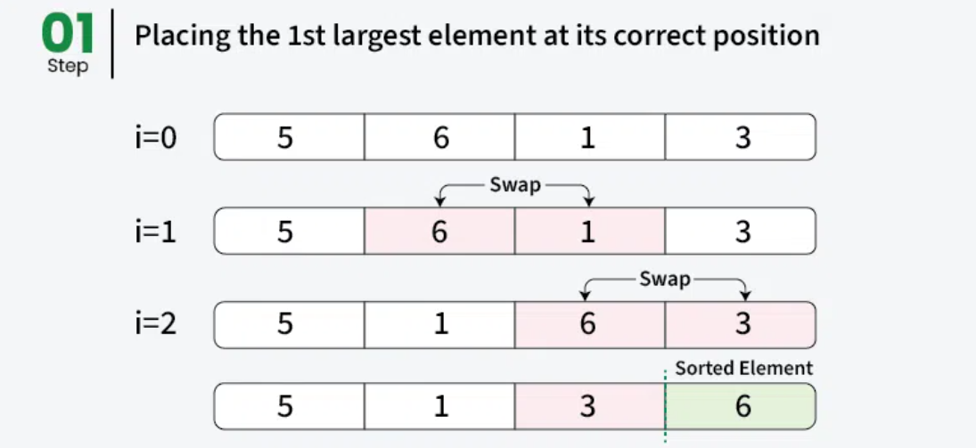
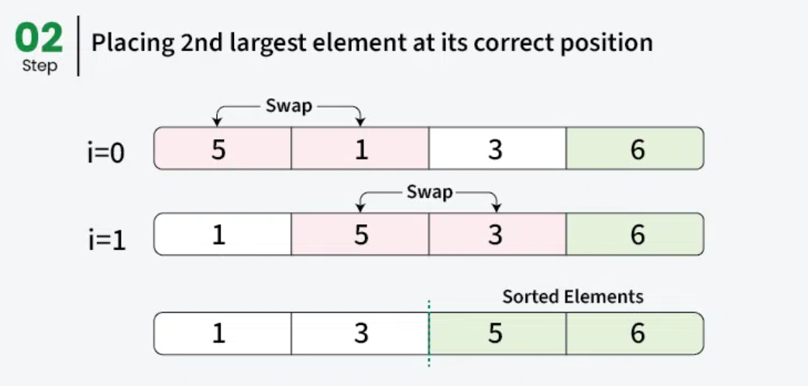
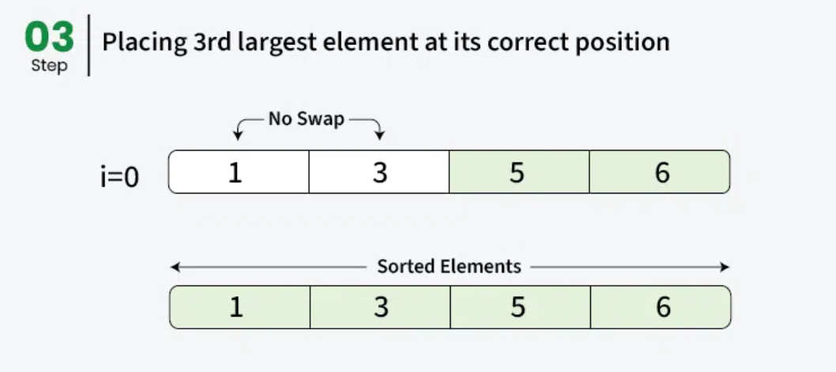

Task 24:
Java Program for Selection Sort
public class SelectionSort {

public static void main(String[] args) {

int[] arr = { 64, 25, 12, 22, 11 };
int n = arr.length;

// Selection Sort
for (int i = 0; i < n - 1; i++) {

// Assume the current position has the minimum element
int min = i;

// Find the smallest element in the remaining array
for (int j = i + 1; j < n; j++) {

if (arr[j] < arr[min]) {
min = j;
}
}

// Swap the minimum element with the current element
int temp = arr[i];
arr[i] = arr[min];
arr[min] = temp;
}

// Display the sorted array
System.out.println("Sorted Array:");

for (int value : arr) {
System.out.print(value + " ");
}
}
}

Task 25:
Java Program for Linear Search
Java Code

public class LinearSearch {

public static void main(String[] args) {

int[] arr = {10, 25, 30, 45, 50, 65};
int key = 45;

int result = search(arr, key);

if (result != -1) {
System.out.println(
"Element " + key + " found at index: " + result
);
} else {
System.out.println(
"Element " + key + " not found in the array."
);
}
}

// Linear Search
static int search(int[] arr, int key) {

for (int i = 0; i < arr.length; i++) {

if (arr[i] == key) {
return i;
}
}

return -1;
}
}

