Day 8 - 27th July 2026

java -version
java version "26.0.2" 2026-07-21
Java(TM) SE Runtime Environment (build 26.0.2+10-55)
Java HotSpot(TM) 64-Bit Server VM (build 26.0.2+10-55, mixed mode, sharing)
mvn -v
Apache Maven 3.9.6 (bc0240f3c744dd6b6ec2920b3cd08dcc295161ae)
Maven home: C:\Program Files\apache-maven-3.9.6
Java version: 17.0.12, vendor: Oracle Corporation, runtime: C:\Program Files\Java\jdk-17
Default locale: en_IN, platform encoding: Cp1252
OS name: "windows 11", version: "10.0", arch: "amd64", family: "windows"
>mvn archetype:generate -DgroupId=com.bank -DartifactId=Demo02_DependencyInjection -DarchetypeArtifactId=maven-archetype-quickstart -DinteractiveMode=false

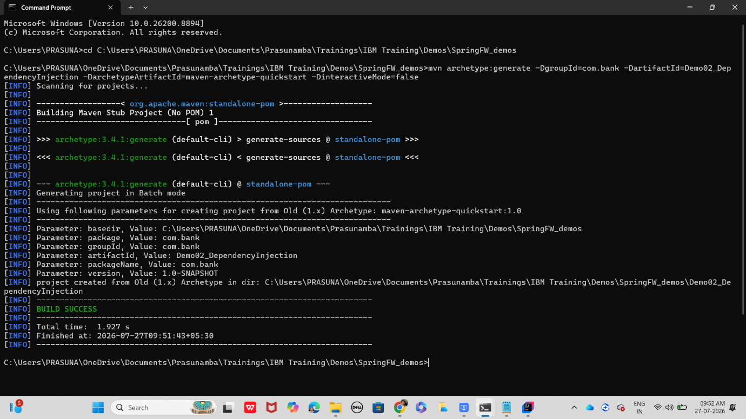

Cd folder name
Project structure
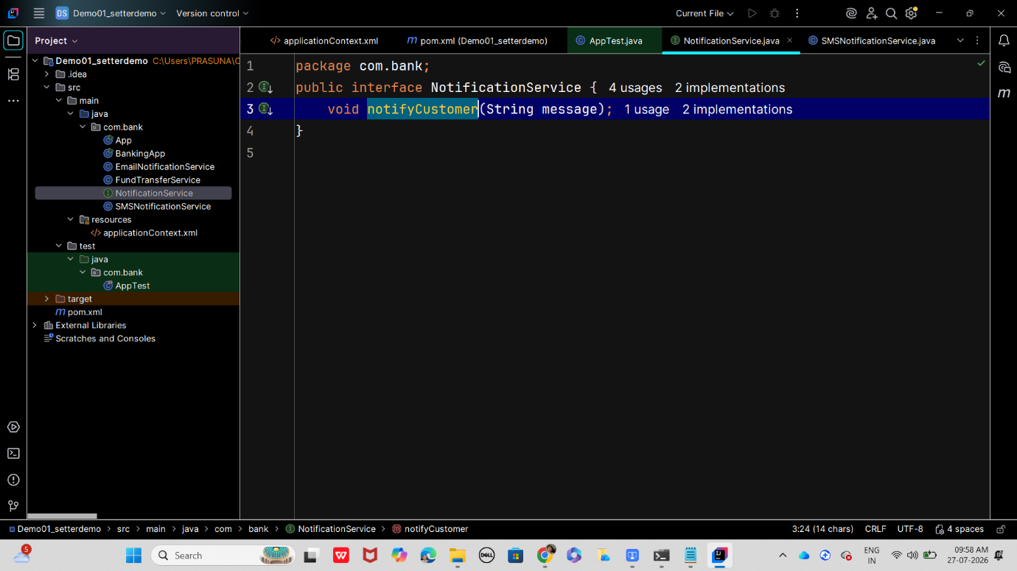
Dependency in [pom.xml
<dependency>
<groupId>org.springframework</groupId>
<artifactId>spring-context</artifactId>
<version>6.1.2</version>
</dependency>
App.java
package com.bank;
import org.springframework.context.ApplicationContext;
import org.springframework.context.support.ClassPathXmlApplicationContext;
public class App {
public static void main(String[] args) {
// Load Spring configuration from applicationContext.xml
ApplicationContext context = new ClassPathXmlApplicationContext("applicationContext.xml");
// Get FundTransferService bean
FundTransferService service = context.getBean(FundTransferService.class);
// Perform a demo transfer
service.transferFunds("ACC123", "ACC456", 5000.0);
}
}
bankingApp.java
package com.bank;
import org.springframework.context.ApplicationContext;
import org.springframework.context.support.ClassPathXmlApplicationContext;
public class BankingApp {
public static void main(String[] args) {
ApplicationContext context = new ClassPathXmlApplicationContext("applicationContext.xml");
FundTransferService service = context.getBean(FundTransferService.class);
service.transferFunds("ACC123", "ACC456", 5000.0);
}
}
EmailNotificationService .java
package com.bank;
import org.springframework.stereotype.Service;
@Service
public class EmailNotificationService implements NotificationService {
@Override
public void notifyCustomer(String message) {
System.out.println("Email sent: " + message);
}
}
FundTransferService.java
package com.bank;
import org.springframework.beans.factory.annotation.Autowired;
import org.springframework.stereotype.Component;
@Component
public class FundTransferService {
private final NotificationService notificationService;
@Autowired
public FundTransferService(NotificationService notificationService) {
this.notificationService = notificationService;
}
public void transferFunds(String fromAcc, String toAcc, double amount) {
System.out.println("Transferred " + amount + " from " + fromAcc + " to " + toAcc);
notificationService.notifyCustomer("Transfer of " + amount + " completed.");
}
}
NotificationService.java
package com.bank;
public interface NotificationService {
void notifyCustomer(String message);
}
SMSNotificationService.java
package com.bank;
public class SMSNotificationService implements NotificationService {
@Override
public void notifyCustomer(String message) {
System.out.println("SMS sent: " + message);
}
}
In src/main add resources folder
applicationContext.xml
<beans xmlns="http://www.springframework.org/schema/beans"
xmlns:xsi="http://www.w3.org/2001/XMLSchema-instance"
xsi:schemaLocation="http://www.springframework.org/schema/beans
http://www.springframework.org/schema/beans/spring-beans.xsd">
<!-- Choose implementation -->
<bean id="notificationService" class="com.bank.EmailNotificationService"/>
<!-- Inject dependency -->
<bean id="fundTransferService" class="com.bank.FundTransferService">
<constructor-arg ref="notificationService"/>
</bean>
</beans>
For Executing
cd setterdemo mvn clean install Mvnn clean compile
mvn exec:java -Dexec.mainClass="com.bank.App"
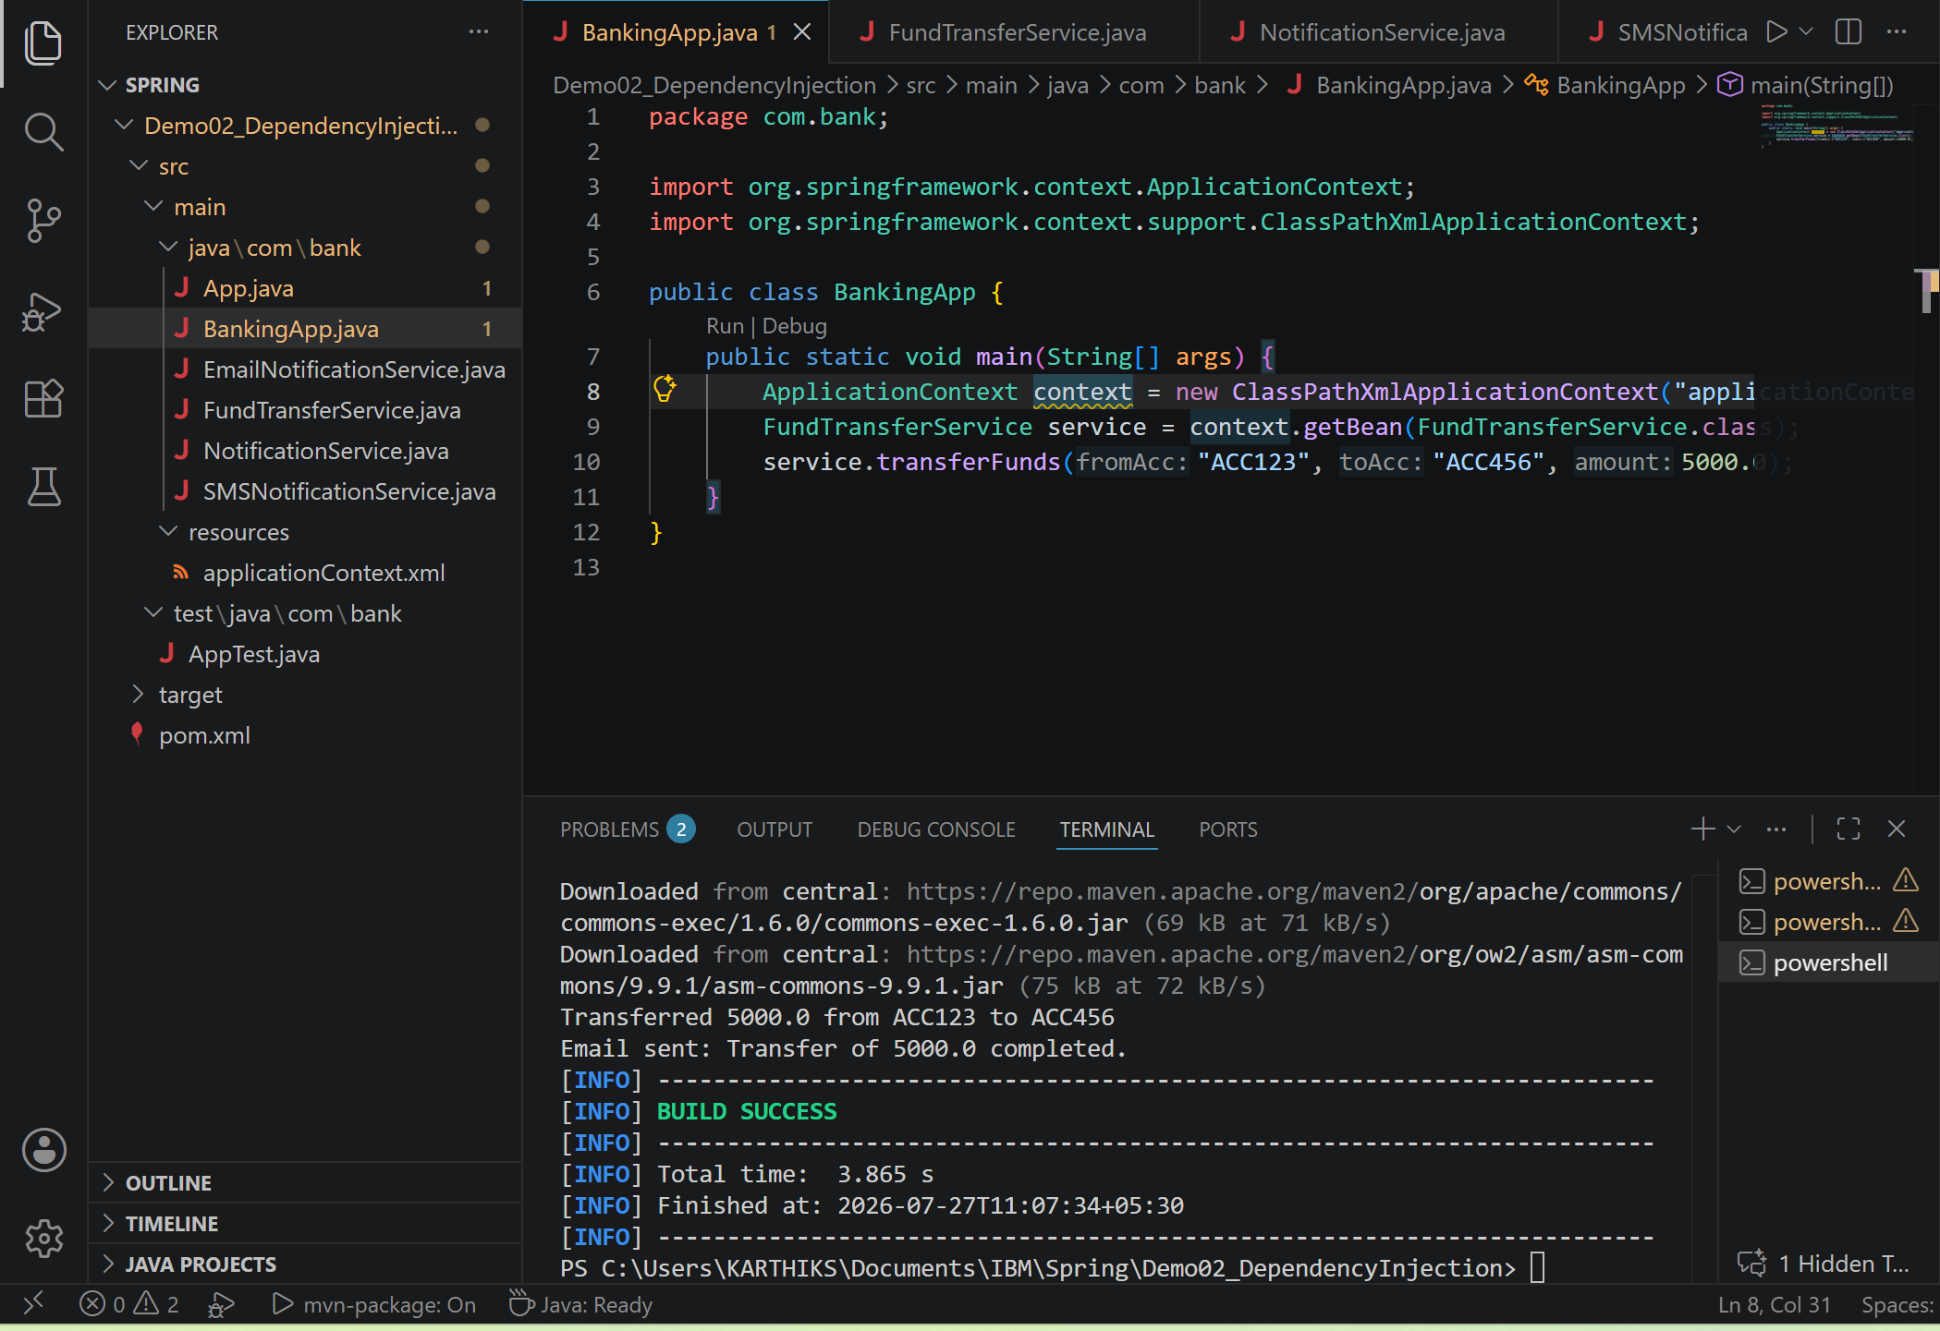
Task 01:
What do you understand by Spring frame work?
The Spring Framework is a lightweight Java framework used to build scalable, maintainable enterprise applications. It offers a programming and configuration model for modern Java development.
Reduces boilerplate code using Dependency Injection and AOP for faster, cleaner development.
Promotes independent components, improving maintainability and ease of testing.
Offers seamless integration with technologies like JDBC, JMS, and JPA.
Task 02:
What is spring boot?
Spring Boot comes with an embedded server, making applications production ready out of the box. It supports web apps, REST APIs, microservices, security and seamless cloud deployment.
Task 03:
What is the diff b/w spring framework and spring boot?
Spring Framework is the main Java framework used to build applications, but it needs more manual configuration.
Spring Boot is built on top of Spring Framework and makes development faster by providing auto-configuration and ready-to-use features.
With Spring Boot, we can create and run Spring applications easily with less code and fewer setup steps.
In simple words, Spring is the foundation, and Spring Boot is a faster and easier way to use Spring.
Task 04:
What is Dependency Injection?
Dependency Injection (DI) is a design pattern in Spring that allows objects to get the required dependencies from the Spring container instead of creating them by themselves.
It helps reduce dependency between classes and makes the code easier to maintain, test, and reuse.
In simple words, Spring creates and provides the required objects automatically when they are needed.
Task 05:
create a simple OrderService that depends on a PaymentService. Instead of creating objects manually, inject them.
interfaces:
paymentService ' ----> credit card or debit card class
and orderservice ---> PaymentService implementation class
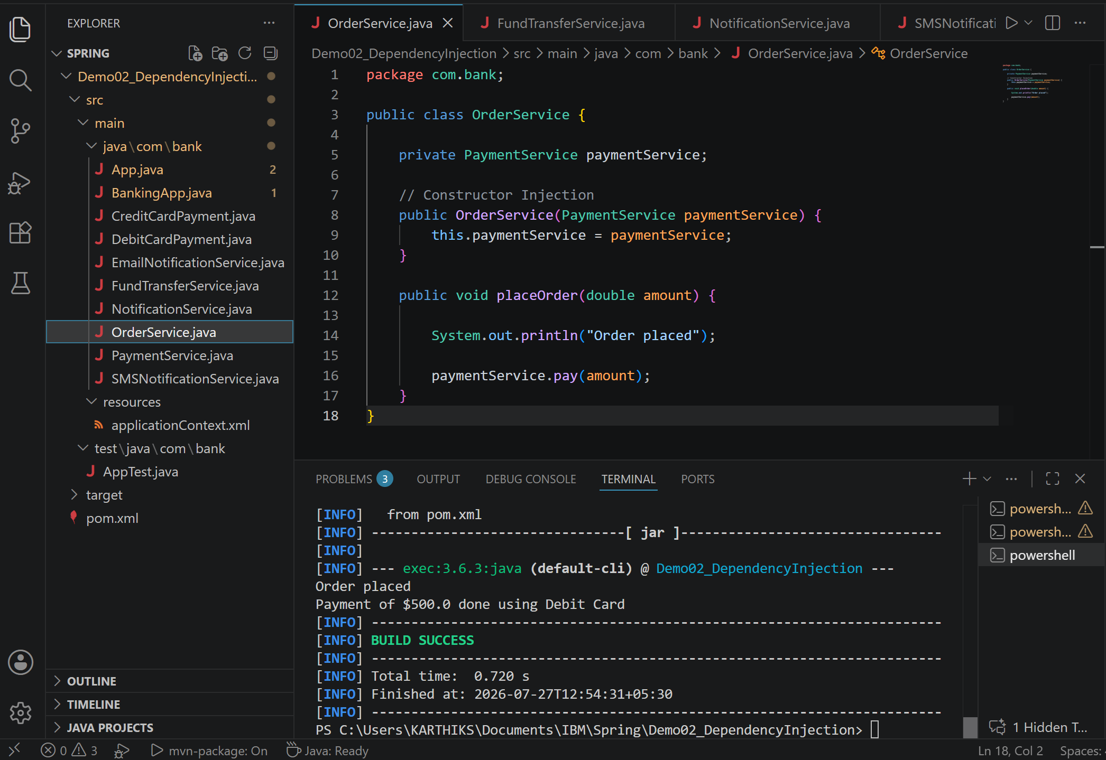
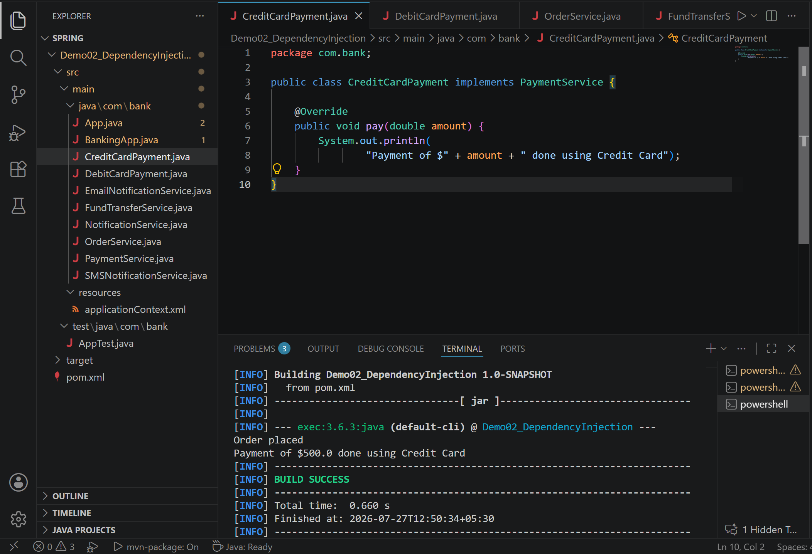
Task 06:
—-----------------------------------------------------------------------------------------------------------**********************************************************************************
Dependency Check, Inner beans and Scopes **********************************************************************************
—-----------------------------------------------------------------------------------------------------------
In cmd move to projects folder

mvn archetype:generate -DgroupId=com.bank -DartifactId=DependencyChk_InrBns_BnsScop -DarchetypeArtifactId=maven-archetype-quickstart -DinteractiveMode=false

Dependency check : spring can validate weather req props are set or not
Bank account.java

package com.bank;

public class BankAccount {
private int accountId;
private String accountHolder;

public void setAccountId(int accountId) { this.accountId = accountId; }
public void setAccountHolder(String accountHolder) { this.accountHolder = accountHolder; }

public void display() {
System.out.println("Account ID: " + accountId + ", Holder: " + accountHolder);
}
}

In src/main/ resources

applicationContext.xml

<beans xmlns="http://www.springframework.org/schema/beans"
xmlns:xsi="http://www.w3.org/2001/XMLSchema-instance"
xsi:schemaLocation="
http://www.springframework.org/schema/beans
http://www.springframework.org/schema/beans/spring-beans.xsd">

<!-- Dependency Check ensures accountHolder must be set -->
<bean id="bankAccount" class="com.bank.BankAccount" dependency-check="all">
<property name="accountId" value="101"/>
<property name="accountHolder" value="Prasunamba"/>
</bean>
</beans>

If you remove accountHolder, Spring will throw an error at startup.

Next

Inner Beans
Inner beans are defined inside another bean, useful for one-time use objects.

Customer.java

package com.bank;

public class Customer {
private String name;
private Address address;

public void setName(String name) { this.name = name; }
public void setAddress(Address address) { this.address = address; }

public void display() {
System.out.println("Customer: " + name + ", Address: " + address.getCity());
}
}

Address.java

package com.bank;

public class Address {
private String city;

public void setCity(String city) { this.city = city; }
public String getCity() { return city; }
}

In appContext.xml file ADD
One more bean

<bean id="customer" class="com.bank.Customer">
<property name="name" value="Prasunamba"/>
<property name="address">
<!-- Inner bean -->
<bean class="com.bank.Address">
<property name="city" value="Bengaluru"/>
</bean>
</property>
</bean>

Bean Scopes
Spring supports different bean scopes: singleton, prototype, request, session, application.

In appcontext.xml

Add
<!-- Singleton scope: same instance every time -->
<bean id="singletonAccount" class="com.bank.BankAccount" scope="singleton">
<property name="accountId" value="201"/>
<property name="accountHolder" value="Singleton User"/>
</bean>

<!-- Prototype scope: new instance each time -->
<bean id="prototypeAccount" class="com.bank.BankAccount" scope="prototype">
<property name="accountId" value="202"/>
<property name="accountHolder" value="Prototype User"/>
</bean>

In app.java

package com.bank;

import org.springframework.context.ApplicationContext;
import org.springframework.context.support.ClassPathXmlApplicationContext;

public class App {
public static void main(String[] args) {
ApplicationContext context = new ClassPathXmlApplicationContext("applicationContext.xml");

// Dependency Check demo
BankAccount account = (BankAccount) context.getBean("bankAccount");
account.display();

// Inner Bean demo
Customer customer = (Customer) context.getBean("customer");
customer.display();

// Scope demo
BankAccount acc1 = (BankAccount) context.getBean("singletonAccount");
BankAccount acc2 = (BankAccount) context.getBean("singletonAccount");
System.out.println("Singleton same object? " + (acc1 == acc2));

BankAccount acc3 = (BankAccount) context.getBean("prototypeAccount");
BankAccount acc4 = (BankAccount) context.getBean("prototypeAccount");
System.out.println("Prototype same object? " + (acc3 == acc4));
}
}

