Day 9 Task

Task 1:
Can you create a Maven based spring project using ide.. To print a welcome..note
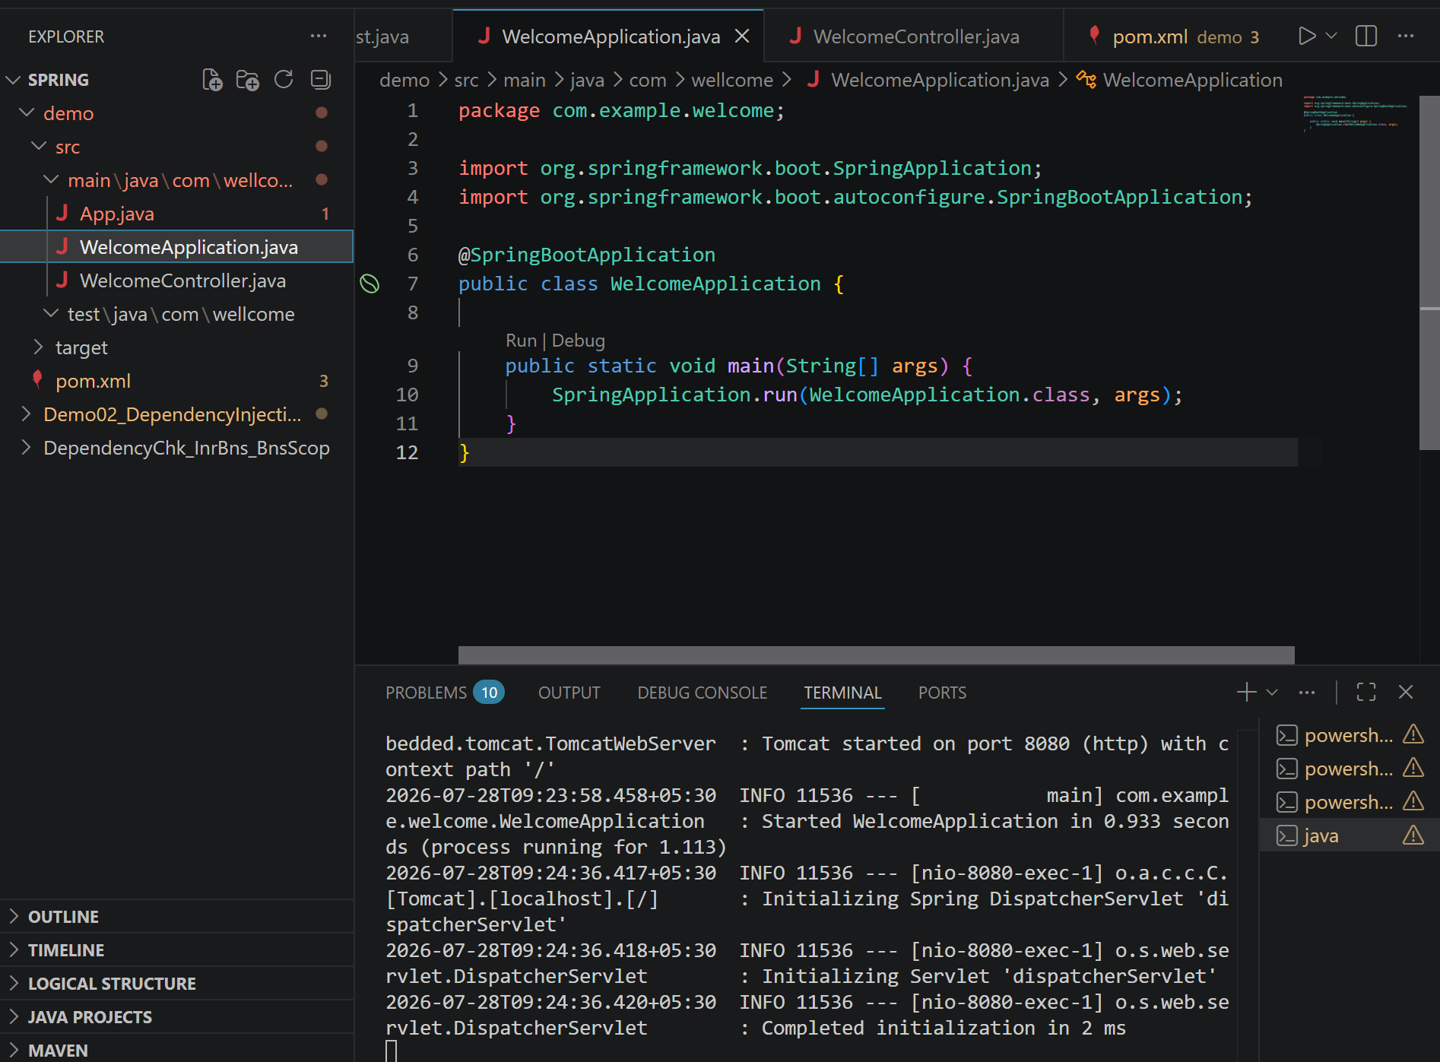
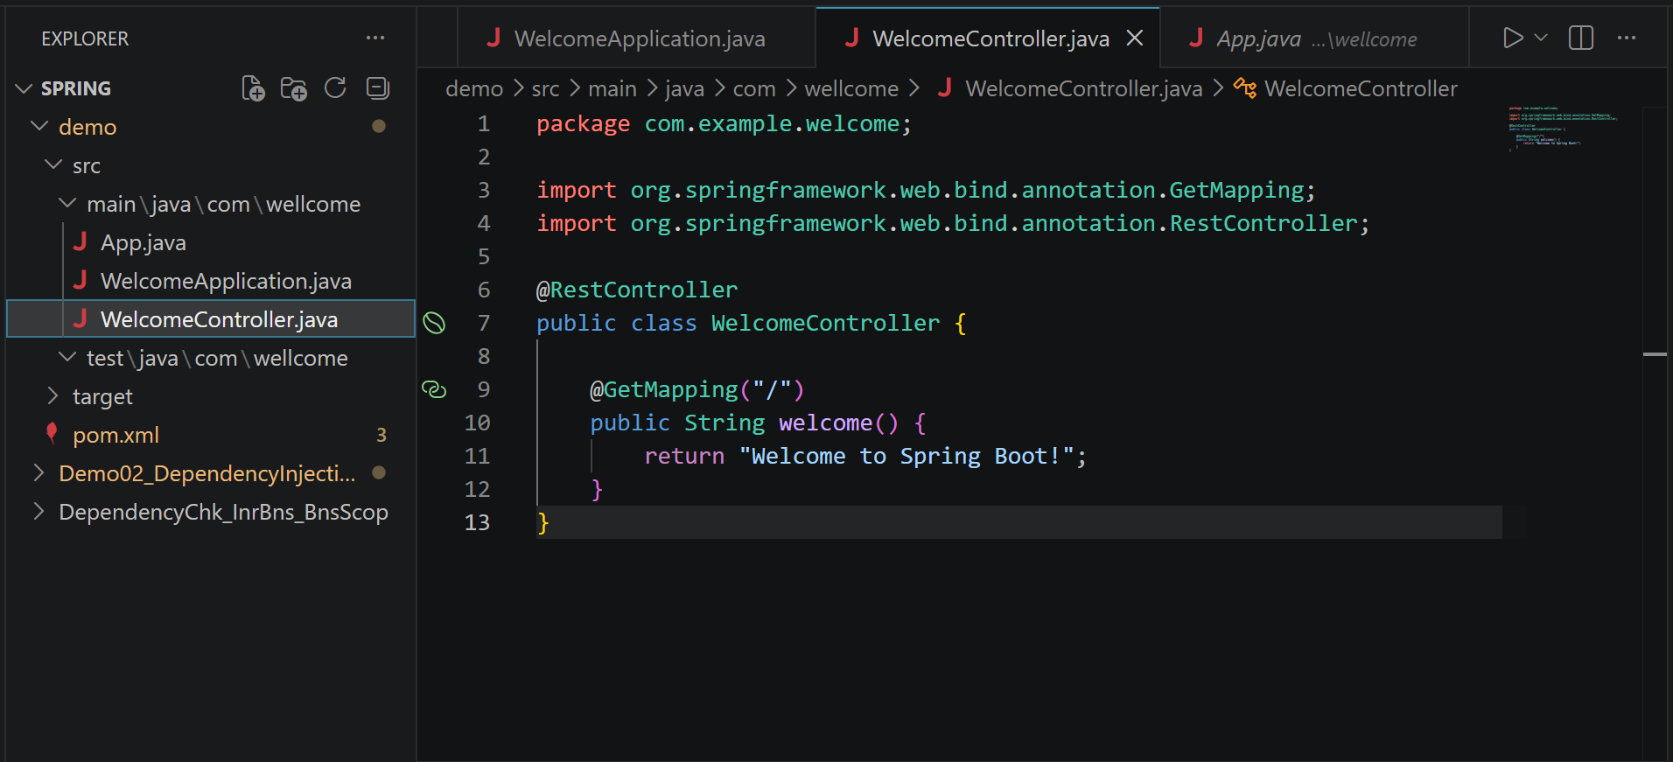

Task 2:
Now create a POJO class for student so that can be managed as a spring bean
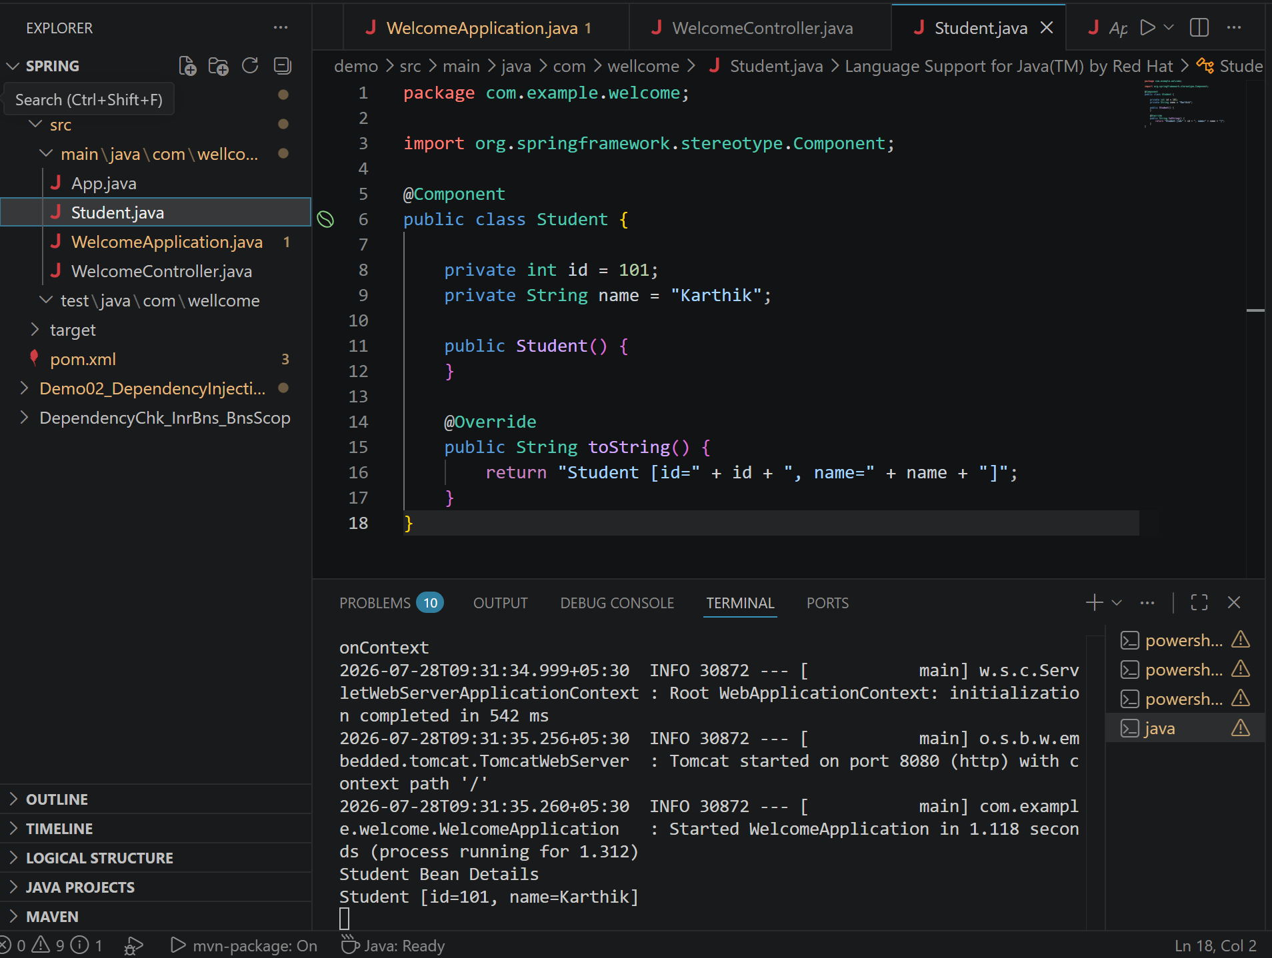

Task 3:
Configure the above Student bean in the bean-factory-demo.xml file.
That means you need to configure the Student bean in the XML file so the BeanFactory knows how to create it.
And create a main class and run it.. A pictorial rep of the scenario is given below

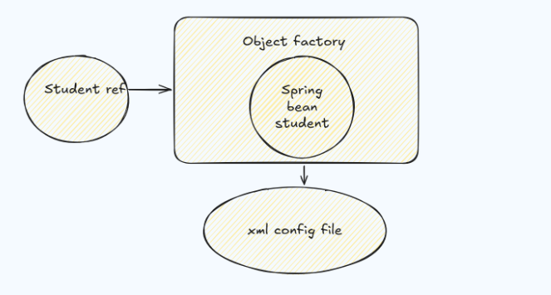
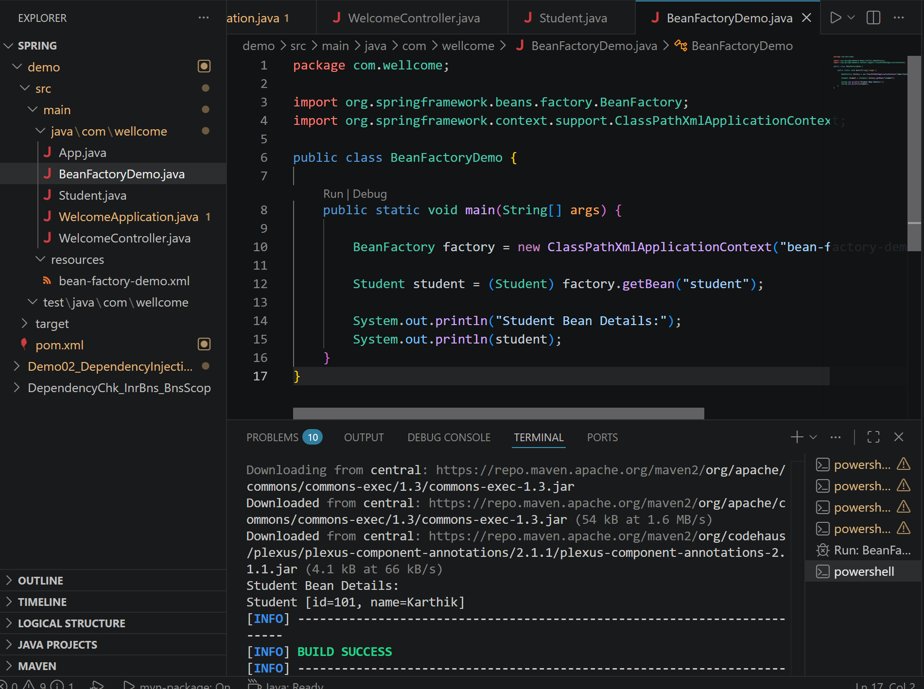

Task 4:
Can you explain application context with the syntax..
Application Context in Spring Boot is a container that manages all the Spring beans and their dependencies in an application. It helps Spring create, configure, and connect objects automatically. We can access it using the ApplicationContext interface.
ApplicationContext context = SpringApplication.run(Application.class, args);
MyBean bean = context.getBean(MyBean.class);

Task 5:
Why use application context .. plz list some uses?
Application Context is used in Spring Boot to manage and control the objects (beans) of an application.
- Creating and managing Spring beans automatically.
- Getting beans and their dependencies using getBean().
- Managing application configuration and resources.
- Supporting features like dependency injection and event handling.

Task 6:
What are features of Spring Framework .. list them with 1 or 2 lines explanation?
Features of Spring Framework:
- Dependency Injection (DI):
Spring automatically provides required objects to a class, which reduces code dependency and makes the application easier to maintain.
- Inversion of Control (IoC):
Spring manages the creation and lifecycle of objects instead of the developer creating them manually.
- Aspect-Oriented Programming (AOP):
Helps separate common tasks like logging, security, and transaction management from the main business logic.
- Spring MVC:
Provides a framework to build web applications by separating application logic into Model, View, and Controller.
- Transaction Management:
Simplifies managing database transactions and ensures data consistency.
- Data Access Support:
Provides easy integration with databases using JDBC, ORM tools like Hibernate, and JPA.
- Security Support:
Provides authentication and authorization features to secure applications.
- Easy Integration:
Supports integration with other technologies like databases, messaging systems, and web services.

Task 7:
Why do you thunk w e use spring framework.. Advantages list them down?
We use Spring Framework because it makes Java application development easier, faster, and more organized. Some advantages are:
- Reduces code complexity using features like Dependency Injection and IoC.
- Provides easy integration with databases, web services, and other technologies.
- Improves application security, scalability, and maintainability.
- Supports faster development with reusable components and built-in features.

Task 8:
What do you understand by IOC? Explain with diagram..
The Spring Inversion of Control (IoC) container is a core component of the Spring Framework, streamlining object creation and management. It promotes flexibility and maintainability by managing dependencies and configurations automatically, allowing developers to concentrate on core business logic.
- The container creates instances of beans as per the configuration.
- Automatically resolves and injects the necessary dependencies into beans.
- Manages bean initialization, destruction, and scope (singleton, prototype, etc.).
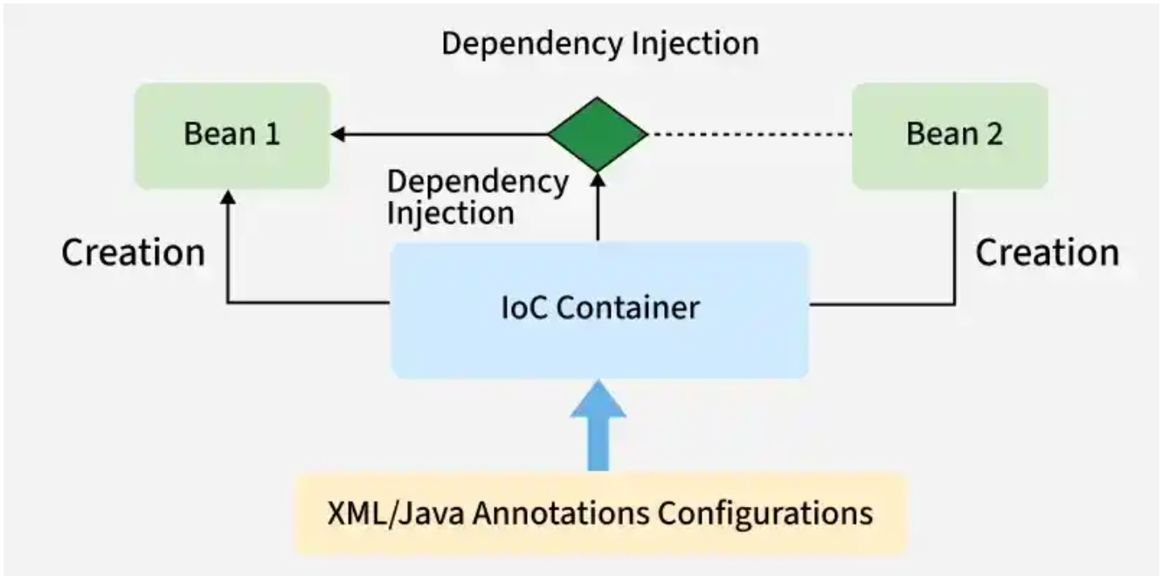

Task 9:
How many types of IOC do you have in spring?
What are they with explanation
In Spring, there are mainly two types of IoC (Inversion of Control):
- Dependency Injection (DI):
Spring provides the required objects (dependencies) to a class instead of the class creating them by itself.
- Dependency Lookup (DL):
The application asks the Spring container to provide the required object using methods like getBean().
Task 11:
How many types of DI do we have?
In Spring, there are mainly three types of Dependency Injection (DI):
- Constructor Injection:
Dependencies are provided through a class constructor. It is the recommended approach because it ensures required objects are available when the class is created.
- Setter Injection:
Dependencies are provided using setter methods after the object is created. It is useful when dependencies are optional.
- Field Injection:
Dependencies are directly injected into class fields using annotations like @Autowired. It is simple to use but generally less preferred compared to constructor injection.

Task 12:
What is Spring Application Configuration?
Spring Application Configuration is the process of defining and managing application settings in a Spring Boot project. It includes properties like database details, server ports, and other environment-specific values. These configurations are usually stored in files like application.properties or application.yml. It helps make the application easier to manage and customize without changing the code.

Task 13:
What are the different ways to configure spring applications?
Different ways to configure Spring applications are:
- XML Configuration: Uses XML files to define beans and application settings.
- Java-based Configuration: Uses Java classes with annotations like @Configuration and @Bean to configure components.
- Annotation-based Configuration: Uses annotations like @Component, @Service, and @Autowired to configure and manage beans.
- Properties/YAML Configuration: Uses application.properties or application.yml files to store application settings.

Task 14:
Why we need spring application copnfiguration?
We need Spring Application Configuration to manage application settings easily without changing the code. It helps store details like database connections, server settings, and environment-specific values in one place. It makes the application easier to maintain, configure, and deploy in different environments like development, testing, and production.
Task 16:
What is bean scope .. give different scopes with description
Bean Scope in Spring defines the lifecycle and visibility of a bean, meaning how and when a bean object is created and used. The different types of bean scopes are:
- Singleton: Creates only one instance of a bean for the entire Spring container (default scope).
- Prototype: Creates a new bean instance every time it is requested.
- Request: Creates one bean instance for each HTTP request (used in web applications).
- Session: Creates one bean instance for each user session.
- Application: Creates one bean instance for the entire web application lifecycle.

Task 17
What is autowiring in spring?
Autowiring in Spring is a feature that automatically injects the required dependencies (beans) into a class. It reduces the need to manually create and connect objects. Spring identifies the required bean and provides it using annotations like @Autowired. This makes the code cleaner, loosely coupled, and easier to maintain.
Task 18:
What are diff ways of autowiring?
Different ways of autowiring in Spring are:
- By Name: Spring injects the dependency by matching the bean name with the variable name.
- By Type: Spring injects the dependency by matching the data type of the bean.
- By Constructor: Spring injects dependencies through the class constructor.
- Using @Autowired Annotation: Spring automatically injects the required bean using annotations, and it is the most commonly used approach.
Task 19:
What is diff between a normal java object and Spring bean?
A normal Java object is created and managed by the developer using the new keyword, while a Spring Bean is created and managed by the Spring container. Spring Beans support features like dependency injection, lifecycle management, and configuration. Normal objects do not have these Spring features unless they are managed by the Spring framework.

Task 20:
What is diff between @ component and @ bean
@Component and @Bean are used to create Spring beans, but they work in different ways.
- @Component is used on a class, and Spring automatically detects and creates the bean through component scanning.
- @Bean is used on a method inside a @Configuration class when we want to manually create and configure a bean.
- @Component is commonly used for our own classes, while @Bean is useful for third-party classes or custom bean configuration.

Task 21: A different way to create an application using https://start.spring.io/ try it .. and let me know what is it?
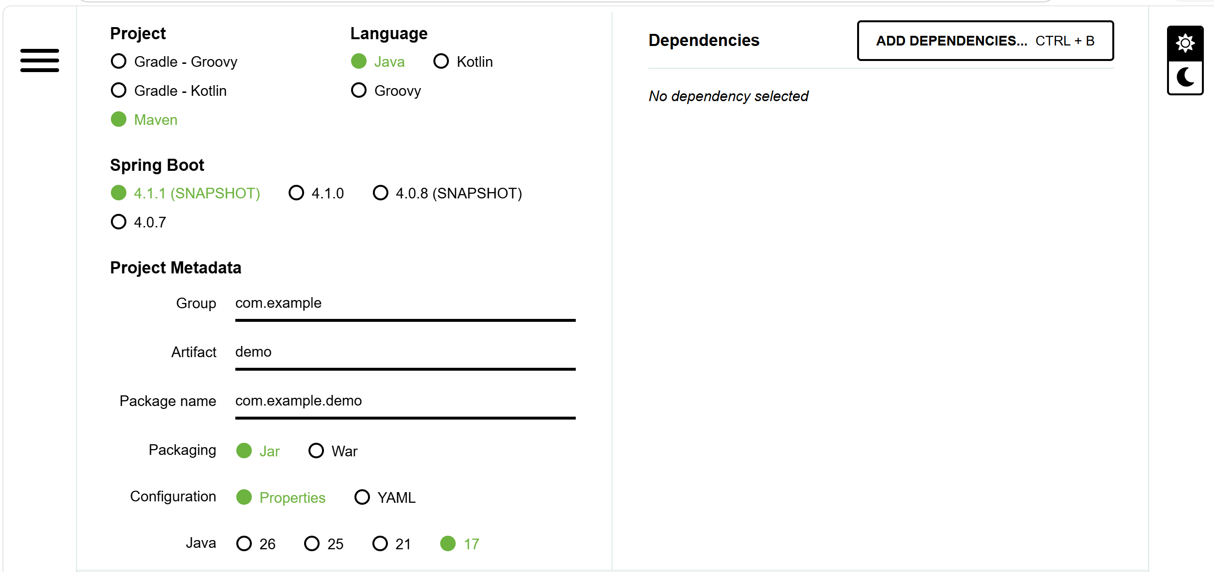
Steps to create a Spring Boot application using Spring Initializr:
- Open the website: https://start.spring.io/
- Select project type (Maven or Gradle), language (Java), and Spring Boot version.
- Enter project details like Group, Artifact, and project name.
- Add required dependencies (for example: Spring Web, Spring Data JPA, MySQL Driver).
- Click Generate to download the project as a ZIP file.
- Extract the ZIP file and import it into an IDE like Eclipse, IntelliJ IDEA, or STS.
- Run the main class containing @SpringBootApplication to start the Spring Boot application.

Task 22:
Using Spring initialiser create an employee class , appcofig file, and main class and see how it works
EmployeeApplication.java
package com.wellcome;

import org.springframework.beans.factory.annotation.Autowired;
import org.springframework.boot.CommandLineRunner;
import org.springframework.boot.SpringApplication;
import org.springframework.boot.autoconfigure.SpringBootApplication;

@SpringBootApplication
public class EmployeeApplication implements CommandLineRunner {

@Autowired
private Employee employee;

public static void main(String[] args) {

SpringApplication.run(EmployeeApplication.class, args);

}

@Override
public void run(String... args) {

employee.setId(101);
employee.setName("Karthik");
employee.setDepartment("Development");

System.out.println("Employee Details:");
System.out.println(employee);

}
}
Employee.java
package com.wellcome;

import org.springframework.stereotype.Component;

@Component
public class Employee {

private int id;
private String name;
private String department;

public Employee() {
}

public int getId() {
return id;
}

public void setId(int id) {
this.id = id;
}

public String getName() {
return name;
}

public void setName(String name) {
this.name = name;
}

public String getDepartment() {
return department;
}

public void setDepartment(String department) {
this.department = department;
}

@Override
public String toString() {
return "Employee [id=" + id +
", name=" + name +
", department=" + department + "]";
}
}

• Task 23:
We have spring annotations:
@Bean – Used to manually create and register an object as a Spring bean inside a @Configuration class.
@Controller – Used to create a controller class that handles web requests and usually returns views (HTML pages).
@Value – Used to inject values from configuration files (application.properties) or environment variables into fields.
@ComponentScan – Tells Spring where to search for classes annotated with @Component, @Service, and @Repository.
@Configuration – Indicates that a class contains Spring bean configuration using @Bean methods.
@Service – Used to mark a class as a service layer component that contains business logic.
@Repository – Used to mark a class as a data access component that communicates with databases.
@Qualifier – Used with @Autowired to specify which bean should be injected when multiple beans of the same type exist.
@Required – Used to indicate that a bean property must be set during configuration (deprecated in newer Spring versions).
@Component – A generic annotation that marks a class as a Spring-managed bean.
@Autowired – Automatically injects required dependencies (beans) into a class.
@Scope – Defines the lifecycle of a Spring bean, such as singleton, prototype, request, or session.

Task 24: What are the features of Spring Boot?
Spring Boot provides features like auto-configuration, embedded servers, and starter dependencies to simplify application development.
It reduces manual configuration and helps developers quickly build production-ready applications.
It also provides tools like Actuator for monitoring and managing applications easily.

Task 25: What are the advantages of Spring Boot?
Spring Boot makes development faster by reducing boilerplate code and configuration.
It provides embedded servers like Tomcat, so applications can run independently without external setup.
It improves productivity with ready-to-use dependencies and easy integration with other Spring modules.

Task 26: What are the key components of Spring Boot?
The main components of Spring Boot are Spring Boot Starter, Auto Configuration, Spring Boot CLI, and Actuator.
Starter dependencies provide required libraries automatically for different types of applications.
Auto Configuration configures the application based on the dependencies available in the project.

Task 27: Why Spring Boot over Spring?
Spring Boot is preferred over traditional Spring because it requires less configuration and setup.
It provides auto-configuration, embedded servers, and faster application development.
With Spring Boot, developers can create and deploy applications quickly compared to the traditional Spring framework.

Task 28: Can you explain the internal working of Spring Boot?
Spring Boot internally uses Spring Framework features along with auto-configuration and dependency management.
When the application starts, it scans the project, identifies required dependencies, and automatically configures components.
The embedded server starts the application, and the Spring container manages all required beans.

Task 29: List out the starter dependencies for Spring Boot.
Spring Boot starter dependencies are pre-defined dependency packages that simplify project setup.
Some common starters are Spring Boot Starter Web, Data JPA, Security, Test, Thymeleaf, and JDBC.
They automatically include the required libraries needed for specific application development.
Task 30:
import org.springframework.boot.SpringApplication;
import org.springframework.boot.autoconfigure.SpringBootApplication;
@SpringBootApplication
public class MyApplication
{
public static void main(String[] args) {
SpringApplication.run(MyApplication.class, args);
}
}
In this above code ..
What is the internal working of above code ..
Give thhe step by step explanation
Internal working of the Spring Boot application:
- JVM starts the execution by calling the main() method of MyApplication.
- SpringApplication.run() starts the Spring Boot application and creates the Spring Container (IoC Container).
- @SpringBootApplication enables configuration, auto-configuration, and component scanning.
- Spring scans the project and detects classes like @Component, @Service, @Repository, and @Controller.
- Required Spring beans are created and dependencies are injected automatically.
- Spring Boot reads configuration from files like application.properties or application.yml.
- Based on dependencies, Spring Boot automatically configures required features like embedded Tomcat.
- The embedded server starts and the application becomes ready to handle requests.
- The Spring Application Context manages the complete lifecycle of beans during execution.
- Finally, the application runs and provides services like REST APIs or web functionality.

Task 31:
What is the syntax to change the port of the embedded Tomcat server in Spring Boot?

mvn spring-boot:run -Dspring-boot.run.arguments="--server.port=9090 --name=Karthik"

mvn spring-boot:run -Dspring-boot.run.arguments="--server.port=9090"

