Day 20 - 12th Aug 2026
Task 1:
What do you understand about Integration Testing?
Integration testing is a type of software testing where we test two or more modules/components together to verify that they work correctly when they interact with each other.
The main purpose is to identify problems in the communication and interaction between modules, such as incorrect data passing, API failures, database issues, or interface mismatches.
Example:
In a banking application:
- Login module authenticates the user.
- Account module retrieves the user's balance.
- Transfer module deducts money and updates the balance.
Integration testing checks whether these modules work correctly together, rather than testing each module separately.
In simple terms:
Unit testing tests individual components, while integration testing tests how multiple components work together.
Task 2:
Where do you use Integration Testing and when?
Where do we use it?
Integration testing is used wherever multiple modules, services, or components need to communicate with each other.
For example:
- Application + Database → Check whether data is correctly saved and retrieved.
- Frontend + Backend API → Check whether requests and responses work correctly.
- Payment service + Banking system → Check whether payment transactions are processed correctly.
- Login + User Database → Check whether authentication works with stored user data.
- Microservices → Check whether different services communicate correctly.
When do we use it?
Integration testing is generally performed after unit testing and before system/end-to-end testing.
Typical flow:
Unit Testing → Integration Testing → System Testing → Acceptance Testing
Simple example:
Suppose a banking application has a Transfer module and a Database module.
- Unit testing → Test the transfer calculation separately.
- Integration testing → Check whether the transfer module correctly updates the database.
- System testing → Test the complete transfer functionality from the user's perspective.

Task 3:
Can you write an integration test for your existing code ?
BankingIntegrationIT.java
package com.bank;

import com.bank.model.*;
import com.bank.processor.TransactionProcessor;
import com.bank.service.BankService;
import org.junit.jupiter.api.AfterEach;
import org.junit.jupiter.api.BeforeEach;
import org.junit.jupiter.api.DisplayName;
import org.junit.jupiter.api.Test;

import java.io.ByteArrayOutputStream;
import java.io.PrintStream;
import java.time.LocalDateTime;
import java.util.List;

import static org.junit.jupiter.api.Assertions.*;

/**
* Integration test — wires together real BankService, TransactionProcessor,
* and the sealed Transaction model with NO mocking. Verifies the components
* work correctly end-to-end, including virtual-thread based concurrent
* processing.
*
* Naming convention "*IT" is picked up by maven-failsafe-plugin, separate
* from unit tests run by surefire. Run with: mvn verify
*/
@DisplayName("Banking App Integration Tests")
class BankingIntegrationIT {
private final BankService bankService = new BankService();
private final TransactionProcessor processor = new TransactionProcessor();

private ByteArrayOutputStream outputCapture;
private PrintStream originalOut;

@BeforeEach
void redirectStdOut() {
originalOut = System.out;
outputCapture = new ByteArrayOutputStream();
System.setOut(new PrintStream(outputCapture));
}

@AfterEach
void restoreStdOut() {
System.setOut(originalOut);
}

@Test
@DisplayName("Customer record validates blank id/name via compact constructor")
void customerValidationIntegratesWithRecordConstructor() {
assertThrows(IllegalArgumentException.class,
() -> new Customer("", "Ravi", "ravi@example.com"));
assertThrows(IllegalArgumentException.class,
() -> new Customer("C001", "", "ravi@example.com"));

Customer valid = new Customer("C001", "Ravi Kumar", "ravi@example.com");
assertEquals("Ravi Kumar", valid.name());
}

@Test
@DisplayName("TransactionProcessor produces correct receipt for a Credit")
void processorHandlesCreditCorrectly() {
Credit credit = new Credit("T1", "A100", 5000.0, LocalDateTime.now());

String receipt = processor.process(credit);

assertTrue(receipt.contains("CREDIT RECEIPT"));
assertTrue(receipt.contains("T1"));
assertTrue(receipt.contains("A100"));
assertTrue(receipt.contains("+5000"));
}

@Test
@DisplayName("TransactionProcessor produces correct receipt for a Debit")
void processorHandlesDebitCorrectly() {
Debit debit = new Debit("T2", "A100", 1500.0, LocalDateTime.now());

String receipt = processor.process(debit);

assertTrue(receipt.contains("DEBIT RECEIPT"));
assertTrue(receipt.contains("-1500"));
}

@Test
@DisplayName("TransactionProcessor flags high-value transfers via guarded pattern")
void processorFlagsHighValueTransfer() {
Transfer bigTransfer = new Transfer("T3", "A100", "A200", 150000.0, LocalDateTime.now());
Transfer normalTransfer = new Transfer("T4", "A100", "A300", 25000.0, LocalDateTime.now());

String bigReceipt = processor.process(bigTransfer);
String normalReceipt = processor.process(normalTransfer);
assertTrue(bigReceipt.contains("HIGH VALUE TRANSFER"));
assertTrue(bigReceipt.contains("FLAGGED FOR REVIEW"));
assertFalse(normalReceipt.contains("FLAGGED FOR REVIEW"));
assertTrue(normalReceipt.contains("TRANSFER RECEIPT"));
}

@Test
@DisplayName("BankService.totalAmount sums all transactions correctly")
void bankServiceCalculatesTotalAmount() {
List<Transaction> transactions = List.of(
new Credit("T1", "A100", 5000.0, LocalDateTime.now()),
new Debit("T2", "A100", 1500.0, LocalDateTime.now()),
new Transfer("T3", "A100", "A200", 25000.0, LocalDateTime.now()));

double total = bankService.totalAmount(transactions);

assertEquals(31500.0, total, 0.001);
}

@Test
@DisplayName("BankService processes all transactions concurrently via virtual threads and prints every receipt")
void bankServiceProcessesAllTransactionsConcurrently() {
List<Transaction> transactions = List.of(
new Credit("T1", "A100", 5000.0, LocalDateTime.now()),
new Debit("T2", "A100", 1500.0, LocalDateTime.now()),
new Transfer("T3", "A100", "A200", 25000.0, LocalDateTime.now()),
new Transfer("T4", "A100", "A300", 150000.0, LocalDateTime.now()));

bankService.processAllConcurrently(transactions);

String output = outputCapture.toString();

// All four receipts should have been printed, regardless of thread ordering
assertTrue(output.contains("CREDIT RECEIPT"));
assertTrue(output.contains("DEBIT RECEIPT"));
assertTrue(output.contains("TRANSFER RECEIPT"));
assertTrue(output.contains("HIGH VALUE TRANSFER"));
assertTrue(output.contains("T1"));
assertTrue(output.contains("T2"));
assertTrue(output.contains("T3"));
assertTrue(output.contains("T4"));
}
@Test
@DisplayName("Full app flow: create customer, process transactions, verify totals")
void endToEndBankingFlow() {
Customer customer = new Customer("C001", "Ravi Kumar", "ravi@example.com");

List<Transaction> transactions = List.of(
new Credit("T1", "A100", 2000.0, LocalDateTime.now()),
new Debit("T2", "A100", 500.0, LocalDateTime.now()));

bankService.processAllConcurrently(transactions);
double total = bankService.totalAmount(transactions);

assertEquals("Ravi Kumar", customer.name());
assertEquals(2500.0, total, 0.001);
assertTrue(outputCapture.toString().contains("CREDIT RECEIPT"));
assertTrue(outputCapture.toString().contains("DEBIT RECEIPT"));
}
}
Why BankingIntegrationIT.java is an integration test
Look at what bankServiceProcessesAllTransactionsConcurrently() actually does:
- It calls the real BankService.processAllConcurrently()
- Which internally uses the real TransactionProcessor.process()
- Which pattern-matches against real Credit/Debit/Transfer records
- Running on real virtual threads (actual concurrency, not simulated)
- We only capture System.out to verify the result — nothing is mocked
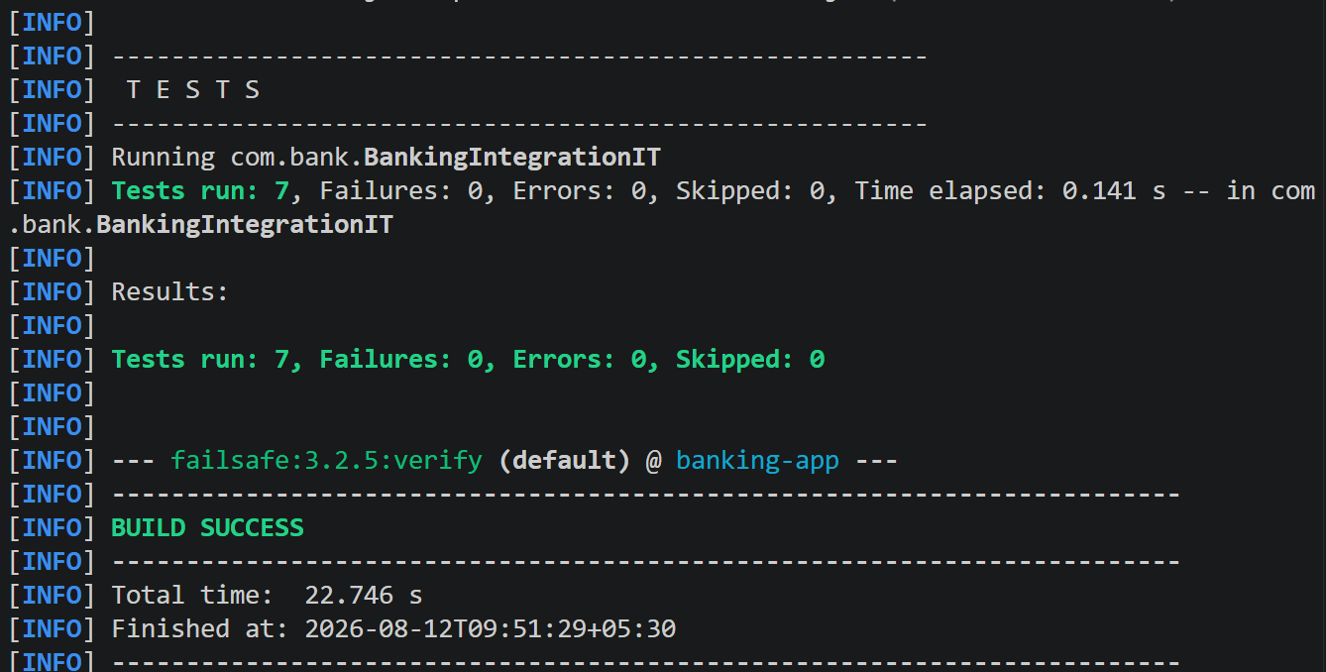

Task 4:
What are Testcontainers?
Testcontainers is an open-source framework/library that allows developers to run real dependencies inside temporary Docker containers during testing.
Instead of using mocked databases or manually installing services, Testcontainers can automatically start a real service such as MySQL, PostgreSQL, Redis, or Kafka, run the tests, and then remove the container after testing.
Example
Suppose you have a Java Spring Boot application that uses PostgreSQL.
With Testcontainers:
Test → Spring Boot App → Real PostgreSQL Container
The test can:
- Start a PostgreSQL Docker container.
- Connect the application to that database.
- Perform database operations.
- Verify the results.
- Stop and remove the container.

Task 5:
When do we use Testcontainers, and what is the need for it?
We use Testcontainers mainly during integration testing, when our application needs to communicate with a real external dependency such as a database, message broker, or another service.
When do we use it?
We use Testcontainers when:
- We need to test with a real database like PostgreSQL, MySQL, or MongoDB.
- We need to test communication with Redis, Kafka, RabbitMQ, etc.
- We don't want tests to depend on services installed on a developer's machine.
- We want every test environment to be consistent and isolated.
- We want to verify that our application works with the actual technology used in production.
What is the need?
The main need is to avoid relying only on mocked or locally installed dependencies.
For example:
Without Testcontainers:
Application → Local PostgreSQL
This can cause problems because every developer may have a different database version, configuration, or data.
With Testcontainers:
Application → Temporary PostgreSQL Docker Container
The container is created for testing, used by the tests, and then removed.
Simple example
Suppose your Spring Boot application uses PostgreSQL.
You want to test:
"When I save a customer, is the customer actually stored correctly in PostgreSQL?"
Testcontainers can start a real PostgreSQL container, run the test against it, and clean it up afterward.
Task 6:
Can you write a piece of code for your existing application to see how test container works?
TransactionRepositoryContainerIT.java
package com.bank.repository;

import com.bank.model.Credit;
import com.bank.model.Debit;
import com.bank.model.Transaction;
import org.junit.jupiter.api.*;
import org.testcontainers.containers.PostgreSQLContainer;
import org.testcontainers.junit.jupiter.Container;
import org.testcontainers.junit.jupiter.Testcontainers;

import java.sql.SQLException;
import java.time.LocalDateTime;

import static org.junit.jupiter.api.Assertions.*;

/**
* Demonstrates Testcontainers: @Container spins up a REAL PostgreSQL
* instance inside a Docker container before tests run, and tears it
* down automatically afterward. No mocking, no embedded/in-memory DB —
* this hits an actual Postgres server, just like production would.
*/
@Testcontainers
@DisplayName("TransactionRepository - Testcontainers PostgreSQL Integration Tests")
class TransactionRepositoryContainerIT {

@Container
static PostgreSQLContainer<?> postgres = new PostgreSQLContainer<>("postgres:16-alpine")
.withDatabaseName("banking_test")
.withUsername("bank_user")
.withPassword("bank_pass");

private static TransactionRepository repository;

@BeforeAll
static void setUp() throws SQLException {
// By this point Testcontainers has already started the container
// and postgres.getJdbcUrl() points at a real, running Postgres instance.
repository = new TransactionRepository(
postgres.getJdbcUrl(),
postgres.getUsername(),
postgres.getPassword());
repository.createSchema();
}

@Test
@DisplayName("Container starts and is reachable")
void containerIsRunning() {
assertTrue(postgres.isRunning());
assertNotNull(postgres.getJdbcUrl());
}

@Test
@DisplayName("Saves a Credit transaction into real Postgres and counts it")
void savesAndCountsCreditTransaction() throws SQLException {
Transaction credit = new Credit("PG-T1", "A100", 5000.0, LocalDateTime.now());

repository.save(credit);

assertTrue(repository.countAll() >= 1);
}

@Test
@DisplayName("Sums Debit transaction amounts per account correctly")
void sumsAmountsByAccount() throws SQLException {
repository.save(new Debit("PG-T2", "A200", 1200.0, LocalDateTime.now()));
repository.save(new Debit("PG-T3", "A200", 300.0, LocalDateTime.now()));

double total = repository.sumAmountByAccount("A200");

assertEquals(1500.0, total, 0.001);
}
}

Task 7:
What is Code Coverage?
Code coverage is a metric that tells us how much of our source code is executed by our automated tests.
It helps us understand whether our tests are covering enough of the application code.
Example
Suppose we have 100 lines of executable code and our tests execute 80 of them.
Code Coverage = 80%
The remaining 20 lines are not executed by the tests.
Common types of code coverage
- Line Coverage → How many lines of code are executed.
- Branch Coverage → How many decision branches (if/else, switch) are tested.
- Method Coverage → How many methods are executed by tests.
- Statement Coverage → How many executable statements are executed.
Important point
High code coverage does not necessarily mean high-quality testing.
For example, you might achieve 90% coverage but still have tests that don't properly verify the expected results.
So, code coverage is a measurement of test completeness, not a guarantee that the application is bug-free.
Task 8:
What is the need for Code Coverage?
The main need for code coverage is to identify which parts of our application are actually being tested and which parts are not.
Why do we need it?
- Find untested code – Identifies lines, methods, or branches that tests never execute.
- Improve test quality – Helps us add tests for missing scenarios.
- Reduce the chance of hidden bugs – Untested code may contain bugs that are never discovered.
- Measure testing progress – Gives the team a measurable indication of how much code is covered.
- Support regression testing – Helps ensure that important parts of the application continue to be tested after changes.
Example
Suppose your application has:
100 lines of executable code
↓
Tests execute 85 lines
↓
Code Coverage = 85%
The remaining 15 lines should be investigated to determine whether they need additional tests.
Important point
We should not blindly aim for 100% coverage. Some code may not need direct testing, and high coverage doesn't guarantee that the tests are good.
Task 9:
📂 Project Structure
Code
banking-app/
│── public/
│ └── index.html
│── src/
│ ├── components/
│ │ ├── AccountDetails.js
│ │ ├── Transactions.js
│ │ └── TransferFunds.js
│ ├── pages/
│ │ ├── Home.js
│ │ ├── Accounts.js
│ │ └── About.js
│ ├── App.js
│ ├── index.js
│ └── api.js
└── package.json
lets simulate a backend API call using fetch. In accountDetails.java class in useEffect..
we will use fetch
// we are Simulate backend API call (replace with real endpoint)
fetch("https://api.examplebank.com/accounts/12345")

AccountDetails.js
import React, { useEffect, useState } from "react";

function formatCurrency(value) {
return value.toLocaleString("en-US", { style: "currency", currency: "USD" });
}

export default function AccountDetails({ accounts, loading, selectedId, onSelect }) {
const [fetchError, setFetchError] = useState(null);

useEffect(() => {
let isMounted = true;

// Simulate backend API call (replace with real endpoint)
fetch("https://api.examplebank.com/accounts/12345")
.then((response) => {
if (!response.ok) {
throw new Error(`Request failed with status ${response.status}`);
}
return response.json();
})
.then((data) => {
if (isMounted) {
console.log("Fetched account from API:", data);
}
})
.catch((error) => {
// Expected in this demo: api.examplebank.com is a placeholder host.
// In a real app this is where you'd surface a retry UI or a toast.
if (isMounted) {
console.warn("Falling back to local account data:", error.message);
setFetchError(error.message);
}
});

return () => {
isMounted = false;
};
}, []);

if (loading) {
return <p className="empty-state">Loading accounts…</p>;
}

if (!accounts.length) {
return <p className="empty-state">No accounts found.</p>;
}

return (
<div>
{fetchError && (
<p className="empty-state" style={{ padding: "0 0 12px", textAlign: "left" }}>
Live account service unavailable — showing local data.
</p>
)}
<div className="account-list">
{accounts.map((account) => (
<div
key={account.id}
className={`account-card${account.id === selectedId ? " is-selected" : ""}`}
onClick={() => onSelect(account.id)}
role="button"
tabIndex={0}
onKeyDown={(e) => {
if (e.key === "Enter" || e.key === " ") onSelect(account.id);
}}
>
<span className="type">{account.type}</span>
<div className="name">{account.name}</div>
<div className="balance">{formatCurrency(account.balance)}</div>
<div className="number">{account.accountNumber}</div>
</div>
))}
</div>
</div>
);
}
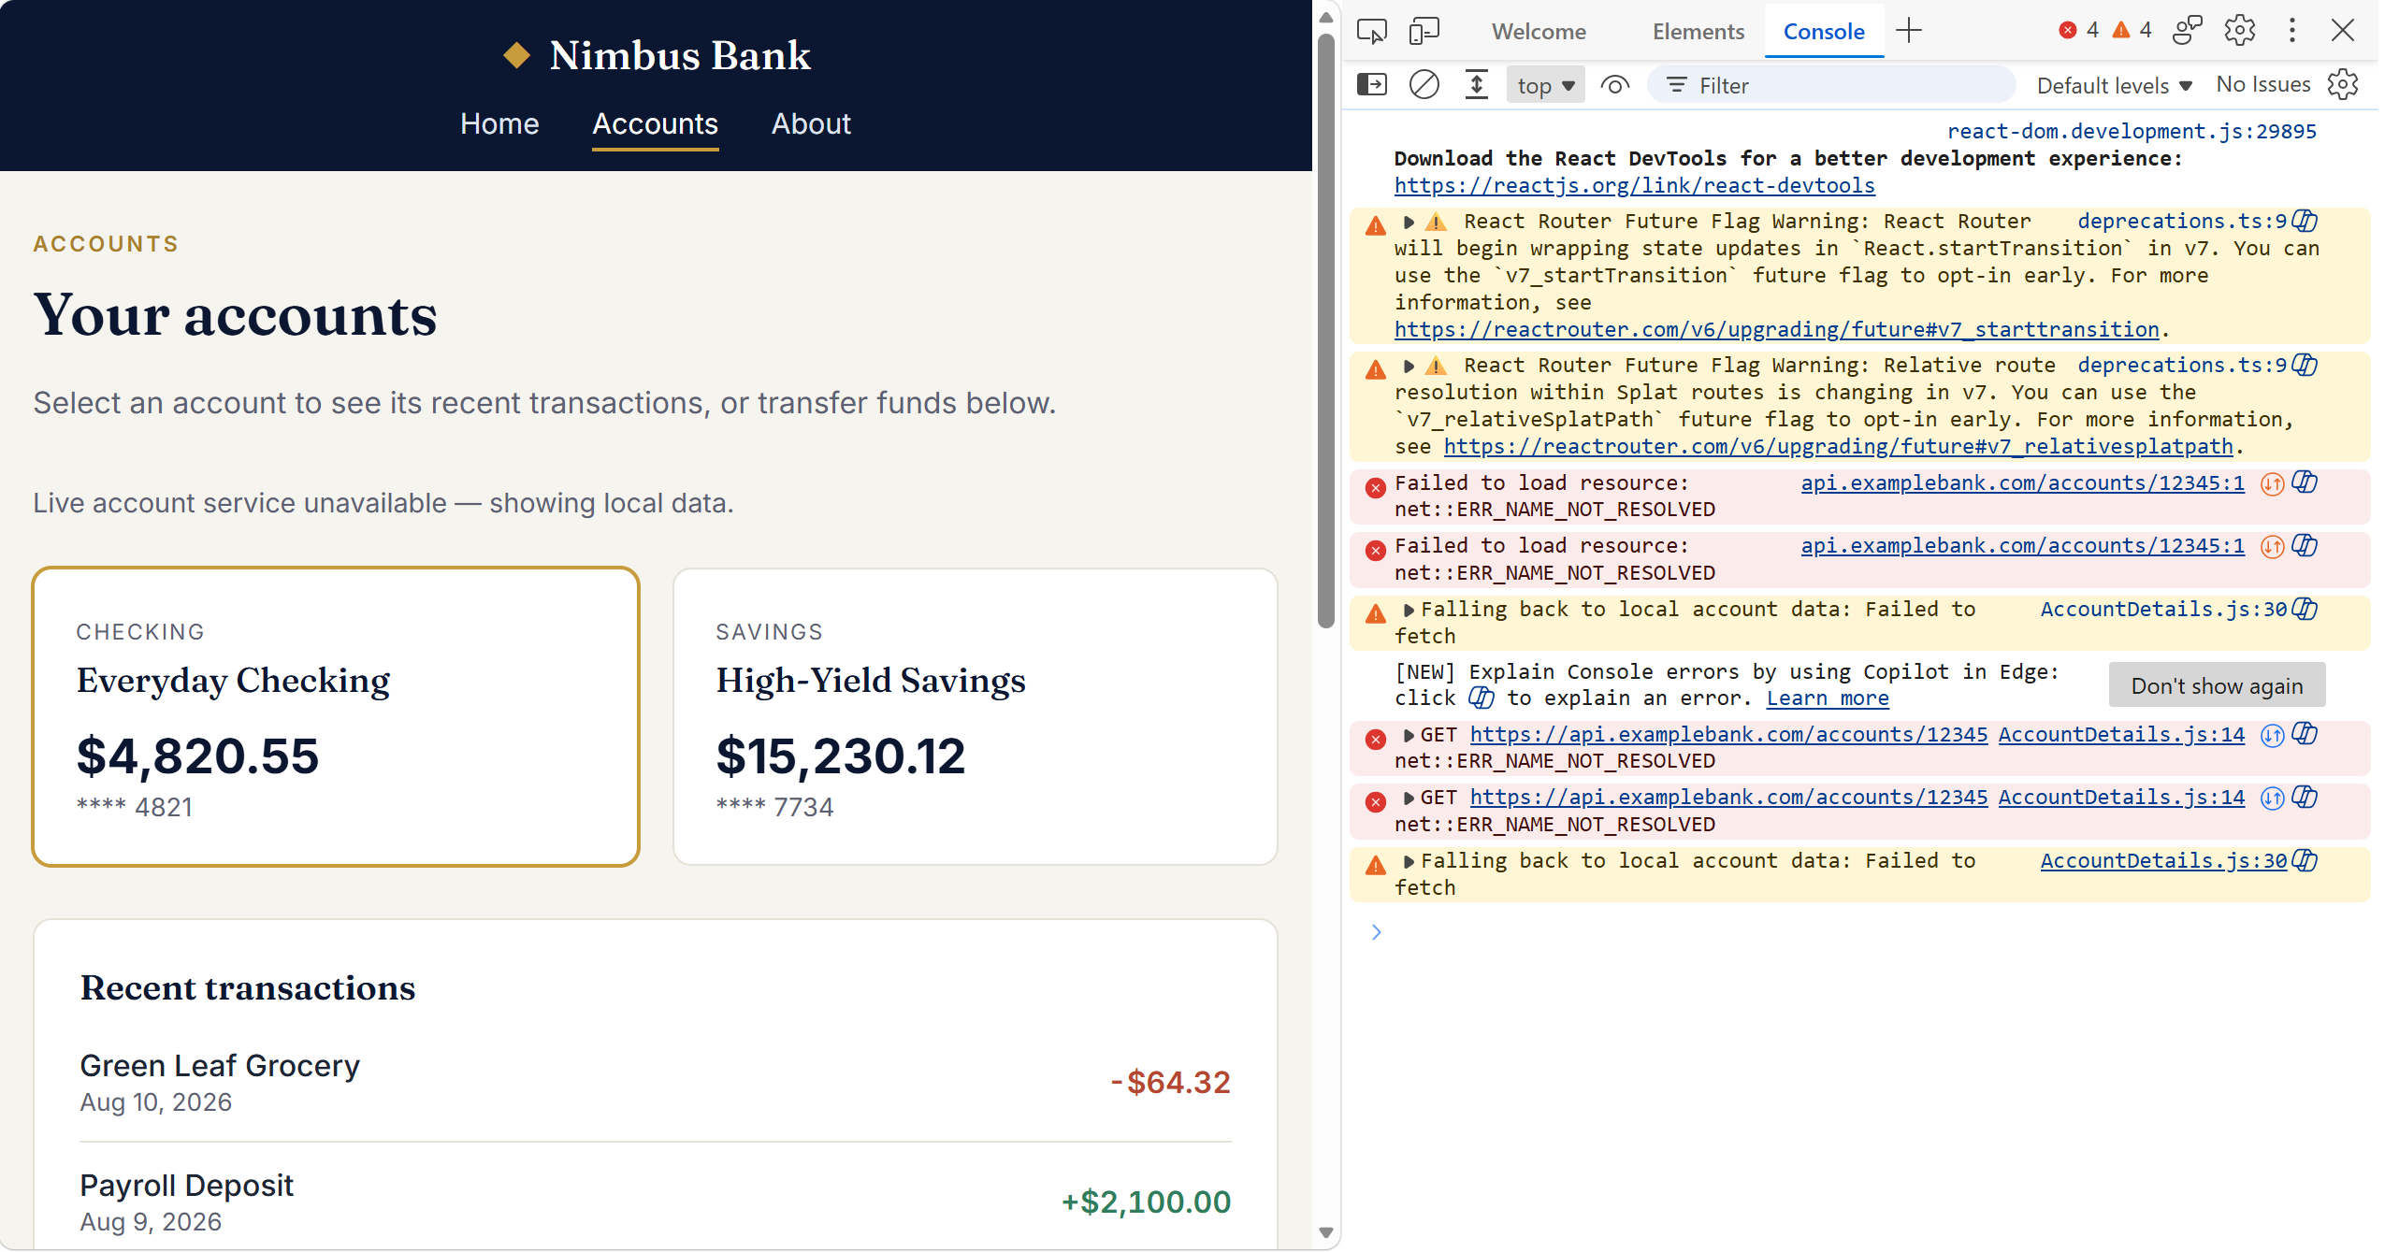

Task 10: What is Redux used for?
Redux is a state management library commonly used with React applications to manage shared/global application state in a predictable and centralized way.
Why do we use Redux?
Imagine your React application has many components:
Login
↓
Dashboard
↓
Accounts
↓
Transfer
↓
Transaction History
If multiple components need the same data, passing it through props can become complicated. This is called prop drilling.
Redux provides a central store where shared state can be maintained.
Redux Store
┌──────────────┐
│ User │
│ Balance │
│ Transactions │
└──────┬───────┘
│
┌─────────┼─────────┐
↓ ↓ ↓
Dashboard Accounts Transfer
Example
In your banking application, Redux could store:
{
user: {
name: "Karthik",
accountNumber: "123456789"
},
balance: 25000,
transactions: []
}
Then both Dashboard and Accounts can access the balance from the Redux store instead of passing it through several components.
What does Redux provide?
- Centralized state management
- Avoids excessive prop drilling
- Predictable state updates
- Makes shared state accessible to multiple components
- Useful for debugging and tracking state changes
- Helps manage complex application state

Task 11: Why do we need to maintain state throughout the app?
We maintain state throughout the application when multiple components need to access or react to the same data.
For example, in your banking application:
Redux Store
│
┌─────────┼─────────┐
↓ ↓ ↓
Dashboard Accounts Transfer
│
Balance
Suppose the user's balance is ₹10,000.
If the user transfers ₹2,000:
Before Transfer → ₹10,000
↓
Transfer ₹2,000
↓
After Transfer → ₹8,000
The Dashboard, Accounts page, and Transfer page may all need to show the updated balance.
Instead of maintaining separate copies of the balance in each component, we maintain it in a shared state.
Why is this useful?
- Keeps data consistent across components.
- Prevents different components from having different values for the same data.
- Avoids excessive prop drilling.
- Allows multiple components to access the same information.
- Makes state changes more predictable and easier to manage.

Task 12: What is useSelector used for?
useSelector is a React-Redux hook used to read or access data from the Redux store inside a React component.
For example, suppose Redux has:
const initialState = {
balance: 10000
};
In a component, we can access the balance using:
import { useSelector } from "react-redux";
function Dashboard() {
const balance = useSelector(
(state) => state.account.balance
);
return <h2>Balance: ₹{balance}</h2>;
}
Here:
useSelector((state) => state.account.balance)
means:
"Go to the Redux store and give me the balance from account state."
Important point
useSelector is mainly for reading state.
If we want to change/update Redux state, we generally use:
useDispatch()
So remember:
useSelector → Read data from Redux store
useDispatch → Send an action to update Redux state

Task 13:
After the break we would be working with the Redux ..

In this can you create a store

Step 1:
Import createstore from Redux

show how the state changes based on the action type.. Like if with draw , deposit… etc..

Now create store with a reducer..

Step 2:
Now in app.js use – useSelector and useDispatcher from react-redux;

Access balance from redux store and dispatch action to the dispatch function

Step 3:

Create a controller class like BalanceController.js .. which has component for withdraw and deposit.

index.js, index. html (save in public folder) and package.json code is given for your ref

BalanceController.js
import React, { useState } from "react";
import { useDispatch, useSelector } from "react-redux";
import "./BalanceController.css";

function BalanceController() {
const dispatch = useDispatch();
const balance = useSelector((state) => state.balance);
const [amount, setAmount] = useState("");
const [error, setError] = useState("");

const handleAmountChange = (event) => {
setAmount(event.target.value);
if (error) {
setError("");
}
};

const validateAmount = (value) => {
const parsed = Number(value);
if (!value || Number.isNaN(parsed)) {
return "Please enter a valid amount.";
}
if (parsed <= 0) {
return "Amount must be greater than zero.";
}
return "";
};

const runTransaction = (type) => {
const validationError = validateAmount(amount);
if (validationError) {
setError(validationError);
return;
}

const amountNumber = Number(amount);
if (type === "WITHDRAW" && amountNumber > balance) {
setError("Insufficient balance for this withdrawal.");
return;
}

dispatch({
type,
payload: amountNumber,
});

setAmount("");
setError("");
};

return (
<section className="balance-controller">
<div className="balance-controller__header">
<h2>Balance Controller</h2>
<p className="balance-controller__hint">
Enter the amount you want to deposit or withdraw.
</p>
</div>

<div className="balance-controller__form">
<label htmlFor="amount" className="balance-controller__label">
Amount
</label>
<input
id="amount"
type="number"
min="1"
step="1"
value={amount}
onChange={handleAmountChange}
placeholder="Enter amount"
className="balance-controller__input"
/>
</div>

{error && <div className="balance-controller__error">{error}</div>}

<div className="balance-controller__actions">
<button
type="button"
className="balance-controller__button balance-controller__button--deposit"
onClick={() => runTransaction("DEPOSIT")}
>
Deposit
</button>
<button
type="button"
className="balance-controller__button balance-controller__button--withdraw"
onClick={() => runTransaction("WITHDRAW")}
>
Withdraw
</button>
</div>

<p className="balance-controller__balance">
Current balance: <strong>₹{balance.toLocaleString()}</strong>
</p>
</section>
);
}

export default BalanceController;
Redux / store.js
import { createStore } from "redux";

const initialState = {
balance: 5000
};

function balanceReducer(state = initialState, action) {
switch (action.type) {
case "DEPOSIT":
return {
...state,
balance: state.balance + action.payload
};

case "WITHDRAW":
return {
...state,
balance: state.balance - action.payload
};

default:
return state;
}
}

const store = createStore(balanceReducer);

export default store;

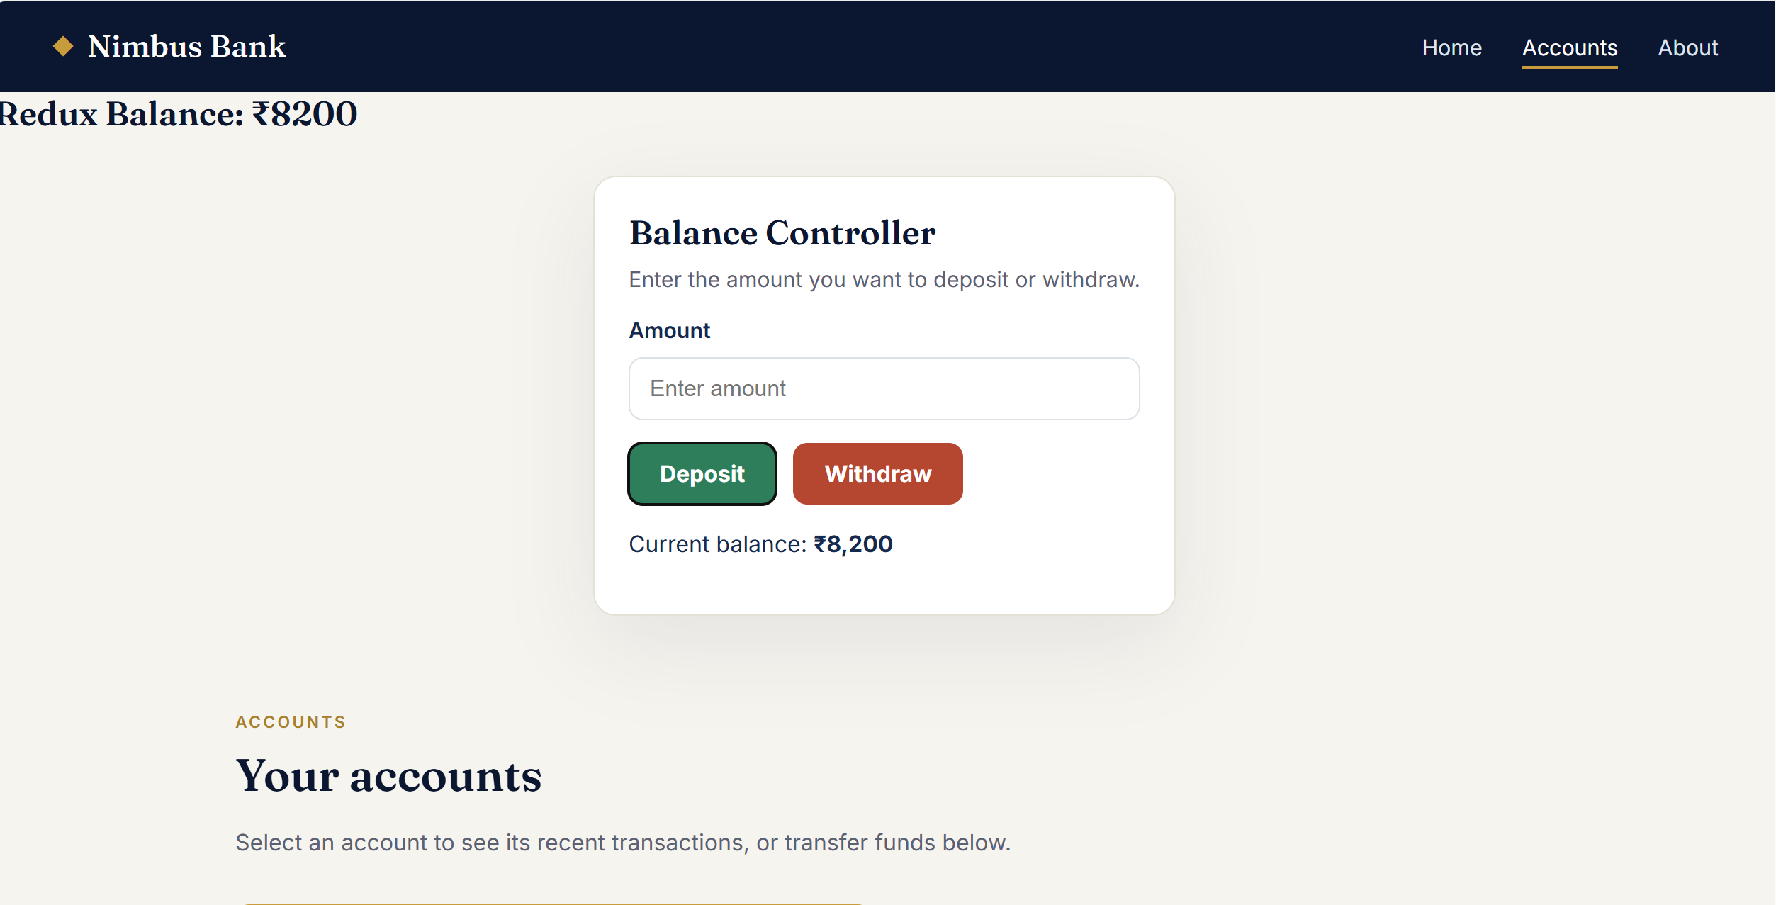
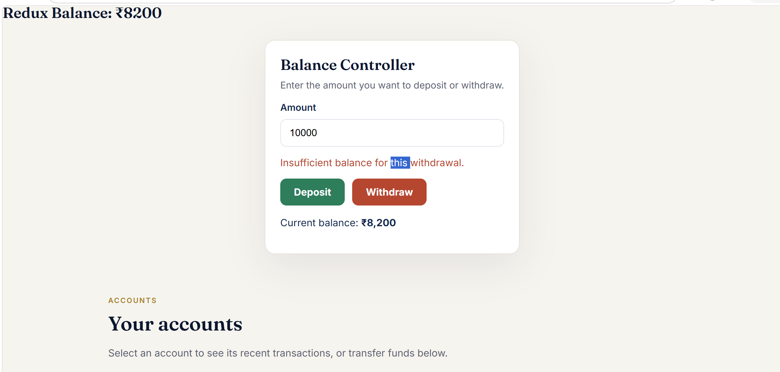

Task 14:
What is Node JS for?
Node.js is a JavaScript runtime environment that allows us to execute JavaScript outside the browser. It is mainly used for backend development, building APIs, and running JavaScript-based development tools. In a React project, Node.js is used to run tools such as npm and the React development server.
Task 15: Why do we use Node.js?
We use Node.js because it allows us to run JavaScript outside the browser and is especially useful for building backend services and running JavaScript development tools.
Main reasons
- JavaScript on the server
We can use JavaScript for both frontend and backend development.
- Fast and efficient
Node.js uses a non-blocking, event-driven architecture, which is useful for handling many concurrent requests.
- Build APIs and backend applications
Frameworks such as Express.js can be used with Node.js to create REST APIs.
- Large npm ecosystem
npm provides thousands of reusable packages, making development faster.
- Required for many frontend tools
In your React project, Node.js allows you to run commands such as:
- npm install
- npm start
npm run build
- Good for real-time applications
It is commonly used for chat applications, live notifications, streaming-related services, etc.
Task 16: What are Common and Modern Modules in Node.js?
I think you mean CommonJS and modern ES Modules (ESM) in Node.js.
Both are module systems used to organize, reuse, and share JavaScript code between files.
1. CommonJS (CJS)
CommonJS is the traditional Node.js module system.
It uses:
- require() → import a module
- module.exports → export a module
Example:
// math.js
function add(a, b) {
return a + b;
}

module.exports = { add };
// app.js
const { add } = require("./math");
console.log(add(10, 20));
Here:
module.exports → Export
require() → Import

2. ES Modules (ESM)
ES Modules are the modern JavaScript module standard and are widely used in modern Node.js applications.
They use:
- export → export code
- import → import code
Example:
// math.js
export function add(a, b) {
return a + b;
}
// app.js
import { add } from "./math.js";

console.log(add(10, 20));
Here:
export → Export
import → Import

