Day 14 - 04th Aug 2026

Task 1:
What do you understand by Git collaboration?
Git Collaboration means working together on the same project using Git, a version control system.
- It allows multiple team members to work on different parts of a project at the same time.
- Each person can make changes without affecting others' work immediately.
- Git keeps track of all changes, making it easy to see who changed what and when.
- Team members can combine their work using branches and merge their changes safely.
- It also helps resolve conflicts if two people edit the same file.
- Overall, Git collaboration makes teamwork more organized, efficient, and reduces the risk of losing important work.

Task 2:
Why is collaboration necessary while working on git?
Collaboration is necessary because it allows many people to work on the same project together.
It helps team members work on different features without disturbing each other's work.
Git keeps a record of all changes, so nothing important gets lost.
It makes it easy to share updates and combine everyone's work into one project.
Team members can review each other's code and fix mistakes before the final version.
Overall, Git collaboration improves teamwork, saves time, and helps complete projects more efficiently.

Task 3:
What are the commands that we use while collaborating?
git clone – Copies a remote repository to your computer so you can start working on it.
git branch – Creates or shows branches, allowing different team members to work on separate features.
git checkout or git switch – Moves from one branch to another.
git pull – Downloads the latest changes from the remote repository to keep your project up to date.
git add, git commit, and git push – These commands save your changes and upload them to the remote repository.
git merge – Combines changes from different branches into one, making teamwork easier.

Task 4:
Can you show the typical work flow while working on Git ?
- Start the Day
  - Open the project and switch to the correct branch.
  - Pull the latest changes from GitHub to make sure your local project is up to date.
git pull origin main
(or git pull origin develop if your team uses a develop branch)
- Create or Switch to Your Feature Branch
  - If you're working on a new task, create a new branch.
git checkout -b feature/login-page
  - If the branch already exists:
git checkout feature/login-page
- Work on Your Task
  - Write code, fix bugs, or add new features.
  - Test your changes to make sure everything works correctly.
- Check What Has Changed
  - Before saving your work, check the modified files.
git status
- Stage the Changes
  - Add the files you want to commit.
git add .
(or add specific files if needed)
- Commit with a Proper Message
  - Save your work with a clear and meaningful commit message.
git commit -m "Added login page validation"
Examples of good commit messages:
  - Fixed navigation bar issue
  - Added user profile page
  - Updated dashboard UI
  - Resolved login authentication bug
- Push Your Changes to GitHub
  - Upload your committed changes to the remote repository.
git push origin feature/login-page
- Create a Pull Request (PR)
  - Open GitHub and create a Pull Request from your feature branch to the main or develop branch.
  - Team members review your code and suggest improvements if needed.
- Merge the Changes
  - After the review is approved, merge the Pull Request into the main project branch.
  - Everyone on the team can now access the new changes.
- Repeat the Next Day
  - Before starting new work, pull the latest changes again:
git pull origin main
This ensures your local project is always synchronized with the latest code from your team.

Task 5:
Give some to do practices that we need to follow while working on Git Repo on a daily basis.
Always pull the latest changes from the remote repository before starting your work to avoid conflicts.
Create a separate branch for every new feature or bug fix instead of working directly on the main branch.
Make small and meaningful commits with clear commit messages that describe what you changed.
Test your code before committing to make sure everything works correctly.
Push your changes regularly to GitHub so your work is safely backed up and visible to your team.
Review your code and resolve any merge conflicts carefully before creating a Pull Request, and keep your local repository updated by pulling the latest changes regularly.

Task 6:
Create a demo typescript file and execute it
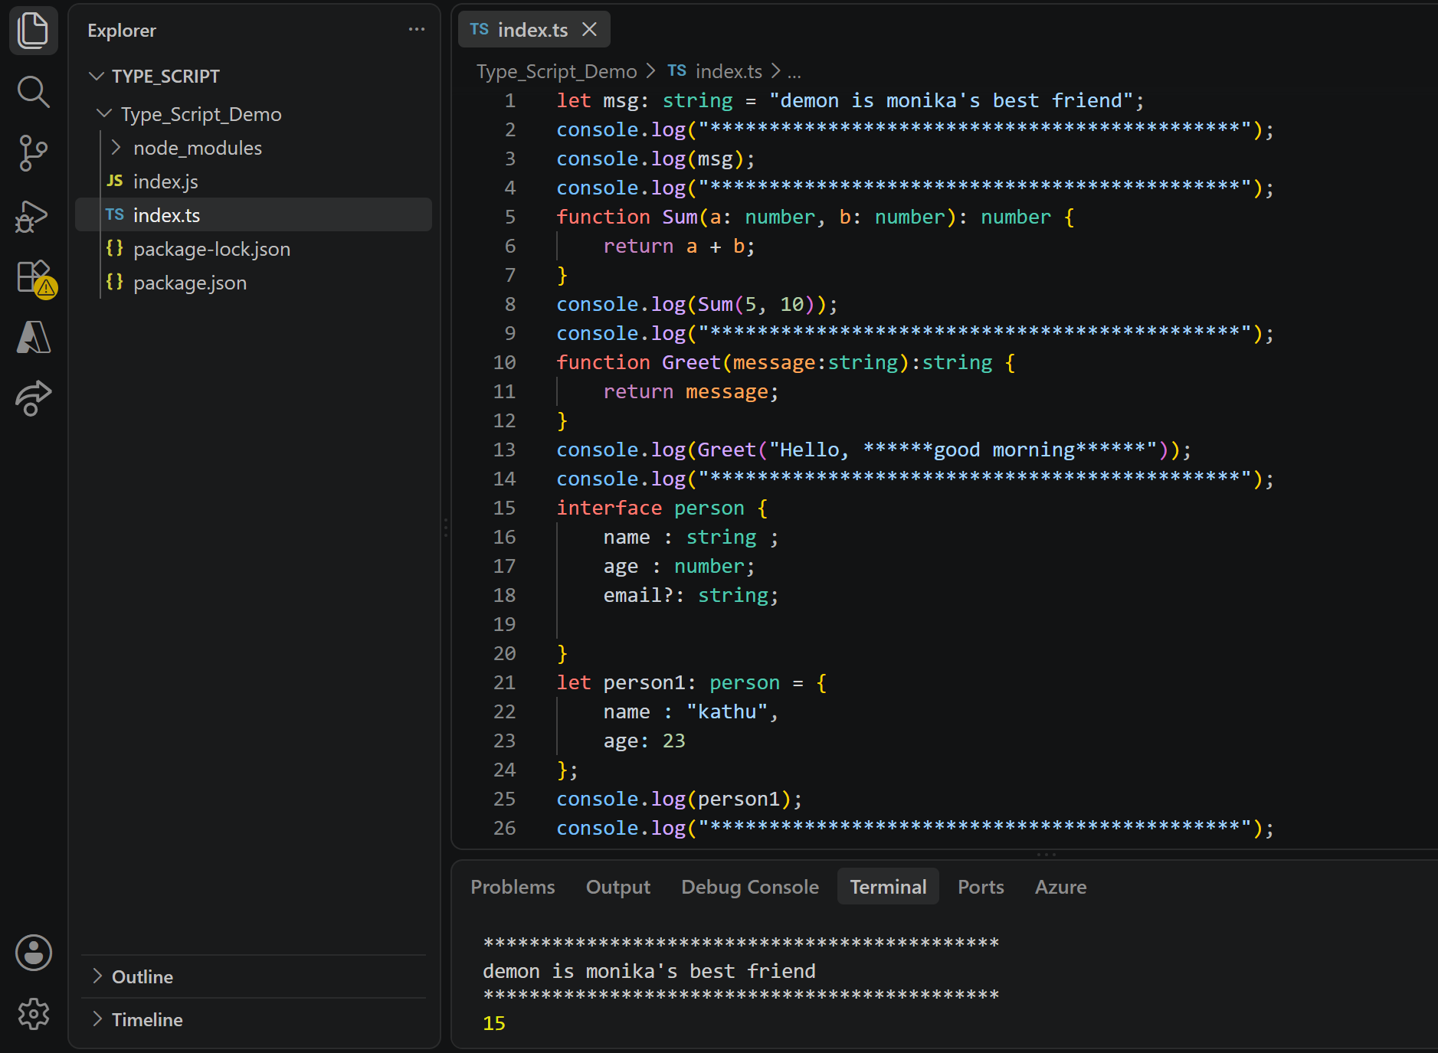
Task 7:
Create an interface and try it out?
interface person {
name : string ;
age : number;
email?: string;

}
let person1: person = {
name : "kathu",
age: 23
};
console.log(person1);
console.log("*********************************************");

Task 8:
In the above code use optional variable ?
interface person {
name : string ;
age : number;
email?: string;

}
let person1: person = {
name : "kathu",
age: 23
};
console.log(person1);
console.log("*********************************************");

Task 9:
Create a demo with constructor, default and with parameterised..

class Student {
name: string = "Vicky";

constructor() {
console.log("Default Constructor Called");
}
}

const s1 = new Student();

console.log(s1.name);
console.log("*********************************************");
class Employee {
emp_id:number;
emp_name:string;
constructor(id:number, name:string) {
this.emp_id = id;
this.emp_name = name;
}
}
let emp1 = new Employee(1, "Alice");
console.log(emp1);
console.log("*********************************************");

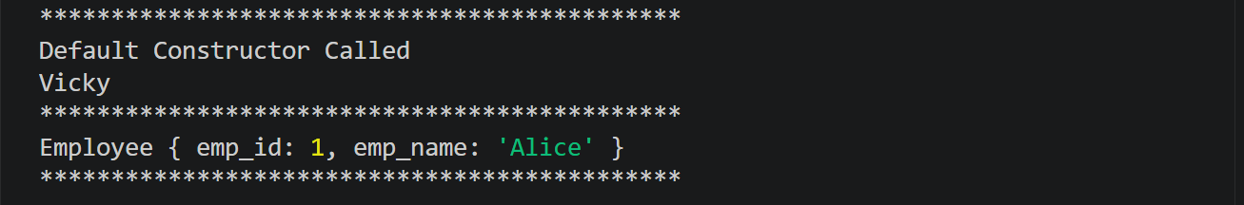

Task 10;
What are primitive and special data types in typescript?
Primitive Data Types
Primitive types represent the most basic values and are not objects. TypeScript has these main primitive types:
Type | Description | Example
string | Represents text values | let name: string = "John";
number | Represents integers and floating-point numbers | let age: number = 25;
boolean | Represents true/false values | let isActive: boolean = true;
bigint | Represents very large integers | let id: bigint = 123n;
symbol | Represents unique identifiers | let key: symbol = Symbol("id");
undefined | Represents a variable that has no assigned value | let x: undefined = undefined;
null | Represents an intentional absence of value | let data: null = null;

Task 11:
Create a class with access modifiers.

// Class with access modifiers
class Employee_details {
public name: string;
private salary: number;
protected department: string;

constructor(name: string, salary: number, department: string) {
this.name = name;
this.salary = salary;
this.department = department;
}

public displayDetails(): void {
console.log("Name:", this.name);
console.log("Salary:", this.salary);
console.log("Department:", this.department);
}
}

const emp = new Employee_details("Karthik", 50000, "IT");

console.log(emp.name);

emp.displayDetails();
console.log("*********************************************");

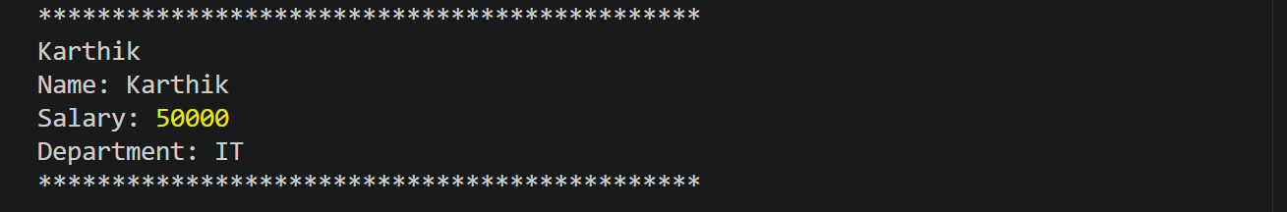

Task 12:
To create a typescript file and run it… what are the steps … that we need to follow.. (lets suppose if I am creating ts file for the first time in my sys).
Install Node.js on the system.
Create a new project folder and open it in VS Code.
Open the terminal and run npm init -y to create a package.json file.
Install TypeScript using npm install -D typescript.
Create a TypeScript file, for example index.ts.
Initialize TypeScript configuration using npx tsc --init.
Write the TypeScript code in index.ts.
Compile the file using npx tsc index.ts, which generates index.js.
Run the JavaScript file using node index.js to see the output.

Task 13:
Create a demo and see how generics work in ts.
// Generic function
function display<T>(value: T): T {
return value;
}

console.log(display<string>("Hello"));
console.log(display<number>(100));

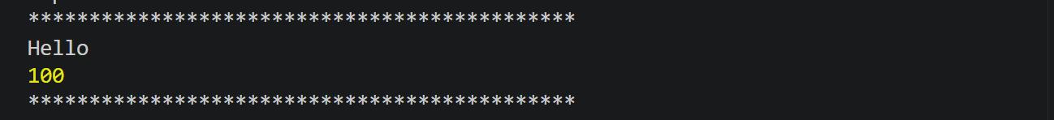

Task 14:
What are type annotations in typescript?
Type Annotations in TypeScript are used to specify the data type of a variable, function parameter, or return value. They help TypeScript understand what type of data should be stored or used. By using type annotations, we can catch errors during development instead of at runtime. This makes the code more reliable and easier to maintain. Type annotations are written using a colon (:) followed by the data type.
Example:
let name: string = "Karthik";
let age: number = 25;
In simple terms, type annotations improve code readability, provide type safety, and help developers write error-free code.

Task 15:
What is the purpose of the any keyword in typescript?
The any keyword in TypeScript is used when we want a variable to accept any type of value. It disables TypeScript's type checking for that variable, which means the variable can store a string, number, boolean, or any other data type. The any type is useful when the data type is unknown or may change during execution. However, it should be used carefully because it reduces the benefits of TypeScript's type safety. Overusing any can make the code harder to debug and maintain.
Example:
let data: any = "Hello";
data = 100;
data = true;
Task 16:
Can you give an example to show the difference between any and unknown.
any and unknown both allow a variable to store any type of value, but unknown is safer because it requires type checking before use.
let value1: any = "Hello";
console.log(value1.toUpperCase()); // Works without checking

let value2: unknown = "Hello";

// console.log(value2.toUpperCase()); // Error: Need type checking first

if (typeof value2 === "string") {
console.log(value2.toUpperCase()); // Works after checking the type
}

console.log("*********************************************");

In this example, any allows direct usage without restrictions, while unknown forces us to verify the data type before performing operations. This makes unknown a safer choice in TypeScript.

Task 18:
Code
banking-app/
├── backend/
│ ├── src/
│ │ ├── index.ts
│ │ ├── routes/
│ │ │ └── accountRoutes.ts
│ │ ├── controllers/
│ │ │ └── accountController.ts
│ │ ├── models/
│ │ │ └── account.ts
│ │ └── services/
│ │ └── accountService.ts
└── frontend/
└── Angular project (ng new banking-ui)
index.ts
import { getAccount, deposit, withdraw } from "./services/accountService";

const accountId = 101;

console.log("Initial Account:");
console.log(getAccount());

console.log("After Deposit:");
console.log(deposit(accountId, 1000));

console.log("After Withdraw:");
console.log(withdraw(accountId, 5000));

accountRoutes.ts
import type { Account } from "../models/account";

let account: Account = {
id: 101,
accountHolderName: "KATHUS",
accountNumber: "ACC1001",
balance: 50000
};

export function getAccount(): Account {
return account;
}

export function getAccounts(): Account[] {
return [account];
}

export function deposit(id: number, amount: number): Account | undefined {
if (id !== account.id) {
return undefined;
}

account.balance += amount;
return account;
}

export function withdraw(id: number, amount: number): Account | undefined {
if (id !== account.id) {
return undefined;
}

if (amount > account.balance) {
return undefined;
}

account.balance -= amount;
return account;
}

accountController.ts
import { Request, Response } from "express";
import * as accountService from "../services/accountService";

export const getAllAccounts = (_req: Request, res: Response) => {
res.json(accountService.getAccounts());
};

export const depositAmount = (req: Request, res: Response) => {
const { id, amount } = req.body;
const account = accountService.deposit(id, amount);
account ? res.json(account) : res.status(404).send("Account not found");
};

export const withdrawAmount = (req: Request, res: Response) => {
const { id, amount } = req.body;
const account = accountService.withdraw(id, amount);
account ? res.json(account) : res.status(400).send("Insufficient funds");
};

account.ts
// models/account.ts
export interface Account {
id: number;
accountNumber: string;
accountHolderName: string;
balance: number;
}

accountService.ts
import type { Account } from "../models/account";

let account: Account = {
id: 101,
accountHolderName: "kathu",
accountNumber: "ACC1001",
balance: 50000
};

export function getAccount(): Account {
return account;
}

export function getAccounts(): Account[] {
return [account];
}

export function deposit(id: number, amount: number): Account | undefined {
if (id !== account.id) {
return undefined;
}

account.balance += amount;
return account;
}

export function withdraw(id: number, amount: number): Account | undefined {
if (id !== account.id) {
return undefined;
}

if (amount > account.balance) {
return undefined;
}

account.balance -= amount;
return account;
}

sconfig.json
{
"compilerOptions": {
"target": "ES2020",
"module": "CommonJS",
"rootDir": "./src",
"outDir": "./dist",
"strict": true,
"esModuleInterop": true,
"skipLibCheck": true
},
"include": ["src"]
}

